CT1 Individual Assignment (MLOps)
End to End MLOps Workflow for Bank Term Deposit Marketing
Submitted by: AJEET KUMAR
12510040
AMPBA
16th Dec 2025

1. Business Problem and Objective
- Briefly describe the bank’s marketing context
  - The bank runs outbound campaigns to sell term deposits to customers.
  - Contacting every customer is costly. Only a small fraction accepts the offer.
- State the business objective clearly
  - Build a prediction model that identifies customers who are most likely to subscribe to a term deposit.
  - Use this model to prioritize outreach and improve campaign efficiency.
Target variable:
- y = 1 if customer subscribes to term deposit
- y = 0 otherwise
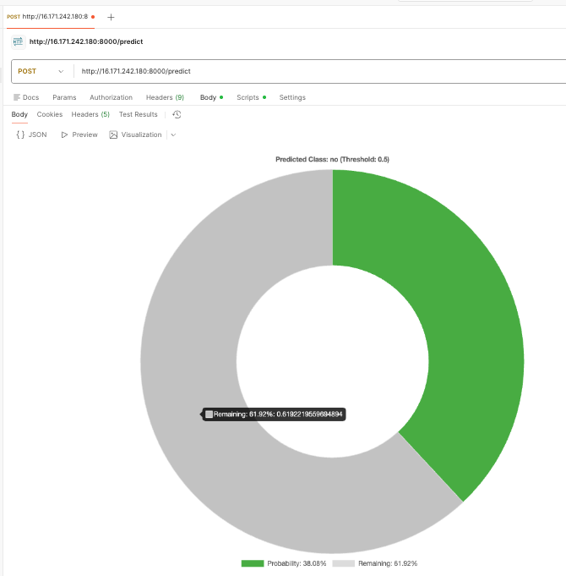

2. Dataset and Modelling Approach
2.1 Dataset Overview
- Mention dataset name and size
  - 4119 observations
  - 21 columns (20 input features plus target y)
- Feature groups
  - Client and demographic attributes (age, job, marital, education, etc.)
  - Campaign interaction variables (duration, campaign, previous, contact, month, day_of_week, poutcome)
  - Macroeconomic indicators (emp.var.rate, cons.price.idx, cons.conf.idx, euribor3m, nr.employed)
2.2 Model and Preprocessing
- Algorithm
  - Logistic Regression for binary classification
- Preprocessing pipeline
  - Numeric features scaled using StandardScaler
  - Categorical features encoded using OneHotEncoder with handle_unknown set to ignore
- Handling class imbalance
  - Used class_weight balanced in Logistic Regression to give more weight to the minority positive class
2.3 Key Evaluation Metrics
- Report test set metrics from the notebook
  - ROC AUC
  - Precision, recall, F1 for both classes, with focus on the positive class (y = 1)
  - Confusion matrix to show trade off between true positives and false positives
- One short interpretation
  - For example, “The model achieves a ROC AUC of 0.9423. This indicates good ranking ability between converters and non converters and makes the model suitable for prioritising leads in marketing campaigns.”
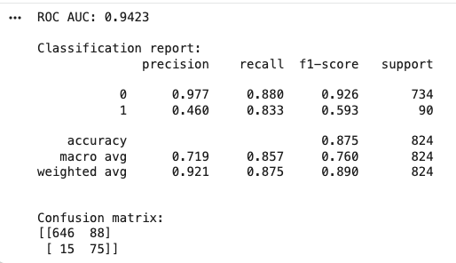

3. MLOps Pipeline Implementation
3.1 Local Model Development
- Tools
  - Python and Jupyter notebook
  - scikit learn for modeling, joblib for saving the model
- Steps
  - Loaded bank-additional.csv
  - Performed basic EDA
  - Defined numeric and categorical feature lists
  - Built preprocessing plus Logistic Regression pipeline
  - Trained and evaluated the model
  - Saved the model as bank_term_deposit_model.joblib
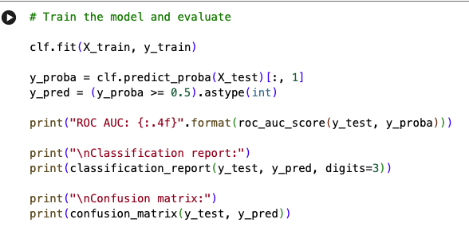
3.2 API and Containerization with Docker
- API layer
  - Implemented a Flask app in app.py with two endpoints
    - GET /health to verify service status
    - POST /predict to accept JSON input and return prediction and probability
  - The API expects all 20 original input fields and returns “yes” or “no” along with probability
- Docker container
  - Defined Dockerfile based on python:3.11 slim
  - Installed dependencies from requirements.txt
  - Copied app.py and bank_term_deposit_model.joblib into the container
  - Exposed port 8000 and used gunicorn to serve the Flask app
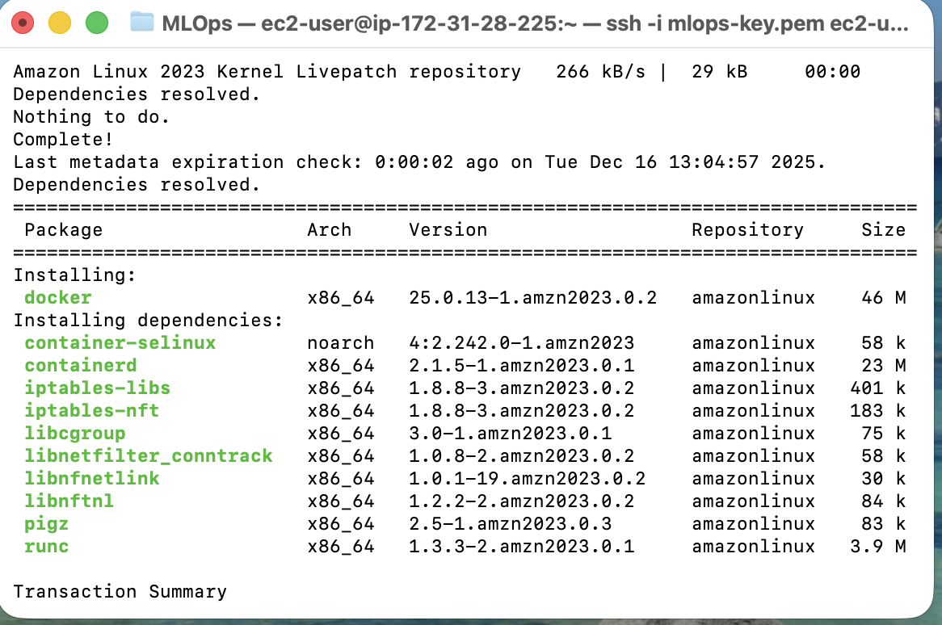
3.3 AWS Deployment and Inference
- AWS setup
  - Launched an EC2 instance
  - Installed Docker on the instance
  - Copied code and model files to the instance
  - Built the Docker image and ran the container on port 8000
- Public endpoint testing
  - Used the EC2 public IP and port 8000
  - Verified health endpoint using curl or browser
  - Sent POST requests using curl or Postman to /predict with a sample JSON request
  - Confirmed that the prediction and probability received from the deployed model matched local predictions for the same record
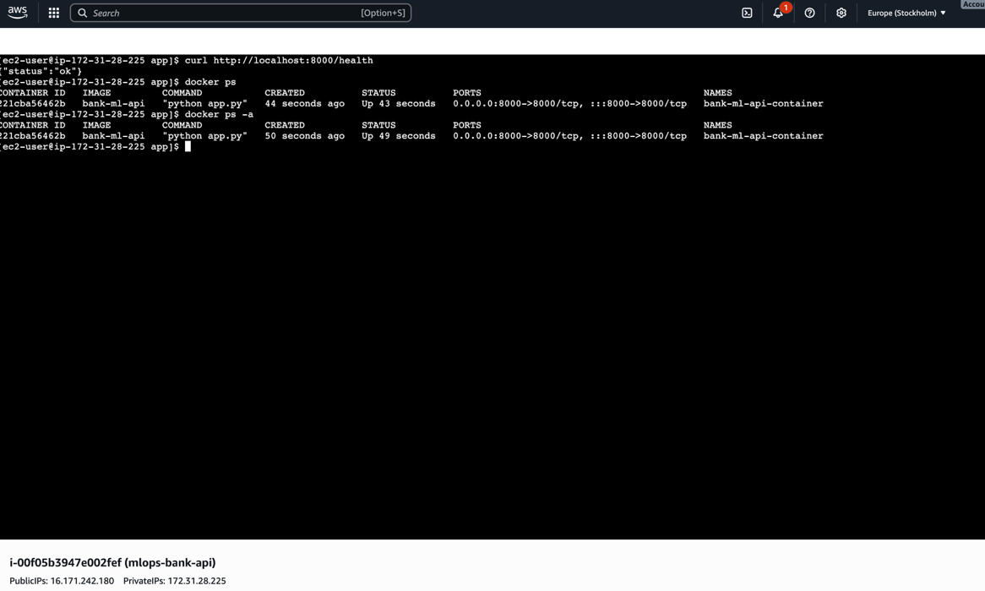
- EC2 instance or SSH session showing the container running
- Postman or terminal showing a successful prediction response from the public endpoint
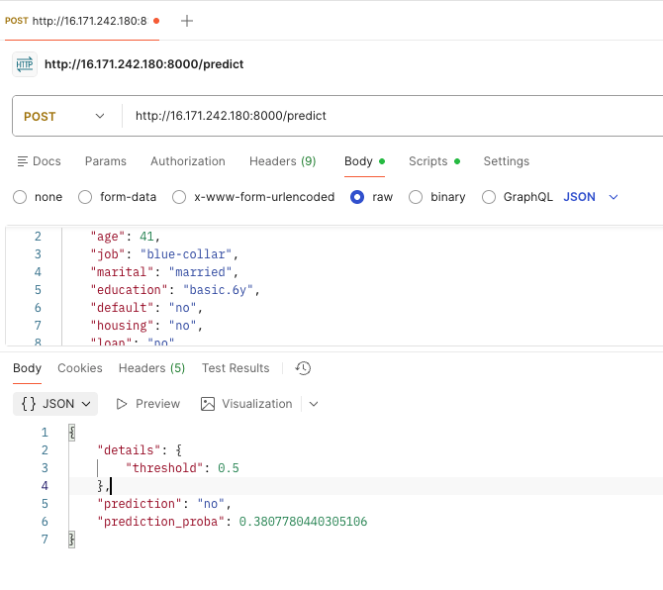

4. Conclusion
- Summarised workflow
  - Built a supervised classification model locally using the bank marketing dataset to predict term deposit subscription (y)
  - Performed preprocessing through a single reproducible pipeline (numeric scaling and categorical one hot encoding), trained a Logistic Regression model with class balancing, and evaluated performance using ROC AUC, classification report, and confusion matrix (ROC AUC = 0.9423, accuracy = 0.875)
  - Containerized the application using Docker (Dockerfile + requirements), validated it locally, and then deployed the same container to an AWS EC2 instance with port 8000 exposed for public access
- Business value
  - The deployed model enables the bank to prioritize outreach toward customers most likely to subscribe, improving campaign efficiency by reducing unnecessary calls/emails while increasing conversion rates.
  - With strong ranking capability (ROC AUC 0.9423) and high recall for the positive class (0.833), the solution is well-suited for marketing use cases where capturing potential subscribers is critical, and targeting thresholds can be tuned to match budget, call capacity, and cost per contact.

