Q. Demonstrate telnet in packet Tracer.
Aim:-To demonstrate Telnet in packet Tracer. Setup:
- 1 PC , 1 Router , 1 switch.
- PC --->Switch--> Router connect using copper straight wire through cables.
- Do Router ,Switch interface Up. Topology:
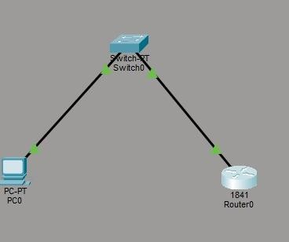

Config:
Switch :
Switch>enable Switch#configure terminal
Switch(config-if)# ip address) 192.168.1.2 255.255.255.0 Switch(config-if)# no shutdown
Switch(config-if)#exit Switch(config-if)# line vtg 04

Switch(config-if)# password cisco Switch(config-line)#login Switch(config-line)#end
Switch# write memory Router:
Router>enable Router#configure terminal
Router(config-if)# ip address 192.168.1.1 Router(config-if)#no shutdown Router(config-if)#exit
Router(config)# line vty 04 Router(config-line)# password cisco Router(config-line)#login Router(config-line)#end
Router# write memory

Verify:
PC0:

C:\ipconfig
C:\>ping 192.168.1.1
Telnet 192.168.1.1
Telnet 192.168.1.2

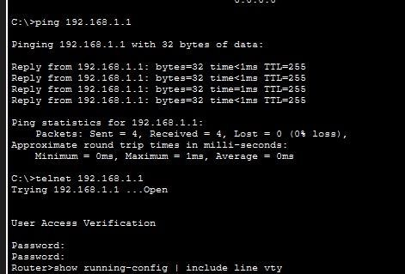
Conclusion:The above Topology has been executed successfully.

