2 .Interpolation
Q. Write a program in python to demonstrate Forward difference table. Aim: To write a program in python to demonstrate Forward difference table. Program:
def forward_difference_table(x, y): n = len(y) diff_table = [y.copy()] # first row is y values

# generate forward differences for i in range(1, n):
row = []
for j in range(n - i):
value = diff_table[i - 1][j + 1] - diff_table[i - 1][j] row.append(value)
diff_table.append(row) return diff_table

def display_table(x, diff_table): n = len(x) print("\nForward Difference Table:") print("x\t" + "\t".join([f"Δ^{i}y" for i in range(n)]))
for i in range(n): print(f"{x[i]:.2f}", end="\t") for j in range(n - i):
print(f"{diff_table[j][i]:.2f}", end="\t") print()

def main(): n = int(input("Enter the number of data points: "))

print("Enter x values (equally spaced):")
x = [float(input(f"x[{i}]: ")) for i in range(n)]

print("Enter corresponding y values:")
y = [float(input(f"y[{i}]: ")) for i in range(n)]

# check if x values are equally spaced h = x[1] - x[0]
if not all(abs(x[i + 1] - x[i] - h) < 1e-5 for i in range(n - 1)): print("Error: x values are not equally spaced.")

return

diff_table = forward_difference_table(x, y) display_table(x, diff_table)
if name == "main": main() Result:
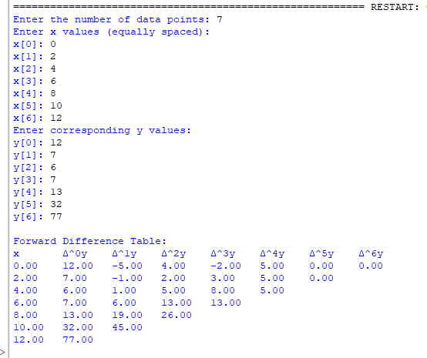

Conclusion: The above program has been executed successfully.

