Q. Write a program in python to demonstrate Newton Raphson method. Aim: To write a program in python to demonstrate Newton Raphson method. Formula:

Program:
Xn + 1 = xr - f(x) / f’(x)
Xn+1 = (xr - (f(x) / f’(x))

def f(x, func_str):

return eval(func_str, {"x": x, "math":math}) def derivative(x, func_str):
h = 1e-5 return (f(x + h, func_str) - f(x - h, func_str)) / (2 * h) def newton_raphson(func_str, x0, tol):
print("\nIter\t x\t\t f(x)\t\t f'(x)\t\t Next x") iter = 1

while True:
fx = f(x0, func_str)
dfx = derivative(x0, func_str)

if dfx == 0:
print("Error: Derivative is zero. Method fails.") return

x1 = x0 - fx / dfx
print(f"{iter}\t {x0:.5f}\t {fx:.5f}\t {dfx:.5f}\t {x1:.5f}")

if abs(x1 - x0) < tol: break

x0 = x1 iter += 1

print(f"\nApproximate root = {x1:.3f} (correct to 3 decimal places)")

print("=== Newton–Raphson Method ===") func_str = input("Enter the function f(x): ") # Example: x*3 - 2x - 5 x0 = float(input("Enter the initial guess: ")) # Example: 2 tol = 0.0001 #
Accuracy newton_raphson(func_str, x0, tol) Result:
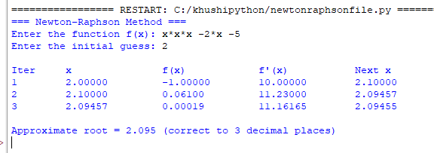

Conclusion: The above program has been executed successfully.

