For github login

https://github.com/login

username—give emailid(noble.....) or AjeetPrakashMIexpert
pwd---------9626344519a

click new on top left to create a new repo in github
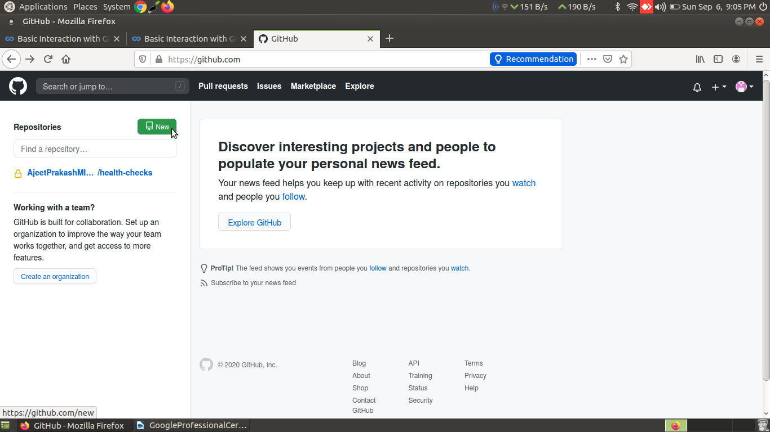
then this age will come
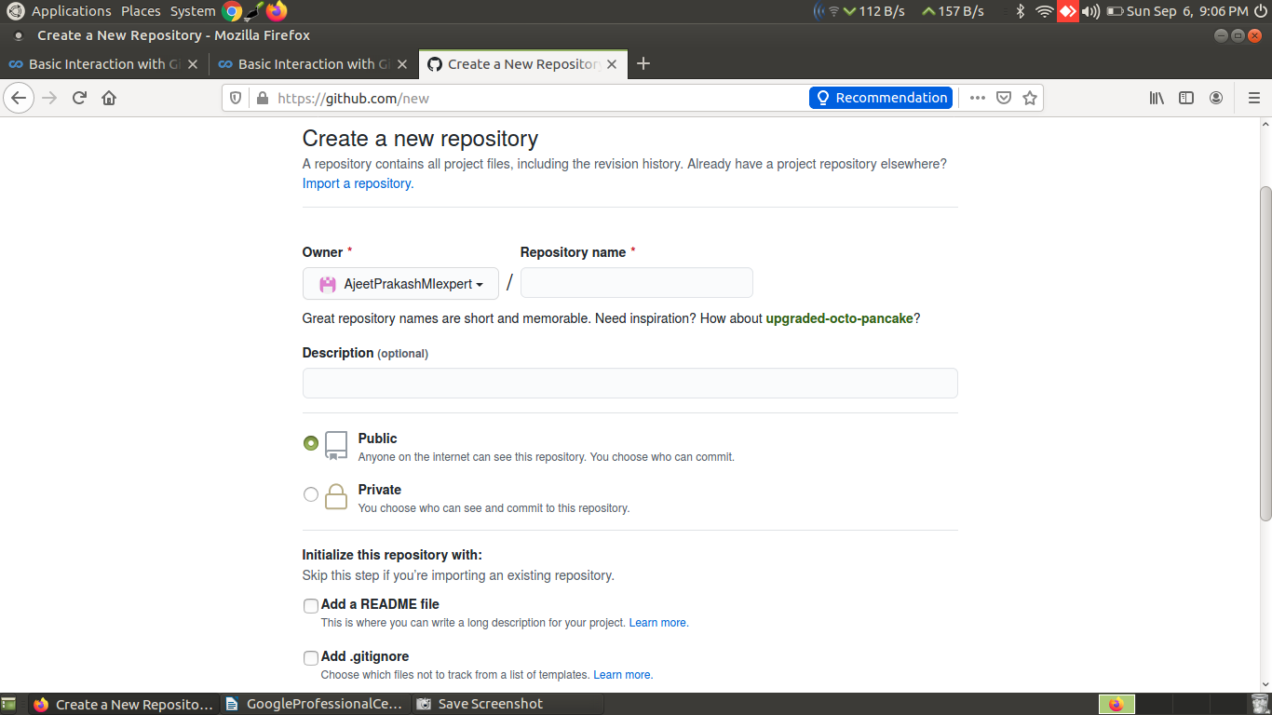
fill all the details for now just select readme
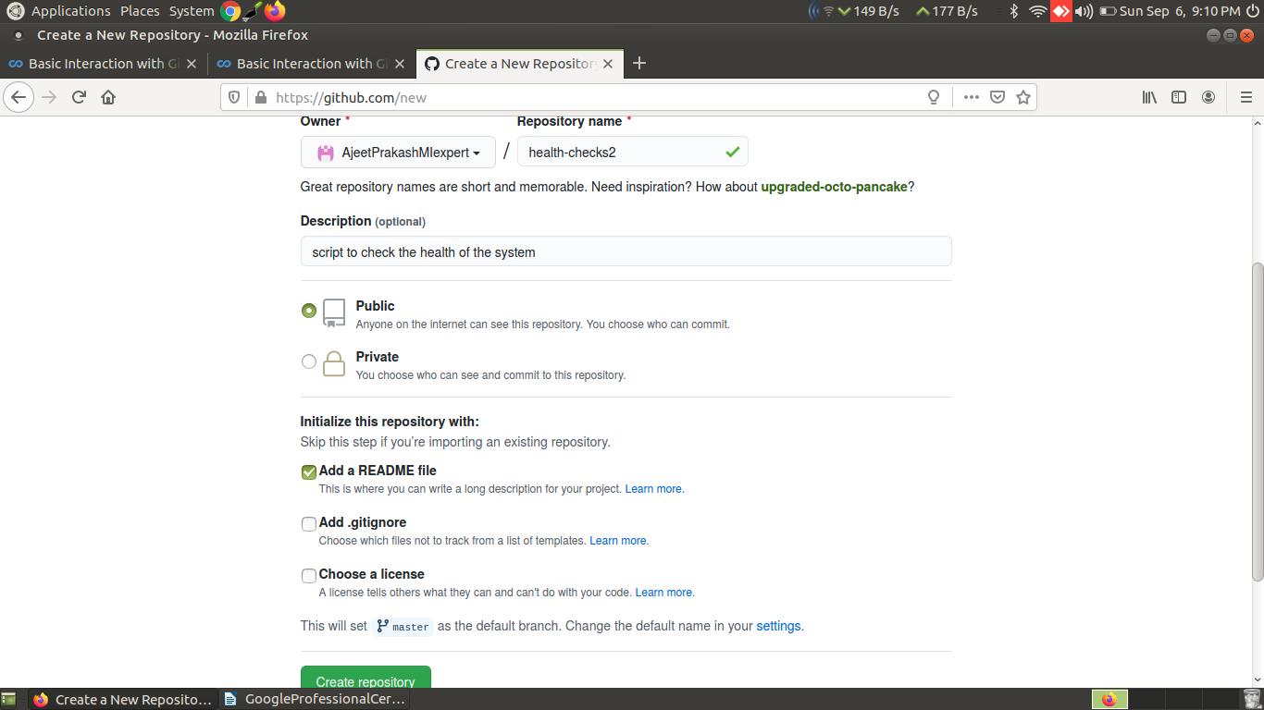
and then click on create repository
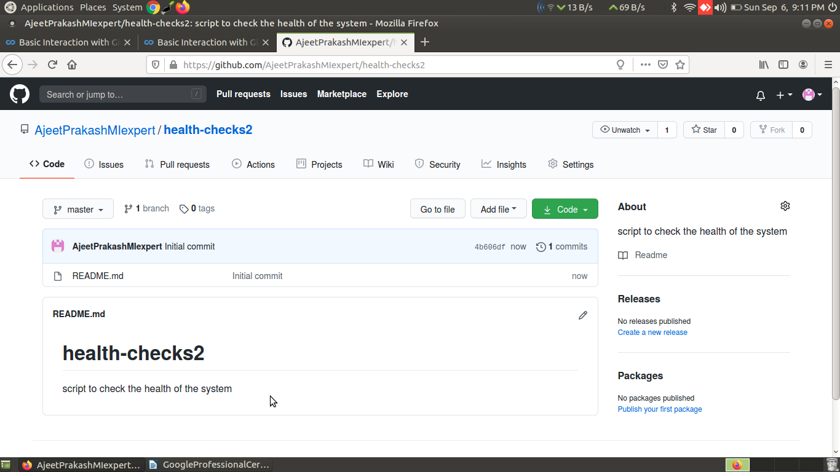
so now we have created a remote new repo named health-checks2 in the github(an online service)

lets create a local copy of this remote repo

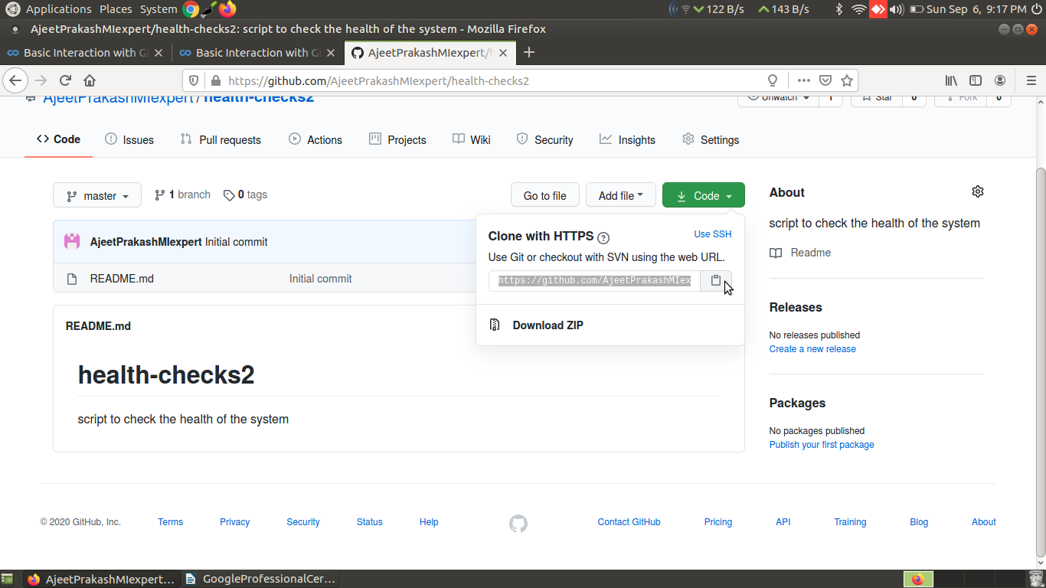
click on code as shown above and copy the url of this health-checks2 repo

using the git clone command we will copy this remote repo to our local

(base) ajeetprakash@ajeet-PC:~/gitDir$ git clone https://github.com/AjeetPrakashMIexpert/health-checks2.git

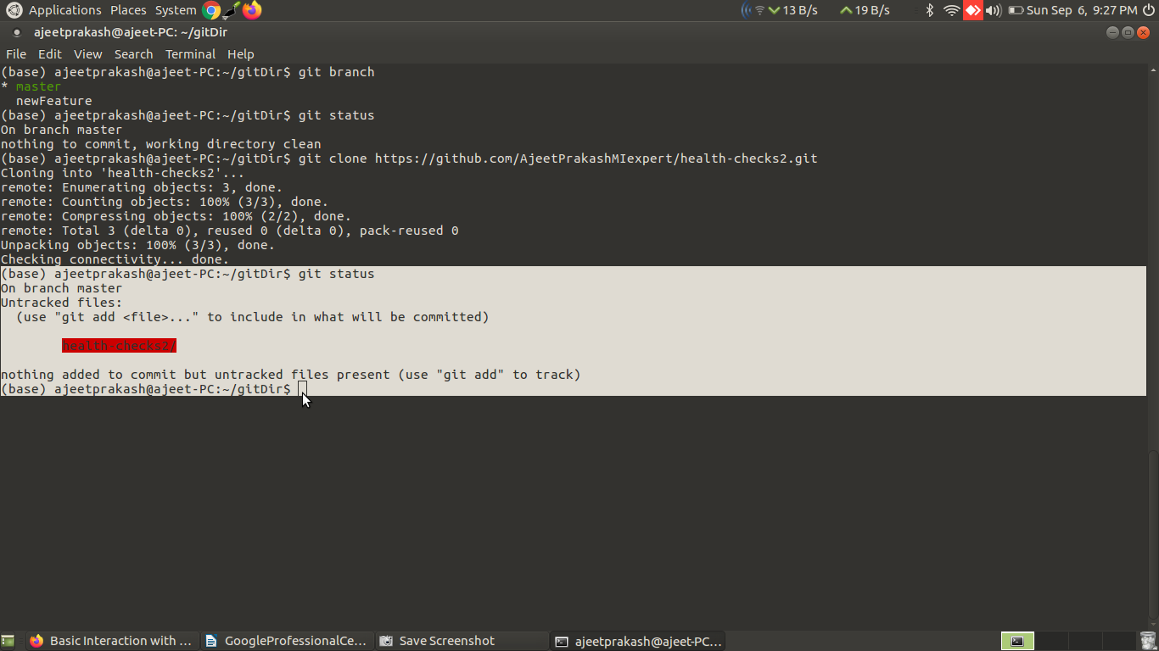
and the remote repo is cloned on our local and we can see that it needs to be added and tracked
in other words we just downloaded a repo from git hub to our local machine

Note: while using the clone command it can ask for the git hub credentials as sir shown:
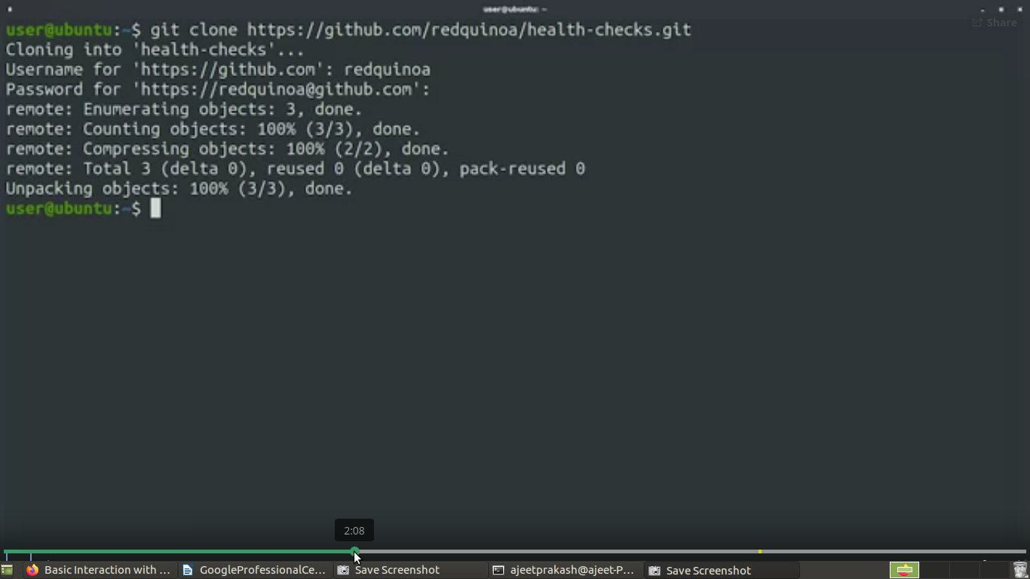
In such case just enter git hub credentials and the reo will be downloaded.

Since the repo is
called health-checks2, a directory with that name
was automatically created for us and now has the working
tree of the Repository in it

(base) ajeetprakash@ajeet-PC:~/gitDir$ ls
abc abc2 abc3 ajeeb bcerror.txt def health-checks2 rearrange.py
(base) ajeetprakash@ajeet-PC:~/gitDir$ cd health-checks2
(base) ajeetprakash@ajeet-PC:~/gitDir/health-checks2$ ls -l
total 4
-rw-r--r-- 1 ajeetprakash adm 58 Sep 6 21:23 README.md
(base) ajeetprakash@ajeet-PC:~/gitDir/health-checks2$

Our repo is basically empty. It only has the README file
that GitHub created for us. This file is in a special
format called markdown(README.md)

let’s change this file
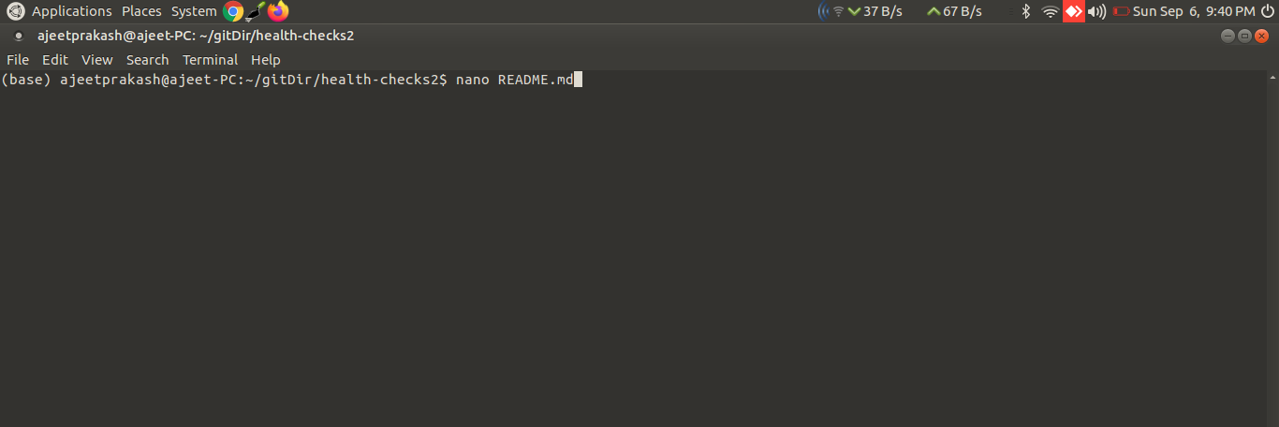
the content of README.md before change
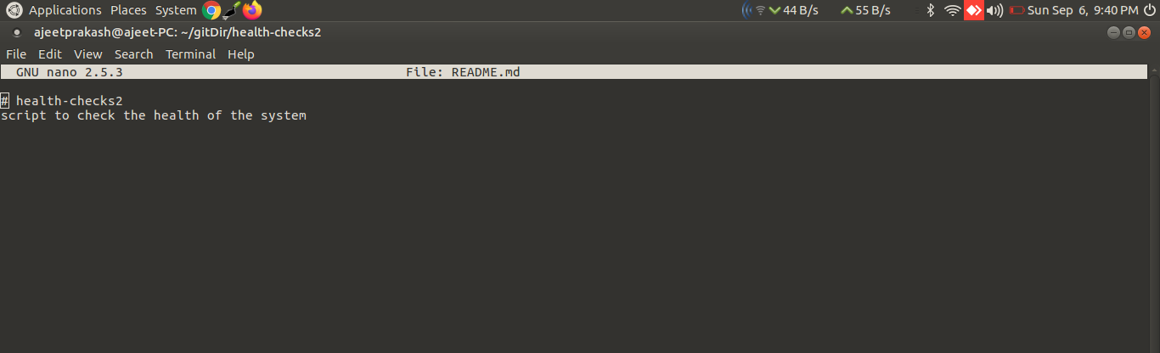

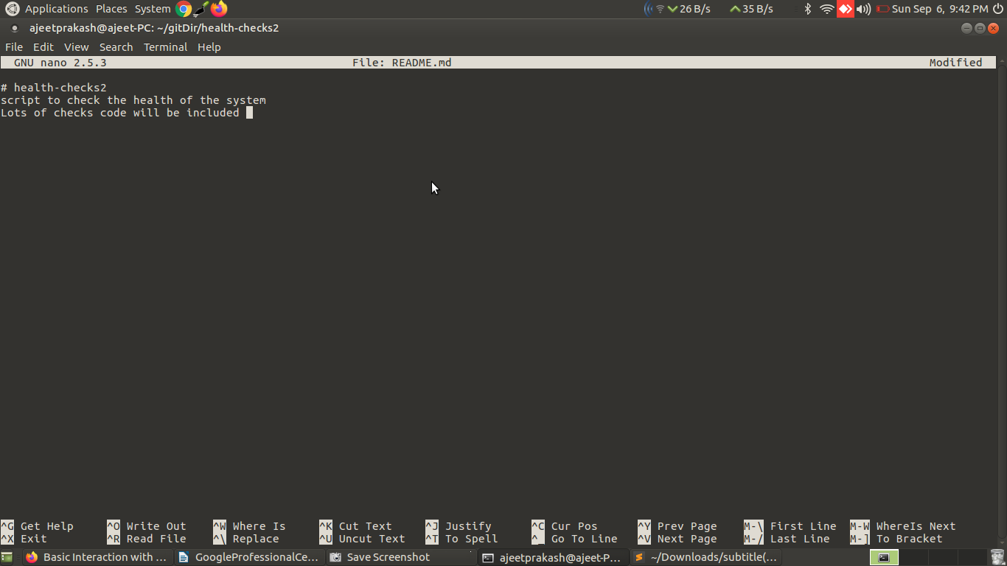
adding one more line

then press ctrl+x

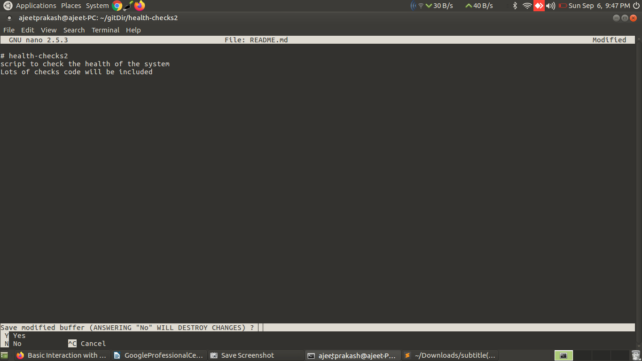
Enter Y and get:
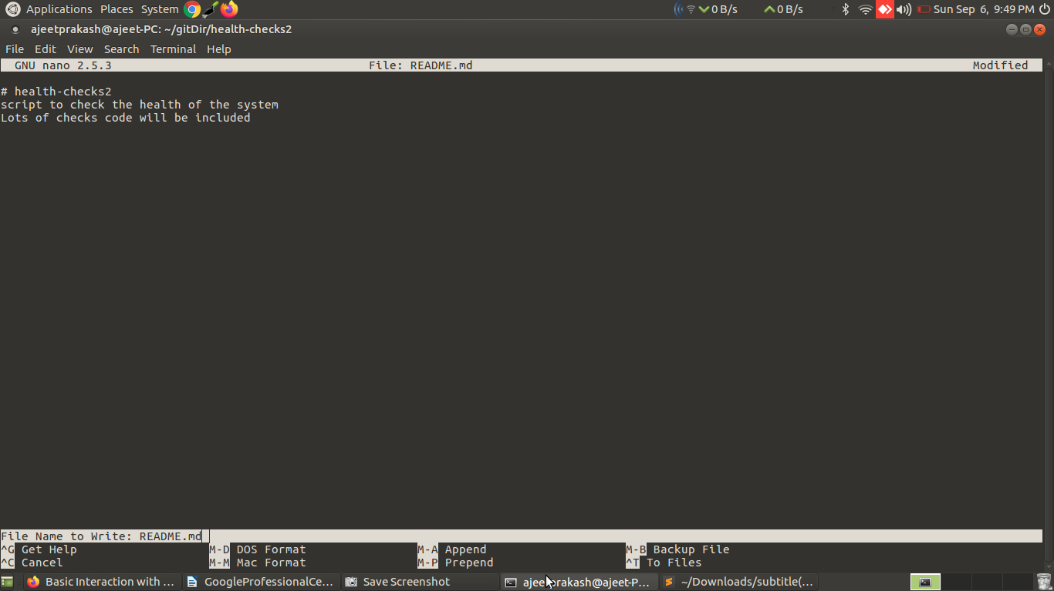

then press enter and the initial screen is dislayed again:

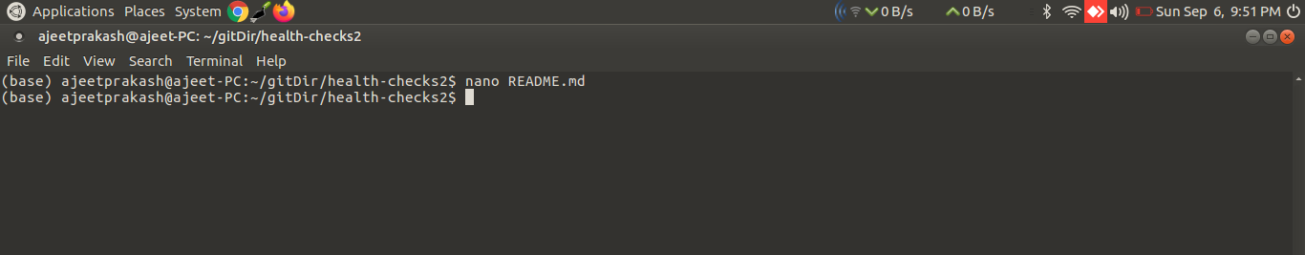

Finally staging and commiting the changes and then checking the git status:
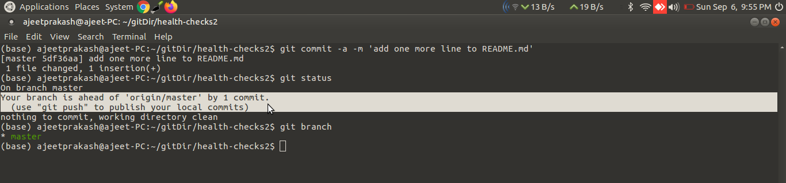
check the highlighted message....it is saying

Your branch is ahead of 'origin/master' by 1 commit.----i think here by branch it means local branch
i.e. the branch of the cloned repo on our local system and not on the online github

(use "git push" to publish your local commits)----it is suggesting using the git push we can publish these changes to this same repo in the online github

using git push command:
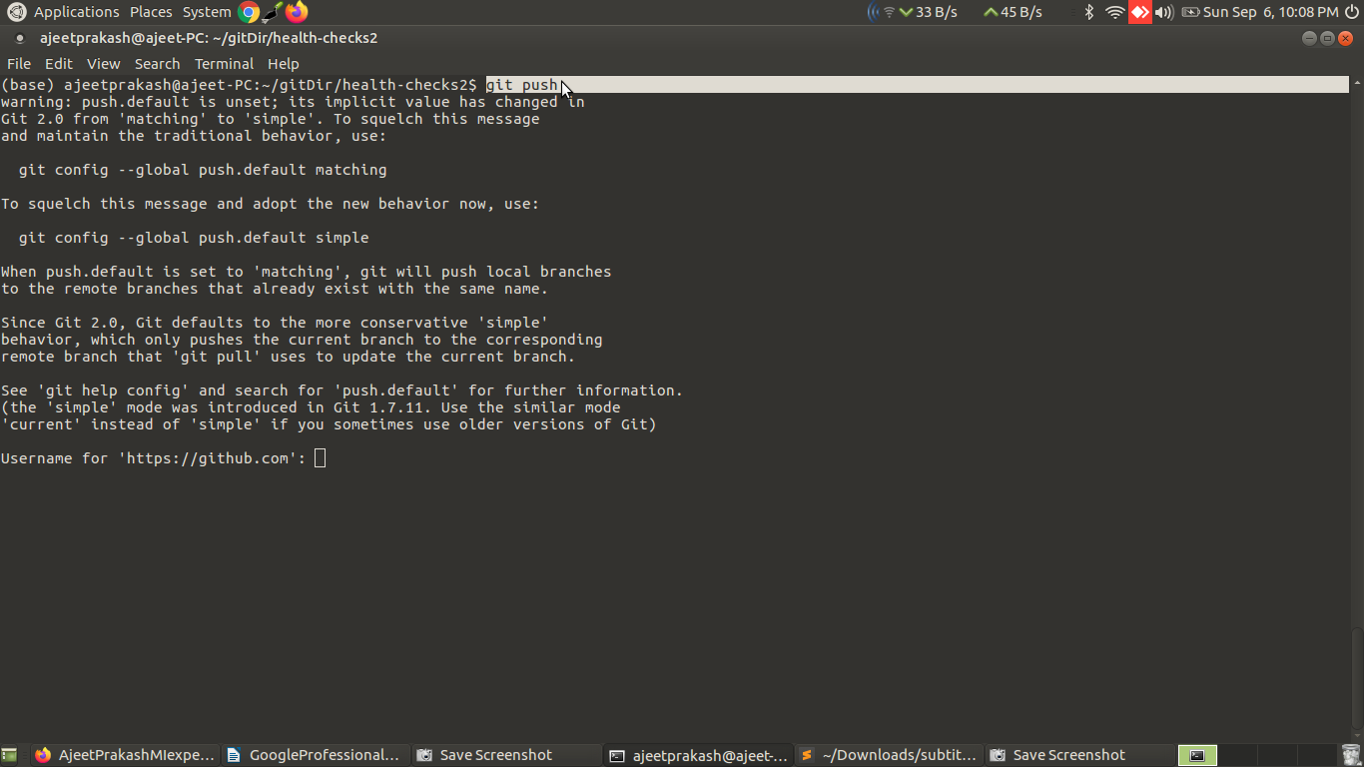

enter userid and password and press enter
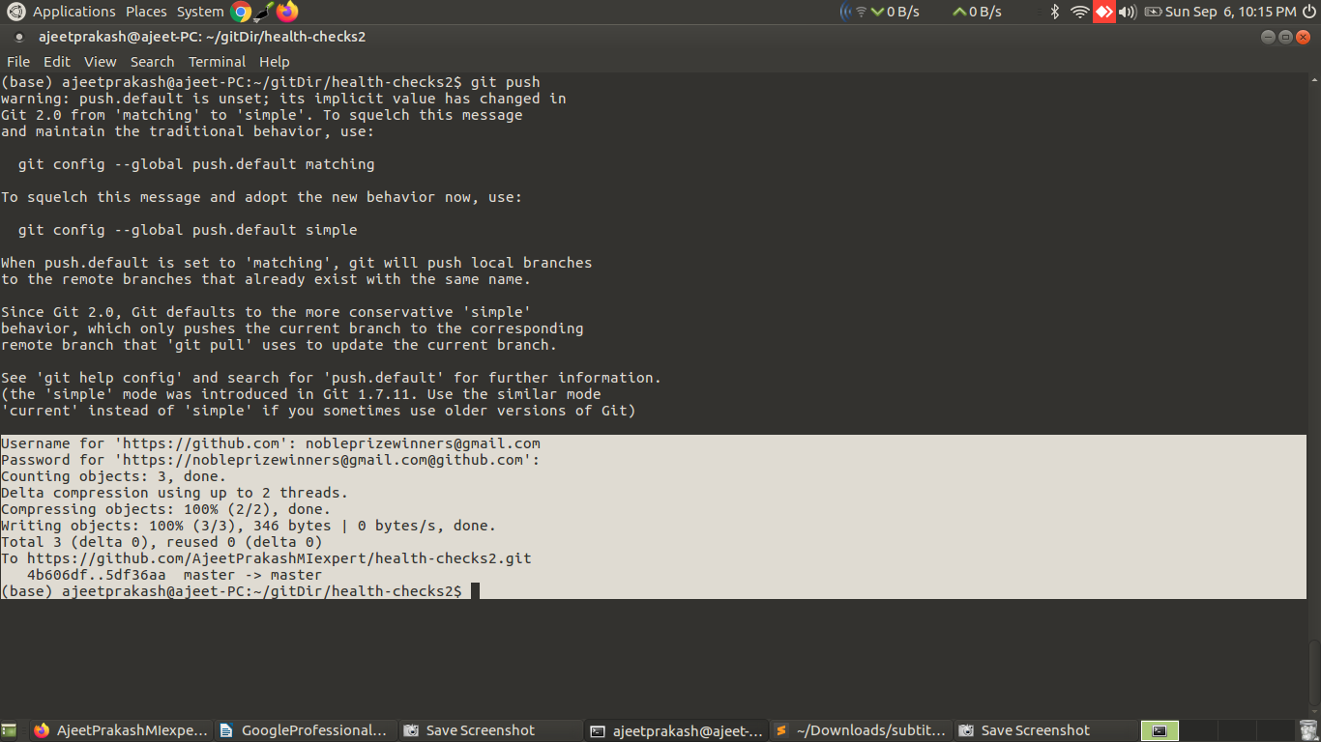

Before using git push command on our command line interpretor of the system
checkout the online repo has the following README mesaage as highlighted

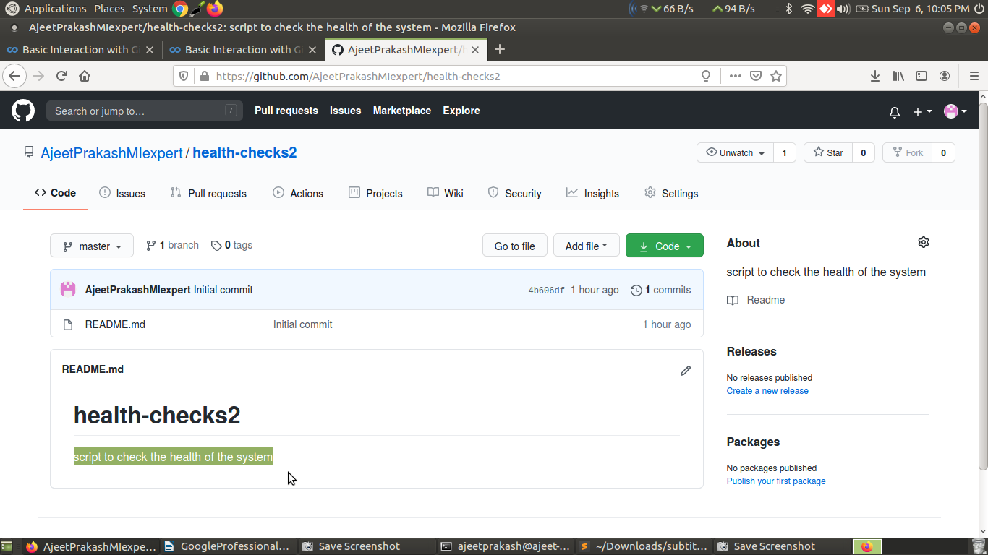

Refresh the above page of the browse and see:
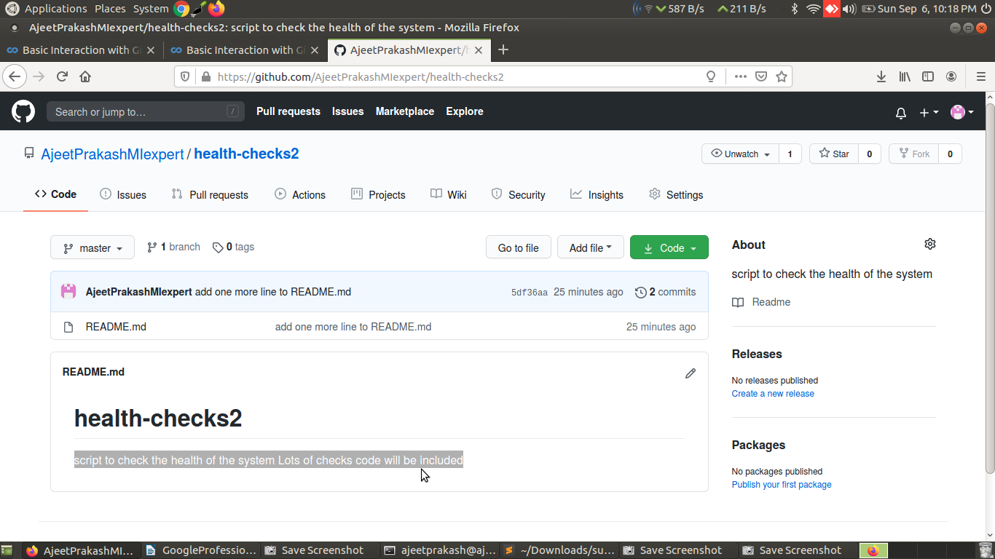
clearly the README messag is update.....saala secod line jo ham terminal se add kiye thay for README file wo doosre line mey kiye thay..par yaha pata nhi dono single line mey kaise aa gaya?

Saayad:
script to check the health of the system
Lots of checks code will be included

ye dono lines ke beech mey ga nhi diye thay isliye

we had to enter our password both when retrieving the repo and when
pushing changes to the repo. There are a couple ways to
avoid having to do this.

One way is to create an
SSH key pair and store the public key in our profile so that GitHub recognizes
our computer.

Another option is to use a
credential helper which caches our credentials for a
time window so that we don't need to enter our password
with every interaction.

Git already comes with a credential helper .

We just need to enable it.

We do that by calling git config - - global credential.helper cache.

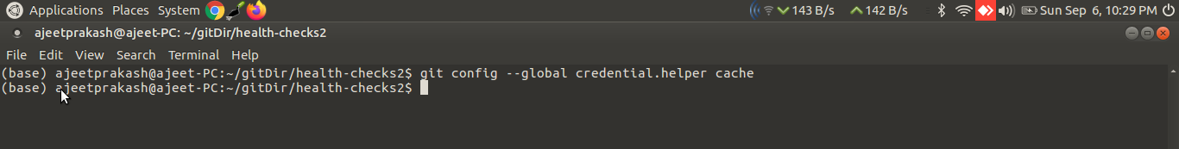

Now that we've enabled the credential helper, we'll need to enter our credentials once more. ---that’s
what sir said ...but it didn’t ask me..may be these things have changed now

After that, they'll be cached for 15 minutes.

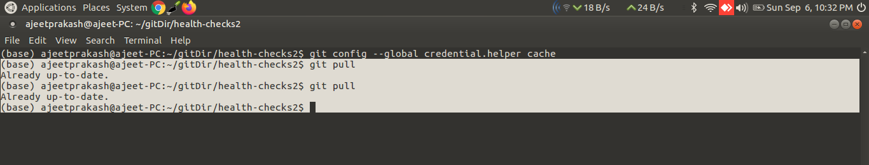

There are various remote repository hosting sites:
- GitHub
- BitBucket
- Gitlab.

git pull | Git pull is used to fetch the newest updates from a remote repository

Question
git config --global credential.helper cache allows us to configure the credential helper, which is used for ...what?
1 / 1 point

Ans: Allowing automated login to GitHub
Question
Name the command that gathers all the snapshots we've taken and sends them to the remote repository.
Ans: git push

What will happen if the master repository receives a major update since the last local copy was synced?
Git will let you know it's time for an update.
if there are pending changes in the master branch, Git will let you know.
Git will let you know it's time for an update.

Remote repositories are a big part of the distributed nature of Git collaboration.
It let lots of developers contribute to a project from their own workstations making changes to local copies of the project independently of one another.
When they need to share their changes, they can issue git commands to pull code from a remote repository or push code into one.

There are a bunch of ways to host remote repositories.
As we called out, there is many internet-based Git hosting providers like GitHub, BitBucket or GitLab which offer similar services.

We can also set up a Git server on our own network to host private repositories.
A locally hosted Git server can run on almost any platform including Linux, mac OS, or Windows.
This has benefits like increased privacy, control,and customization.

Alongside the local development branches like master, Git keeps copies of the
commits that have been submitted to the remote repository and separate branches.
If someone has updated a repository since the last time you synchronize your local copy,
Git will tell you that it's time to do an update.

If you have your own local changes when you pull down the code from the remote repo, you might need to fix merge conflicts before you can push your own changes. In this way Git let's multiple people work on the same project at the same time.

When pulling new code it will merge the changes automatically if possible or will
tell us to manually perform the integrating if there are conflicts.

So when working with remotes(remote repository) the workflow for making changes has some extra steps. Will still modify stage and commit our local changes. After committing, we'll fetch any new changes from the remote repo manually merge if necessary and only then will push our changes to the remote repo.

Git supports a variety of ways to connect to a
remote repository. Some of the most common
are using the HTTP, HTTPS and SSH protocols and
their corresponding URLs. HTTP is generally used to allow read only
access to a repository. In other words, it lets
people clone the contents of your repo without letting
them push new contents to it. Conversely HTTPS and SSH, both provide methods
of authenticating users so you can control who
gets permission to push.

The distributed nature of the work means
that there are no limits to how many people can push
code into a repository. It's a good idea to control
who can push codes to repos and to make sure you give access only to people you trust.
Web services like GitHub, offer a bunch of
different mechanisms to control access
to Repositories. Some of these are available
to the general public while others are only
available to enterprise users.

If we want to make a change to a remote branch, what must we do?

Ans: Pull the remote branch, merge it with the local branch, then push it back to its origin.

We can look at the configuration for that remote by running git remote -v in the directory of the repo
(base) ajeetprakash@ajeet-PC:~/gitDir$ git remote -v
(base) ajeetprakash@ajeet-PC:~/gitDir$

to use git remote -v command we must be inside the remote repo directory that we cloned from git hub,else this command will show nothing

so changing directory to the cloned remote repo
(base) ajeetprakash@ajeet-PC:~/gitDir$ cd health-checks2

and then using this command:
(base) ajeetprakash@ajeet-PC:~/gitDir/health-checks2$ git remote -v
origin https://github.com/AjeetPrakashMIexpert/health-checks2.git (fetch)
origin https://github.com/AjeetPrakashMIexpert/health-checks2.git (push)
(base) ajeetprakash@ajeet-PC:~/gitDir/health-checks2$

There are two URLs. One will be used to fetch data from the remote repository, and the other one to
push data to that remote repo.

They'll usually point at the same place. But in some cases, you can have the fetch
URL use HTTP for read only access, and the push URL use HTTPS or
SSH for access control.

This is fine as long as the contents of the repo that you read when fetching are the same that you write to in pushing.

Remote repositories have a name assigned to them, by default, the assigned name is origin.
This lets us track more than one remote in the same Git directory. While this is not the typical usage, it can be useful when collaborating with different teams on projects that are related to each
other.

If we want to get even more information about our remote, we can call git remote show origin
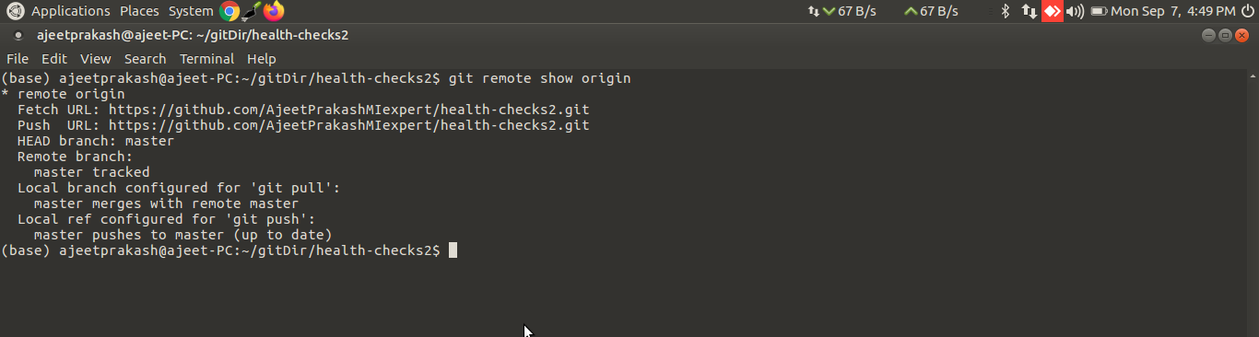
what are these remote branches that we're talking about anyways?

Whenever we're operating with remotes,(the repo that we cloned from remote repository in github)
Git uses remote branches to keep copies of the data that's stored in the remote repository.

We could have a look at the remote branches that our Git repo is currently tracking
by running git branch -r.
These branches are read only.
We can look at the commit history,like we would with local branches, but we can't make any
changes to them directly. To modify their contents, First, we pull any new changes to our local
branch, then merge them with our changes and push our changes to the repo.
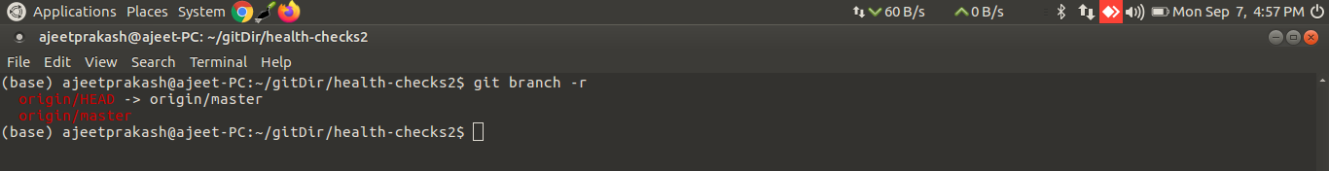
We can also use git status to check the status of our changes in remote branches as well.
Now that we're working with a remote repository, git status gives us additional information.
It tells us that our branch is up to date with the origin/master branch, which means that the
master branch in the remote repository called origin, has the same commits as our local
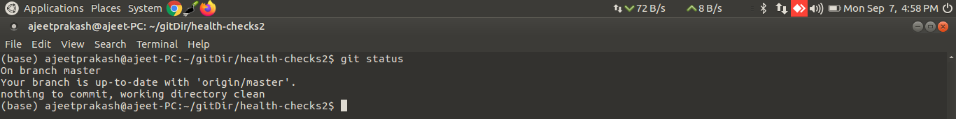
master branch.

What’s the main difference between git fetch and git pull?
Ans: git fetch fetches remote updates but doesn't merge; git pull fetches remote updates and merges.
Say myself or anyone else added new files in the remote health-checks2 repo
How to do it?
Soln:
Go to the required repo in github and in Add file click on create new file
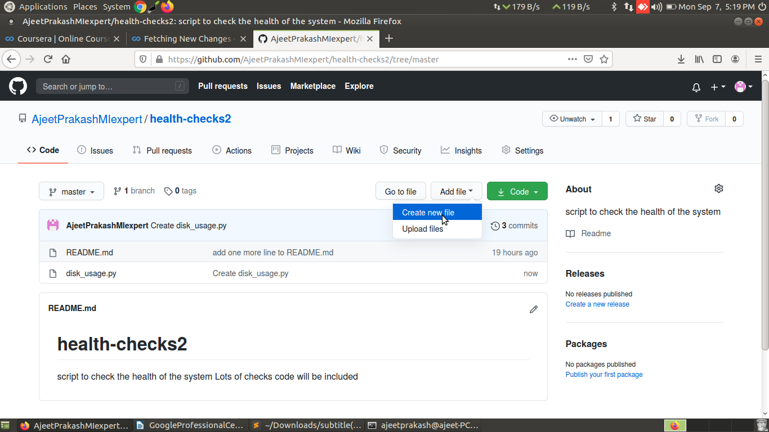
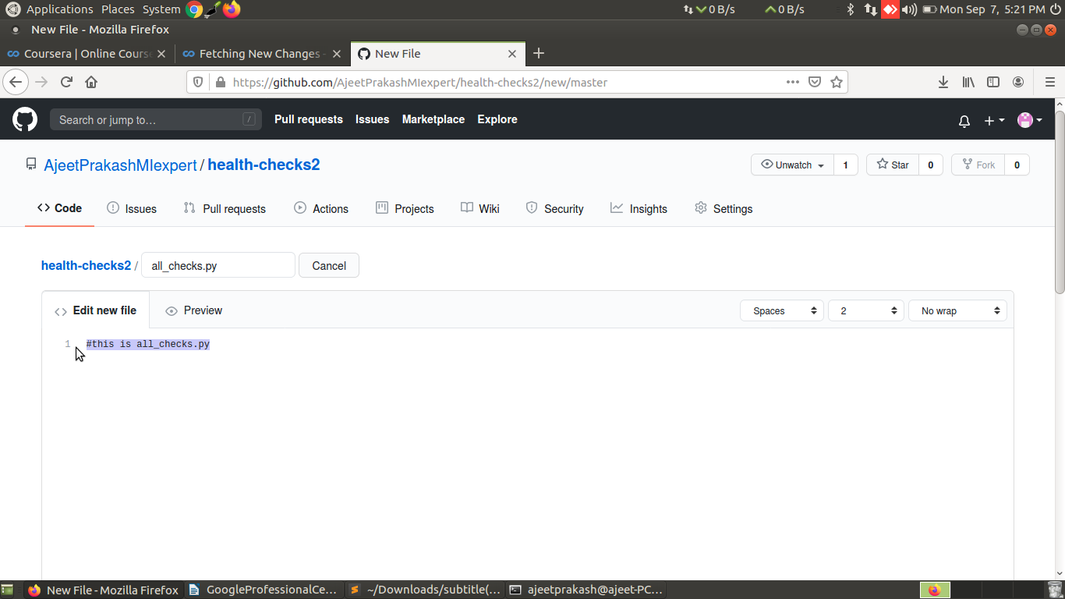
Give name to your file ex- ‘all_checks.py’ and you can edit this file ,I have ust added a comment :
Scroll down ,add a commit message and click on commit new file
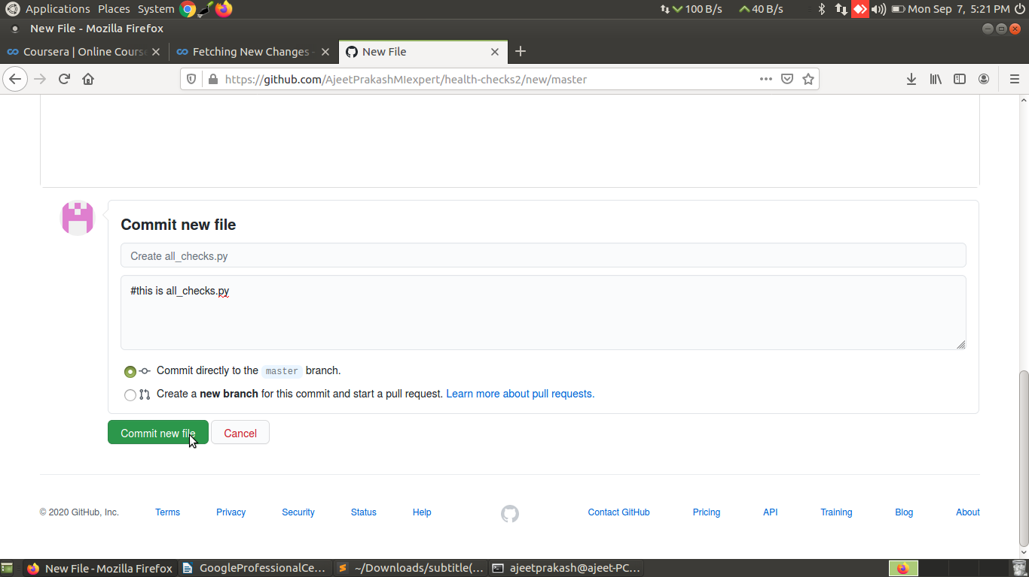
The file all_checks.py is created in the repo as can be seen from the highlighted text in screenshot
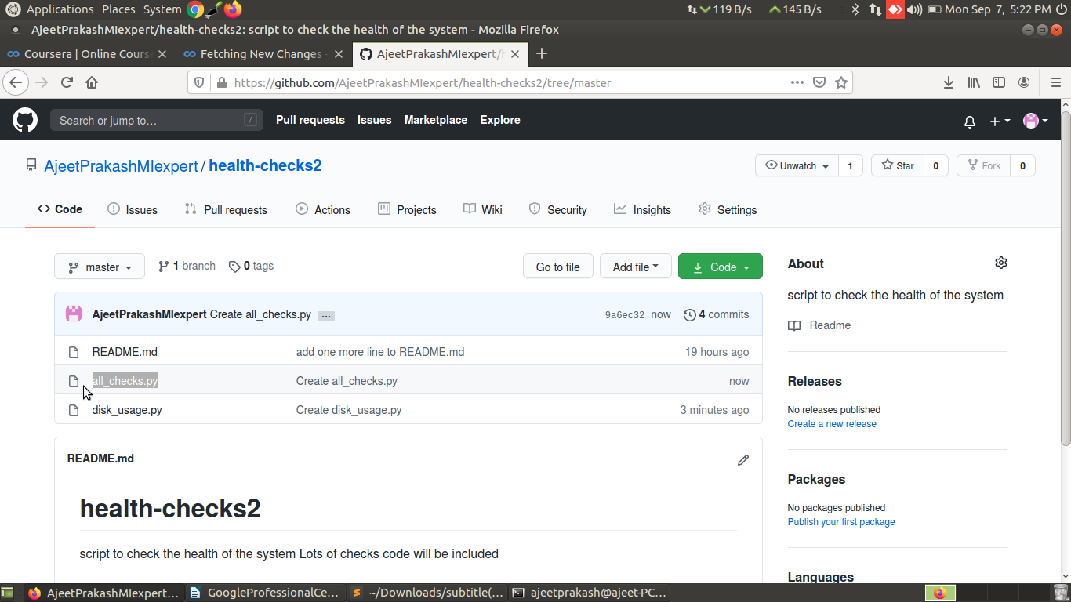

Checkout the difference in the output of the command
git remote show origin
before and after our colleague added new files in the ‘health-checks2’ remote repo in github
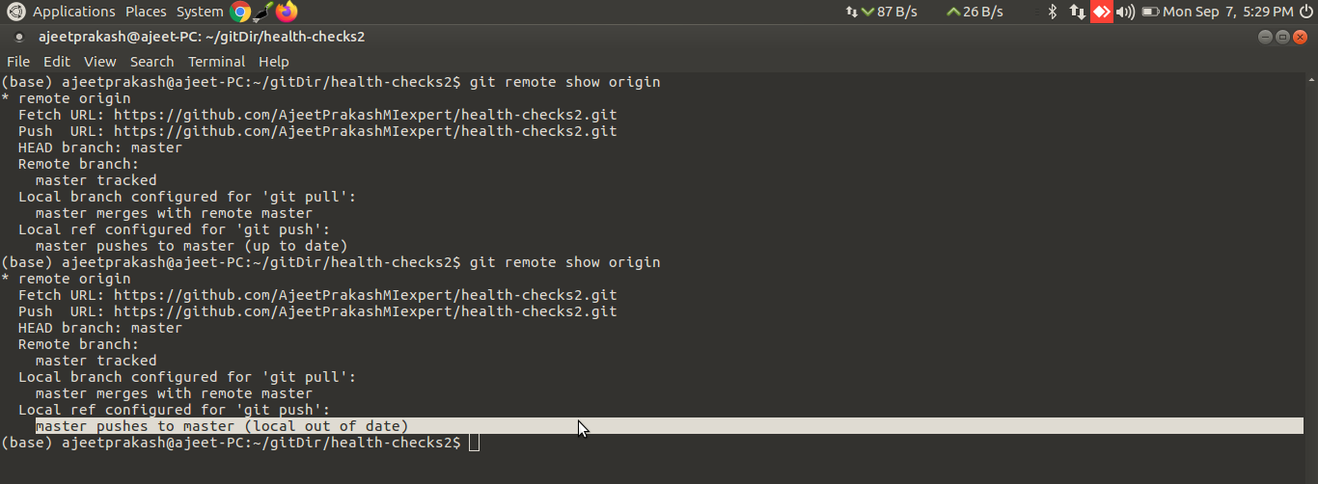
After new files were added we can see that
master pushes to master (local out of date)

This happens when there were commits done to the repo that aren't yet reflected locally.
Git doesn't keep remote and local branches in sync automatically, it waits until we execute
commands to move data around when we're ready.
To sync the data, we use the git fetch command.
This command copies the commits done in the remote repository to the remote branches, so we can
see what other people have committed.

Let’s execute git fetch command:
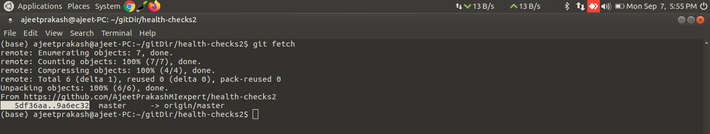
Fetched content is downloaded to the remote branches on our repository.
So it's not automatically mirrored to our local branches.

We can run git checkout on these branches to see the working tree, and we can run git log to
see the commit history.
Let's look at the current commits in the remote repo by running git log origin/master.
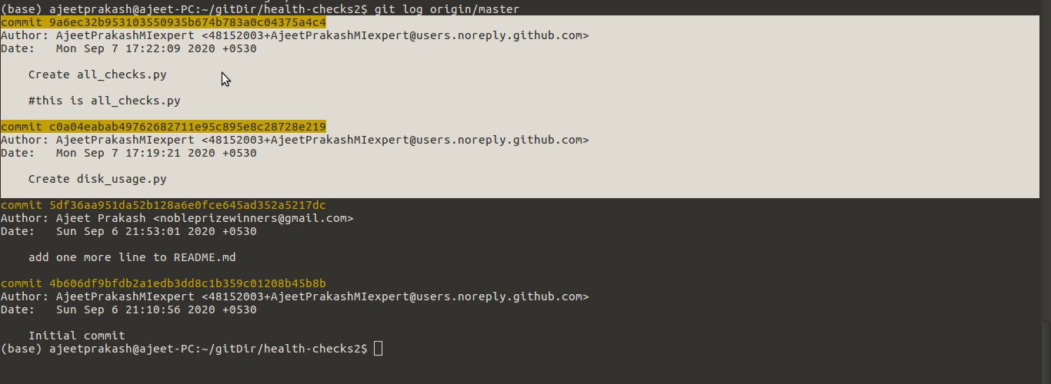
Looking at this output, we can see that the remote origin/branch is pointing to the latest commit.
As first disk_usage.py and then at last all_checks.py was added to the remote repo(repository)
health_checks2 in github by our colleague.
While the local master branch is pointing to the previous commit we made earlier on:
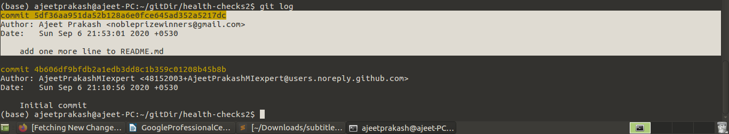
git log-----use this command to get logs of the cloned remote repo health-checks2present in our local
git log origin/master-----use this command to get logs of the remote repo health-checks2 in github
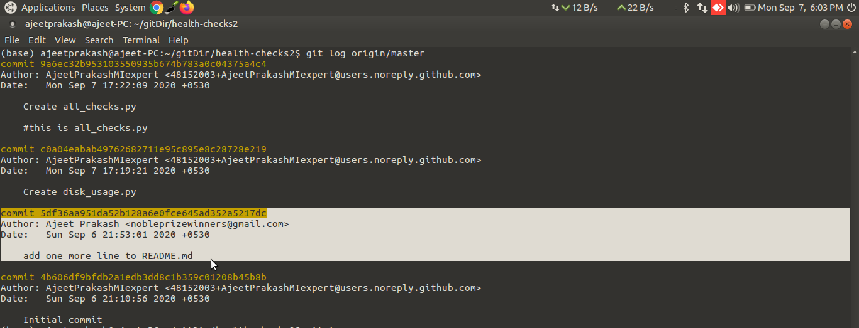
Let's see what happens if we run git status now.
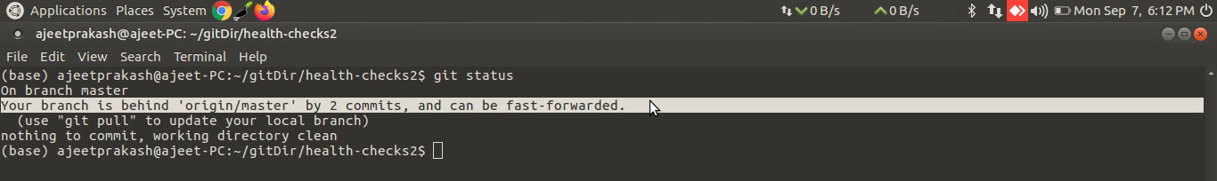
Git status helpfully tells us that there's a commit that we don't have in our branch.
It does this by letting us know our branches behind their remote origin/master branch.
If we want to integrate the branches into our master branch, we can perform a merge operation,
which merges the origin/master branch into our local master branch.
To do that, we'll call git merge origin/master.
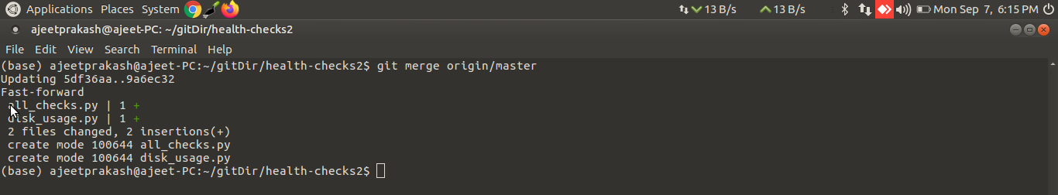
Git tells us that the code was integrated using fast-forward.
It also shows that two files were added, all_checks.py and disk_usage.py.

If we look at the log output on our branch now, we should see the new commit.
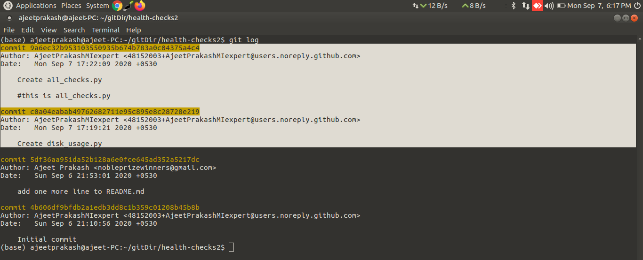
We see that now our master branch is up to date with the remote origin/master branch.
With that, we've updated our branch to the latest changes.
Obviously these 2 commit ids’ in the output of git log and git log origin/master for the all_checks.py
and disk_usage.py files will be same in both log outputs
9a6ec32b953103550935b674b783a0c04375a4c4
c0a04eabab49762682711e95c895e8c28728e219

Assuming no merge conflicts, which type of merge does git pull perform automatically?
Three-way merge
Explicit merge
Fast-forward merge
Half-merge
soln:
Fast-forward merge
As long as there are no conflicts, Git will move the current branch tip up to the target branch tip and combine histories of both commits.

Creating a new branch in the health-checks2 remote repo in git hub:

click on the dropdown of the master branch as shown
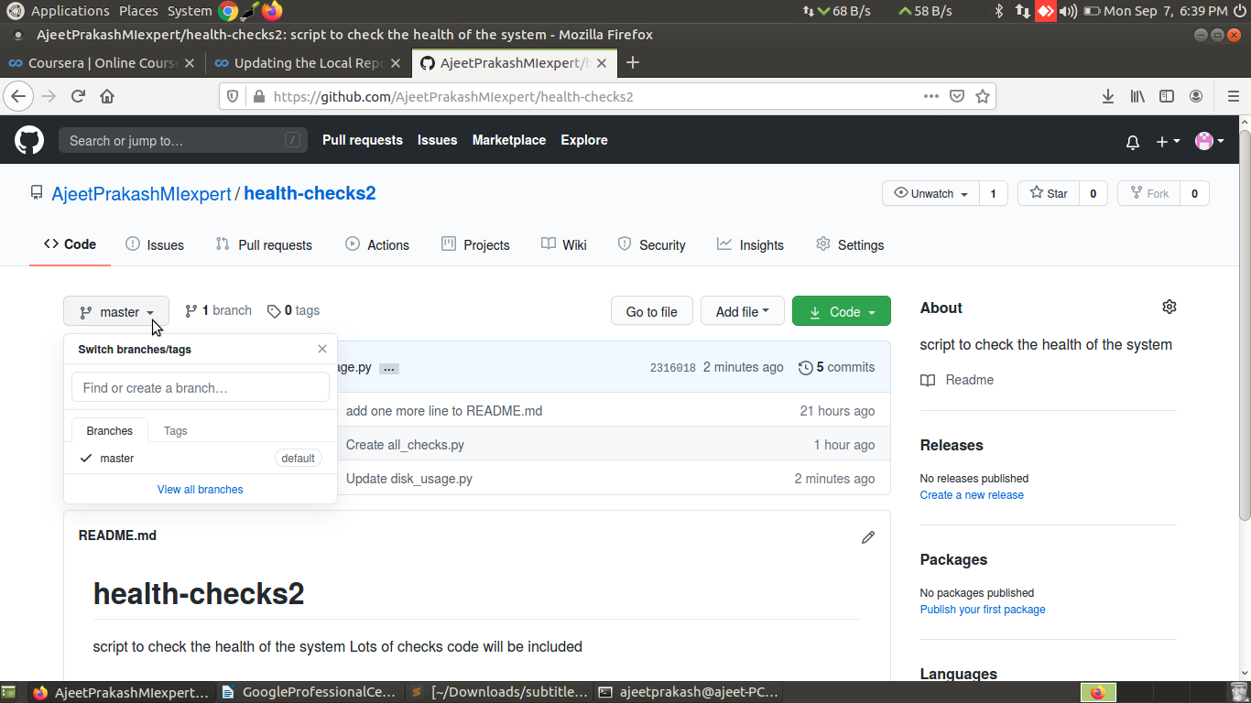
Write the branch name ex- ‘experimental’
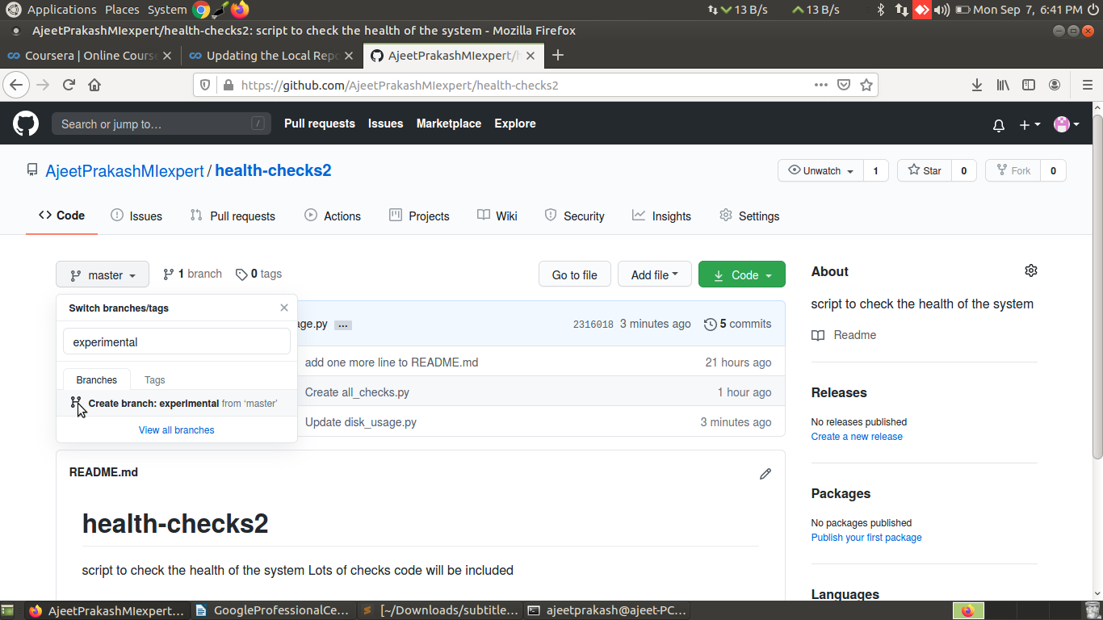
Click on the create branch :experimental from master
A new branch experimental is created and now we hae 2 branches as shown:
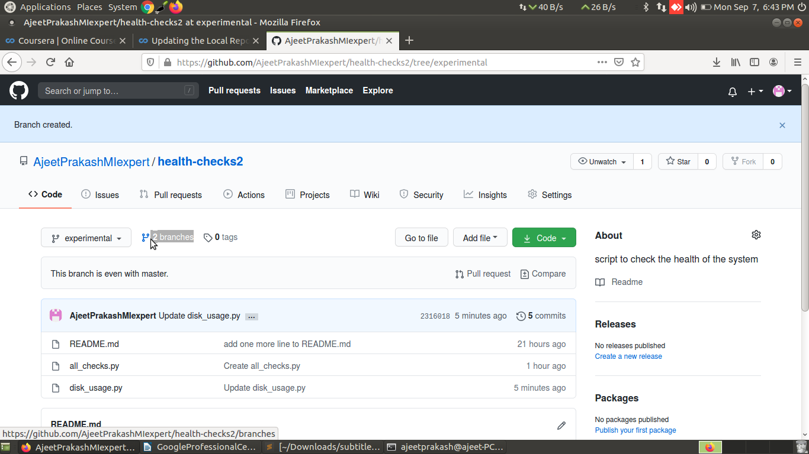

Now if we click the drodown near experimental branch we can see in this repo we have
two branches master and experimental
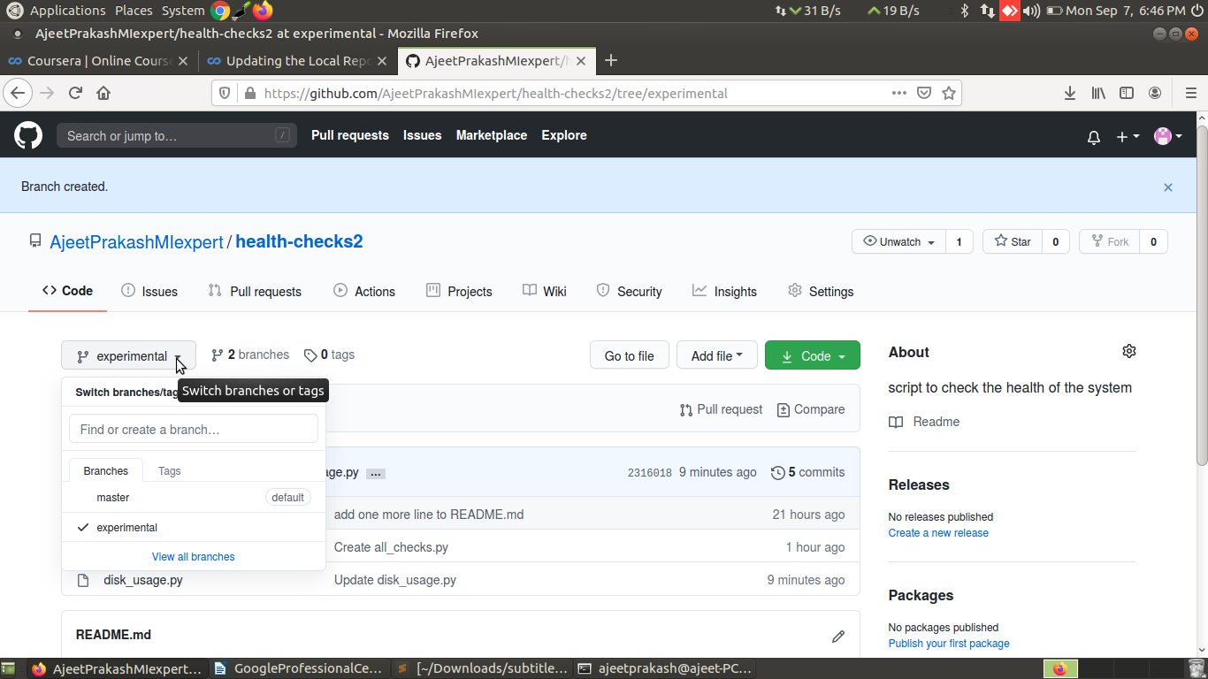

So we have created a new branch experimental in the remote repo health-check2 in git hub.
Also our colleague informed that he made changes in the disk_usage.py file of the master branch in the repo health-check2 in git hub.

git remote show origin-----this command is used to know if any new changes have been made to the remote repo health-checks2 in the git hub and not git status origin/master command
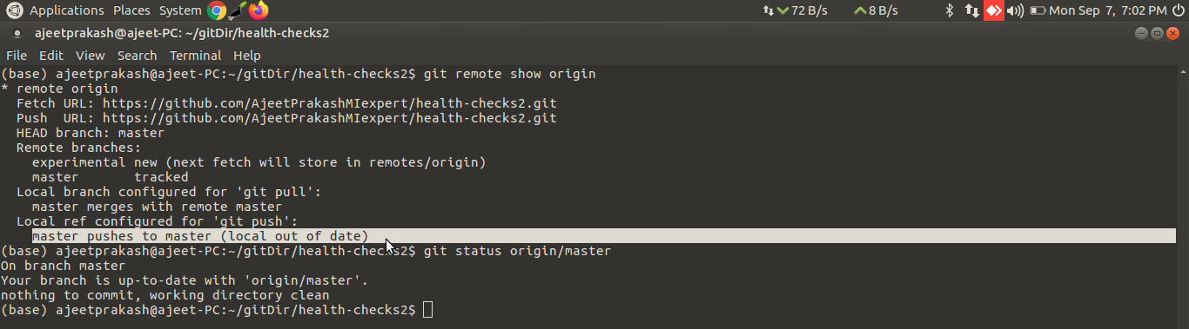
In the above screen shot we can see that the git remote show origin output is saying
master pushes to master (local out of date)

However the git status origin/master command is saying
Your branch is up-to-date with 'origin/master'---which is wrong as the disk_uasge.py file in the master branch in the health-checks2 remote repo in github was updated by our colleaague.

Anyway

We can again do git fetch and then git merge origin/master such that the the disk_usage.py file of the master branch in the repo health-check2 in our local is updated .

Alternatively we can simply use git pull command which will do both fetching and merging.

Let’s try git pull

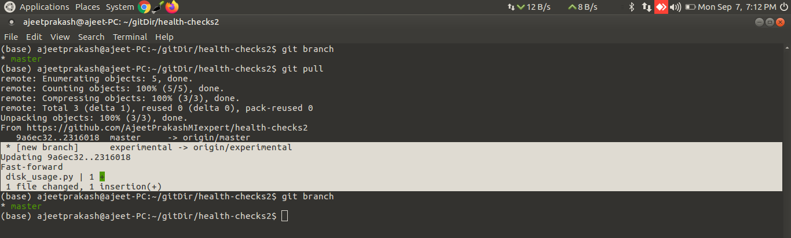
Here we can see initially before doing git pull we have only master branch in the local coy of the
health-checks2 repo.

The output of the git pull clearly shows the new branch experimental that was added to the repo in github
* [new branch] experimental -> origin/experimental

Also the output shows that git ull has updated the disk_usage.py with the latest changes that our colleague made to this file in the repo in git hub

Clearly now gitl log and git log origin/master both pointing to same commit
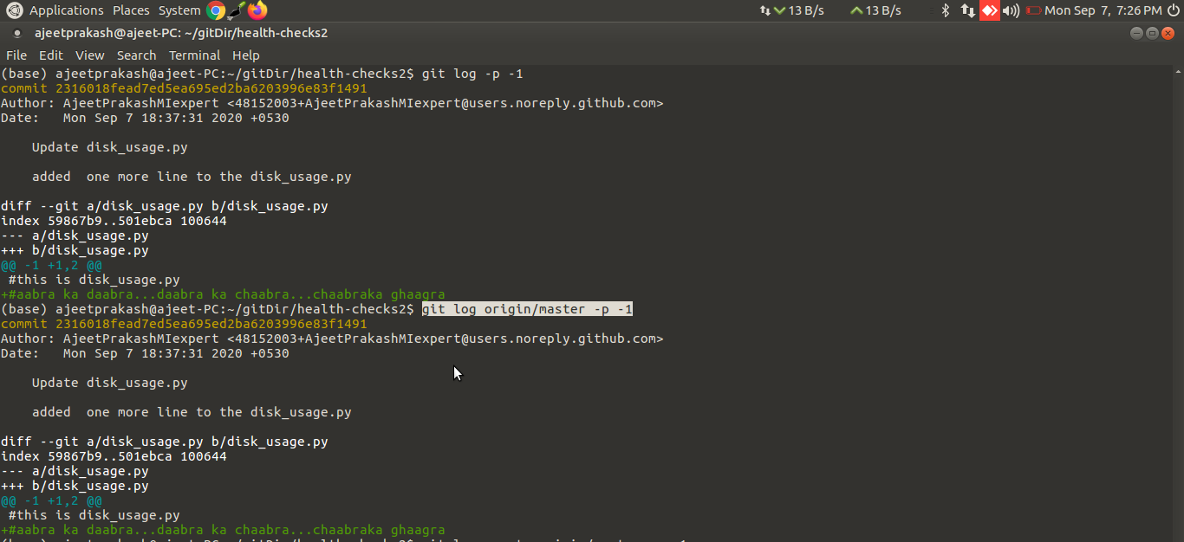
Also git status is saying Your branch is up-to-date with 'origin/master'
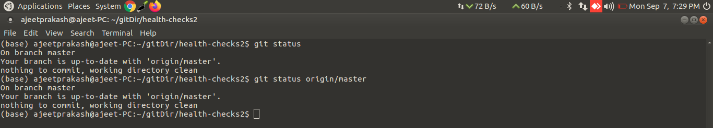
And now the git remote show origin command says
master pushes to master (up to date)
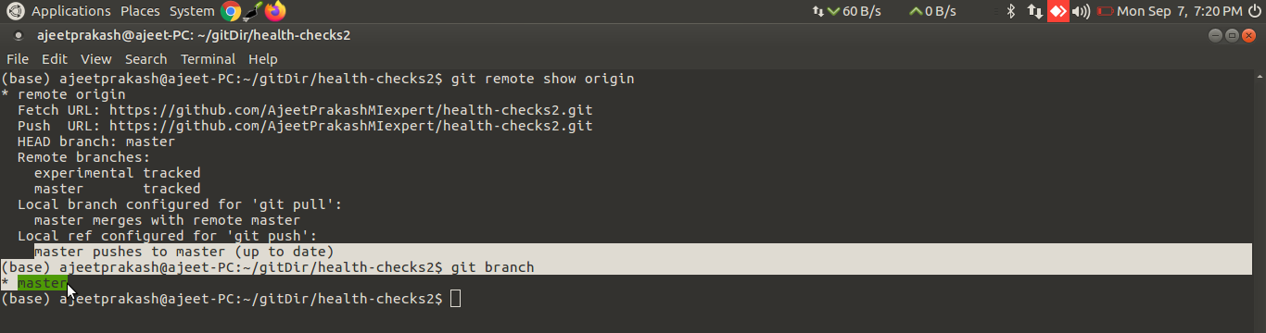
But still in the local copy of the health-checks2 repo we only have master branch
why experimental branch was not added to it---WHY?????????????????????????

To add the experimental branch which is present in the remote repo health-checks2 in the github to the local health-chedks2 repo we will use git checkout command

Also note that due to checkout command the branch in the local repo is automatically switched to experimental branch
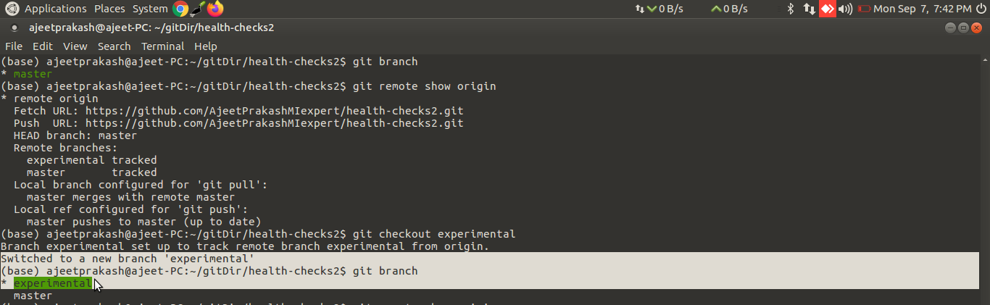

Difference in the output of the git remote show origin command
I executed this command before and after git checkout command
and stored their outputs in the files beforeGitCheckoutExperimental and
afterGitCheckoutExperimental respectively.
Finally I used vimdiff command with -y option to see the difference between them crystal clearly
vimdiff -y beforeGitCheckoutExperimental afterGitCheckoutExperimental
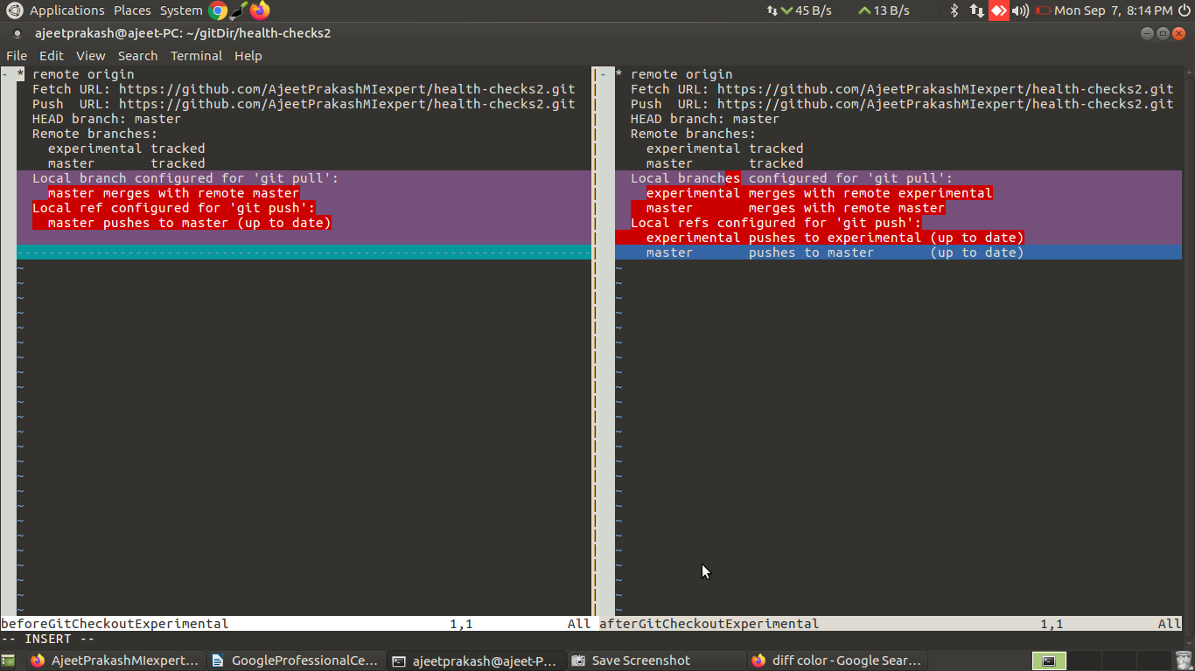
See how the new branch exerimental is now showing up in the ‘local branch configured’ and in the ‘local reference configured’ where earlier only master branch was showing up(after git checkout command was used)

Command | Explanation & Links
git remote | Lists remote repos
git remote -v | List remote repos verbosely
git remote show <name> | Describes a single remote repo
git remote update | Fetches the most up-to-date objects
git fetch | Downloads specific objects
git branch -r | Lists remote branches; can be combined with other branch arguments to manage remote branches

Difference between git branch and git branch -r commands:
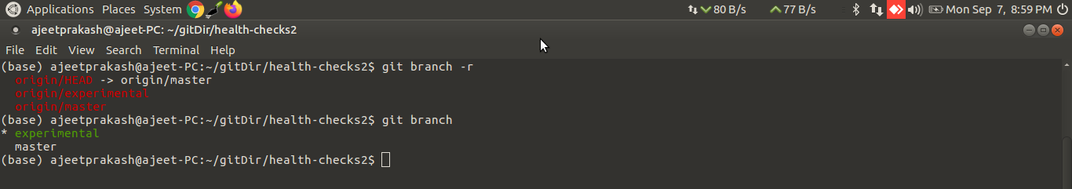
Difference between git remote and git remote -v commands:
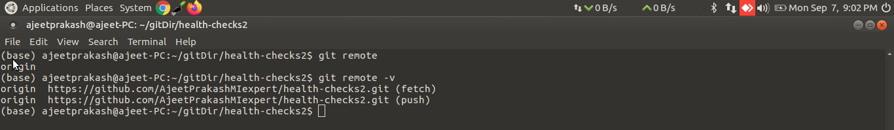

Difference between git remote show and git remote show<name> commands:
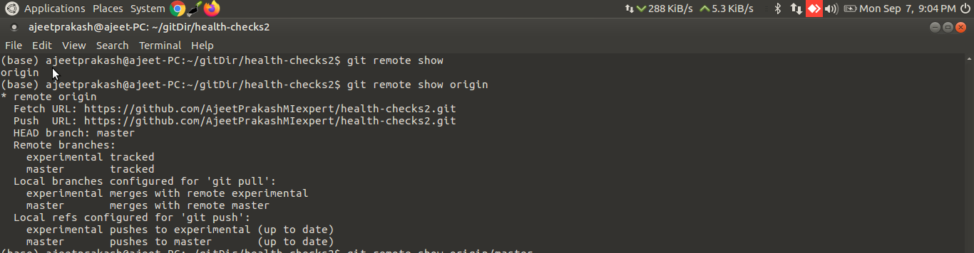

Difference between git remote update and git fetch commands:
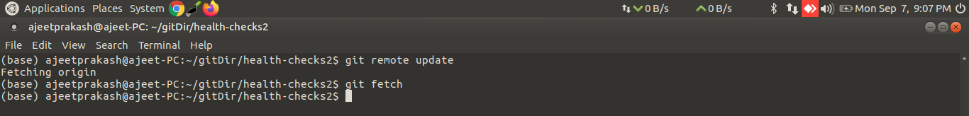
SWP stands for SWaP file. SWP files are located on a computer's hard drive, used by the virtual memory component of the computer to increase available memory. SWP files contain any data that has been “swapped” from the computer's memory to the hard drive

Question 1
In order to get the contents of a remote branch without automatically merging, which of these commands should we use?
ANS: git remote update

Question 2
If we need to find more information about a remote branch, which command will help us?

ANS: git remote show origin
If you want to see more information about a particular remote branch, you can use the git remote show command. Don't forget the commit ID!

NOTE:
1>git fetch will download remote updates, such as objects and refs, from the remote branch.
2>An explicit merge creates a new merge commit. This alters the commit history and explicitly shows where a merge was executed.

What should you do with the <<<<<<<, =======, and >>>>>>> conflict markers when resolving a merge conflict?
ANS: Remove all of the conflict markers and only leave the code as it should be after the merge.

Pull then merge then push work flow:
let’s edit a file all_checks.py in the master branh of health-checks2 repo in our local(on our system)
earlier
(base) ajeetprakash@ajeet-PC:~/gitDir/health-checks2$ cat all_checks.py
#this is all_checks.py
(base) ajeetprakash@ajeet-PC:~/gitDir/health-checks2$
after editing this file
(base) ajeetprakash@ajeet-PC:~/gitDir/health-checks2$ cat all_checks.py
#this is all_checks.py
print("this is all_checks.py in master branch in the local repo health-checks2")
(base) ajeetprakash@ajeet-PC:~/gitDir/health-checks2$
after modifying the file on our local we added and commited the changes
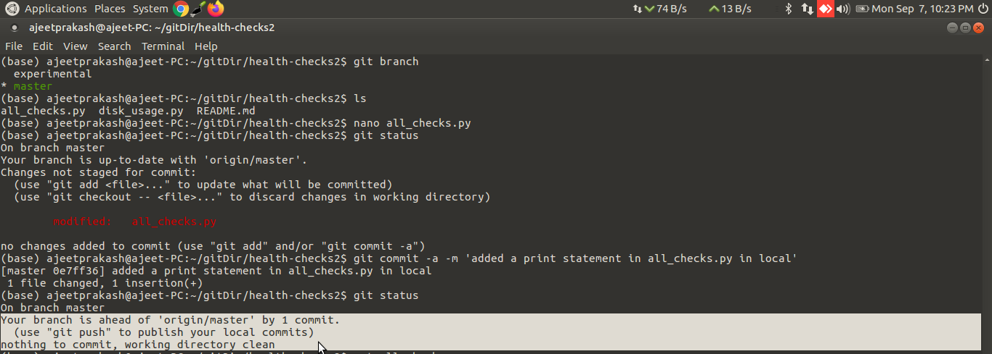
clearly as per the git status the master branch of the local it is clean and nothing to commit
and
this local master branch of the health-checks2 repo is ahead of the origin/master branch of the
health-checks2 remote repo of the github
thus
this command is giving us suggestion to publish our local commit to the origin/master branch of the
health-checks2 remote repo of the github

In fact git status or git status origin/master both are saying this only:
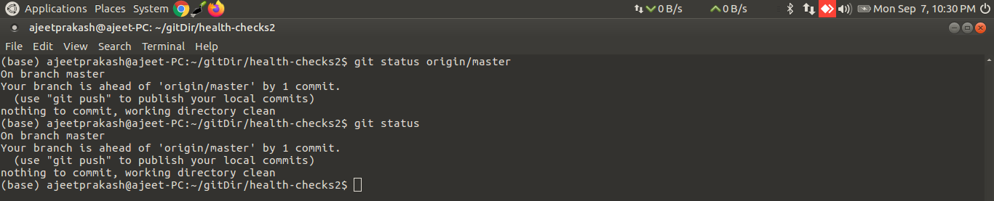
But wait the git remote show origin command is showing that both the experimental and master branches in the local are out of date
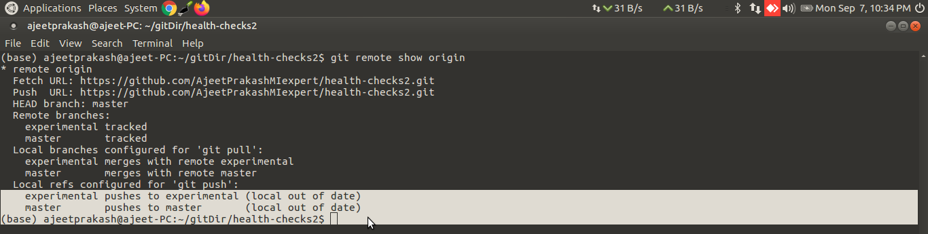
but why?
Because some colleague of ours has changed some file in the experimental and master branches of
the health-checks2 remote repository in the github and those changes are not present in the
experimental and master branches of the health-checks2 repository in our local.
Hence if we push our changes to the repo in github it is bound to fail
Thus always first we need to pull from github then merge (if any conflict is there) and then only
push the changes made to files in our local repository to files in the remote repository in gihub.
Anyway let’s try push and see if it fails:
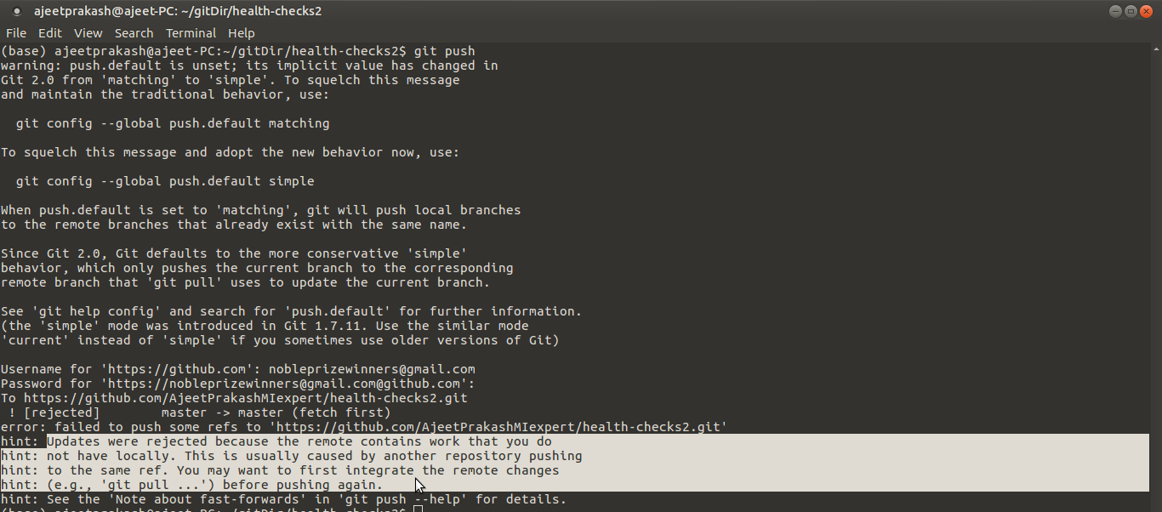
clearly the git push failed and it failed due to the same reason that we were suspecting
Hence let’s do git pull first:
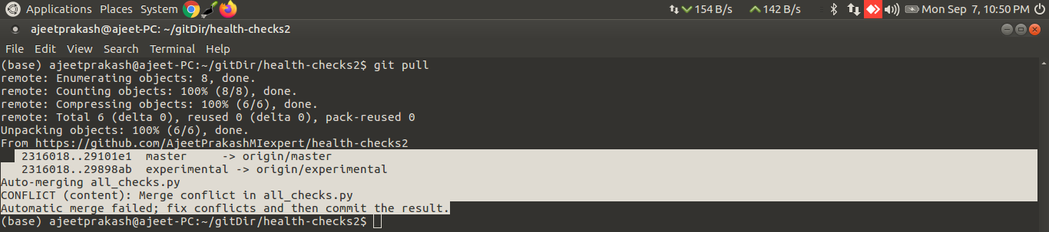
The output shows clearly there is conflict and automatic merge failed for all_checks.py file

all_checks.py the content of the same file is different in the master branch of the local health-
checks2 repo,the master and the experimenatl branches of the health-checks2 repo of the github
which led to conflict:

master branch local repo:
(base) ajeetprakash@ajeet-PC:~/gitDir/health-checks2$ cat all_checks.py
#this is all_checks.py
print("this is all_checks.py in master branch in the local repo health-checks2")
(base) ajeetprakash@ajeet-PC:~/gitDir/health-checks2$
master branch github
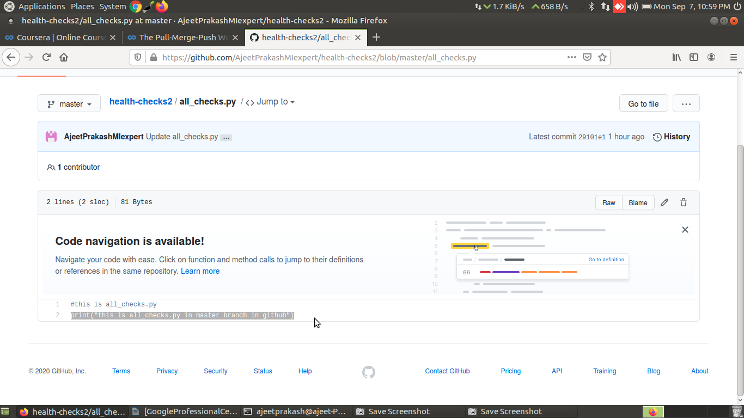

experimental branch github
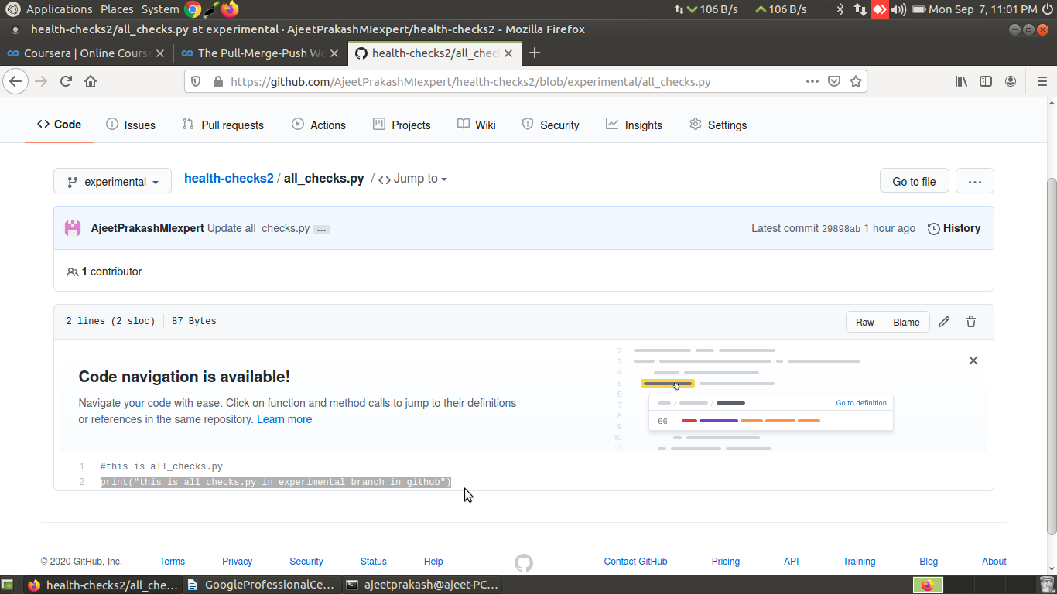
when we did git pull that led to conflict..let’s checkout the content of the all_checks.py in the master
branch of the local repo after conflict is encountered:
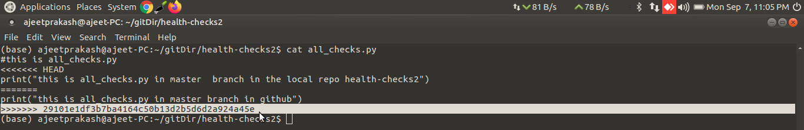
One important point to note/observe is that when we do git pull,then by default the master branch of
the repo in the github ,those changes will be pulled and that has led to conflict ....and not the content
of the experimental branch of github wont be pulled(as master branch is default branch in github)
as print("this is all_checks.py in master branch in github") confirms the same as experimental
branch of github has different print statement than this.
let’s look at the tree of commits on all the branches using the following command
git log –graph –oneline --all
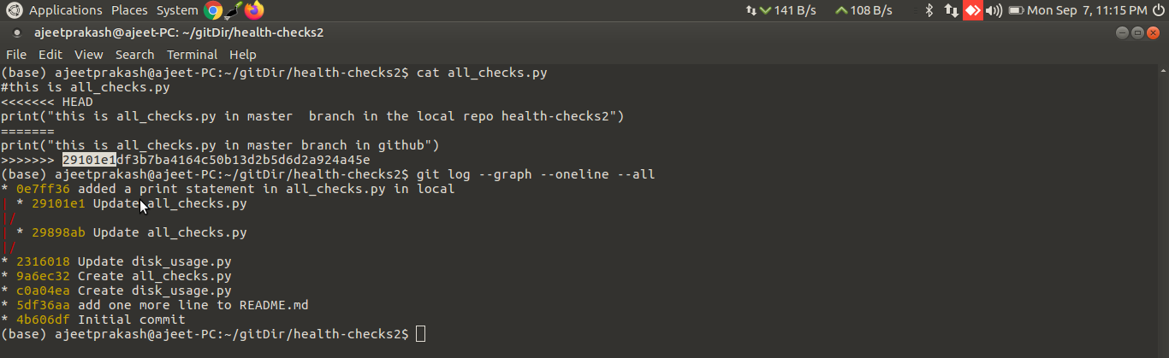
We can see the commit id 29101e1 is the commit id of the master branch commit in github(as the same commit id present in the all_checks.py file after conflict)

0e7ff36 is the commit id of the commit done in the master branch of the local repo

29898ab is the commit id of the commit done in the all_checks.py file in the experimental branch of the health-checks2 repo in github:
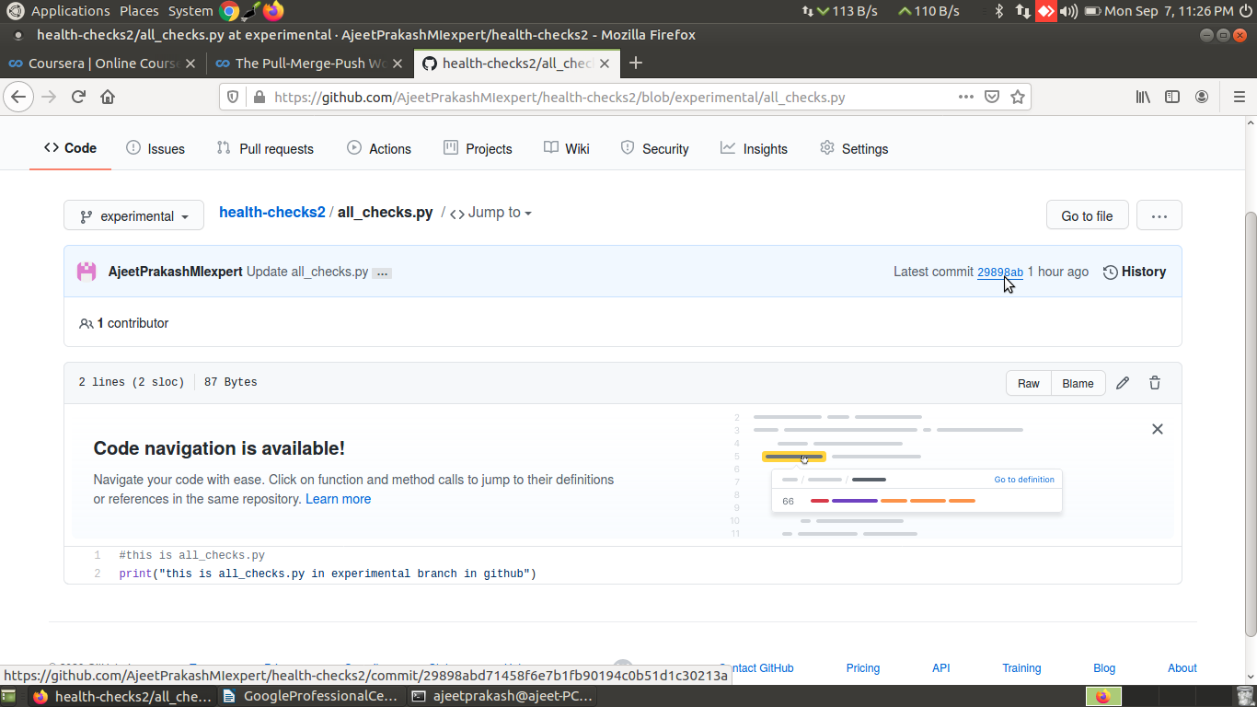

Using the git log -p command also we can see the comments for the changes made for the above 3 commit ids that led to the conflict

git log -p -1 origin/master
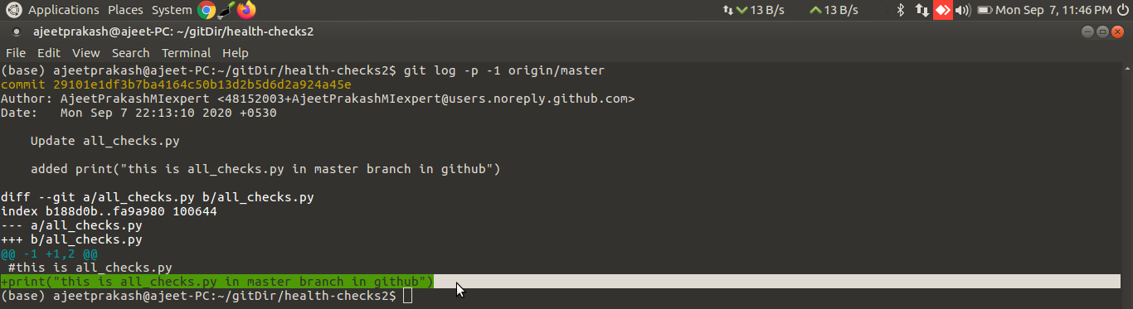
git log -p -1 origin/experimental
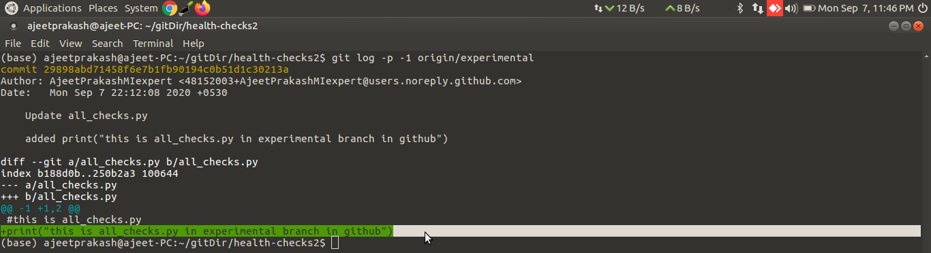
git log -p -1 (since we are in master branch of the local repo thus this command will fetch the latest log of that)
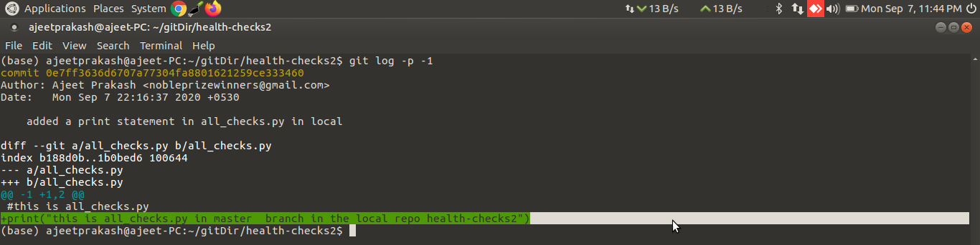
clearly in all these 3 different commits the print statement added in the same line is different and so here the different print statement of the master branch of the local repo and the master branch of the remote repo of the github is causing conflict while merging

Fixing the conflict
Open the all_checks.py file in the master branch of the local repo which led to conflict using nano
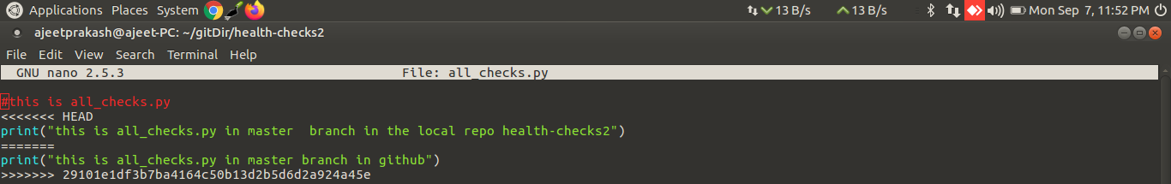
then remove lines having<<<<<<<<<<<< and >>>>>>>>> and ================
also delete one print statement that you dont want to keep that will resolve the conflict as we have
decided that out of those 2 print statements which one to keep
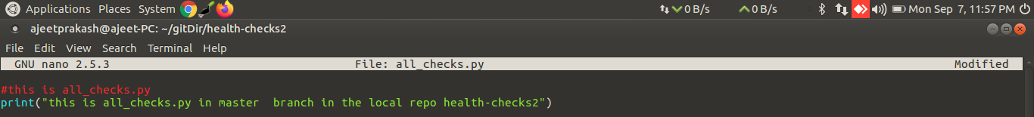
save the file,then add all_checks.py to the satging area and then commit the changes
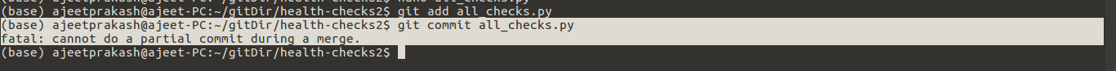
But when i use git commit all_checks.py
I get cannot do a partial commit during merge error

let’s check git status
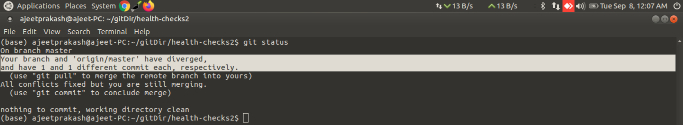
If you get such error then just use git commit instead of git commit <fileName that caused conflict during merge>

when you use git commit command and press enter you can see the following screen,you can add any message if you want for this commit,finally save it
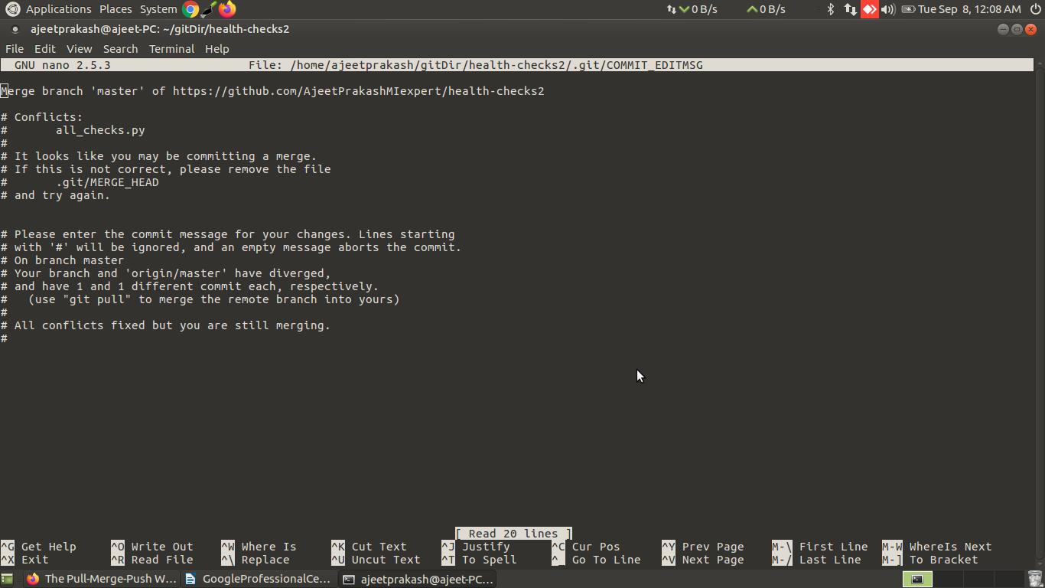
git status after resolving the conflict and commiting it:
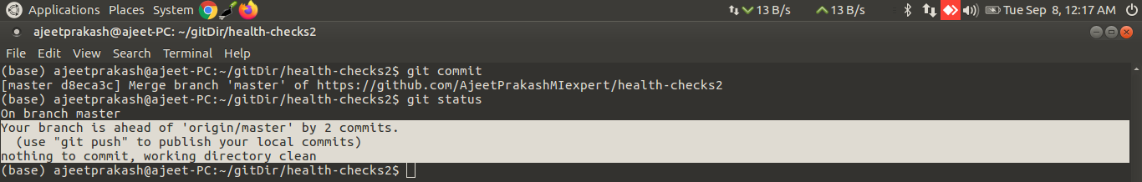
Your branch is ahead of 'origin/master' by 2 commits.
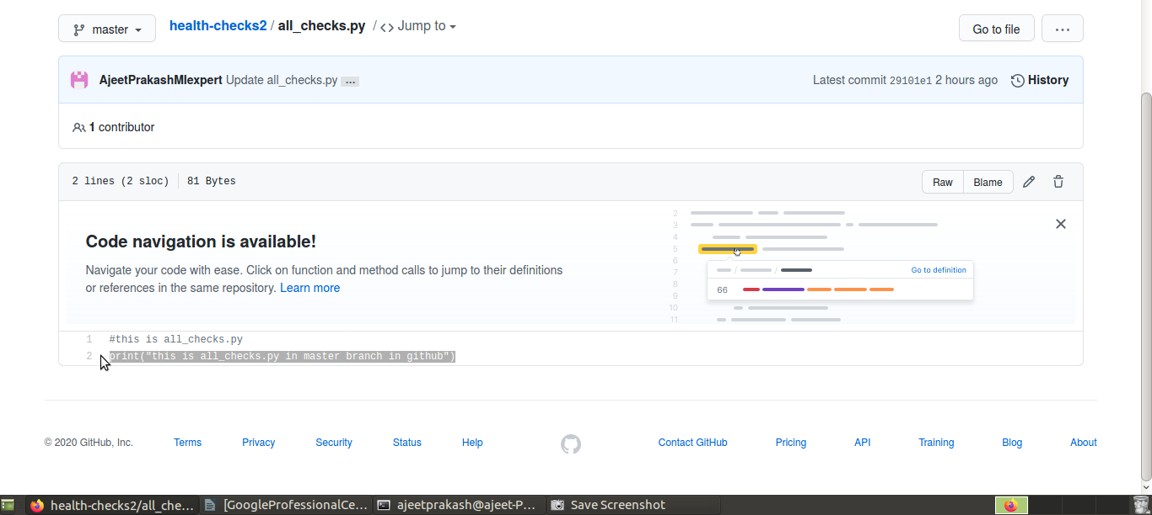
Checkout the print statement in master branch in git hub before git push
Checkout the print statement in experimental branch in git hub before git push
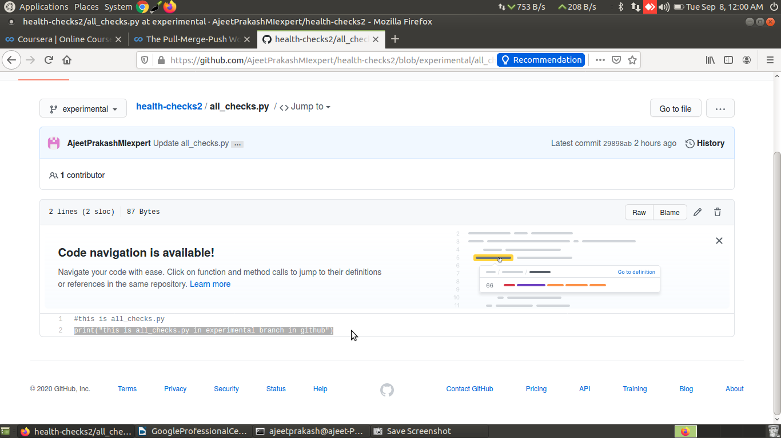
FINALLY DOING git push
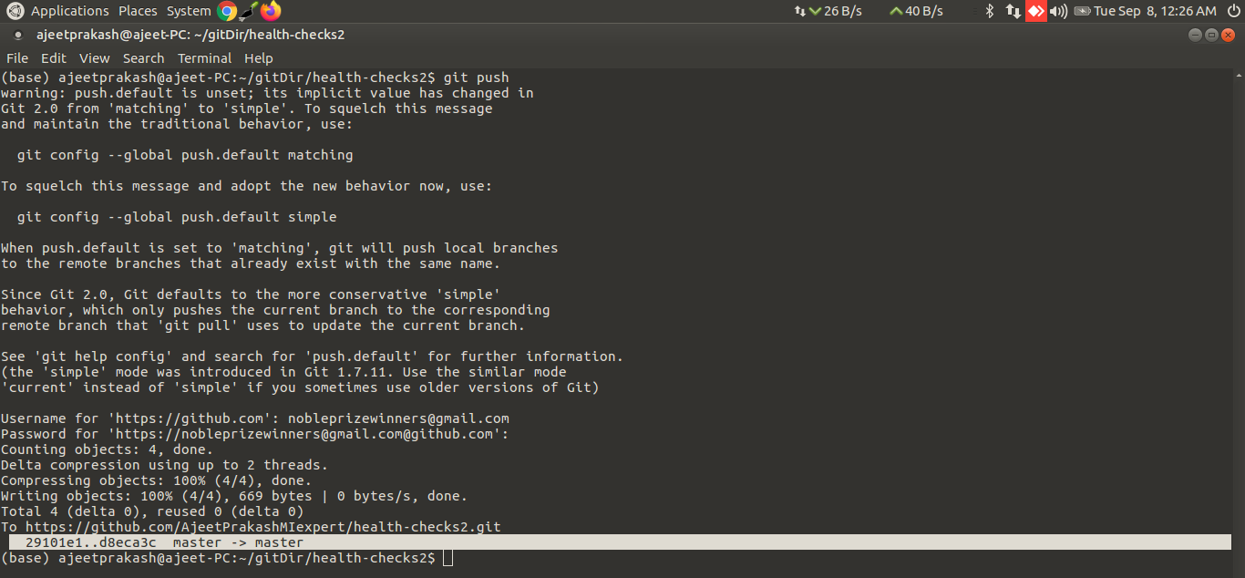
This time git push is successful and the commit id ending in d8eca3c

the print statement of the master branch of the github is now updated with the print statement
of the master branch of the local(that we kept while resolving merge conflict) after git push
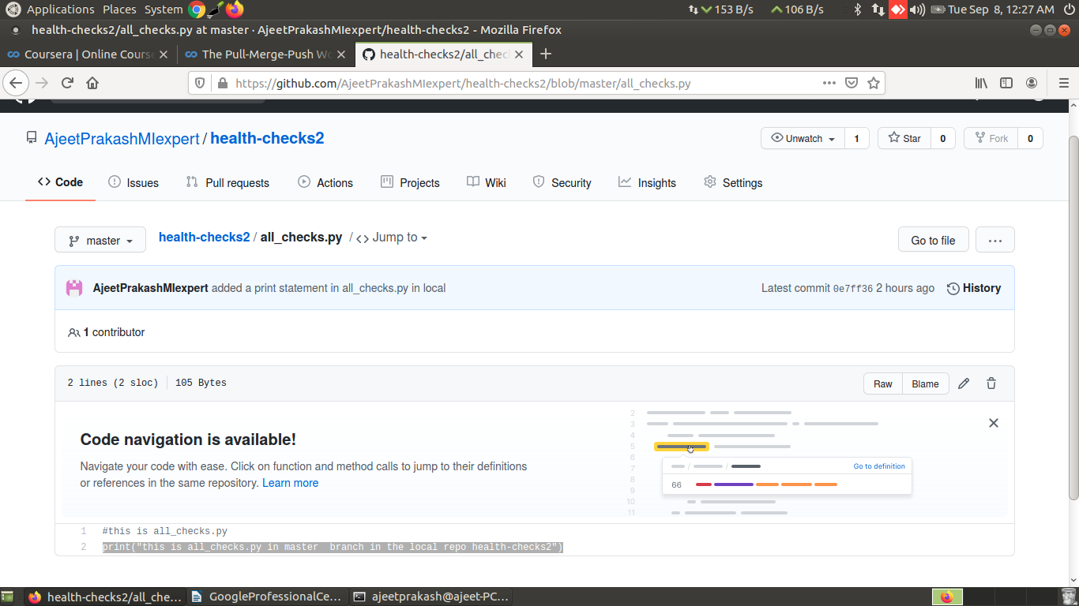
print statement of the experimental branch of the github has not changed even after merge and git push...bcoz local master branch was merged with remote master branch of github and not with remote experimental branch of github
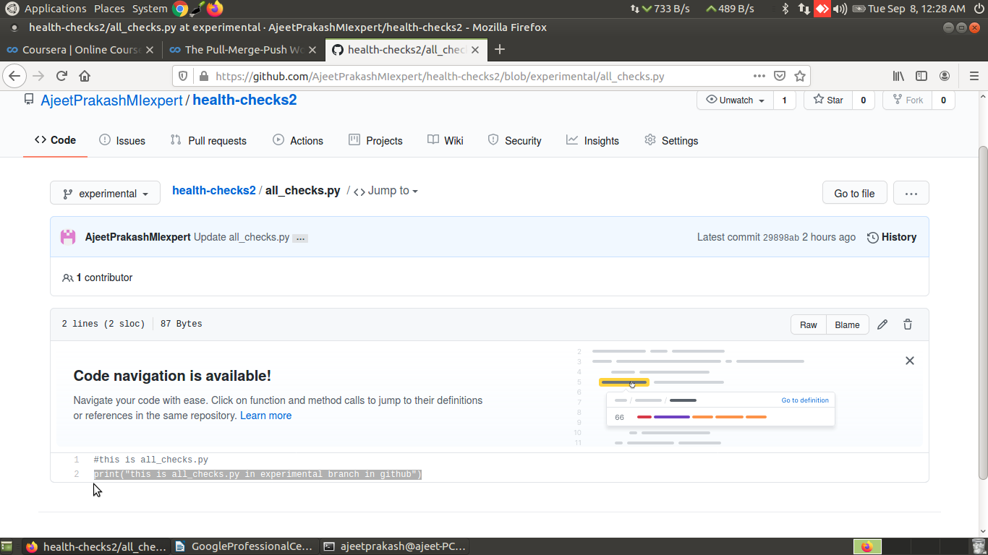

Let's look at the commit history
of the master branch now, by calling git log --graph –oneline.(exactly same output even when you use git log origin --graph --oneline)
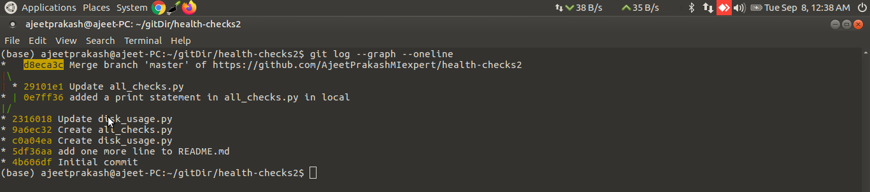
the commit id for this 3 way merge ends with d8eca3c which is the same that was displayed in the screenshot when the git push was successful after merge conflict was resolved

