Software Requirements Specification
for
CareFrame
Version 1.0
Prepared by
Abhishek kumar singh — 2400290120013
Abhisht singh — 2400290120016
Ajeet shukla — 2400290120024
Akshat agrawal — 2400290120028
KIET Deemed To Be University
Branch: Computer Science (CS) — B.Tech 3rd Year

Revision History
Version | Date | Author | Reason For Changes
1.0 | September 2026 | Project Team | Initial SRS for CareFrame

Table of Contents
- 1. Introduction
- 1.1 Purpose
- 1.2 Document Conventions
- 1.3 Intended Audience and Reading Suggestions
- 1.4 Product Scope
- 1.5 References
- 2. Overall Description
- 2.1 Product Perspective
- 2.2 Product Functions
- 2.3 User Classes and Characteristics
- 2.4 Operating Environment
- 2.5 Design and Implementation Constraints
- 2.6 User Documentation
- 2.7 Assumptions and Dependencies
- 3. External Interface Requirements
- 3.1 User Interfaces
- 3.2 Hardware Interfaces
- 3.3 Software Interfaces
- 3.4 Communications Interfaces
- 4. System Features
- 4.1 Authentication and Authorization
- 4.2 Patient Health Record Management
- 4.3 Doctor-Patient Access Management
- 4.4 Medical Report Upload and Processing
- 4.5 Timeline, Trends and Conflict Detection
- 4.6 AI Clinical Summary
- 4.7 Patient-Friendly AI Health Summary
- 4.8 Audit and Administration
- 5. Other Nonfunctional Requirements
- 5.1 Performance Requirements
- 5.2 Safety Requirements
- 5.3 Security Requirements
- 5.4 Software Quality Attributes
- 5.5 Business Rules
- 6. Other Requirements
- Appendix A: Glossary
- Appendix B: Analysis Models
- Appendix C: To Be Determined List

1. Introduction

1.1 Purpose
This Software Requirements Specification (SRS) defines the functional and non-functional requirements for CareFrame, a MERN-based digital health record management system. It specifies the system scope, users, interfaces, medical-record workflows, AI-assisted summary capabilities, security expectations, constraints, and acceptance-oriented requirements for Version 1.0.

1.2 Document Conventions
This document follows the IEEE-style organization shown in the supplied reference template. Functional requirements use unique FR-xx identifiers. SHALL/MUST indicates a mandatory requirement; SHOULD indicates a recommended requirement.

1.3 Intended Audience and Reading Suggestions
The SRS is intended for developers, testers, project guides, administrators, doctors, patients, and reviewers. Read Sections 1–2 for context, Section 3 for interfaces, Section 4 for detailed features, and Section 5 for non-functional requirements.

1.4 Product Scope
CareFrame centralizes longitudinal patient health information in a secure web application. Patients can manage records and reports, while authorized doctors can review history and generate AI-assisted clinical summaries. The system supports report extraction/OCR, structured observations, timelines, trend identification, conflict flagging, evidence references, and audit logging.

1.5 References
- IEEE Software Requirements Specification template supplied as the reference document.
- CareFrame UML diagram set.
- CareFrame Data Flow Diagram (DFD) documentation.
- CareFrame project implementation plan.

2. Overall Description

2.1 Product Perspective
CareFrame is a new self-contained web application. The planned architecture uses a React/Vite frontend, Node.js/Express backend, MongoDB for application data, object storage for original documents, optional OCR, and an external AI service.

2.2 Product Functions
- Separate patient and doctor login experiences.
- Role-based authentication and authorization.
- Patient health-record and document management.
- Explicit doctor-patient access granting and revocation.
- Medical report upload, validation, extraction and OCR.
- Normalization of observations with value, unit, date and source.
- Chronological timeline, trend analysis and conflict detection.
- Evidence-backed AI clinical summaries for authorized doctors.
- Plain-language AI health summaries for patients.
- Audit logging and administration.

2.3 User Classes and Characteristics
User | Main responsibilities
Patient | Manage personal records, upload reports, view timeline/medications/visits, manage doctor access.
Doctor | Access authorized patients, review history/reports, inspect trends/conflicts, generate AI summaries.
Administrator | Manage users/roles and review audit information.

2.4 Operating Environment
Modern desktop or mobile web browsers; React/Vite frontend; Node.js/Express backend; MongoDB; REST APIs; configured object storage; optional OCR and AI services.

2.5 Design and Implementation Constraints
- MERN-oriented implementation.
- Server-side authorization is mandatory for protected operations.
- Medical information is sensitive and requires controlled access.
- Extracted observations and AI claims must retain source references.
- AI shall not autonomously diagnose, prescribe, change medication, or silently resolve conflicts.
- Synthetic data should be used for development and demonstrations.

2.6 User Documentation
The project should provide concise guidance for patient record management, doctor patient-review and AI-summary workflows, report uploading, and administrator operations.

2.7 Assumptions and Dependencies
- Users have a supported browser and network connection.
- MongoDB is available.
- Secure document storage is available where configured.
- OCR and AI services may depend on external components.
- Users provide accurate information and valid reports.

3. External Interface Requirements

3.1 User Interfaces
Patient screens include dashboard, records, timeline, reports, medications, visits, health summary, doctors, privacy/access, notifications and profile. Doctor screens include dashboard, patient search/list, patient overview, timeline, reports and AI clinical summary. Administrators receive user/role and audit-management screens.

3.2 Hardware Interfaces
No specialized medical hardware is required for Version 1.0. Standard computers, laptops, tablets and smartphones with a supported browser are sufficient.

3.3 Software Interfaces
Interface | Purpose
React/Vite | Web user interfaces.
Node.js/Express | REST API, business logic, authentication and authorization.
MongoDB | Structured application and health-record storage.
Object storage | Original medical-document storage.
OCR service | Text extraction from scanned/image reports.
AI service | AI-assisted clinical summary generation.

3.4 Communications Interfaces
Frontend-backend communication shall use secure HTTP(S) REST APIs, normally with JSON request/response data. External document and AI services shall use protected network connections.

4. System Features

4.1 Authentication and Authorization
Description and Priority: Authentication and Authorization. Priority: High.

Stimulus/Response Sequences
User selects portal → enters credentials → authentication → permission check → dashboard.

Functional Requirements
FR-01: Separate patient and doctor login experiences.
FR-02: Server-side role-based authorization for patient, doctor and administrator operations.
FR-03: Unauthorized requests shall be denied without exposing protected data.

4.2 Patient Health Record Management
Description and Priority: Patient Health Record Management. Priority: High.

Stimulus/Response Sequences
User opens records → permitted data retrieved → allowed action performed.

Functional Requirements
FR-04: Authorized users shall create, view and manage permitted health-record information.
FR-05: Records shall include conditions, allergies, medications, encounters, procedures, observations and documents.
FR-06: Clinically relevant history shall not be silently overwritten.

4.3 Doctor-Patient Access Management
Description and Priority: Doctor-Patient Access Management. Priority: High.

Stimulus/Response Sequences
Doctor requests patient → access checked → data returned or denied.

Functional Requirements
FR-07: The system shall maintain an explicit doctor-patient access relationship.
FR-08: Patients shall be able to view active access and revoke it where permitted.
FR-09: Doctors shall retrieve patient information only when required access is active.

4.4 Medical Report Upload and Processing
Description and Priority: Medical Report Upload and Processing. Priority: High.

Stimulus/Response Sequences
Upload → validate → store → extract/OCR → normalize → validate/flag → store.

Functional Requirements
FR-10: Validate report type and basic file constraints.
FR-11: Store the original report with a source/document identity.
FR-12: Extract text and use OCR when required.
FR-13: Normalize observations with value, unit, date where available and source reference.
FR-14: Failed extraction shall not be presented as confirmed structured data.

4.5 Timeline, Trends and Conflict Detection
Description and Priority: Timeline, Trends and Conflict Detection. Priority: High.

Stimulus/Response Sequences
Retrieve → order → analyze comparable observations → display trends/conflicts.

Functional Requirements
FR-15: Display relevant medical events chronologically.
FR-16: Identify trends only for sufficiently comparable observations.
FR-17: Flag conflicts and retain underlying sources.
FR-18: Identify detectable duplicate or incomplete information.

4.6 AI Clinical Summary
Description and Priority: AI Clinical Summary. Priority: High.

Stimulus/Response Sequences
Doctor opens patient → Generate Summary → build relevant context → AI generation → evidence validation → display for review.

Functional Requirements
FR-19: Authorized doctors shall request an AI clinical summary.
FR-20: AI context shall use relevant current and historical records, reports, medications, observations, trends and conflicts.
FR-21: Summary shall include source/evidence references where applicable.
FR-22: Evidence/source IDs shall be validated.
FR-23: Summary shall clearly require clinician review.
FR-24: AI shall not autonomously diagnose, prescribe, change medication or resolve conflicts.
FR-25: AI/service failure shall show an explicit failure state, not fabricated content.

4.7 Patient-Friendly AI Health Summary
Description and Priority: Patient-Friendly AI Health Summary. Priority: Medium.

Stimulus/Response Sequences
Patient opens Health Summary → permitted information retrieved → summary displayed.

Functional Requirements
FR-26: Provide an optional simplified summary of recorded health information.
FR-27: Use plain language and avoid autonomous treatment recommendations.
FR-28: Provide navigation to underlying records where practical.

4.8 Audit and Administration
Description and Priority: Audit and Administration. Priority: High.

Stimulus/Response Sequences
Admin authenticates → permission checked → audit/admin information displayed.

Functional Requirements
FR-29: Record significant authentication, access, document and AI events in audit logs.
FR-30: Administrators shall review appropriate audit information.
FR-31: Administrative functions shall require administrator authorization.

5. Other Nonfunctional Requirements

5.1 Performance Requirements
- Normal navigation and record retrieval should remain responsive for the expected project workload.
- Long-running OCR and AI operations shall show processing states.
- AI generation shall return a result or explicit failure state within a configured timeout.
- Only necessary patient data should be sent to the AI service.

5.2 Safety Requirements
- AI output is decision support, not an autonomous medical decision.
- Clinicians must review AI summaries before clinical use.
- Conflicting records must be flagged rather than silently resolved.
- Missing/failed extraction must not be represented as confirmed facts.
- AI must not automatically change medication information.

5.3 Security Requirements
- Authentication is required for protected functions.
- Server-side authorization shall protect every patient-data operation.
- Patients shall have controlled visibility of doctor access where supported.
- Revoked access shall prevent subsequent unauthorized retrieval.
- Sensitive data shall be protected in transit and at rest according to deployment.
- Important access, authentication, document and AI events shall be auditable.
- Synthetic data should be used for demonstrations.

5.4 Software Quality Attributes
Attribute | Requirement
Usability | Clear patient and doctor workflows with minimal unnecessary navigation.
Reliability | Records and original documents should not be silently lost.
Maintainability | Authentication, records, documents, AI and audit functions should be modular.
Traceability | Extracted observations and AI claims should retain source references.
Security | Protected health information is accessible only to authorized users.
Testability | Requirements should be verifiable through unit, API, integration and UI tests.
Scalability | Architecture should support growth in users, records and documents.

5.5 Business Rules
- Rule ID | - Rule Name | - Business Rule | - Applicable To
- BR-01 | - Role-Based Access | - Patients, doctors, and administrators shall have different privileges. | - Patient / Doctor / Administrator
- BR-02 | - Doctor-Patient Access | - A doctor shall access a patient's protected health records only when the required doctor-patient access relationship is active. | - Doctor
- BR-03 | - Access Revocation | - A patient shall be able to revoke doctor access where the system permits; after revocation, the doctor shall not receive subsequent unauthorized access to the patient's records. | - Patient / Doctor
- BR-04 | - Patient Record Ownership | - Patients shall be able to view and manage their personal health information according to their permissions. | - Patient
- BR-05 | - Medical History Preservation | - Clinically relevant historical information shall not be silently overwritten or removed. | - Patient / Doctor
- BR-06 | - Original Report Preservation | - Original uploaded medical reports shall remain available as source evidence for extracted or structured information. | - Patient / Doctor
- BR-07 | - Source Traceability | - Information extracted from reports shall retain a reference to its originating document or source record. | - System
- BR-08 | - Conflict Handling | - Conflicting medical information shall be flagged for human review rather than silently resolved by the system. | - Doctor / System
- BR-09 | - Trend Analysis | - Health trends shall be identified only when observations are sufficiently comparable in measurement and context. | - System
- BR-10 | - AI Clinical Summary Access | - Only an authorized doctor shall be able to request an AI-assisted clinical summary for a patient. | - Doctor
- BR-11 | - AI Evidence Requirement | - AI clinical summaries should include source or evidence references so that the doctor can verify important information. | - Doctor / System
- BR-12 | - Clinician Review | - AI-generated clinical summaries shall require clinician review before being used for clinical decision-making. | - Doctor

6. Other Requirements
- Structured health data shall be persistently stored in MongoDB or the configured equivalent.
- Original uploaded reports shall be retained in secure document storage.
- Report-derived observations shall link to their source document.
- Synthetic patient records should be used for academic demonstrations.
- Production compliance, standards-based exchange and additional integrations are outside confirmed Version 1.0 unless separately approved.

Appendix A: Glossary
Term | Meaning
SRS | Software Requirements Specification.
DFD | Data Flow Diagram.
AI | Artificial Intelligence.
OCR | Optical Character Recognition.
RBAC | Role-Based Access Control.
Clinical Summary | Evidence-backed summary of recorded patient information for authorized clinical review.
Source ID | Identifier linking information to an underlying record or document.
Encounter | Recorded interaction such as a consultation or visit.
Observation | Recorded clinical value such as a laboratory result or vital sign.

Appendix B: Analysis Models
The CareFrame analysis-model set includes Use Case, Class, Sequence, Activity, Component, Deployment and State Machine diagrams. The project DFD includes Level 0, Level 1 and Level 2 views covering authentication, records, report processing, trends/conflicts, AI summary generation, and audit/administration.
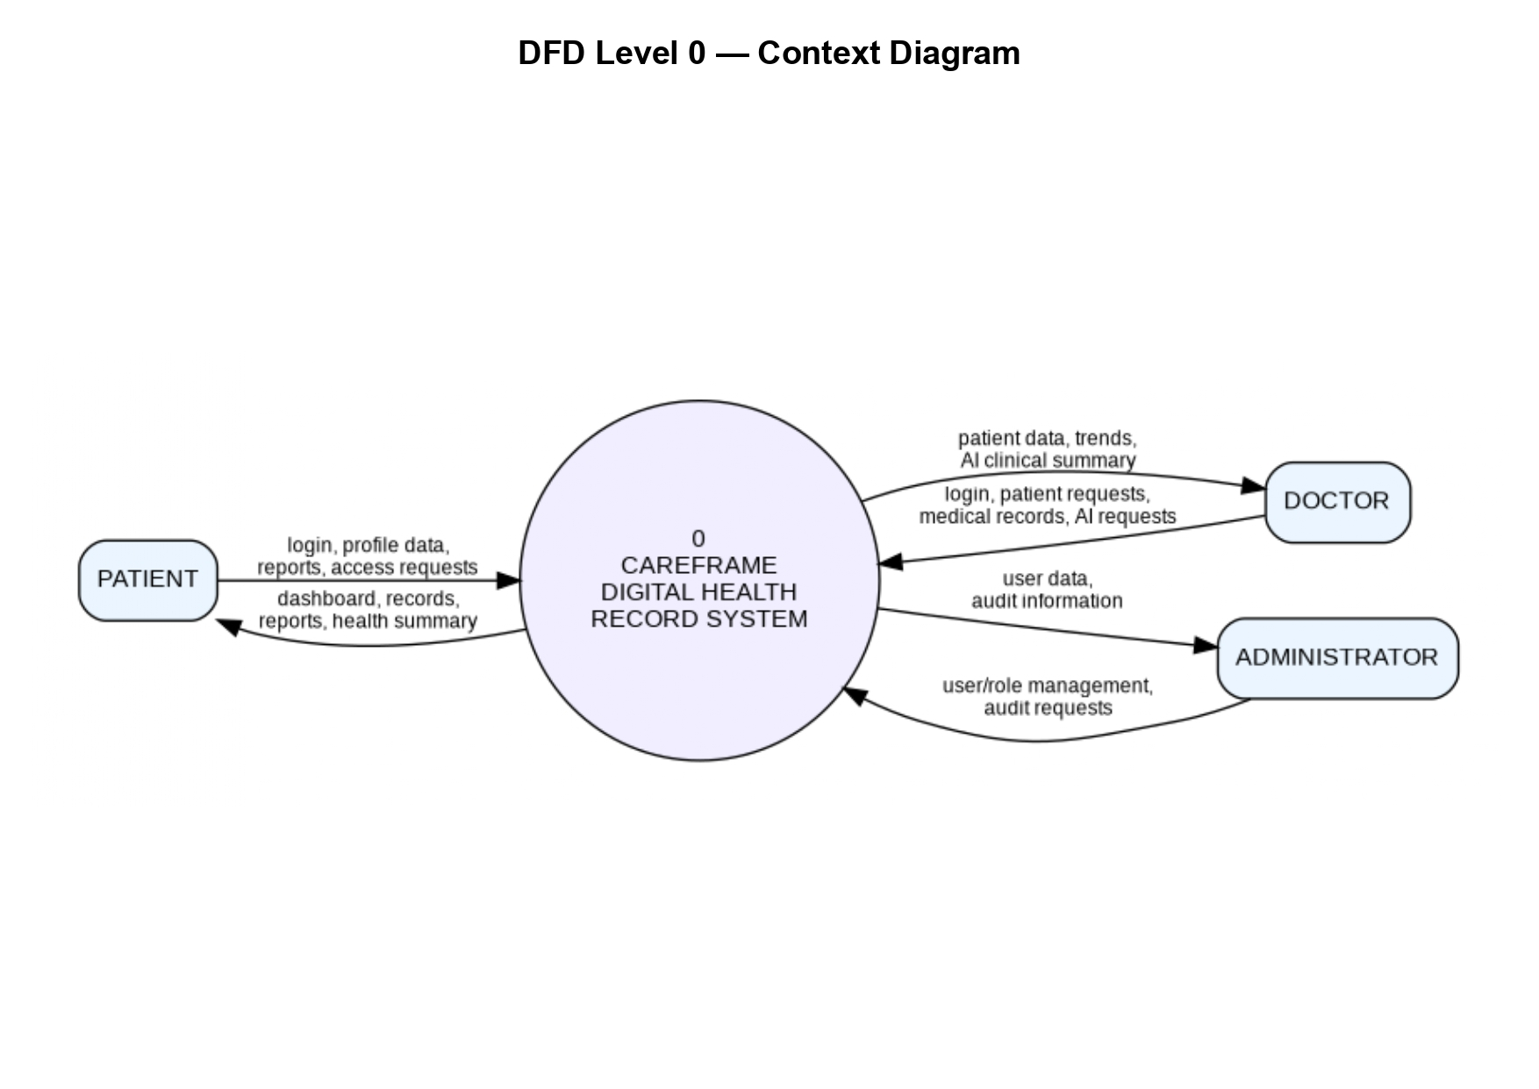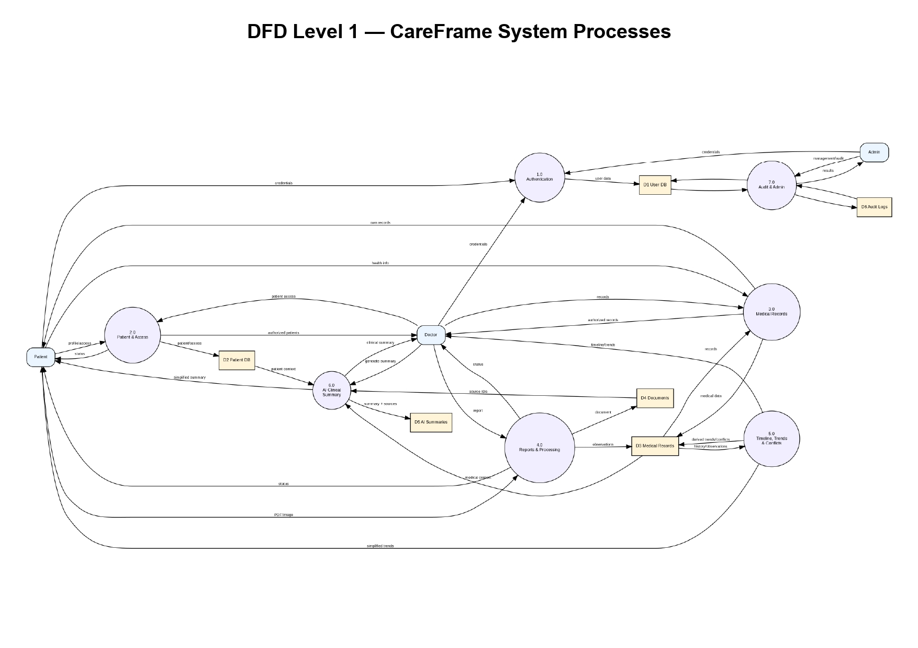
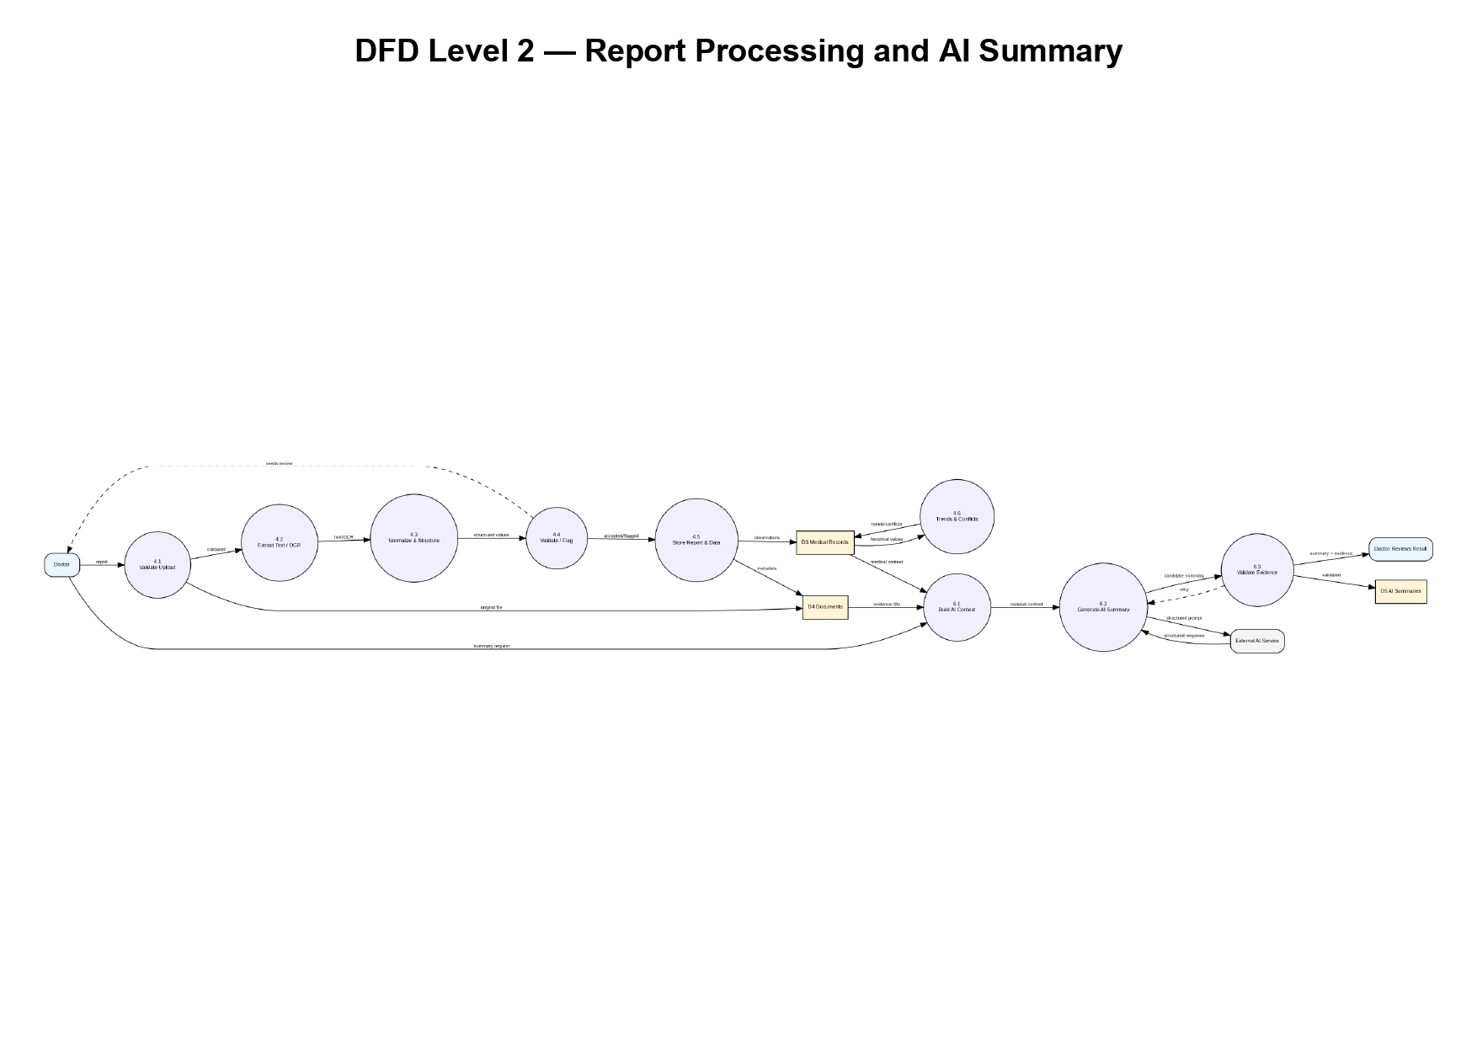
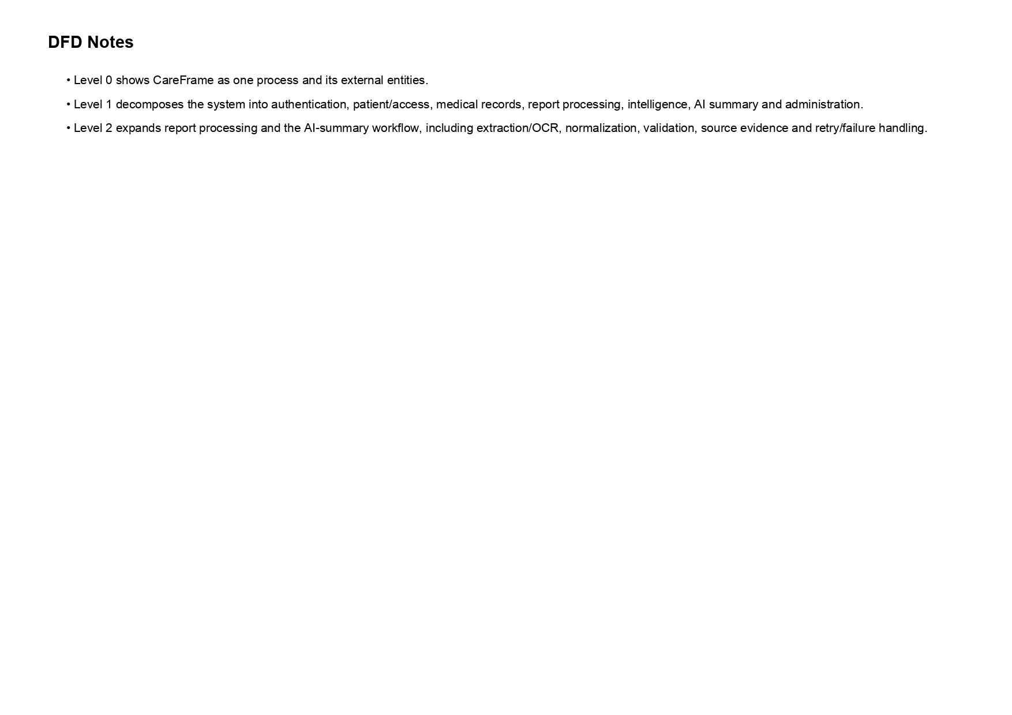

Appendix C: To Be Determined List
TBD ID | Item | Status
TBD-01 | Production hosting configuration | To be decided during deployment.
TBD-02 | Final OCR provider/library | To be selected during implementation.
TBD-03 | Final AI model/provider configuration | To be finalized during implementation.
TBD-04 | Production retention/compliance policy | Requires institutional approval before production use.

Requirement Summary
CareFrame shall provide a secure digital health record platform with distinct patient and doctor portals. It shall manage longitudinal medical information and uploaded reports, process documents through extraction/OCR, structure observations with source references, provide timelines and trend/conflict detection, and offer evidence-backed AI-assisted summaries to authorized doctors. The system shall preserve clinician oversight, enforce access control, and maintain auditability throughout these workflows.

