### “Air canvas(draw in air)”

**Report of Major Project One**

**Submitted in partial fulfillment of the requirement for the award of Degree**

**Bachelor of Technology**

**(Computer Science and Engineering)**

**Submitted to**



**RAJIV GANDHI PROUDYOGIKI VISHWAVIDYALAYA BHOPAL (M.P.)**

**Submitted by**

**Aman Raj – 0192CS201019**

**Under the Guidence of**

**Prof. Onkar Nath Thakur**

**DEPARTMENT OF COMPUTER SCIENCE AND ENGINEERING**

**TECHNOCRATS INSTITUTE OF TECHNOLOGY & SCIENCE, BHOPAL (M.P.)**

**SESSION: 2023– 2024**

**TECHNOCRATS INSTITUTE OF TECHNOLOGY & SCIENCE BHOPAL (M.P.) DEPARTMENT OF COMPUTER SCIENCE AND ENGINEERING**

CERTIFICATE

This is to certify that the work embodies in this Synopsis entitled **“Air canvas(draw in air)”** being submitted by **Aman Raj (0192CS201019)** in partial fulfillment of the requirement for the award of Degree of **Bachelor’s of Technology in Computer Science and Engineering** to **Rajiv Gandhi Proudyogiki Vishwavidyalaya , Bhopal** during the academic year 2023-24 is a record of Bonafide piece of work, carried out by them under my supervision and guidance in the **Department of Computer Science and Engineering, Technocrats Institute of Technology & Science, Bhopal**.

Guided By:

**Prof. Onkar Nath Thakur**

(**Full** **designation, Dept. of CSE)**

Forwarded by: Approved By:

|  |  |
| --- | --- |
| **Prof. Rakesh Kumar Tiwari** | **Prof. (Dr.) Vikas Gupta** |
| **(Head of the Department, CSE)** | **(Director , TIT & Science)** |

**TECHNOCRATS INSTITUTE OF TECHNOLOGY & SCIENCE BHOPAL**

**DEPARTMENT OF COMPUTER SCIENCE AND ENGINEERING**

**CERTIFICATE OF APPROVAL**

The Project entitled “**Air Canvas(Draw in air)**” being submitted by **Aman Raj (0192CS201019)** has been examined by us and is hereby approved for the award of degree Bachelor of Technology (B.Tech.) in Computer Science & Engineering discipline”, for which it has been submitted. It is understood that by this approval the undersigned do not necessarily endorse or approve any statement made, opinion expressed or conclusion drawn there in, but approve the Major Project only for the purpose for which it has been submitted.

|  |  |
| --- | --- |
| **Internal Examiner** | **External Examiner** |
| **Date:** | **Date:** |

**TECHNOCRATS INSTITUTE OF TECHNOLOGY AND SCIENCE, BHOPAL**

**DEPARTMENT OF COMPUTER SCIENCE AND ENGINEERING**

DECLARATION

This is **Aman Raj** (**0192CS201019**) a student of Bachelor of Technology (B.Tech) in Computer Science & Engineering discipline, session: 2023 - 2024, Technocrats Institute of Technology & Science, Bhopal (M.P.) hereby declare that the work presented in this project entitled “**Air Canvas(Draw in air)**” is the outcome of my own work, is Bonafide and correct to the best of my knowledge and this work has been carried out taking care of Engineering Ethics. The work presented does not infringe any patented work and has not been submitted to any other university or anywhere else for the award of any degree or any professional diploma.

**Aman Raj (0192CS201019)**

ACKNOWLEDGEMENT

With due respect, we express our deep sense of gratitude to our respected and learned guide **Prof. onker Nath Thakur** Department of Computer Science & Engineering, TIT & Science, Bhopal, for his valuable help and guidance. We are thankful to him for the encouragement he has given to us in completing this project.

We are also grateful to respected **Prof. Rakesh Kumar Tiwari**, Head of the Department of Computer Science & Engineering, Technocrats Institute of Technology & Science, Bhopal and to respected **Dr. Vikas Gupta, Director**, TIT& Science, Bhopal, for permitting us to utilize all the necessary facilities of the college.

We are also thankful to our guide for their kind co-operation and suggesting improvements in project.

We are also thankful to all the other staff members of our department for their kind co- operation and suggesting improvements in project.

We would like to express our deep appreciation towards our classmates for providing as much needed suggestions and cordial atmosphere.

Last but not the least we would like to thank our family members for their support and

encouragement without which this Major Project would not have been completed.

**Aman Raj** (**0192CS201019**)

Creating Air Canvas Using Computer Vision

**ABSTRACT**

Creating air canvas using computer vision involves using a camera to detect Hand movements and gestures, translating them into drawing on a virtual Canvas. Utilize a camera , often integrated into a device like a smartphone or Webcam. Apply computer vision algorithms to identify and track the user’s Hand in real –time. Define gestures for actions like drawing, erasing, and Changing colors. Establish a virtual canvas where the user’s gestures will translate into drawings. Map hand movements to drawing actions, allowing User to sketch in the air. Implement a mechanism for users to chose colors, Potentially through gestures or a separate interface.

TABLE OF CONTENTS

Certificates………………………………………………………. i

Certificate of Approval………………………………………….. ii

Declaration……………………………………………………… iii

Acknowledgement………………………………………………. iv

Abstract………………………………………………………….. v

CHAPTER 1 INTRODUCTION 1

CHAPTER 2 MOTIVATION 2

CHAPTER 3 CHALLENGES IDENTIFIED 3

3.2 FEATURES 4-6

CHAPTER 4 SYSTEM METHODOLOGY 6-8

CHAPTER 5 SYSTEM DESIGN 9-12

CHAPTER 6 USE CASE DIAGRAM 13

CHAPTER 7 RESULT 14

CHAPTER 8 FUTURE SCOPE 15

CHAPTER 9 CONCLUSION 16

CHAPTER 10 REFERENCES 17

1. INTRODUCTION

At any point needed to draw your creative mind simply by deferring your finger in air. PC Vision is an interdisciplinary logical field that arrangements with how PCs can be made to acquire significant level comprehension by utilization of numerous computerized ways. In this undertaking we will fabricate an Air Canvas which can draw anything on it simply by catching the movement of a finger with Webcam. We will utilize the PC vision procedures of Open CV to fabricate this task. The favored language is python because of its comprehensive libraries and simple to utilize linguistic structure however understanding the fundamentals it very well may be carried out in any Open CV upheld language. Here Color Detection and following is utilized to accomplish the Target

1.1. Air Canvas:- Air Canvas is a without hands computerized Drawing material that uses, a camera and Open CV to perceive and plan hand signals onto a screen

1.2. Contour:- Shapes may be clarified simply as a bend becoming a member of all of the consistent

points(alongside the limit), having equal tone or power. The forms are a valuable instrument for shape analysis and item location and granting.

1. **MOTIVATION**

The underlying inspiration was a requirement for a dustless study hall for the understudies to concentrate in. I realize that there are numerous ways like touch screens and then some yet what might be said about the schools which cannot bear the cost of it to purchase such gigantic huge screens and instruct on them like a T.V. Along these lines, I thought why not can a finger be follo-wed, however that too at an underlying level without profound learning. Consequently it was OpenCV which acted the hero for these PC vision projects.

**3. CHALLENGES IDENTIFIED**

1. Fingertip detection is the system which only works with your fingers, and there are no such devices like highlighters, or any other related gadgets. Identifying and recognition an object like a finger from an RGB image without an advanced device like depth sensor is a great challenge.

2. Lack of pen up and down movement of the system uses RGB camera to write from starting. Since depth sensing is not possible, the pen's up and down movement cannot be tracked. Thus, the entire trajectory of the fingertip is tracked and the resulting image will be meaningless and not recognized by the model The difference identified among hand written and air written „G‟ is shown in Figure

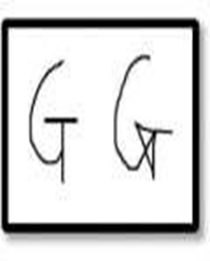

**Figure 3.1**Canvas Based Drawing

transmitter. In beneficiary section RF symptoms may be gotten with the aid of using RF recipient and given to microcontroller. The regulator procedures the records finally then results may be proven on Graphical LCD.

3.2. FEATURES

1. Can track any specific individual required color pointer.

2. Users can draw four different colors and even change them whenever required without any difficulties.

3. There is Clear option at the top of the display that helps to scrub the board at a time.

4. Once the program has started No need to involve the contact with the computer PROBLEM STATEMENT item following is considered as a significant undertaking inside the field of Computer Vision. You never thought, raising your finger in the air can help us draw on a real picture. How wonderful that this aerial web works in Computer Vision Projects.

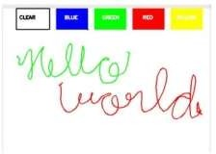

Figure - Structure of Air Canvas

# 

3.3. LITERATURE SURVEY

Powerful hand recognition with Kinect sensor In[3], the proposed system uses depth and color information from the Kinect sensor to detect the shape of the hand. For gesture recognition, with the Kinect sensor is a difficult problem to be noted. The resolution of this kind of Kinect sensor is only 640×480. It works well for tracking a large object, for example, the human body. But something as small as a finger is complicated.

**4. SYSTEM METHODOLOGY** The system needs a data set for finger detection model. The main purpose of the fingertip model is to record movement, this recorded movement is air characters

4.1. Fingertip sensor model: Air writing can be done simply by using a single-color stylus or air pen. However, the system uses fingertips. We believe that people can write in the air without

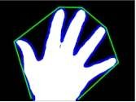

Figure **4.1** Methodology of Air Canvas

4.2. Take photos in separate backgrounds: To overcome the inconvenience caused by the previous method's lack of diversity, we introduced a new dataset. This time we are aware that we need a few gestures to make control the system

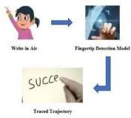

Figure 4.2 Detection of Finger Tips Using OpenCV

**5 SYSTEM DESIGN**

Have you ever wanted to capture your imagination just by lifting your finger in the air Here we will create an aerial canvas that can draw anything on it by capturing the movement of the color marker with the webcam. A colored object which is on the tip of the finger is used as a marker. Open CV helps computer vision techniques in this project. The best preferred language is python as it has many libraries and easy to use syntax, but understanding the basics can be implemented in any language which are supported by Open CV. Here, color detection and tracking are used to achieve our goal. Color marker is detected and a mask is generated. It includes the next stages of morphological activity.

**Server**

**Client**

Read frame from

The webcam

Accept frames

From clients

Detect the

contours

Send frame to server

Process frames 

Show output live

streams

Figure 5.1 Block diagram of client and server

**5.1. Modules of Proposed System**

**5.1.1. Color Tracking**

Understanding the HSV ( Hue , Saturation , Value ) shading space for Color Tracking. Furthermore, following the little hued object at fingertip. The approaching picture from the webcam is to be changed over to the HSV shading space for recognizing the hued object at the tip of finger.

**5.1.2. Trackbars**

When the trackbars are arrangement, we will get the real time esteem from the trackbars and make range. This reach is a numpy structure which is utilized to be passed in the capacity cv2.inrange(). This capacity returns the Mask on the hued object. This Mask is a high contras picture with white pixels at the situation of the ideal tone.

**5.1.3. Contour Detection**

Recognizing the Position of Colored item at fingertip and shaping a circle over it. We are playing out some morphological procedure on the Mask, to make it liberated from contaminations and to distinguish shape without any problem. That is Contour Detection.

**5.2. Frame Processing**

Following the fingertip and drawing focuses at each position for air material impact. That is Frame Processing

**5.2.1. Hardware Requirements**

1. Webcam: A webcam is a video cam that acceptor transfers a picture or video progressively to or through a PC organization, like the Internet.

2. Display Unit (Screen):- Means "Visual Display Unit." A VDU shows pictures created by a PC or other electronic gadget. The term VDU is regularly utilized interchangeably with "screen," however it can likewise allude to one more kind of show, like a computerized projector.

**5.2.2. Software Requirements**

● Open Cv libraries

● Numpy

● Python

5.3.1. Open CV: It is a library of Python which is intended to tackle PC vision issues. Open CV -Python utilizes Numpy, which is an exceptionally upgraded library. Open CV is a friendly language to work with.

5.3.2. Numpy: NumPy is the essential bundle for logical processing in Python. NumPy exhibits work with cutting edge numerical and different kinds of procedure on enormous quantities of information.

5.3.3. Python: Python is a translated, object- arranged, certain level programming language with dynamic semantics. Python utilizes extremely

**6. USE CASE DIAGRAM**

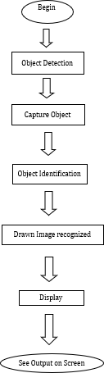

Figure 6.1 use case diagram

**7. RESULT**

Here are the results and output for our project. We used OpenCV module to run our code. We have executed our code in anaconda ,Jupiter Notebook where we first installed required packages and run our code for output.

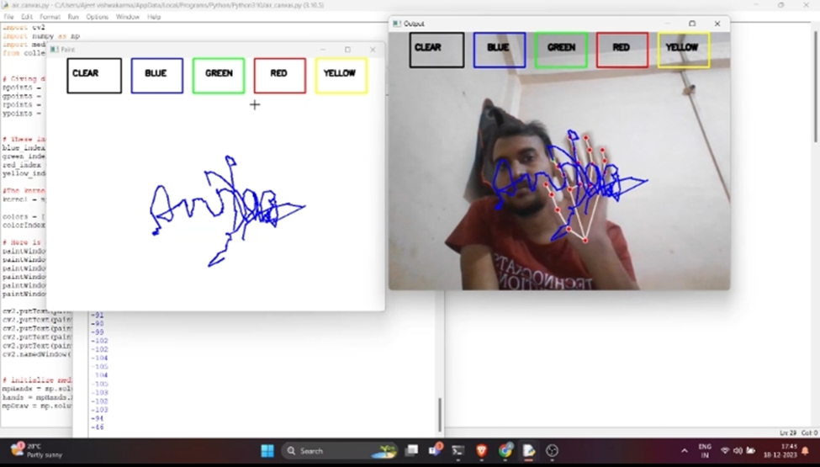

Figure7.1 Diagram showing the result

**8. FUTURE SCOPE**

While there has been a blast of man-made brainpower based programming for workmanship over the most recent couple of years, people, for example, kids and the old regularly don't approach these cutting edge AI models that are right now being created. We move towards filling this hole by making an instinctive interface and application that is redone for supporting the client in their visual articulation. Clients are engaged to rapidly make different imaginative representations in a community oriented exertion between the client and the framework, and an incorporated arrangement of AI models takes into consideration a clever reaction from the framework

**9. CONCLUSION**

The undertaking Air Canvas: Draw in Air has been effectively planned and tried. It has been created by incorporating elements of all the equipment parts and programming utilized. Presence of each module has been contemplated out and set cautiously accordingly adding to the best working of the Secondly we utilized a general programming language called python, NumPy python library which working with exhibits and the assistance of developing innovation the undertaking has been effectively executed.

**ACKNOWLEDGEMENT**

Our colleagues are genuinely appreciative to that multitude of individuals who have been providing us with any sort of help with the creation of this task report.

**10. REFERENCES**

[1] R. Gowarishankar and M. F. Demirkol, “Adaptive M-QAM Modulation for MIMO Systems”, IEEE 2005, University of Hawaii at Manoa, Honolulu, USA, 2005

[2] A. Svensson, “An Introduction to Adaptive QAM Modulation Schemes for Known and Predicted Channels”, Proceedings of the IEEE | Vol. 95, No. 12, December 2007

[3] T. S. Rappaport, “Wireless Communications: Principles and Practice” Second Edition, Prentice Hall, 2003

[4] S. Haykin, “Communication Systems”, John Wiley & Sons, Inc., 2001.