Nama: Ajeng Mayang Arum

Nim: 210511130

Kelas: TI21D

**LATIHAN INHERITANCE**

**Hierarchical Inheritance 1**

class Animal:

    def __init__(self, name, color):

        self.name = name

        self.color = color

    def get_name(self):

        return self.name

    def get_color(self):

        return self.color

class Mammal(Animal):

    def __init__(self, name, color, fur):

        super().__init__(name, color)

        self.fur = fur

    def get_fur(self):

        return self.fur

class Bird(Animal):

    def __init__(self, name, color, wingspan):

        super().__init__(name, color)

        self.wingspan = wingspan

    def get_wingspan(self):

        return self.wingspan

# Hierarchical Inheritance

class Reptile(Mammal):

    def __init__(self, name, color, fur, scale):

        super().__init__(name, color, fur)

        self.scale = scale

    def get_scale(self):

        return self.scale

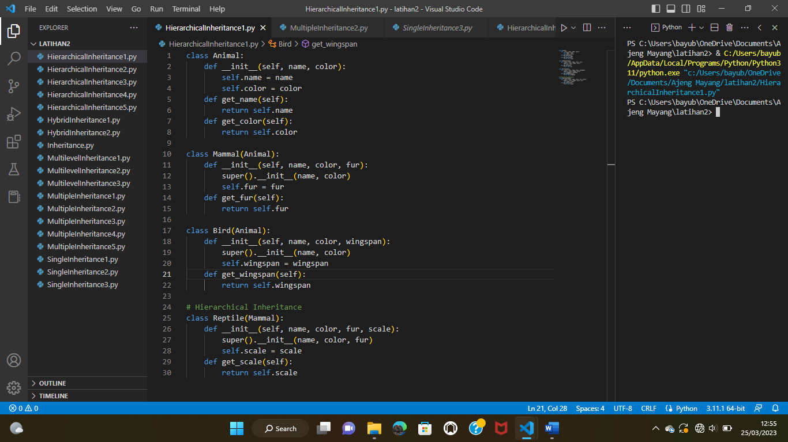

**Hierarchical Inheritance 2**

class Employee:

    def __init__(self, name, age, salary):

        self.name = name

        self.age = age

        self.salary = salary

    def get_name(self):

        return self.name

    def get_age(self):

        return self.age

    def get_salary(self):

        return self.salary

class Manager(Employee):

    def __init__(self, name, age, salary, department):

        super().__init__(name, age, salary)

        self.department = department

    def get_department(self):

        return self.department

class Programmer(Employee):

    def __init__(self, name, age, salary, language):

        super().__init__(name, age, salary)

        self.language = language

    def get_language(self):

        return self.language

# Hierarchical Inheritance

class SeniorProgrammer(Programmer):

    def __init__(self, name, age, salary, language, level):

        super().__init__(name, age, salary, language)

        self.level = level

    def get_level(self):

        return self.level

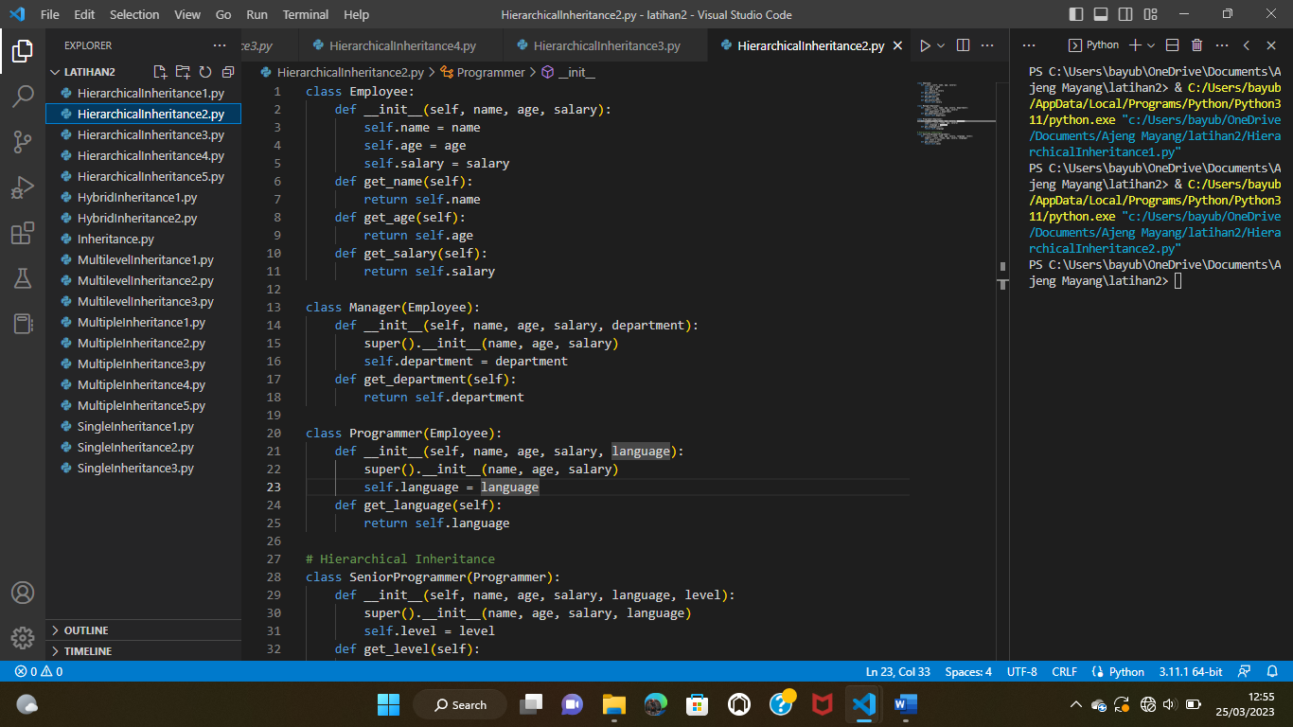

**Hierarchical Inheritance 3**

class Kendaraan:

    def __init__(self, nama):

        self.nama = nama

    def get_nama(self):

        return self.nama

class Mobil(Kendaraan):

    def __init__(self, nama, merek):

        super().__init__(nama)

        self.merek = merek

    def get_merek(self):

        return self.merek

class SepedaMotor(Kendaraan):

    def __init__(self, nama, tipe):

        super().__init__(nama)

        self.tipe = tipe

    def get_tipe(self):

        return self.tipe

# turunan Hierarchical Inheritance

class Truk(Mobil):

    def __init__(self, nama, merek, kapasitas):

        super().__init__(nama, merek)

        self.kapasitas = kapasitas

    def get_kapasitas(self):

        return self.kapasitas

# turunan Hierarchical Inheritance

class MotorListrik(SepedaMotor):

    def __init__(self, nama, tipe, daya):

        super().__init__(nama, tipe)

        self.daya = daya

    def get_daya(self):

        return self.daya

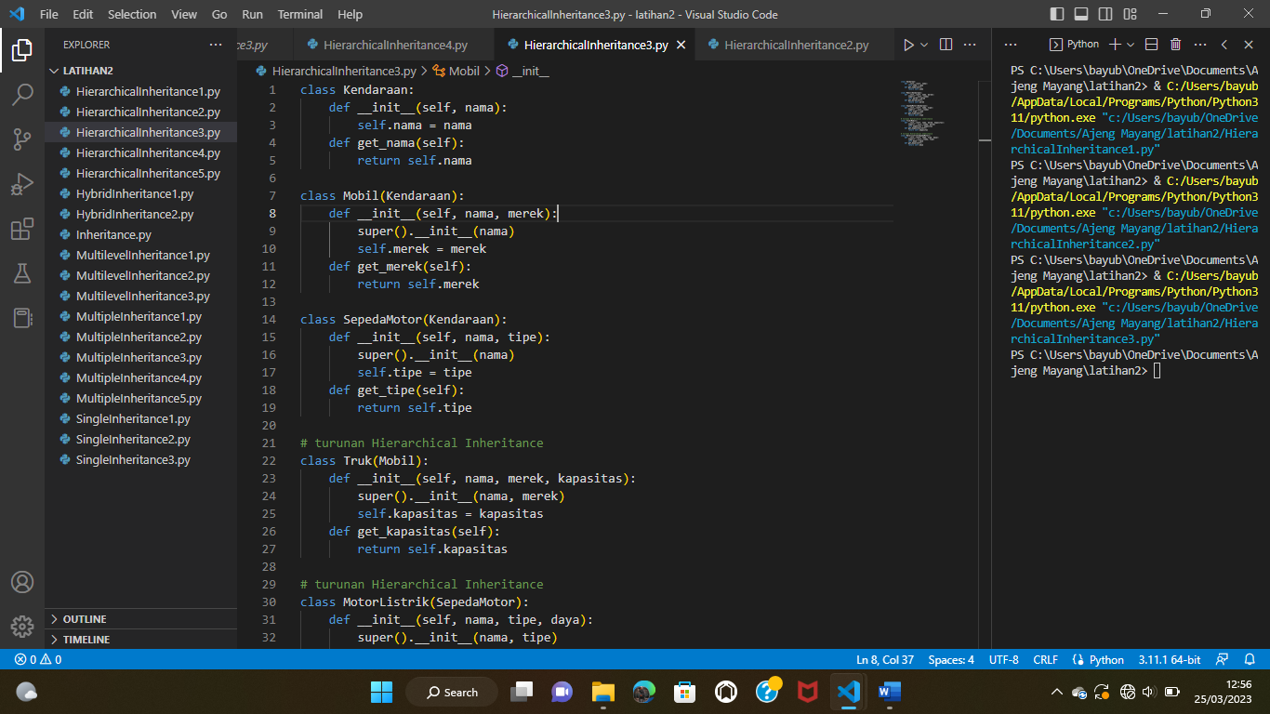

**Hierarchical Inheritance 4**

class Shape:

    def __init__(self, name, color):

        self.name = name

        self.color = color

    def get_name(self):

        return self.name

    def get_color(self):

        return self.color

class TwoDimensional(Shape):

    def __init__(self, name, color, sides):

        super().__init__(name, color)

        self.sides = sides

    def get_sides(self):

        return self.sides

class ThreeDimensional(Shape):

    def __init__(self, name, color, faces):

        super().__init__(name, color)

        self.faces = faces

    def get_faces(self):

        return self.faces

# Hierarchical Inheritance

class Sphere(ThreeDimensional):

    def __init__(self, name, color, faces, radius):

        super().__init__(name, color, faces)

        self.radius = radius

    def get_radius(self):

        return self.radius

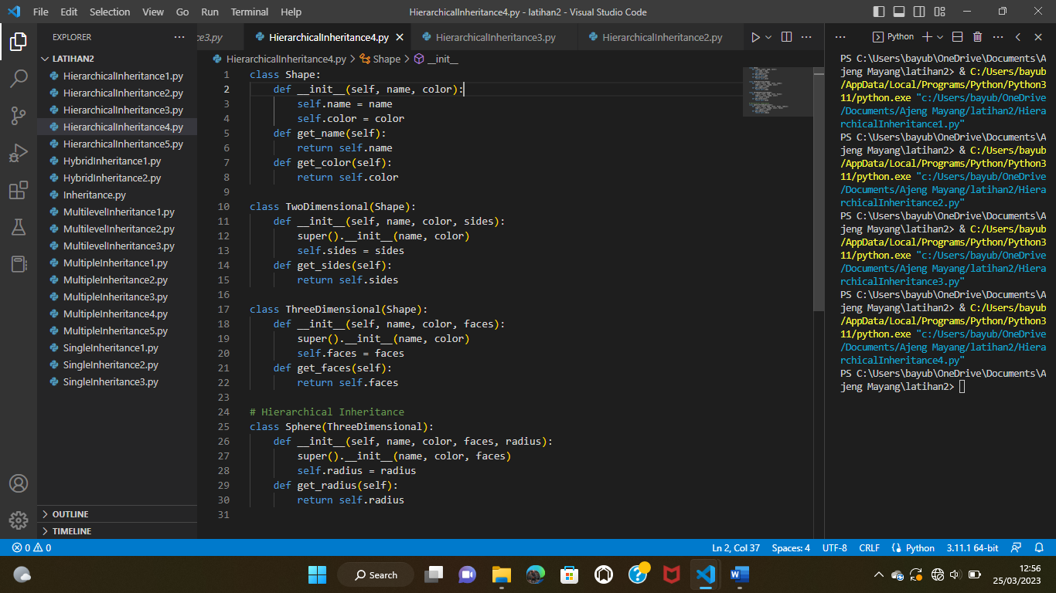

**Hierarchical Inheritance 5**

class AkunBank:

    def __init__(self, nomor_akun, saldo):

        self.nomor_akun = nomor_akun

        self.saldo = saldo

    def get_nomor_akun(self):

        return self.nomor_akun

    def get_saldo(self):

        return self.saldo

class AkunTabungan(AkunBank):

    def __init__(self, nomor_akun, saldo, persentase_bunga):

        super().__init__(nomor_akun, saldo)

        self.persentase_bunga = persentase_bunga

    def get_persentase_bunga(self):

        return self.persentase_bunga

class CekAkun(AkunBank):

    def __init__(self, nomor_akun, saldo, overdraft_limit):

        super().__init__(nomor_akun, saldo)

        self.overdraft_limit = overdraft_limit

    def get_overdraft_limit(self):

        return self.overdraft_limit

# Hierarchical Inheritance

class JointAccount(AkunTabungan):

    def __init__(self, nomor_akun, saldo, persentase_bunga, owners):

        super().__init__(nomor_akun, saldo, persentase_bunga)

        self.owners = owners

    def get_owners(self):

        return self.owners

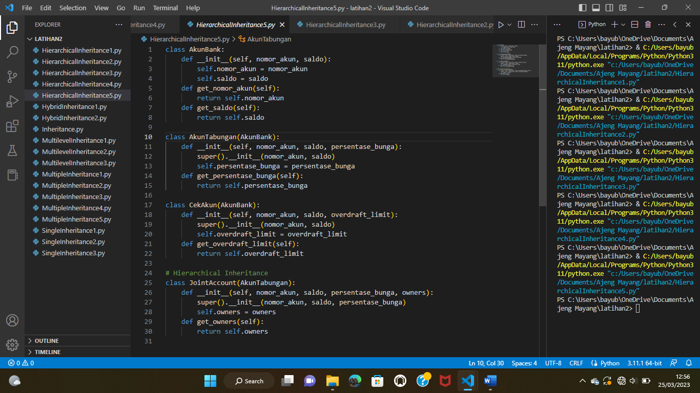

**Hybrid Inheritance 1**

# Single Inheritance

class GameObject:

    def __init__(self, x, y):

        self.x = x

        self.y = y

# Single Inheritance

class Drawable:

    def draw(self):

        print("Drawing object at: ", self.x, self.y)

# Single Inheritance

class Moveable:

    def move(self, dx, dy):

        self.x += dx

        self.y += dy

# Multiple Inheritance

class Player(GameObject, Drawable, Moveable):

    def __init__(self, x, y):

        super().__init__(x, y)

    def update(self):

        self.move(1, 1)

        self.draw()

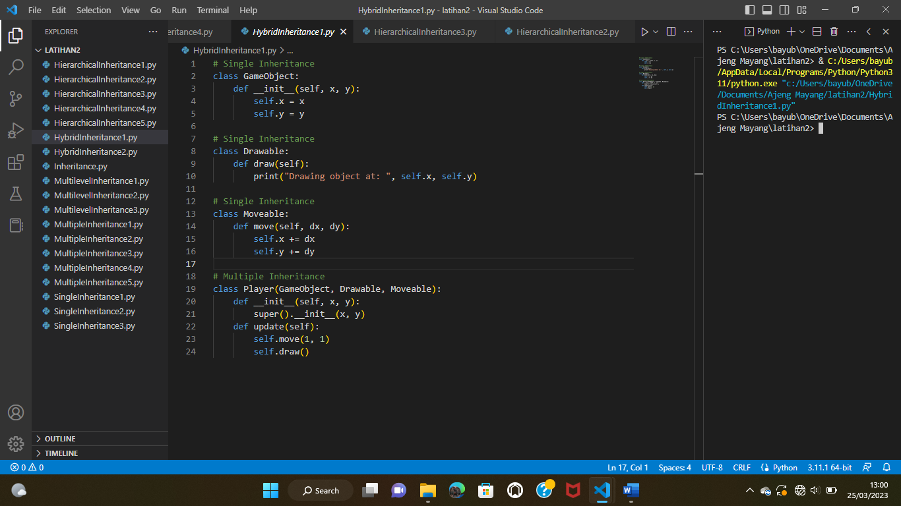

**Hybrid Inheritance 2**

class Seseorang:

    def __init__(self, name, age, address):

        self.name = name

        self.age = age

        self.address = address

    def get_info(self):

        print("Name:", self.name)

        print("Age:", self.age)

        print("Address:", self.address)

# Single Inheritance

class Mahasiswa(Seseorang):

    def __init__(self, name, age, address, student_id):

        super().__init__(name, age, address)

        self.student_id = student_id

    def get_info(self):

        super().get_info()

        print("Student ID:", self.student_id)

# Single Inheritance

class Employee(Seseorang):

    def __init__(self, name, age, address, employee_id, salary):

        super().__init__(name, age, address)

        self.employee_id = employee_id

        self.salary = salary

    def get_info(self):

        super().get_info()

        print("Employee ID:", self.employee_id)

        print("Salary:", self.salary)

# Multiple Inheritance

class Penulis(Employee, Mahasiswa):

    def __init__(self, name, age, address, employee_id, salary, student_id, published_books):

        Employee.__init__(self, name, age, address, employee_id, salary)

        Mahasiswa.__init__(self, name, age, address, student_id)

        self.published_books = published_books

    def get_info(self):

        super().get_info()

        print("Student ID:", self.student_id)

        print("Published Books:", self.published_books)

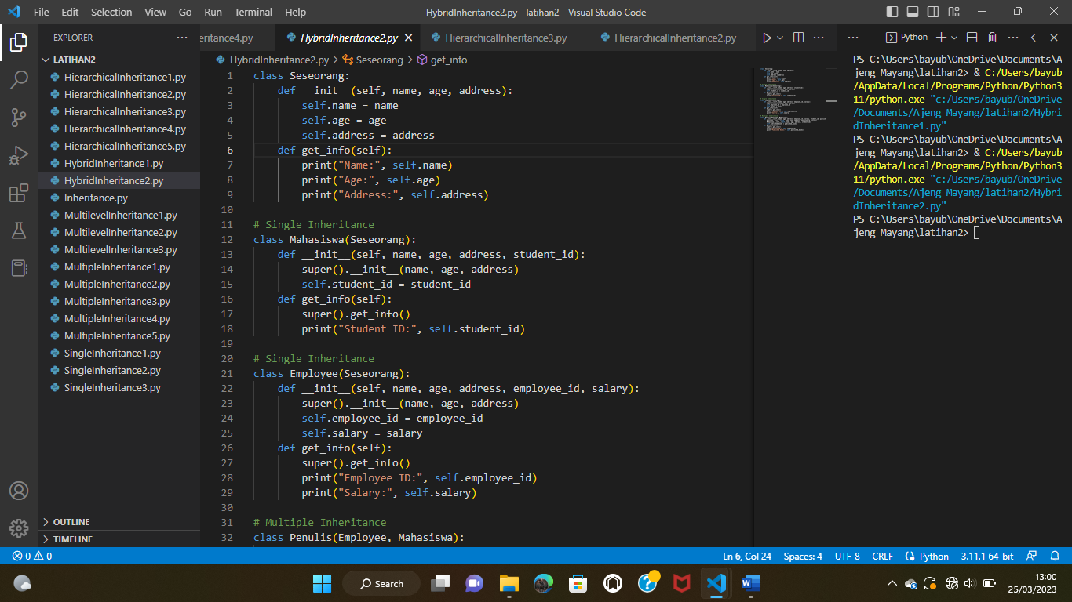

**Inheritance**

class BangunDatar:

    def __init__(self, sisi):

        self.sisi = sisi

    def luasArea(self):

        pass

class Persegi(BangunDatar):

    def __init__(self, sisi):

        super().__init__(sisi)

    def luasArea(self):

        return self.sisi * self.sisi

    def Nilaikeliling(self):

        return 4 * self.sisi

class Lingkaran(BangunDatar):

    def __init__(self, jari_jari):

        super().__init__(jari_jari)

    def luasArea(self):

        return 3.14 * self.sisi * self.sisi

    def Nilaikeliling(self):

        return 2 * 3.14 * self.sisi

persegi = Persegi(29)

lingkaran = Lingkaran(31)

print("Luas persegi:", persegi.luasArea())

print("Keliling persegi:", persegi.Nilaikeliling())

print("Luas lingkaran:", lingkaran.luasArea())

print("Keliling lingkaran:", lingkaran.Nilaikeliling())

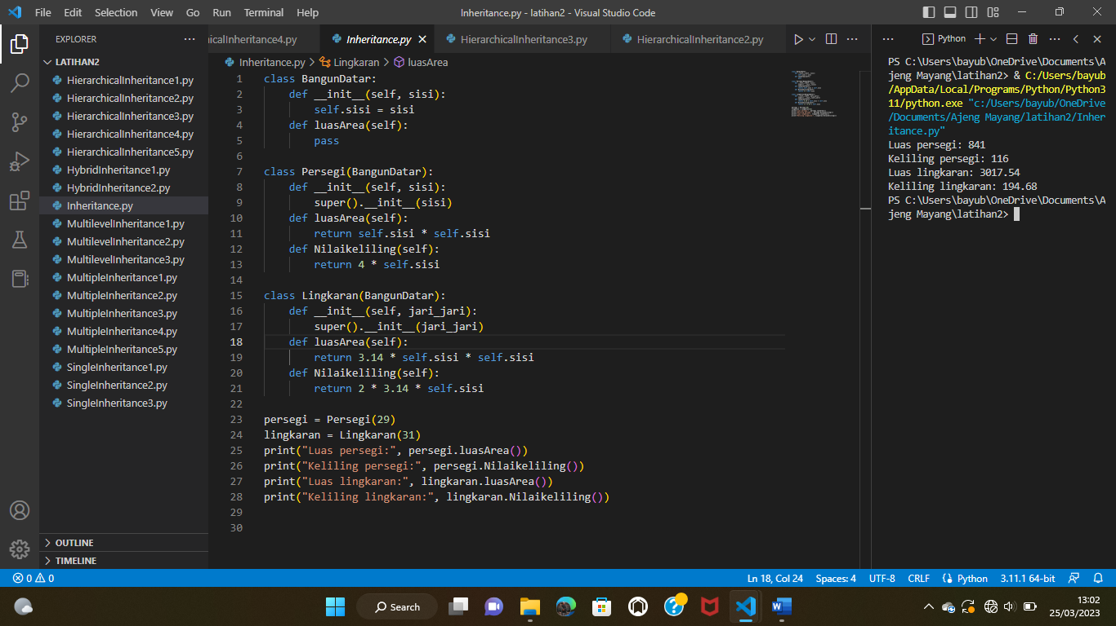

**Multilevel Inheritance 1**

class Animal:

    def __init__(self, name):

        self.name = name

    def speak(self):

        print("The animal speaks")

class Dog(Animal):

    def __init__(self, name, breed):

        super().__init__(name)

        self.breed = breed

    def speak(self):

        print("The dog barks")

class Bulldog(Dog):

    def __init__(self, name, breed, origin):

        super().__init__(name, breed)

        self.origin = origin

    def speak(self):

        print("The bulldog growls")

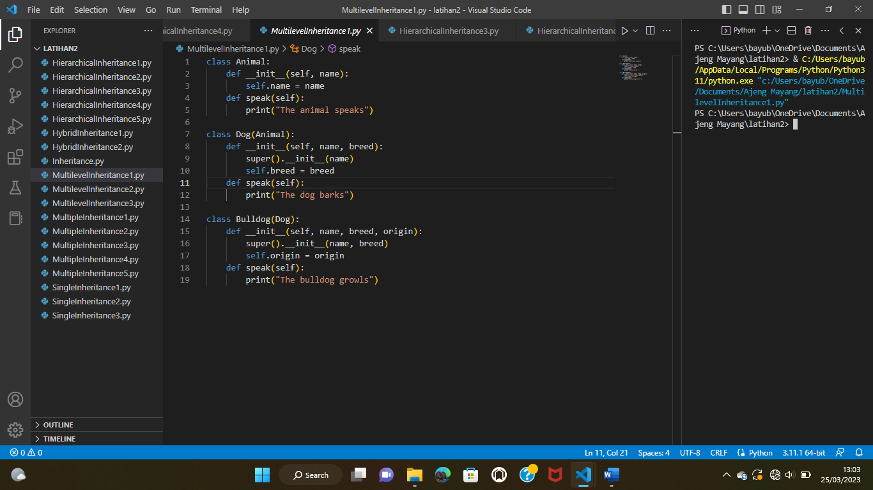

**Multilevel Inheritance 2**

class Person:

    def __init__(self, name, age):

        self.name = name

        self.age = age

    def get_details(self):

        print(f"Name: {self.name}, Age: {self.age}")

class Employee(Person):

    def __init__(self, name, age, id, salary):

        super().__init__(name, age)

        self.id = id

        self.salary = salary

    def get_details(self):

        super().get_details()

        print(f"ID: {self.id}, Salary: {self.salary}")

class Manager(Employee):

    def __init__(self, name, age, id, salary, department):

        super().__init__(name, age, id, salary)

        self.department = department

    def get_details(self):

        super().get_details()

        print(f"Department: {self.department}")

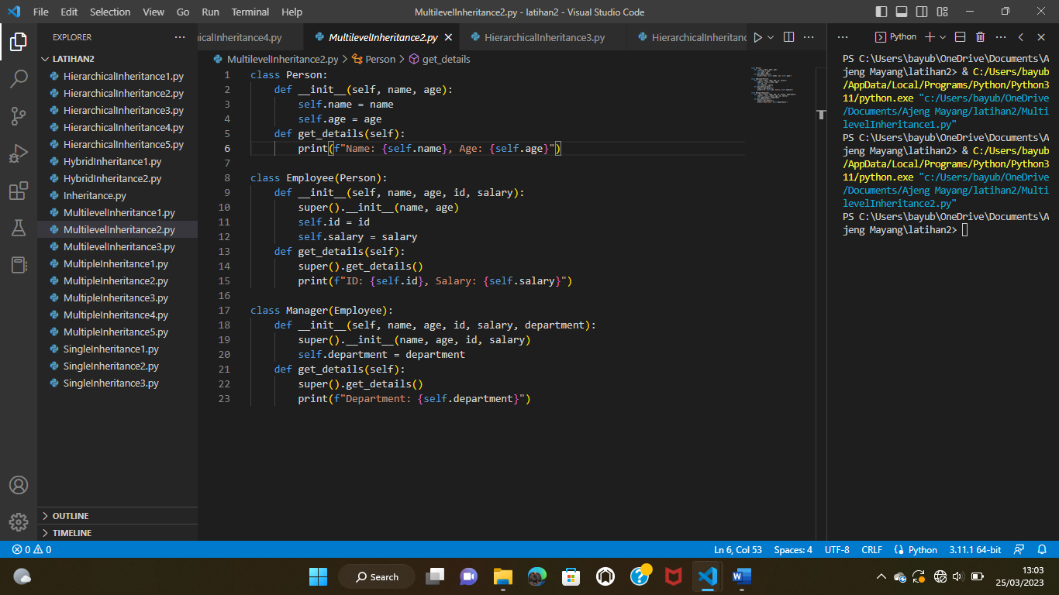

**Multilevel Inheritance 3**

class Animal:

    def __init__(self, name):

        self.name = name

    def speak(self):

        print(f"{self.name} speaks")

class Bird(Animal):

    def __init__(self, name, wingspan):

        super().__init__(name)

        self.wingspan = wingspan

    def fly(self):

        print(f"{self.name} is flying with a wingspan of {self.wingspan}")

class Parrot(Bird):

    def __init__(self, name, wingspan, color):

        super().__init__(name, wingspan)

        self.color = color

    def speak(self):

        print(f"{self.name} is a {self.color} parrot that talks")

parrot = Parrot("Rio", 12, "blue")

parrot.speak() # Output: Rio is a blue parrot that talks

parrot.fly() # Output: Rio is flying with a wingspan of

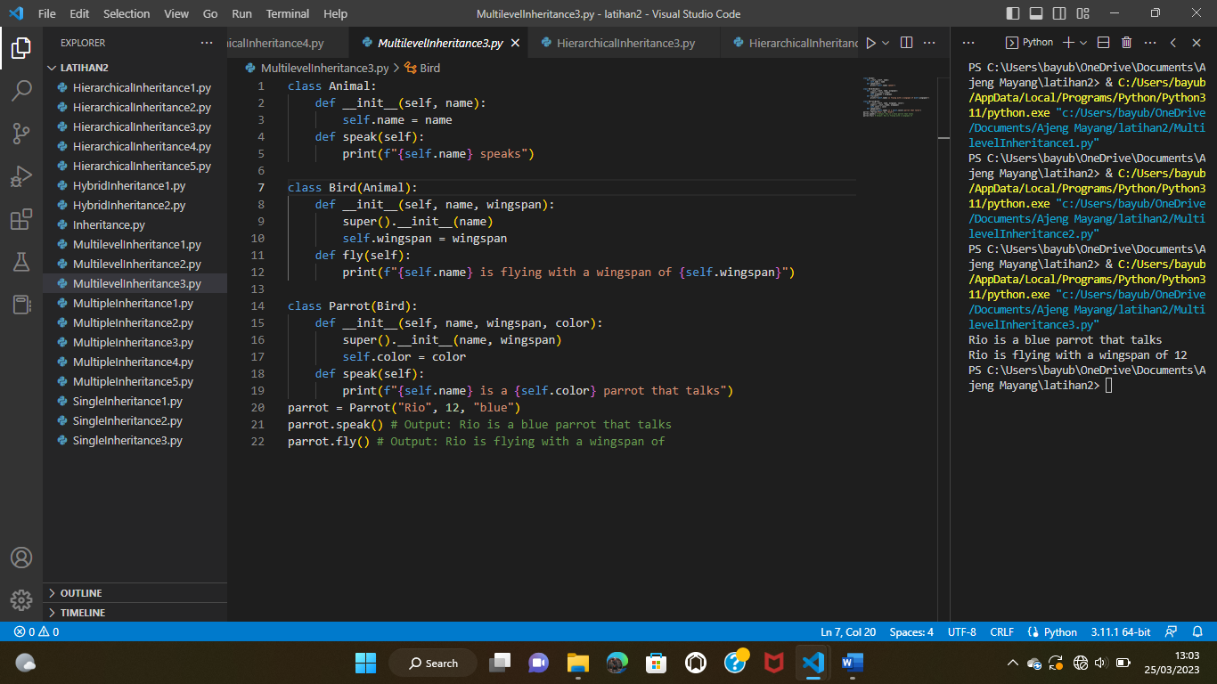

**Multiple Inheritance 1**

class Mahasiswa:

    def __init__(self, nama, nim):

        self.nama = nama

        self.nim = nim

    def belajar(self):

        print(self.nama, "sedang belajar")

class Pekerja:

    def __init__(self, nama, pekerjaan):

        self.nama = nama

        self.pekerjaan = pekerjaan

    def bekerja(self):

        print(self.nama, "sedang bekerja")

class MahasiswaPekerja(Mahasiswa, Pekerja):

    def __init__(self, nama, nim, pekerjaan):

        Mahasiswa.__init__(self, nama, nim)

        Pekerja.__init__(self, nama, pekerjaan)

    def bersosialisasi(self):

        print(self.nama, "sedang bersosialisasi")

mhs_pekerja = MahasiswaPekerja("Ajeng", "190001", "Programmer")

mhs_pekerja.belajar() # output: Ajeng sedang belajar

mhs_pekerja.bekerja() # output: Ajeng sedang bekerja

mhs_pekerja.bersosialisasi() # output: Ajeng sedang bersosialisasi

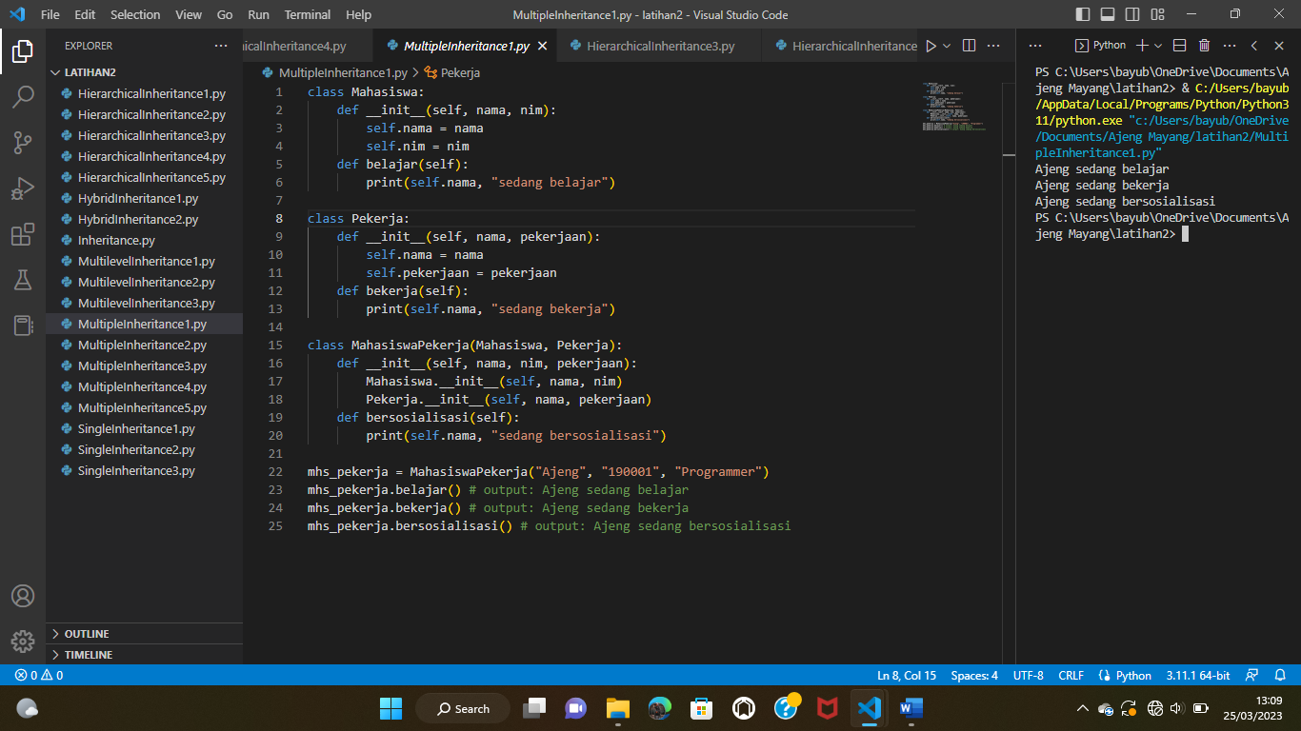

**Multiple Inheritance 2**

class Hewan:

    def __init__(self, nama, umur):

        self.nama = nama

        self.umur = umur

    def display_info(self):

        print(f"Nama: {self.nama}")

        print(f"Umur: {self.umur}")

class Reptil:

    def __init__(self, jenis, habitat):

        self.jenis = jenis

        self.habitat = habitat

    def display_info(self):

        print(f"Jenis: {self.jenis}")

        print(f"Habitat: {self.habitat}")

class Amphibi:

    def __init__(self, metamorfosis, habitat):

        self.metamorfosis = metamorfosis

        self.habitat = habitat

    def display_info(self):

        print(f"Metamorfosis: {self.metamorfosis}")

        print(f"Habitat: {self.habitat}")

class Katak(Reptil, Amphibi):

    def __init__(self, nama, umur, jenis, habitat, metamorfosis):

        Hewan.__init__(self, nama, umur)

        Reptil.__init__(self, jenis, habitat)

        Amphibi.__init__(self, metamorfosis, habitat)

    def display_info(self):

        super().display_info()

        print(f"Nama: {self.nama}")

        print(f"Umur: {self.umur}")

        print(f"Jenis: {self.jenis}")

        print(f"Habitat: {self.habitat}")

        print(f"Metamorfosis: {self.metamorfosis}")

katakA = Katak("Katak Hijau", 2, "Reptil-Amphibi", "Air", "Telur")

katakA.display_info()

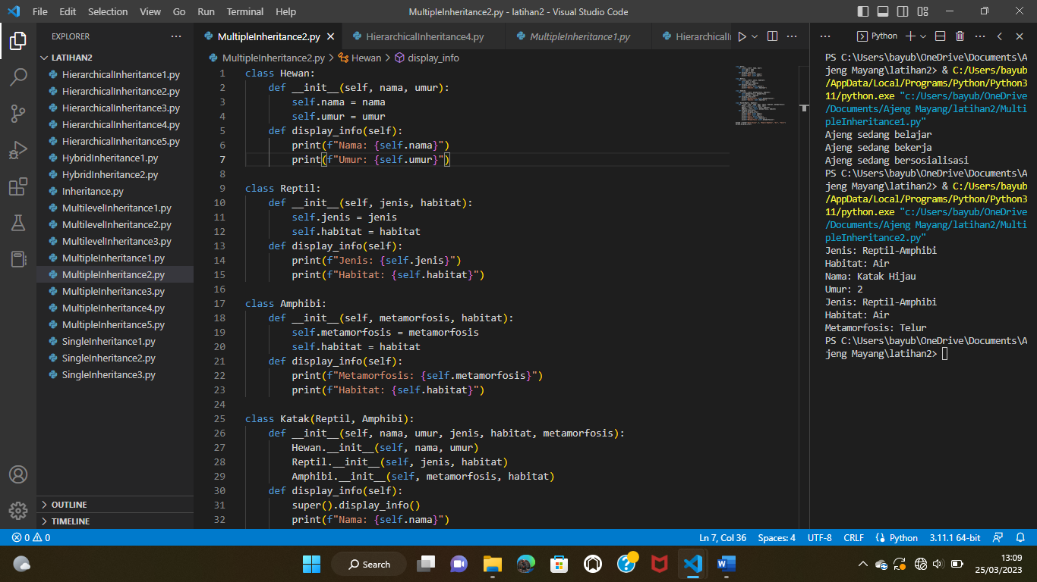

**Multiple Inheritance 3**

class Orang:

    def __init__(self, nama, umur):

        self.nama = nama

        self.umur = umur

    def display_info(self):

        print(f"Nama: {self.nama}")

        print(f"Umur: {self.umur}")

class Pekerja:

    def __init__(self, pekerjaan, gaji):

        self.pekerjaan = pekerjaan

        self.gaji = gaji

    def display_info(self):

        print(f"Pekerjaan: {self.pekerjaan}")

        print(f"Gaji: {self.gaji}")

class Penulis:

    def __init__(self, buku, genre):

        self.buku = buku

        self.genre = genre

    def display_info(self):

        print(f"Buku: {self.buku}")

        print(f"Genre: {self.genre}")

class PenulisPekerja(Orang, Pekerja, Penulis):

    def __init__(self, nama, umur, pekerjaan, gaji, buku, genre):

        Orang.__init__(self, nama, umur)

        Pekerja.__init__(self, pekerjaan, gaji)

        Penulis.__init__(self, buku, genre)

    def display_info(self):

        super().display_info()

        print(f"Pekerjaan: {self.pekerjaan}")

        print(f"Gaji: {self.gaji}")

        print(f"Buku: {self.buku}")

        print(f"Genre: {self.genre}")

# contoh penggunaan

penulis_pekerjaC = PenulisPekerja("Jane Doe", 30, "Penulis", "$5000", "TheBook", "Fiksi")

penulis_pekerjaC.display_info()

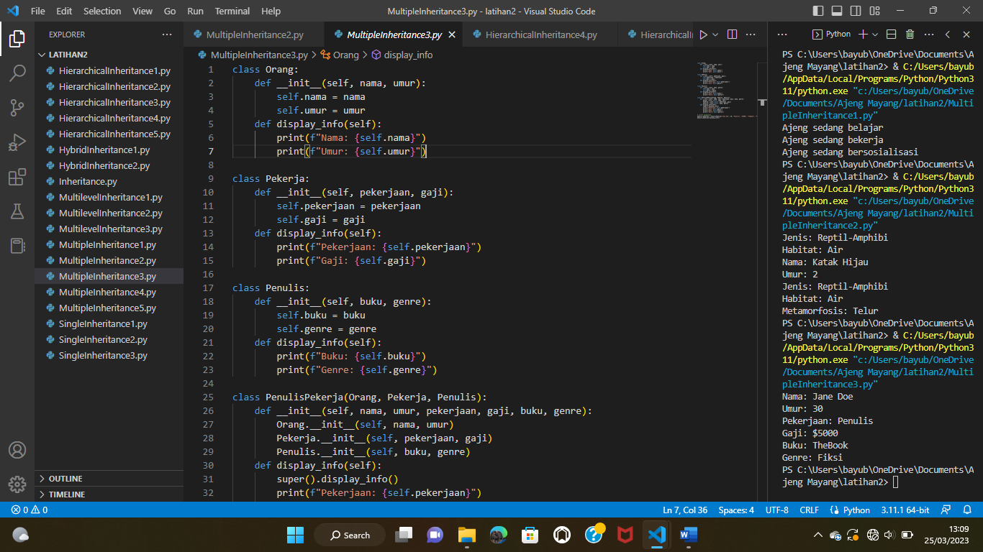

**Multiple Inheritance 4**

class Hewan:

    def __init__(self, jenis):

        self.jenis = jenis

    def display_info(self):

        print(f"Jenis hewan: {self.jenis}")

class Mamalia(Hewan):

    def __init__(self, jenis, nama):

        super().__init__(jenis)

        self.nama = nama

    def display_info(self):

        super().display_info()

        print(f"Nama mamalia: {self.nama}")

class Karnivora(Hewan):

    def __init__(self, jenis, makanan):

        super().__init__(jenis)

        self.makanan = makanan

    def display_info(self):

        super().display_info()

        print(f"Jenis makanan: {self.makanan}")

class Harimau(Mamalia, Karnivora):

    def __init__(self, jenis, nama, makanan):

        Mamalia.__init__(self, jenis, nama)

        Karnivora.__init__(self, jenis, makanan)

    def display_info(self):

        super().display_info()

        print(f"Jenis hewan: {self.jenis}")

# contoh penggunaan

harimauA = Harimau("Mamalia", "Harimau Sumatera", "Daging")

harimauA.display_info()

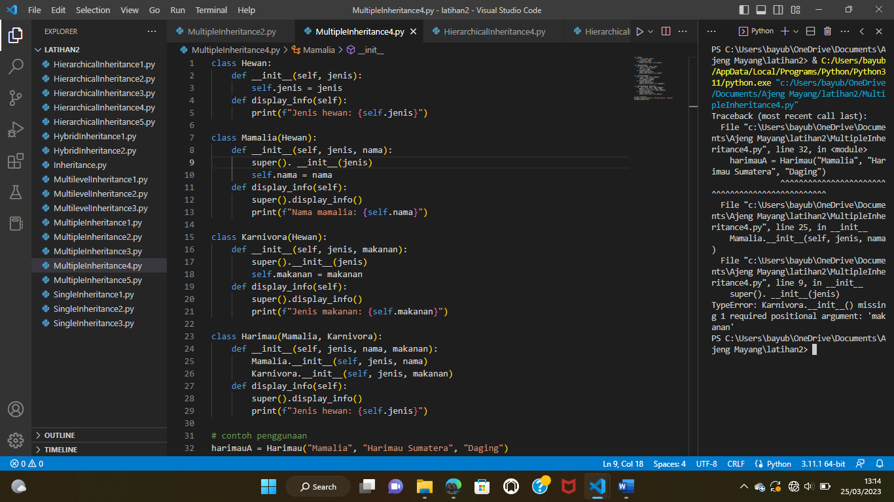

**Multiple Inheritance 5**

class Person:

    def __init__(self, nama, umur):

        self.nama = nama

        self.umur = umur

    def display_info(self):

        print(f"Nama: {self.nama}")

        print(f"Umur: {self.umur}")

class Mahasiswa(Person):

    def __init__(self, nama, umur, jurusan):

        super().__init__(nama, umur)

        self.jurusan = jurusan

    def display_info(self):

        super().display_info()

        print(f"Jurusan: {self.jurusan}")

class Alumni(Person):

    def __init__(self, nama, umur, tahun_lulus):

        super().__init__(nama, umur)

        self.tahun_lulus = tahun_lulus

    def display_info(self):

        super().display_info()

        print(f"Tahun lulus: {self.tahun_lulus}")

class MahasiswaAlumni(Mahasiswa, Alumni):

    def __init__(self, nama, umur, jurusan, tahun_lulus):

        Mahasiswa.__init__(self, nama, umur, jurusan)

        Alumni.__init__(self, nama, umur, tahun_lulus)

    def display_info(self):

        super().display_info()

        print(f"Tahun lulus: {self.tahun_lulus}")

# contoh penggunaan

mahasiswa_alumniA = MahasiswaAlumni("Budi", 20, "Informatika", 2022)

mahasiswa_alumniA.display_info()

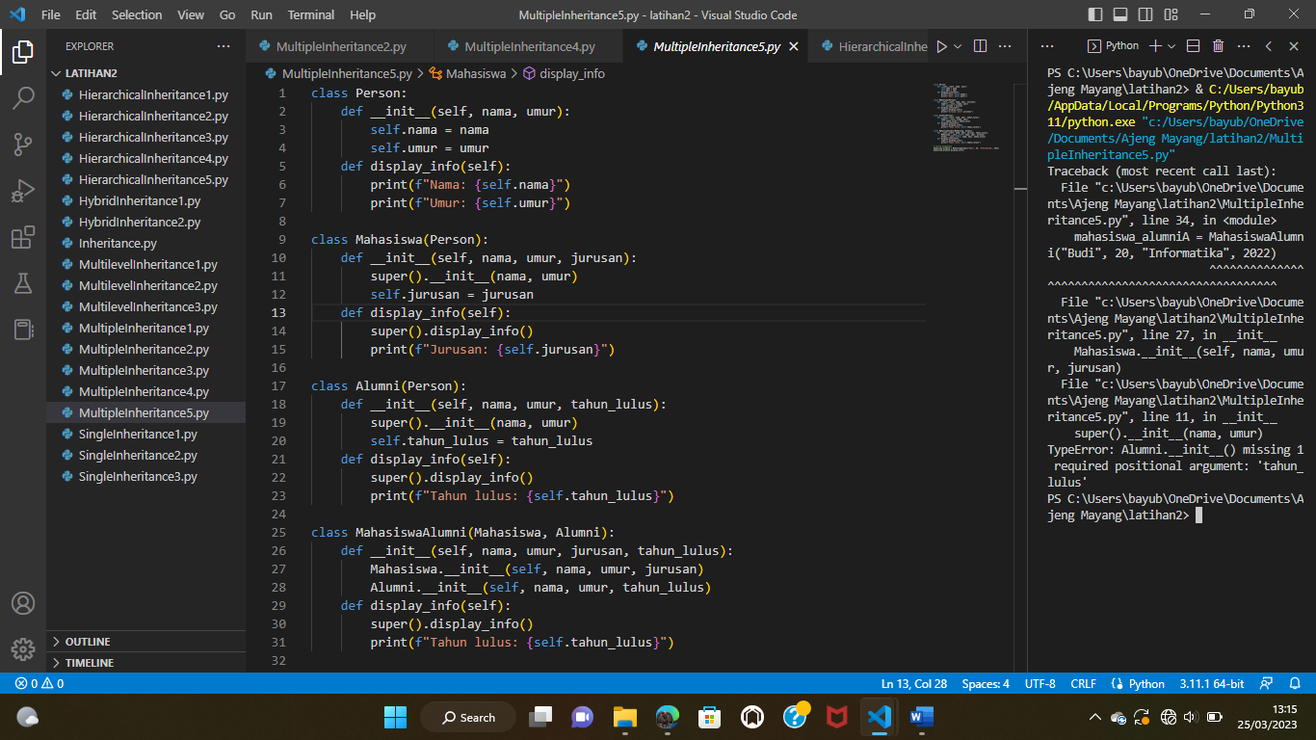

**Single Inheritance 1**

class Hewan:

    def __init__(self, nama, umur):

        self.nama = nama

        self.umur = umur

    def bergerak(self):

        print(self.nama, "bergerak")

class Kucing(Hewan):

    def __init__(self, nama, umur, jenis_bulu):

        super().__init__(nama, umur)

        self.jenis_bulu = jenis_bulu

    def bersuara(self):

        print("Rrraaawwwwrrrr!")

kucingA = Kucing("emon", 2, "Persia")

kucingA.bergerak() # output: Kitty bergerak

kucingA.bersuara() # output: Meow!

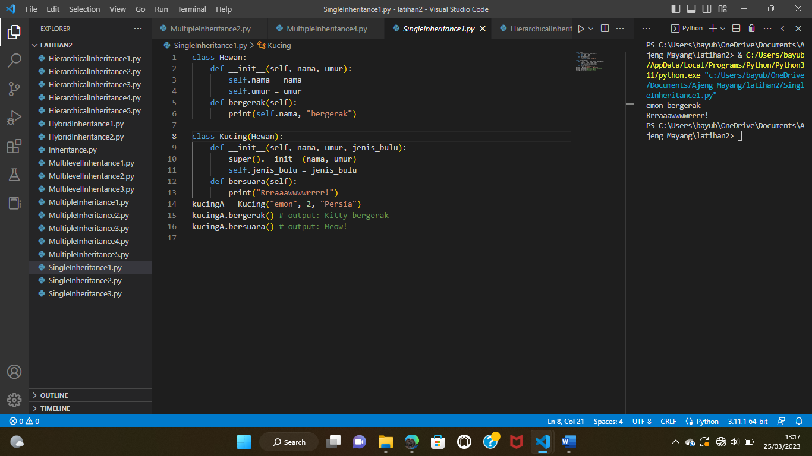

**Single Inheritance 2**

class Manusia:

    def __init__(self, nama, umur):

        self.nama = nama

        self.umur = umur

    def berbicara(self):

        print(f"{self.nama} sedang berbicara.")

class Dosen(Manusia):

    def __init__(self, nama, umur, nip):

        super().__init__(nama, umur)

        self.nip = nip

    def mengajar(self):

        print(f"{self.nama} dengan NIP {self.nip} sedang mengajar.")

dosenA = Dosen("Ajeng", 29, "123456")

dosenA.berbicara() # Output: Ajeng sedang berbicara.

dosenA.mengajar() # Output: Ajeng dengan NIP 123456 sedang mengajar.

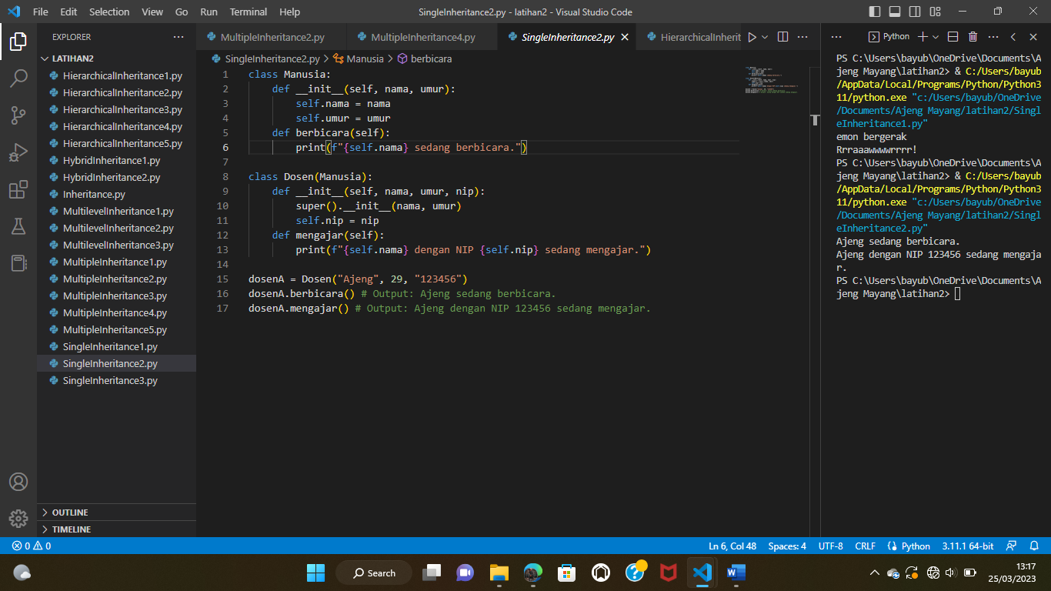

**Single Inheritance 3**

class Kendaraan:

    def __init__(self, jenis, merk, warna):

        self.jenis = jenis

        self.merk = merk

        self.warna = warna

    def berkendara(self):

        print("Kendaraan ini sedang berjalan.")

class SepedaMotor(Kendaraan):

    def __init__(self, jenis, merk, warna, cc):

        super().__init__(jenis, merk, warna)

        self.cc = cc

    def belok(self):

            print("Sepeda motor ini sedang belok.")

motorA = SepedaMotor("Sepeda Motor", "Honda", "Merah", 150)

motorA.berkendara() # Output: Kendaraan ini sedang berjalan.

motorA.belok() # Output: Sepeda motor ini sedang belok.

