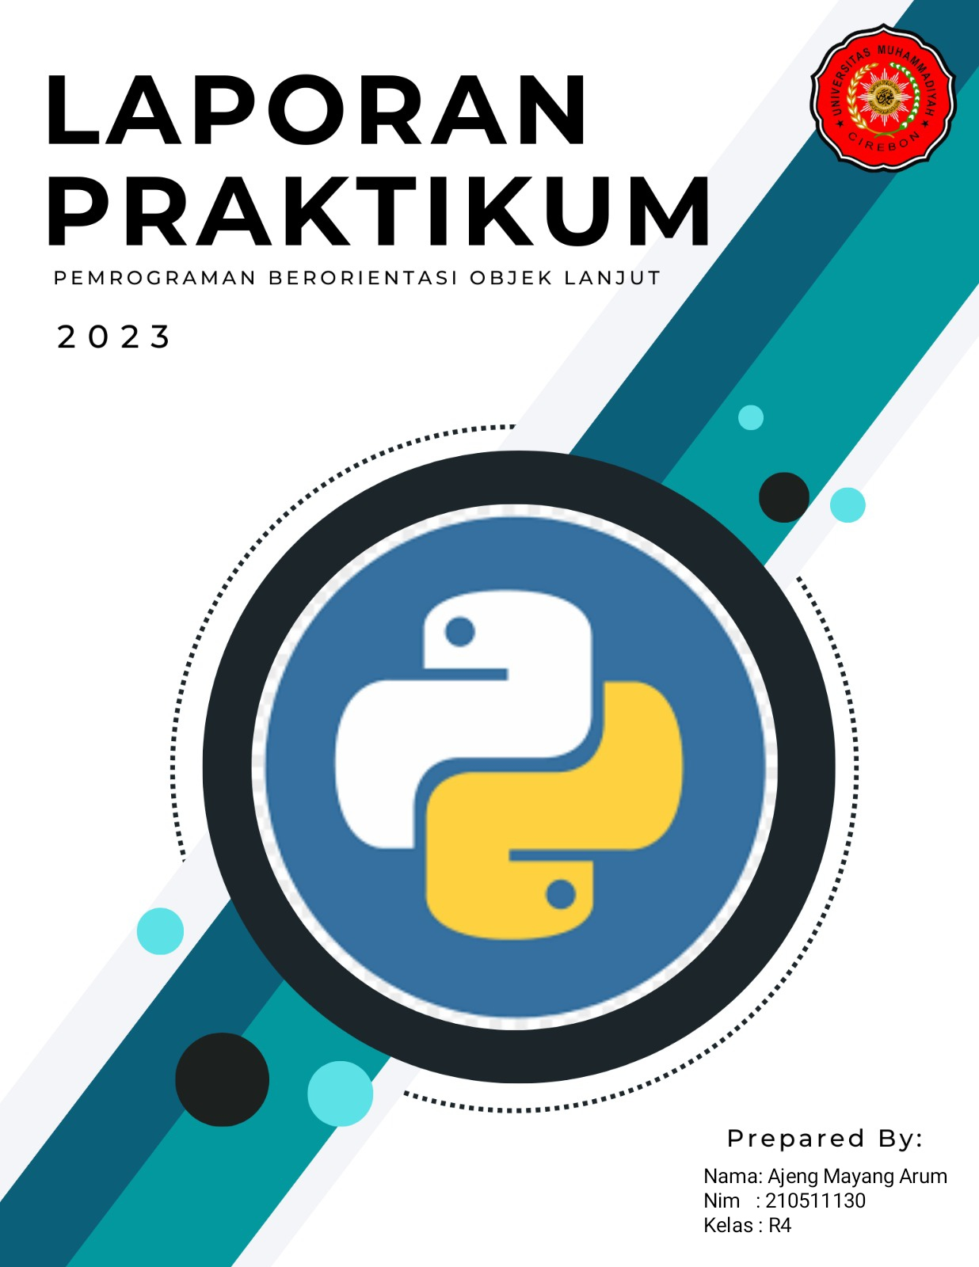

**COMPOSITION.py**

class Pekerja:

    def __init__(self, nama, umur):

        self.nama = nama

        self.umur = umur

class Perusahaan:

    def __init__(self, nama, pekerja):

        self.nama = nama

        self.pekerja = pekerja

    def daftar_pekerja(self):

        for pekerja in self.pekerja:

            print(pekerja.nama, pekerja.umur)

pekerja1 = Pekerja("Andi", 25)

pekerja2 = Pekerja("Budi", 30)

perusahaan = Perusahaan("ABC", [pekerja1, pekerja2])

perusahaan.daftar_pekerja()

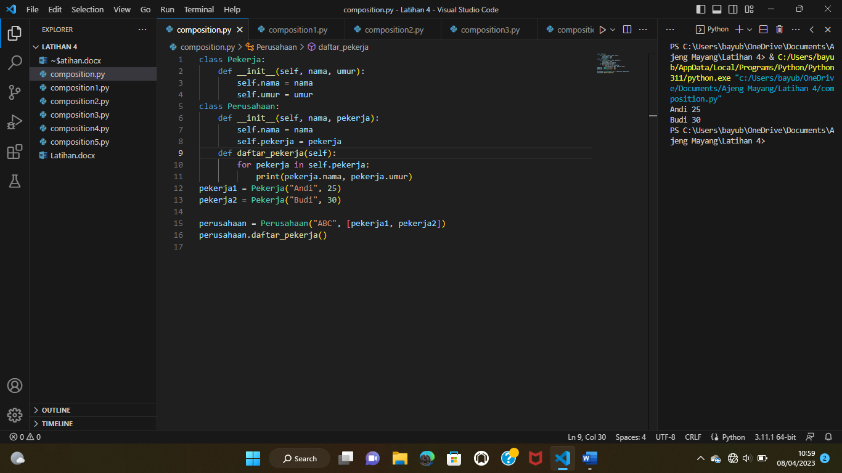

**COMPOSITION1.py**class Player:

    def __init__(self, name):

        self.name = name

        self.inventory = Inventory()

class Item:

    def __init__(self, name):

        self.name = name

class Inventory:

    def __init__(self):

        self.items = []

    def add_item(self, item):

        self.items.append(item)

    def remove_item(self, item):

        self.items.remove(item)

player = Player("John")

sword = Item("Sword")

shield = Item("Shield")

player.inventory.add_item(sword)

player.inventory.add_item(shield)

player.inventory.items # output: [sword, shield]

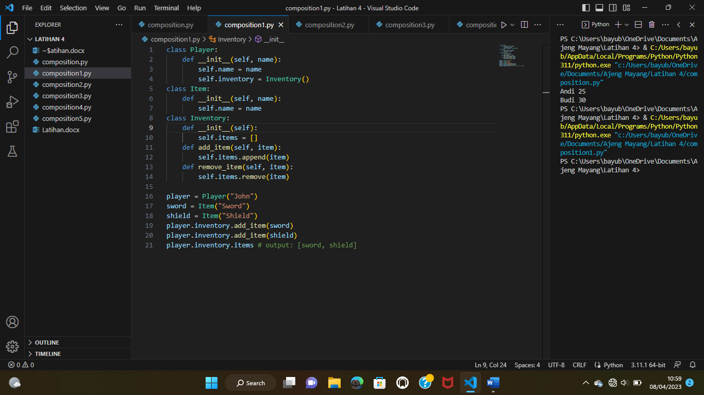

**COMPOSITION2.py**

class Menu:

    def __init__(self, dishes=None):

        if dishes is None:

            self.dishes = []

        else:

            self.dishes = dishes

    def add_dish(self, dish):

        self.dishes.append(dish)

class Dish:

    def __init__(self, name, price):

        self.name = name

        self.price = price

class Restaurant:

    def __init__(self, name, menu):

        self.name = name

        self.menu = menu

dish1 = Dish("Nasi Goreng", 15000)

dish2 = Dish("Mie Goreng", 12000)

menu = Menu([dish1, dish2])

restaurant = Restaurant("Warung Padang", menu)

restaurant.menu.dishes # output: [dish1, dish2]

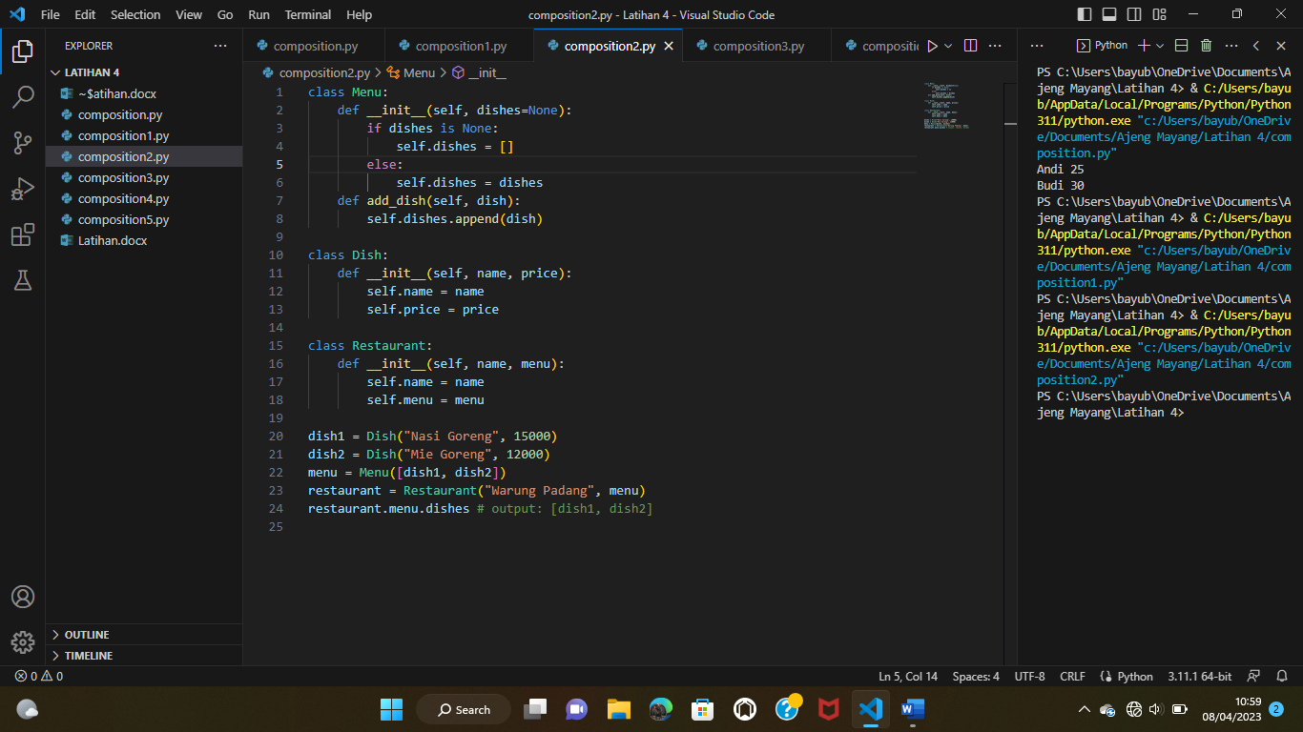

**COMPOSITION3.py**

class Song:

    def __init__(self, title, artist):

        self.title = title

        self.artist = artist

class Playlist:

    def __init__(self):

        self.songs = []

    def add_song(self, song):

        self.songs.append(song)

class MediaPlayer:

    def __init__(self, playlist):

        self.playlist = playlist

song1 = Song("Lose Yourself", "Eminem")

song2 = Song("Someone Like You", "Adele")

playlist = Playlist()

playlist.add_song(song1)

playlist.add_song(song2)

media_player = MediaPlayer(playlist)

media_player.playlist.songs # output: song1, song2

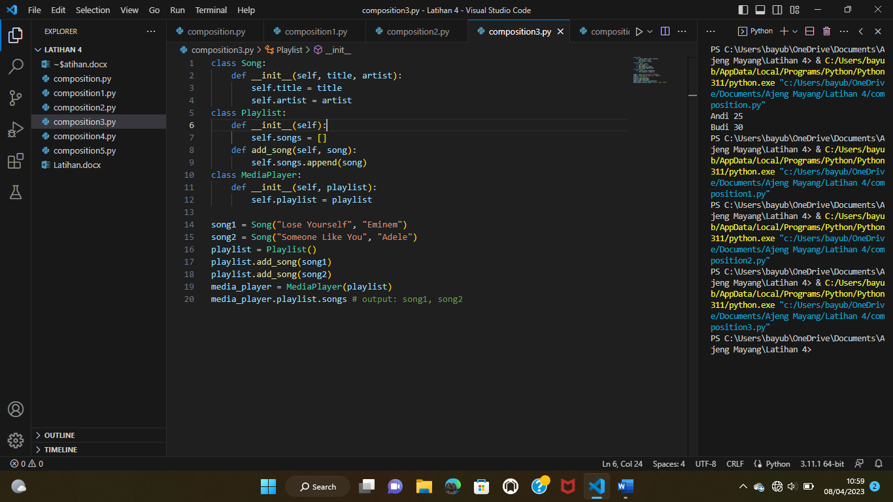

**COMPOSITION4.py**

class RAM:

    def __init__(self, capacity):

        self.capacity = capacity

class Storage:

    def __init__(self, capacity):

        self.capacity = capacity

class Computer:

    def __init__(self, ram, storage):

        self.ram = ram

        self.storage = storage

ram = RAM(8)

storage = Storage(500)

computer = Computer(ram, storage)

print(computer.ram.capacity) # output: 8

print(computer.storage.capacity) # output: 500

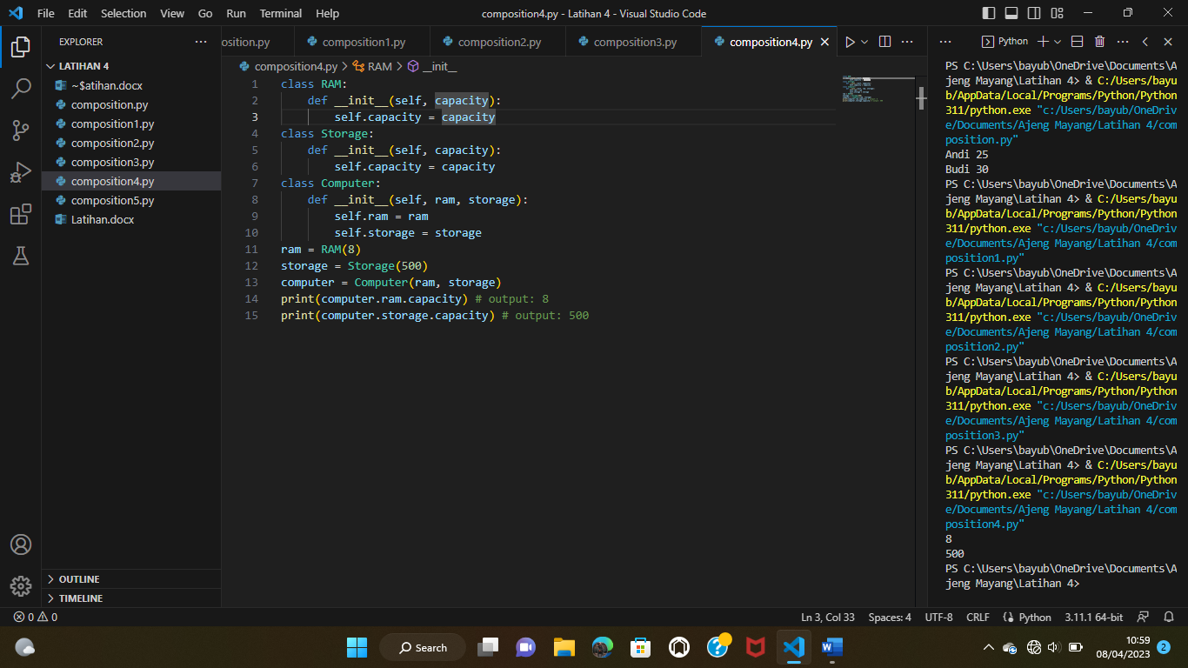

**COMPOSITION5.py**

class Wheel:

    def __init__(self, size):

        self.size = size

class Engine:

    def __init__(self, power):

        self.power = power

class Car:

    def __init__(self, wheels, engine):

        self.wheels = wheels

        self.engine = engine

wheel1 = Wheel(17)

wheel2 = Wheel(17)

wheel3 = Wheel(17)

wheel4 = Wheel(17)

engine = Engine(150)

car = Car([wheel1, wheel2, wheel3, wheel4], engine)

print(car.wheels[0].size) # output: 17

