

**COMPOSITION1.py**

class Wheel:

    def __init__(self, size):

        self.size = size

class Engine:

    def __init__(self, power):

        self.power = power

class Car:

    def __init__(self, wheels, engine):

        self.wheels = wheels

        self.engine = engine

wheel1 = Wheel(29)

wheel2 = Wheel(29)

wheel3 = Wheel(29)

wheel4 = Wheel(29)

engine = Engine(150)

car = Car([wheel1, wheel2, wheel3, wheel4], engine)

print(car.wheels[0].size) # output: 29

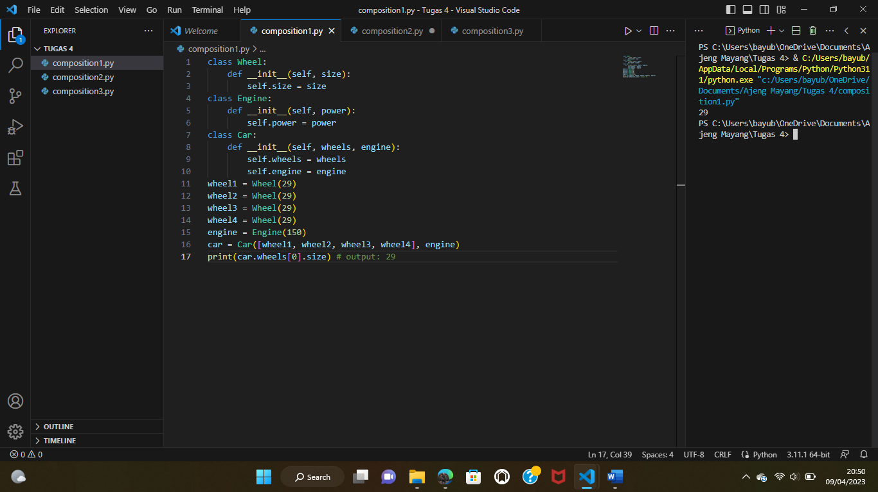

**COMPOSITION2.py**

class penulis:

    def __init__(self, nama, penerbit):

        self.nama = nama

        self.penerbit = penerbit

class buku:

    def __init__(self, judul, penulis):

        self.judul = judul

        self.penulis = penulis

    def daftar_penulis(self):

        for penulis in self.penulis:

            print(penulis.nama, penulis.penerbit, buku.judul)

penulis1 = penulis("Andrea Hirata:","BENTANG PUSTAKA")

buku = buku("Laskar Pelangi", [penulis1])

buku.daftar_penulis()

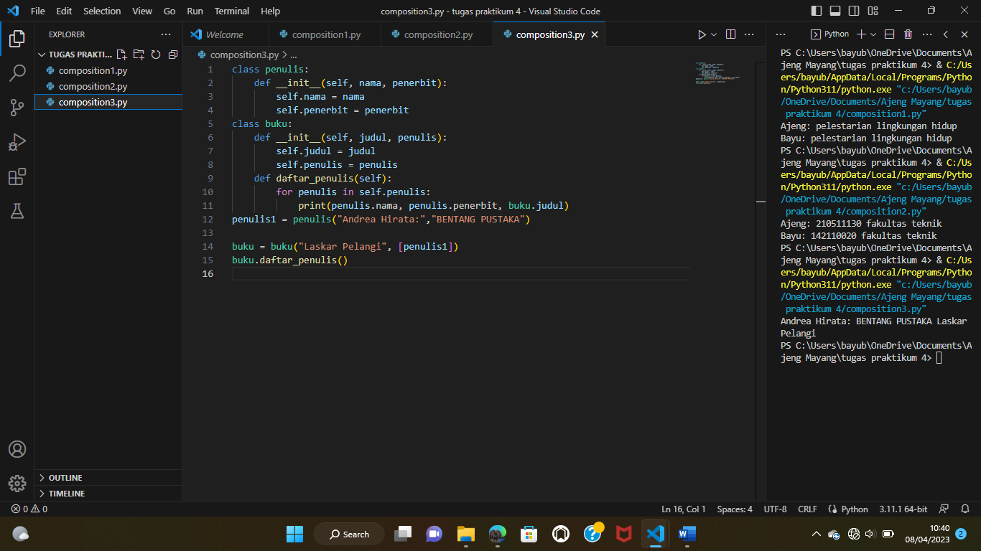

**COMPOSITION3.py**

class Menu:

    def __init__(self, dishes=None):

        if dishes is None:

            self.dishes = []

        else:

            self.dishes = dishes

    def add_dish(self, dish):

        self.dishes.append(dish)

class Dish:

    def __init__(self, name, price):

        self.name = name

        self.price = price

class Restaurant:

    def __init__(self, name, menu):

        self.name = name

        self.menu = menu

    def daftar_Menu(self):

        for Restaurant in self.Restaurant:

            print(Restaurant.name, Restaurant.menu, Dish.price)

dish1 = Dish("Nasi Goreng", 15000)

dish2 = Dish("Mie Goreng", 12000)

menu = Menu([dish1, dish2])

restaurant = Restaurant("Warung Padang", menu)

restaurant.menu.dishes # output: [dish1, dish2]

