**DAILY ONLINE ACTIVITIES SUMMARY**

|  |  |  |  |  |  |  |  |  |  |
| --- | --- | --- | --- | --- | --- | --- | --- | --- | --- |
| **Date:** | **20-06-2020** | | | | | **Name:** | | **Ajeyashree k** | |
| **Sem & Sec** | **6th  Sem ‘A’ Sec** | | | | | **USN:** | | **4AL17CS002** | |
| **Online Test Summary** | | | | | | | | | |
| **Subject** | | **Programming in c++ .** | | | | | | | |
| **Max. Marks** | | **C ++quiz1=6**  **C++quiz2=6** | | **Score** | | | | **Quiz1=not evaluated.**  **Quiz2=not evaluated.** | |
| **Pre-Placement Training Summary** | | | | | | | | | |
| **Course** | **Workshop of C++ programming.** | | | | | | | | |
| **Faculty** | | | **Ankitha mam.**  **Pradeep sir.** | | | | **Duration** | | **4 hours** |
| **Coding Challenges** | | | | | | | | | |
| **Problem Statement:1.** Write a C Program to rotate an array by K positions.  2. Write a Java Program to find area of Square, Rectangle and Circle using Method Overloading.  . | | | | | | | | | |
| **Status: done** | | | | | | | | | |
| **Uploaded the report in Github** | | | | | **yes** | | | | |
| **If yes Repository name** | | | | | Daily Report =<https://github.com/Ajeyashree/19-5-2020-online-coding-activity> | | | | |
| **Uploaded the report in slack** | | | | | **yes** | | | | |

**Class and Quiz Snapshots:**

**Programming in C++:**

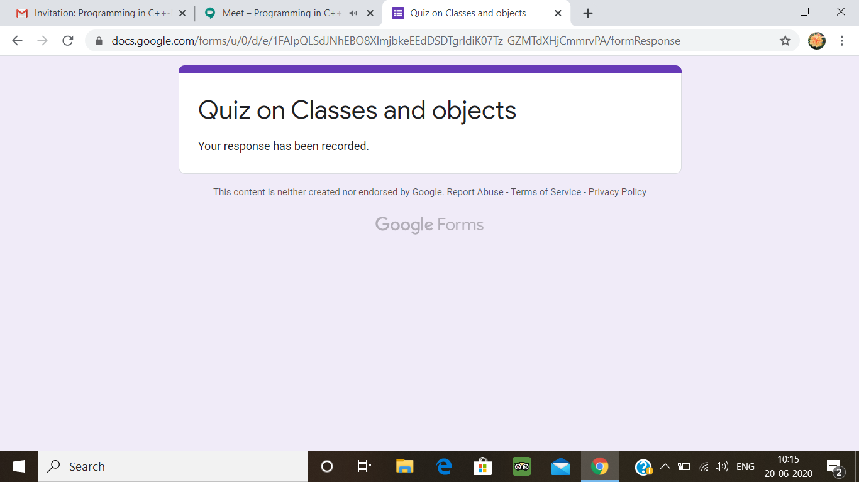



**Coding Challenge:**

1. Write a C Program to rotate an array by K positions.

Circular array rotation means rotating the elements in the array where one rotation operation moves the last element of the array to the first position and shifts all remaining elements to the right.

For example, consider the following array = [4, 5, 6],  
• Initial array [4, 5, 6]  
• After one rotation [6, 4, 5]  
• After two rotations [5, 6, 4]

OUTPUT

Element at index 0: 5  
Element at index 1: 6  
Element at index 2: 4

#include <stdio.h>

int main()

{

int arr[] = {4, 5,6};

int length = sizeof(arr)/sizeof(arr[0]);

int n = 2;

printf("Original array: \n");

for (int i = 0; i < length; i++) {

printf("%d ", arr[i]);

}

for(int i = 0; i < n; i++){

int j, last;

last = arr[length-1];

for(j = length-1; j > 0; j--){

arr[j] = arr[j-1];

}

arr[0] = last;

}

printf("\n");

printf("Array after right rotation: \n");

for(int i = 0; i< length; i++){

printf("%d ", arr[i]);

}

return 0;

}

**Output:**

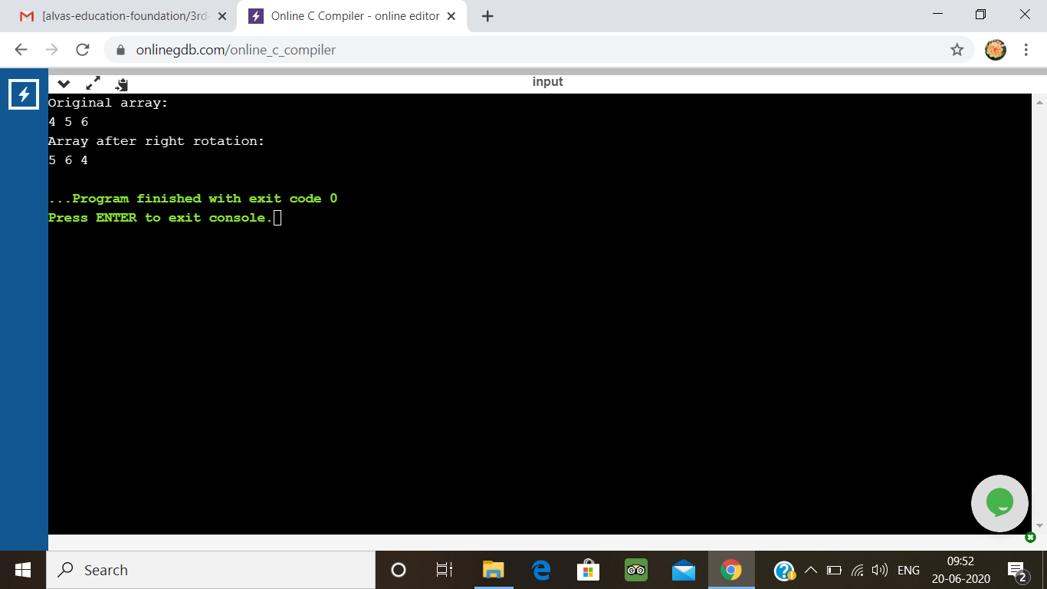

2. Write a Java Program to find area of Square, Rectangle and Circle using Method Overloading

class OverloadDemo

{

void area(float x)

{

System.out.println("the area of the square is "+Math.pow(x, 2)+" sq units");

}

void area(float x, float y)

{

System.out.println("the area of the rectangle is "+x*y+" sq units");

}

void area(double x)

{

double z = 3.14 * x * x;

System.out.println("the area of the circle is "+z+" sq units");

}

}

class Main

{

public static void main(String args[])

{

OverloadDemo ob = new OverloadDemo();

ob.area(5);

ob.area(11,12);

ob.area(2.5);

}

}

**Output:**

