UCLA Football: Dan Guerrero Comparison

#### Win-Loss Records

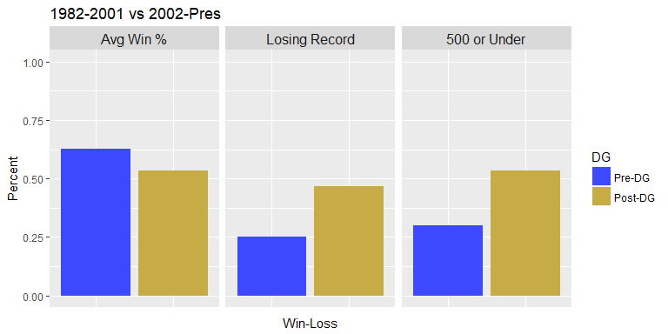

During DG's tenure, UCLA's Avg Win % has fallen from 62.7% in the 20 years beforehand, to 53% in these 15 years. UCLA has ended the sesason with a losing record 47% of the time under DG, compared to 25% beforehand, and has finished .500 or under 53% of the time compared with 30% previously.

#### AP Ranking

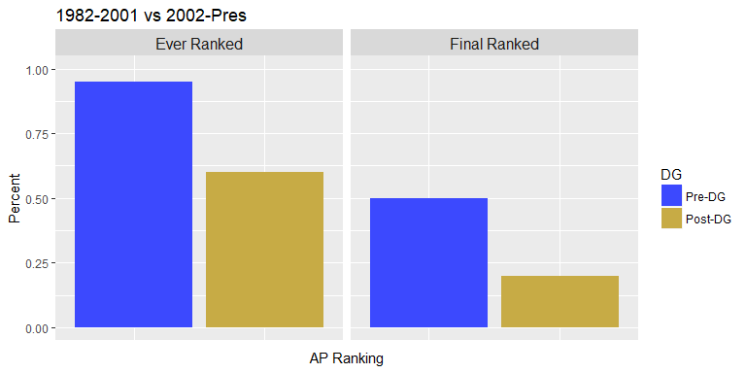

In the 20 years prior to DG's tenure, UCLA was ranked at one point during 95% of seasons, compared to 60% under DG. And UCLA had finished in the top 25 AP 50% of the time prior to DG, compared to 20% since.

#### Postseason/USC

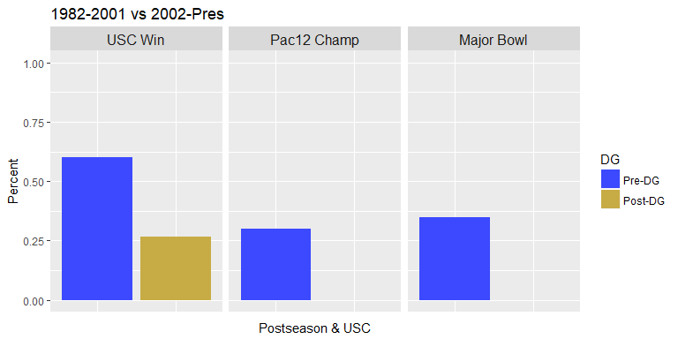

USC victories have shifted from 60% to 27% under under DG, and UCLA has not played in a major bowl game* nor won a Pac12 Championship, compared to 35% and 30% respectively prior to DG's tenure.

*Major Bowls include Rose Bowl, Orange Bowl, Fiesta Bowl, Cotton Bowl, or any BCS Bowl