Andy Gomez

Prof. Adrianna Holden-Gouveia

CIS-245

February 7, 2025

Sed

1. **Change the name Jo to Josephine**

**Command:** Sed s/Jo/Josephine/ datebook

* **sed**: The sed command is used for searching and replacing.
* **s:** The s command specifies the substitution of the two inputs.
* **Jo:** is the name we want to change
* **Josephine:** Is the new name we want.



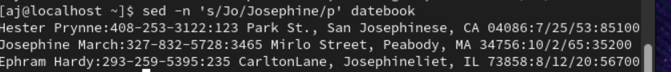

1. **Delete the last 5 lines.**



Command: Sed ’49,53d’ datebook

* **49,53:** The range of lines I want to delete.
* **d:** Delete the number of lines.

The five lines that were deleted.

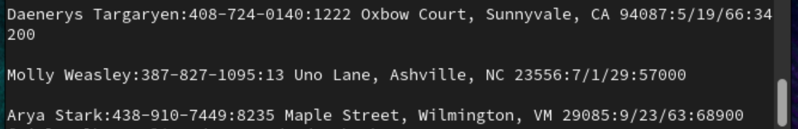

The new ending of the list

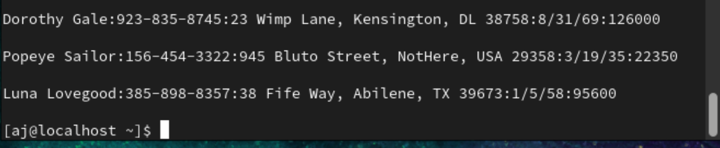

1. Print lines 3-15.

Command: sed -n ‘3,15’ datebook

* -n: Suppresses automatic printing of lines.
* 3,15: The range of lines you want to print (from line 3 to line 15).
* p: Prints the lines in the specified range.

1. Delete lines for people who live in California

Sed ‘/CA/d’ datebook

* /CA/: Matches any line containing the word "California."
* d: Deletes the matched lines.

5. Print all lines where the birthdays are in the first week of the month.

Be careful of the dates for birthdays, the format is MM/DD/YY

Sed -n ‘/[0-9][0-9]\/[1-7]\/[0-9][0-9]/p’ datebook

* /pattern/p: Matches lines that match the pattern and prints them.
* ^[0-9][0-9]\/: Ensures the line starts with a valid digit of the month.
* [1-7]: Matches dates 1 - 7 for the first week of the month.
* \/[0-9][0-9]: Matches a two-digit year.

1. Append three asterisks (*) to the end of lines starting with Sir

Sed -1 ‘/^Sir/ s/$/***/’ datebook

* -i: Edits the file in place.
* **/^Sir/**: Matches lines that start with "Sir."
* ^: Anchors the match to the beginning of the line.
* **s/$/***/**: s, Substitution command. $, Matches the end of the line.
* ***: Adds three asterisks at the end of the line.





7. Replace the line containing ”Westley Pirate” with the phrase ”As you

wish.” Make sure you replace the whole line not just the name

Sed -I ‘/Westley Pirate/c\As you wish.’ Datebook

* **-i**: Edits the file in place.
* **/Westley Pirate/**: Searches for lines containing the text "Westley Pirate."
* **c\As you wish.**: The c\ command replaces the entire line with the new text: "As you wish."

8. Change Minerva McGonagall’s birthday to 10/04/1935. Assume you

don’t know Minerva’s original birthday. Use a regular expression to

search for it.

9. Delete all blank lines.

Sed ‘/^$/d datebook

* /^$/: Matches empty lines.
* d: Deletes the matched lines.

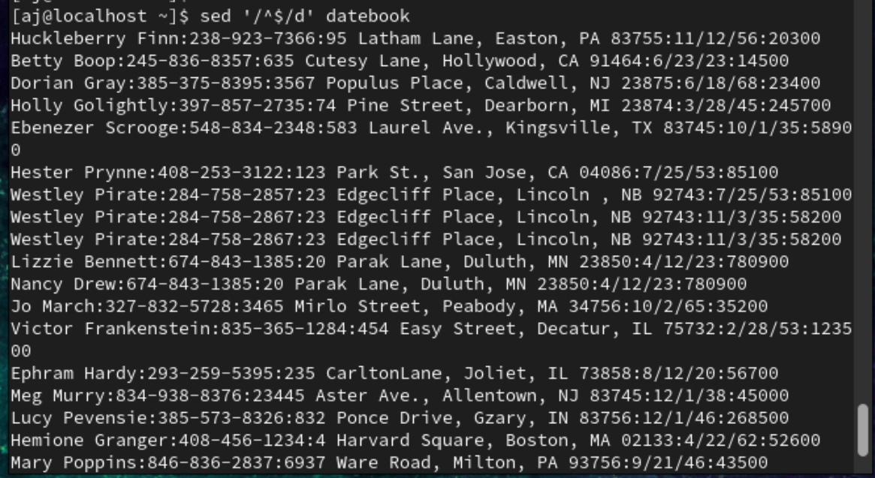

10. Write a sed script that will (actual sed script, NOT just the commands

on the command line)

(a) Insert above the first line the title - Great Literary Characters -.

(b) Print the contents of the file, but instead of the phone number

starting with an area code, have it start with a 1+, then include

the area code and number. For example, (603)123-1234 would

turn into 1+(603)123-1234

(c) Append at the end of the file” Happily Ever after. The End”

Creating a script in terminal by typing “vim scripting.sed”.

* 1i\: Inserts text at the first line.
* Great Literary Characters: Is the text to be inserted at the first line.
* s/\([0-9]\{3\}-[0-9]\{3\}-[0-9]\{4\}\)/1+\/g:
  + s: Substitute command.
  + /\([0-9]\{3\}-[0-9]\{3\}Matches a phone number with an area code in parentheses.
    - [0-9]\{4\}\)/1+\/g: : Captures the three-digit area code inside parentheses.
  + 1+(\1): Replaces the match with 1+ followed by the captured area code and parentheses.
  + g: Applies the substitution globally to all matches in a line.
* $a\: Appends text after the last line of the file.
* Happily Ever after. The End: The text to append.
* :wq – to save and exit the scripting and back to terminal

To run the script in the terminial I ran the following command sed -f scripting.sed datebook

• -f : specifies a script file which is scripting.sed

