Andy Gomez

Prof. Adrianna Holden-Gouveia

CIS-245

January 26, 2025

Server Setup

**Download VirtualBox**

1. Go to VirtualBox website ( [Downloads – Oracle VM VirtualBox](https://www.virtualbox.org/wiki/Downloads) )
2. Locate Download section on the top right of the web page
3. Select the version for your operating system
   1. Ex. If you are working on Windows select “Windows Host”
   2. 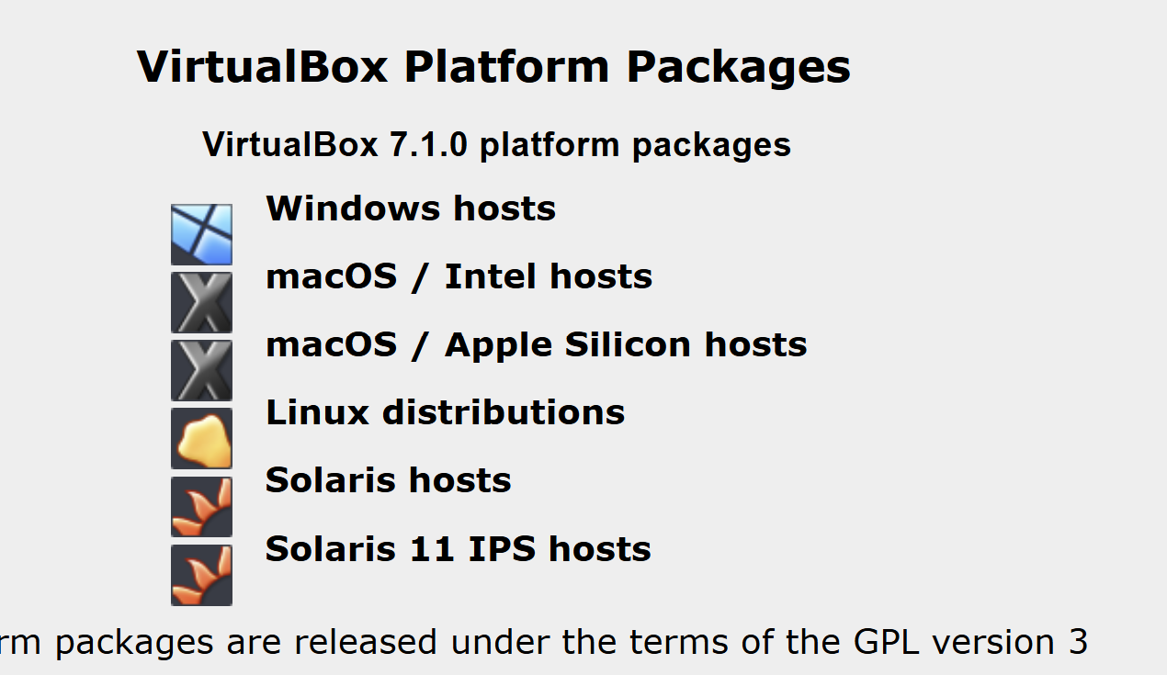
4. File Explorer will pop up, select where you want to save Oracle Virtual Box. (I would recommend your desktop)
5. Once location is selected on the bottom right of File Explore window click save
6. Click File Explorer and on the left panel click downloads
7. Double click your most recent download which should be Virtual Box – version number
8. Windows will ask you if “…you want to allow this app to make changes to your device?”
9. Click Yes

**Install VirtualBox**

1. Oracle Virtual Box Set Up Wizard should pop up a window automatically on your screen.
2. Follow the setup
   1. Click Next on setup wizardA screenshot of a software

      Description automatically generated
   2. Next on custom setup, on custom setup make location is set up correctly and make sure Oracle has its own path.
   3. Yes on “Proceed with installation”
   4. Yes on “Proceed with installation” On window that says “Missing Dependencies Python Core”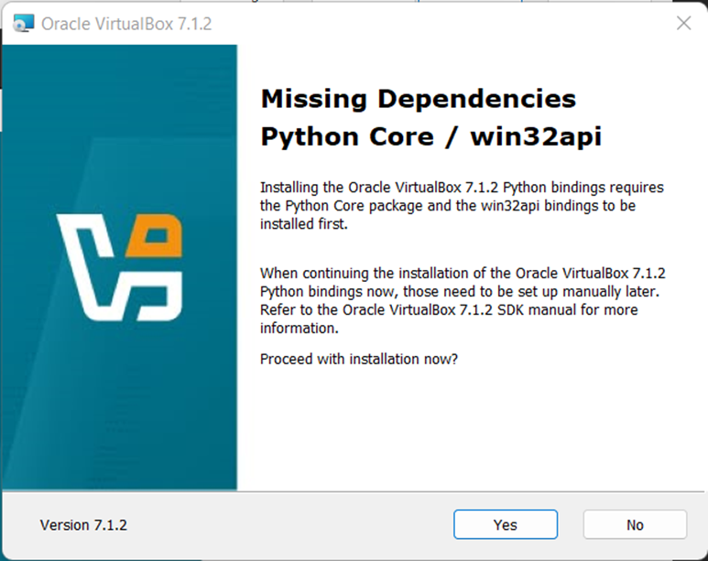
   5. On the next window that says “Choose the option below” make cure everything has a check and click next
   6. Click Install 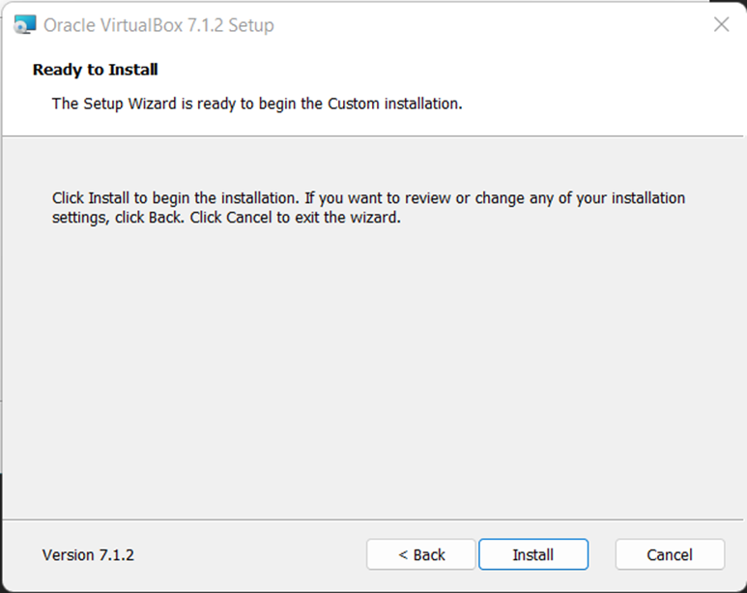
   7. Finish
3. Begin and Complete installation

**Download CentOS**

1. Go to CentOS website ( [Download (centos.org)](https://www.centos.org/download/) )
2. Locate Download section
3. Select and download x86_84 version or the correct one for your operating system
   1. 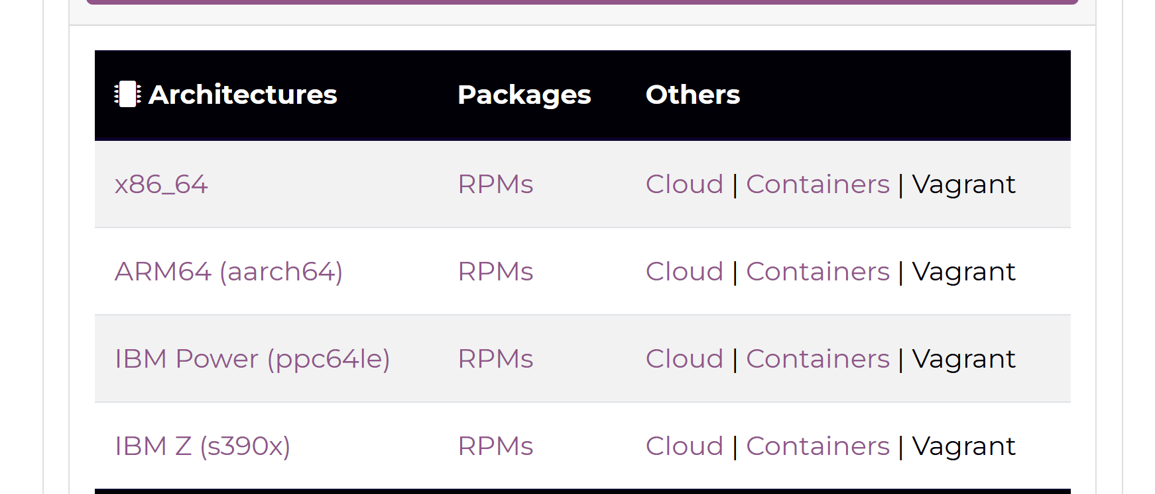
4. File Explorer will pop up, select where you want to save CentOs. (I would recommend your desktop)
5. Once location is selected on the bottom right of File Explore window click save
6. Click File Explorer and on the left panel click downloads
7. Double click your most recent download which should be CentOs
8. Windows will ask you if “…you want to allow this app to make changes to your device?”
9. Click Yes

**Download Ubuntu**

1. Go to Ubuntu website ( [Get Ubuntu | Download | Ubuntu](https://ubuntu.com/download) )
2. Locate download section
3. Select server download link
   1. 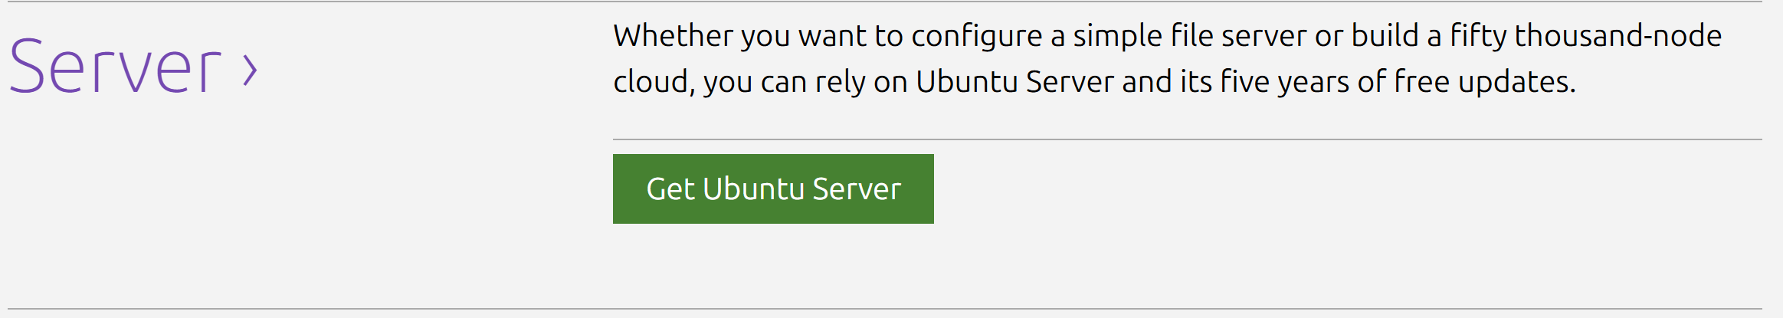
4. File Explorer will pop up, select where you want to save Ubuntu. (I would recommend your desktop)
5. Once location is selected on the bottom right of File Explore window click save
6. Click File Explorer and on the left panel click downloads
7. Double click your most recent download which should be Ubuntu
8. Windows will ask you if “…you want to allow this app to make changes to your device?”
9. Click Yes

**Create and run virtual machine**

1. Open VirtualBox
2. Create new virtual machine
3. Click new to start a new virtual machine
4. Follow all the steps and choose the operating system, allocate memory, and virtual hard disk you want to install.
5. Install an Operating system by selecting ISO file (CentOS, Ubuntu) to install inside the virtual machine
   1. 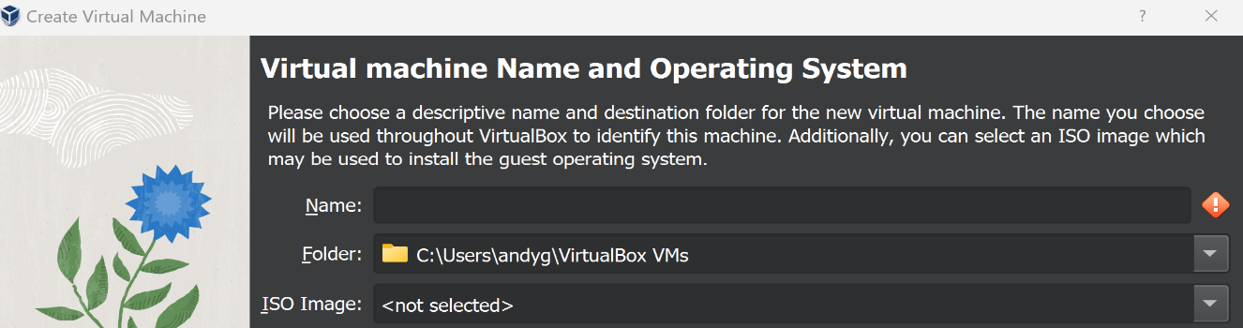
6. Start new virtual machine by clicking start

**Check if there’s internet connection**

1. Open terminal on your operating system in virtual machine
   1. Click on search bar on your task bar and search for terminal
2. Type **“Ping google.com”**
3. Check if there's connection
   1. A screenshot of a computer

      Description automatically generated

**Sharing Folders Between OS’s**

1. Make sure your virtual machine is powered off before starting this
2. On your host Computer, create a new folder under documents or desktop named “Share” or something you will remember
3. Open up VirtualBox, select “Settings”
4. Select “Shared Folders”

1. On the right panel click on the blue folder icon with the green plus sign, then select “other”. Navigate to Documents and Select your “Share” folder

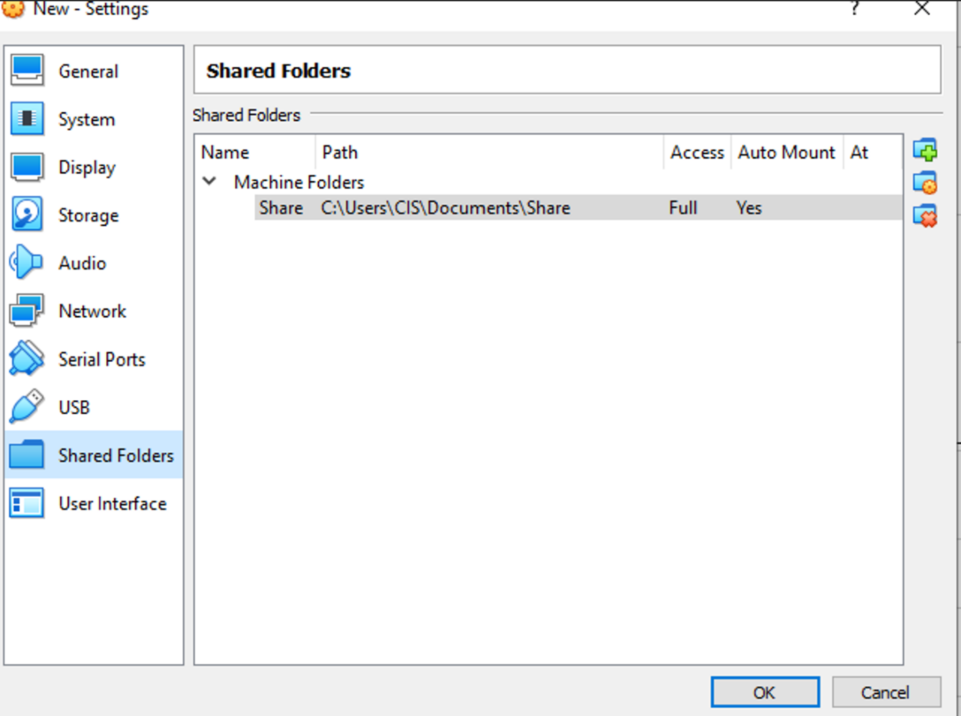

1. Select “automount” option then click “OK”.
2. Now open your virtual machine and log in
3. On top right select “devices” then “optical drive” and “remove disk from current drive”

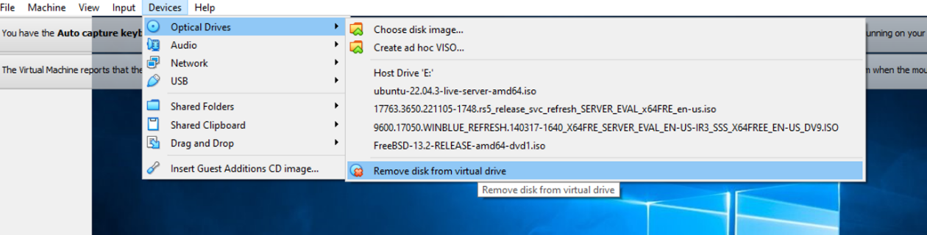

1. Now Select “Devices” again and select “Insert Guest Additions CD”

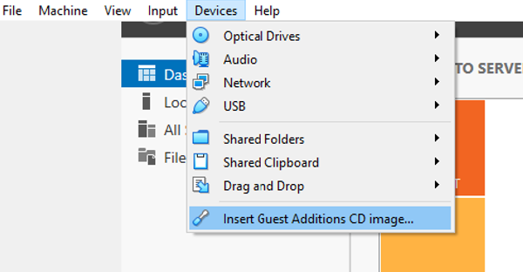

1. Go to file explorer, select the Disc (probably drive D) and then select “VBoxWindowsAdditions-amd64”
2. Reboot the server when prompted.