Andy Gomez

Prof. Adrianna Holden-Gouveia

CIS-245

January 29, 2025

Grep

1. Print all lines containing the string Lane

Grep Lane datebook:

* Grep: The command for searches text.
* Lane: The is the string name you want to search for. This searches every line in the file and prints out every line that contains the name “Lane”.

1. Print all lines where the person’s first name starts with H

Grep ^H datebook

* Grep: The command for searching text.
* ^H: Searches and Matches lines that start (^) with the letter H.

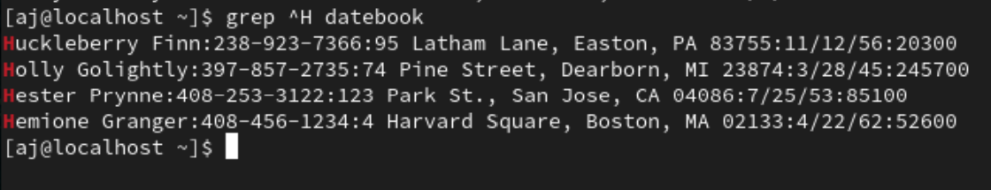

1. Print all lines ending in three zeros (000)

Grep 000$ datebook:

* Grep: The command to search text.
* "000$": A command where: 000 matches all lines ending with three zeros in the file
* $ ensures that your command is at the end of the line.

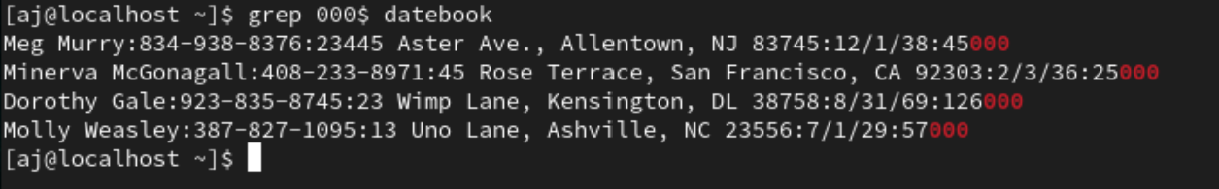

1. Print all lines that don’t contain 408

Grep -V 408 datebook

* Grep: The command for searching text.
* -v: This command excludes lines containing 408.
* "408": The number you want top to exclude in the file.

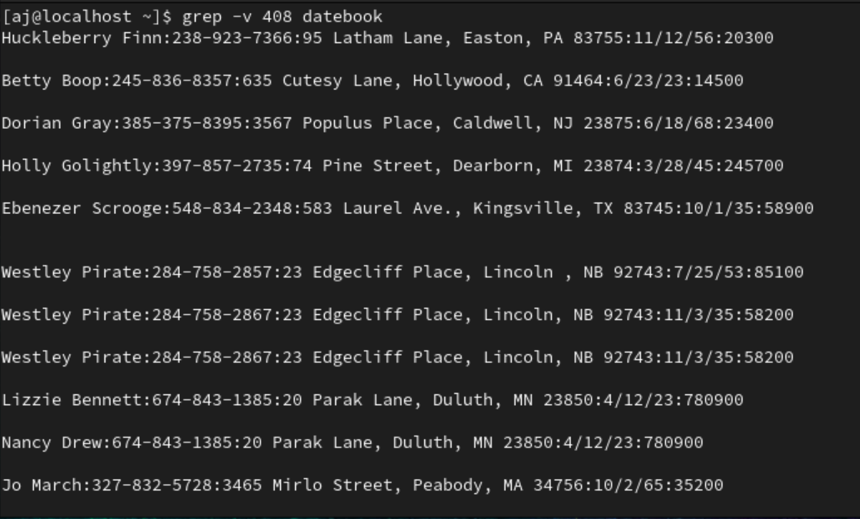

5. Print all lines where birthdays are in the year 1935 (be careful of the

date format! it’s MM/DD/YY)

Grep ‘/35’ datebook

* Grep: The command to search text.
* "/35": Matches any line containing 35, which indicates the year 1935

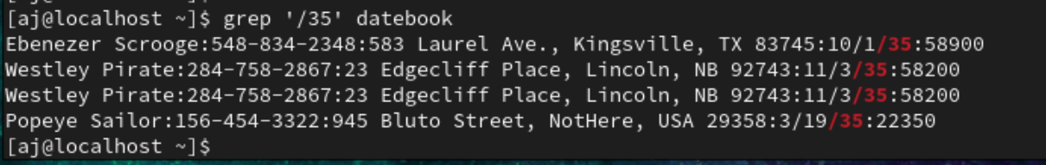

6. Print all lines where the phone number is in an area code that starts

with an 8

7. Print all lines containing an uppercase letter, followed by 4 lowercase

letters, a space and one uppercase letter.

Grep -E ‘[A-Z]+([a-z]{4}) [A-Z]’ datebook

* -E: Enables extended regular expressions (for {4}).
* [A-Z]: Matches uppercase letters.
* [a-z]{4}: Matches exactly 4 lowercase letters.
* Space: puts a single space.
* [A-Z]: Matches another uppercase letter.

8. Print lines where the address begins with a two- or three-digit number

(So, this would be 12 main St. or 123 main street but not 1234 main

street).

Grep -E ‘[0-9]{2,3}’ datebook

* Grep: The command to search text.
* -E: Enables extended regular expressions (for {2,3}).
* ‘[0-9]{2,3} ‘: Matches lines beginning with 2 or 3 digits followed by a space.

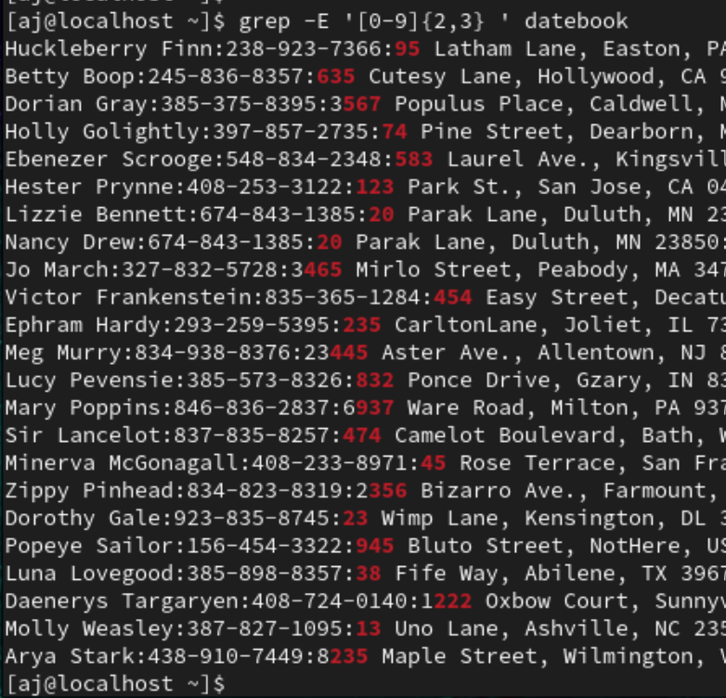

9. Print lines where the person lives in Mass or Illinois

Grep -E ‘MA|IL’ datebook

* Grep: The command for searching text.
* -E: Enables extended regular expressions.
* "MA|IL": Matches lines containing either "Mass" or "Illinois."

10. Print lines containing the addresses that aren’t on a street (You might

see St as shorthand for street)

Grep -v ‘Street,St’’ datebook

* Grep: The command to search text.
* -v: Inverts the match.
* "Street,St": Exclude any line with Street or St.

