1. INTRODUCTION TO PROJECT:

1.1 Introduction

Blogger’s Website is an easy-to-use, web application for Blog lovers. It shows the Current Technological based Articles and Posts which are in ongoing research and released technologies.it can be used for other uses also like entrepreneur articles and many more.

1.2 Goals of the Project

To Stay Update: To know what’s going on in the technological market and IT industry. Since in this growing market people have less time to surf for the new this website will serve them one stop solution for the tech lovers.

User friendliness: The project should be very easy to use enabling even a novice person to use it.

1.3 Innovative Ideas of the Project

One Stop Solution: Easy to use UI (User Interface), hence any user with minimal knowledge of Computer can use the Website.

Platform independence: Website is responsive in nature any individual can operate the website on Computer System as well as on any Mobile phone.

2. REQUIREMENT SPECIFICATION:

The primary goal of the system analyst is to improve the efficiency of the existing system. For that the study of specification of the requirements is very essential. For the development of the new Website, a preliminary survey of the existing system will be conducted. Investigation done whether the up gradation of the system into an application program could solve the problems and eradicate the inefficiency of the Existing system.

HARDWARE REQUIREMENTS:

* 1 GB RAM
* Pentium 4 and above processors
* 2.1 GB Free Space

SOFTWARE REQUIREMENTS:

* Operating system -Windows 98 or above.
* Python 3.6x
* XAMPP server
* Google Chrome , IE ,Mozilla.

3. SYSTEM DESIGN DETAILS:

* Prototyping is to validate software requirements, Software prototype also has other uses.
* A prototype system can be used for training users before the formal system has been delivered.
* Prototype can run back-to-back tests. This reduces the need for tedious manual checking of test run.
* The same test is given to both the prototype and the system under test to look for differences in the final results and thereby making necessary changes. Thus prototype serves as a technique of risk reduction.

Selecting the prototype approach:

* The prototype paradigm can be either close-ended (throw away prototyping) or open-ended (evolutionary prototyping).
* Before selecting closed or open-ended approach, it is necessary to determine whether the system to be built is suitable for prototyping or not.
* This is decided depending on application area, complexity, customer characteristics and projects characteristics.
* The throwaway is developed to understand the system requirements while the evolutionary prototype evolves through a number of versions to the final system.

3.1 METHODOLOGY:

Methodology is the organized, theoretical inspection of the methods dedicated to

a field of study. It consists the theoretical analysis of the structural body of

Methods and principles related with a branch of knowledge. Typically, it

Comprises concepts such as paradigm, abstract model, phases and quantitative

or qualitative techniques. The project follows Waterfall Model

3.1.1 WATERFALL MODEL:

The Waterfall Model was Traditional Process Model to be brought up. It is very basic

And simple to understand and implement. In a Waterfall model, each

Phase/section must be completed before the next phase/section can begin and

There is no overlapping in the phases. Waterfall model is a SDLC way that was

Used for web development.

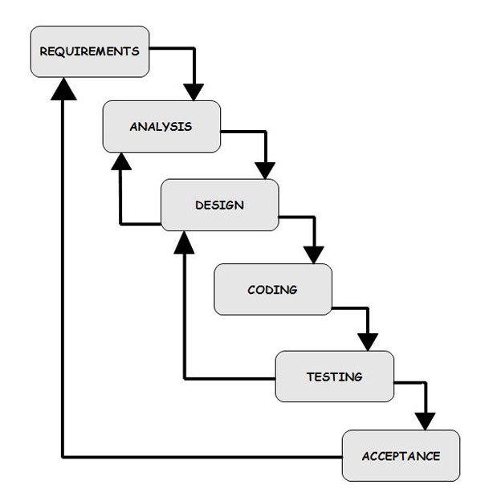

4.1

3.2 ARCHITECTURE:

3.2.1 GANTT CHART:

**DEFINITION:**A Gantt chart is a useful graphical tool which shows activities or tasks performed against time. It is also known as visual presentation of a project where the activities are broken down and displayed on a chart which makes it is easy to understand and interpret.

**DESCRIPTION:**A Gantt chart is a popular tool in project management. It basically drills down activities which need to be done by a fixed time period. It is commonly used for tracking project schedules.   
On the chart, tasks are shown on the vertical axis while the scheduled time-spend is laid out on the horizontal axis. Each task is represented by a bar that shows the time required for the project.

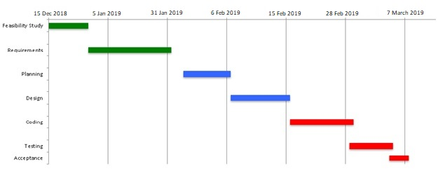

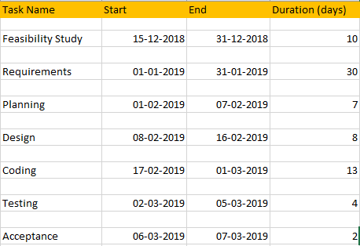

Fig 3.2.1

3.2.2 PERT CHART:

DEFINITION:-  
A PERT chart is a project management tool used to schedule, organize, and coordinate tasks within a project. PERT stands for *Program Evaluation Review Technique*, a methodology developed by the U.S. Navy in the 1950s to manage the Polaris submarine missile program. A similar methodology, the *Critical Path Method* (CPM) was developed for project management in the private sector at about the same time.

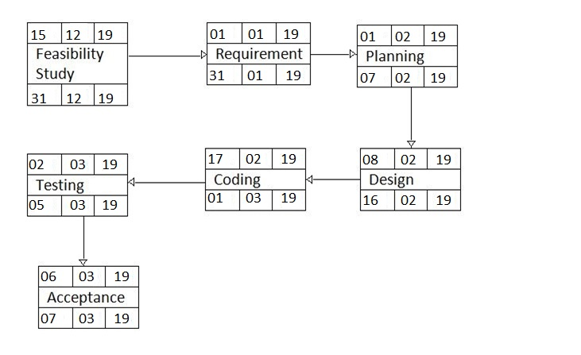

Fig 3.2.2

3.3 UML:

3.3.1 Use case Diagram:

DEFINITION:-  
A [use case](https://searchsoftwarequality.techtarget.com/definition/use-case) is a methodology used in system analysis to identify, clarify, and organize system requirements. In this context, the term "system" refers to something being developed or operated, such as a mail-order product sales and service [Web site](https://searchmicroservices.techtarget.com/definition/Web-site). Use case diagrams are employed in [UML](https://searchsoftwarequality.techtarget.com/definition/Unified-Modeling-Language) (Unified Modeling Language), a standard notation for the modeling of real-world objects and systems.

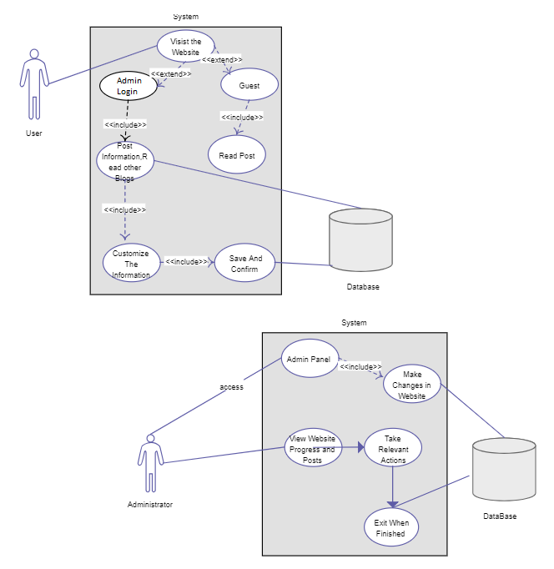

Fig 3.3.1

3.3.2 FLOW CHART:

DEFINITION:-  
A **flowchart** is a type of [diagram](https://en.wikipedia.org/wiki/Diagram) that represents an [algorithm](https://en.wikipedia.org/wiki/Algorithm), [workflow](https://en.wikipedia.org/wiki/Workflow) or process. The flowchart shows the steps as boxes of various kinds, and their order by connecting the boxes with arrows. This diagrammatic representation illustrates a solution model to a given [problem](https://en.wikipedia.org/wiki/Problem_solving). Flowcharts are used in analyzing, designing, documenting or managing a process or program in various fields.

Flowcharts are used in designing and documenting simple processes or programs. Like other types of diagrams, they help visualize what is going on and thereby help understand a process, and perhaps also find less-obvious features within the process, like flaws and [bottlenecks](https://en.wikipedia.org/wiki/Bottleneck_(production)). There are different types of flowcharts: each type has its own set of boxes and notations. The two most common types of boxes in a flowchart are:

* a processing step, usually called *activity*, and denoted as a rectangular box.
* a decision, usually denoted as a diamond.

A flowchart is described as "cross-functional" when the chart is divided into different vertical or horizontal parts, to describe the control of different organizational units. A symbol appearing in a particular part is within the control of that organizational unit. A cross-functional flowchart allows the author to correctly locate the responsibility for performing an action or making a decision, and to show the responsibility of each organizational unit for different parts of a single process.

Flowcharts depict certain aspects of processes and are usually complemented by other types of diagram. For instance, [Kaoru Ishikawa](https://en.wikipedia.org/wiki/Kaoru_Ishikawa) defined the flowchart as one of the seven basic tools of quality control, next to the [histogram](https://en.wikipedia.org/wiki/Histogram), [Pareto chart](https://en.wikipedia.org/wiki/Pareto_chart), [check sheet](https://en.wikipedia.org/wiki/Check_sheet), [control chart](https://en.wikipedia.org/wiki/Control_chart), [cause-and-effect diagram](https://en.wikipedia.org/wiki/Ishikawa_diagram), and the [scatter diagram](https://en.wikipedia.org/wiki/Scatter_diagram). Similarly, in [UML](https://en.wikipedia.org/wiki/Unified_Modeling_Language), a standard concept-modelling notation used in software development, the [activity diagram](https://en.wikipedia.org/wiki/Activity_diagram), which is a type of flowchart, is just one of many different diagram types.

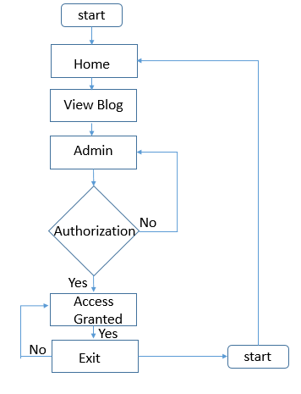

Fig 3.3.2

3.3.3 ACTIVITY DIAGRAM:

**DEFINITION:-  
Activity diagrams** are graphical representations of [workflows](https://en.wikipedia.org/wiki/Workflow) of stepwise activities and actions with support for choice, iteration and concurrency. In the [Unified Modeling Language](https://en.wikipedia.org/wiki/Unified_Modeling_Language), activity diagrams are intended to model both computational and organizational processes (i.e., workflows), as well as the data flows intersecting with the related activities. Although activity diagrams primarily show the overall flow of control, they can also include elements showing the flow of data between activities through one or more data stores.

The basic purpose of activity diagrams is similar to other four diagrams. It captures the dynamic behavior of the system. Other four diagrams are used to show the message flow from one object to another but activity diagram is used to show message flow from one activity to another. Activity is a particular operation of the system. Activity diagrams are not only used for visualizing the dynamic nature of a system, but they are also used to construct the executable system by using forward and reverse engineering techniques. The only missing thing in the activity diagram is the message part. It does not show any message flow from one activity to another. Activity diagram is sometimes considered as the flowchart. Although the diagrams look like a flowchart, they are not. It shows different flows such as parallel, branched, concurrent, and single.

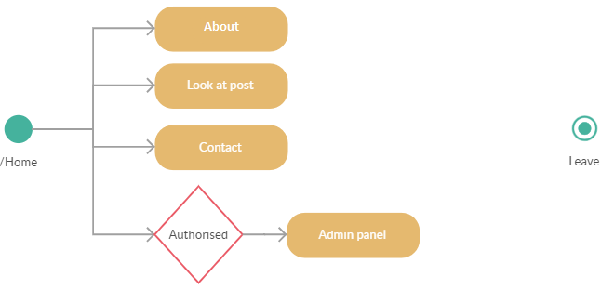

Fig 3.3.3

3.3.4 SEQUENCE DIAGRAM:

A sequence diagram shows object interactions arranged in time sequence. It depicts the objects and classes involved in the scenario and the sequence of messages exchanged between the objects needed to carry out the functionality of the scenario. Sequence diagrams are typically associated with use case realizations in the Logical View of the system under development. Sequence diagrams are sometimes called **event diagrams** or **event scenarios**.

A sequence diagram shows, as parallel vertical lines (*lifelines*), different processes or objects that live simultaneously, and, as horizontal arrows, the messages exchanged between them, in the order in which they occur. This allows the specification of simple runtime scenarios in a graphical manner.

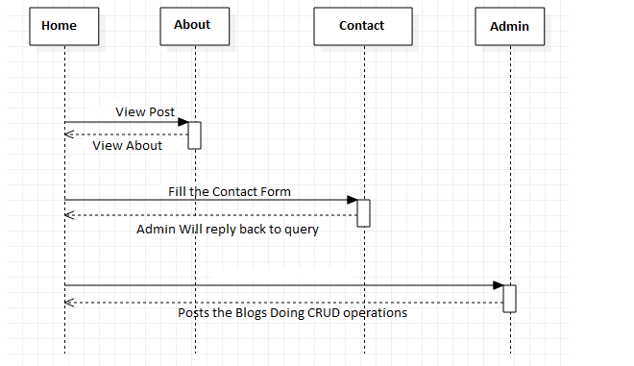

Fig 3.3.4

3.4 DFD (Data Flow Diagram):

**DEFINITION:-**A **data flow diagram** (**DFD**) is a graphical representation of the "flow" of data through an [information system](https://en.wikipedia.org/wiki/Information_system), modelling its *process* aspects. A DFD is often used as a preliminary step to create an overview of the system without going into great detail, which can later be elaborated. DFDs can also be used for the [visualization](https://en.wikipedia.org/wiki/Data_visualization) of [data processing](https://en.wikipedia.org/wiki/Data_processing) (structured design).

A DFD shows what kind of information will be input to and output from the system, how the data will advance through the system, and where the data will be stored. It does not show information about process timing or whether processes will operate in sequence or in parallel, unlike a traditional structured [flowchart](https://en.wikipedia.org/wiki/Flowchart) which focuses on control flow, or a UML activity workflow diagram, which presents both control and data flows as a unified model.

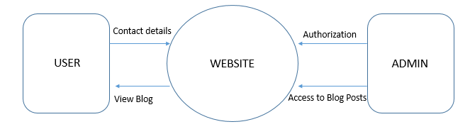

Fig 3.4

3.5 ALGORITHMS:

Steps:

1. Start

2: go to website.

3: Read the Post.

4: Contact Form.

5: Admin Login (Dashboard)

6: CRUD operation

7: Blog posted.

8: Exit.

DETAILED IDEA ABOUT THE PROJECT:-

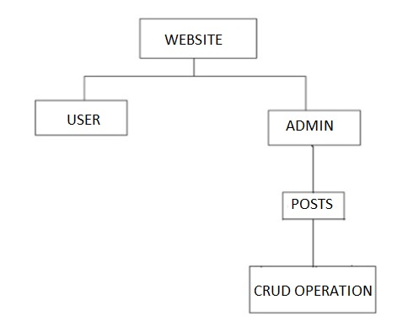

SERVICE:-This Project is a service for the people who all are hungry for learning new things coming up in the future. Project serves the service in the form of Articles, Posts which are posted on the Website.

TIME:-Time the Main factor now a days in our life, to save our time on reading the big thesis this site will tell them in short the new upcoming Technologies. New inventions in the field of Science and technology and computation world.

So the user have to just do one thing visit the Website and read the Articles, Posts posted by the admin after Verifying the news various times and the Genuine news in the form of Articles.

PRESENT PROJECT:-

This Project is all about the Blog, Posting Articles on the Website in the Short form. The Admin has the Right to do the CRUD Operation on the Website Articles. There is an Admin Panel through which All the posts are updated after doing Research on the Topic and finding out its Genuineness the Articles are been Posted.

LIMITATIONS OF PROJECT:-

* There is no Guest login because the guest can post the articles which are not verified and the article can lead some problems if they are not from the genuine source.
* There is only one Authoritative login i.e. (Administrator).
* Posts and Articles are Mainly towards Science and Technology and Computation.

4. SYSTEM IMPLEMENTATION:-

* Implementation is the stage of the project where the theoretical design is turned into a working system.
* The implementation state is a system project in its own right.
* It involves careful planning, investigation of the current system and its constraints on implementation, design of methods to achieve the changeover, training of staff in the changeover procedure and evaluation of change over methods.
* Once the planning has been completed, the major efforts are to ensure that the program in the system is working properly.
* At the same time concentrate on User Experience. When the Project is going on we should take care of GUI, How the Project look like after completion.

TESTING & VALIDATIONS:-

System testing is a critical aspect of Software Quality Assurance and represents the ultimate review of specification, design and coding. Testing is a process of executing a program with the intent of finding an error. A good test is one that has a probability of finding an yet undiscovered error. The purpose of testing is to identify and correct bugs in the developed system. Nothing is complete without testing. Testing is vital in the success of the system.

In the code testing the logic of the developed system is tested. For this every module of the program is executed to find an error. To perform specification test, the examination of the specifications stating what the program should do and how it should perform under various conditions.

Unit testing focuses first on the modules in the proposed system to locate errors. This enables to detect errors in the coding and logic that are contained within that module alone. Those resulting from the interaction between modules are initially avoided. In unit testing step each module has to be checked separately. System testing does not test the software as a whole, but rather the integration of each module in the system. The primary concern is the compatibility of individual modules. One has to find areas where modules have been designed with different specifications of data lengths, type and data element name. Testing and validation are the most important steps of the developed system. The system testing is performed to ensure that there are no errors in the implemented system. The software must be executed several times in order to find out the errors in the different modules of the system.

Validation refers to the process of using the new software for the developed system in a live environment i.e., new software inside the organization, in order to find out the errors. The validation phase reveals the failures and the bugs in the developed system. We will come to know about the practical difficulties the system faces when operated in the true environment. By testing the code of the implemented software, the logic of the program can be examined. A specification test is conducted to check whether the specifications stating the program are performing under various conditions.

5. RESULTS:

5.1 Test Cases:

1. Testing the Home page



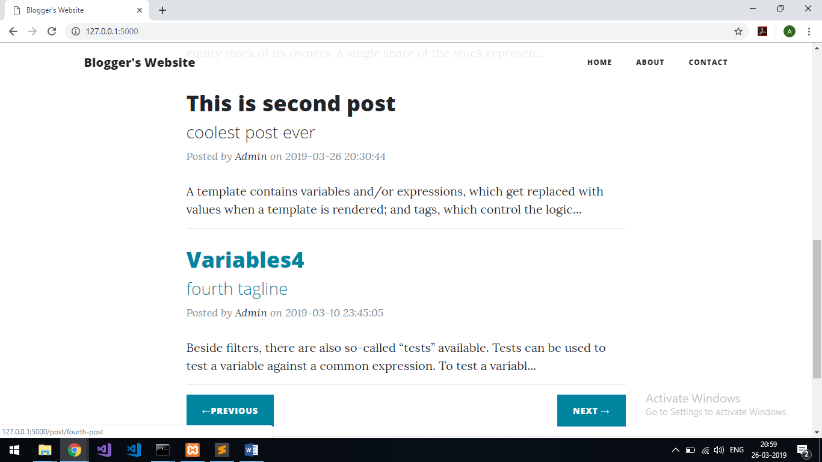

2. About page



3. Contact page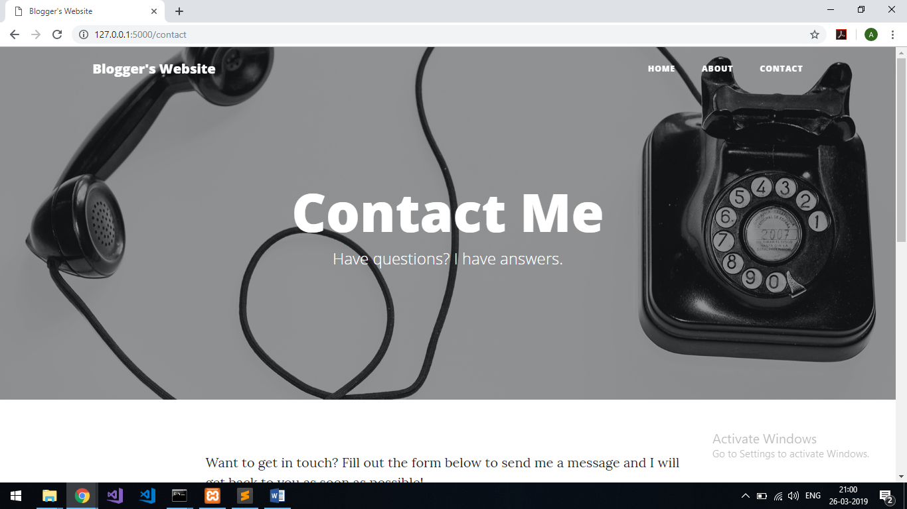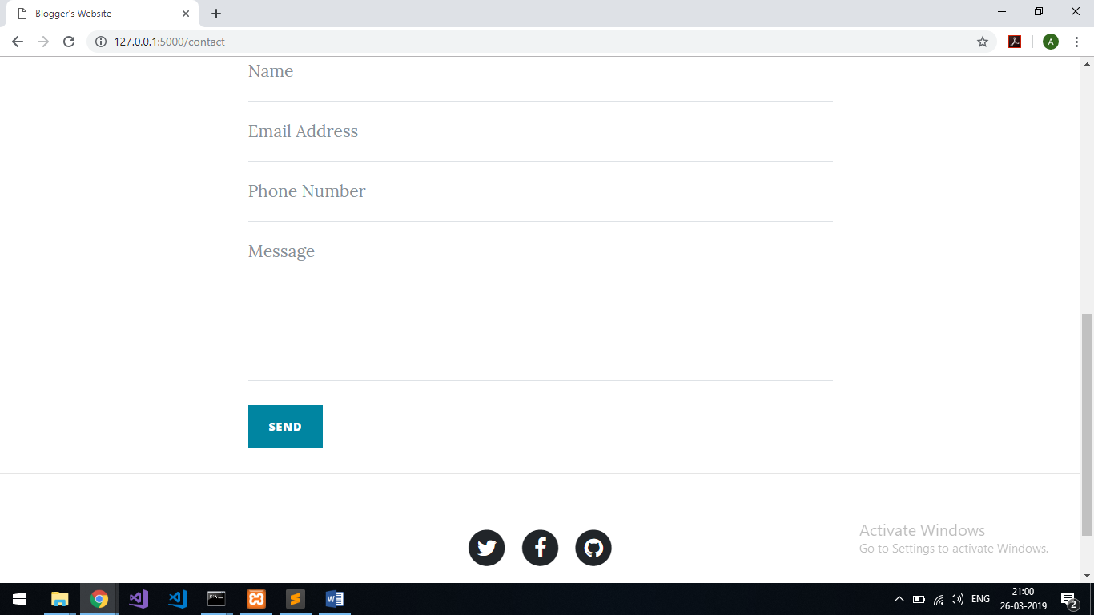

CONCLUSION AND FUTURE SCOPE:

Conclusion:-

This project can be useful for Bloggers to post there Blogs where they can share there researches and many more articles what they seem to be new Thing.

Future Scope:-

This Project is all about Posts now this website is only focusing on technological Blogs, but it can be used for educational purpose teachers, Professors can post there new things to learn ,new Tricks and tips on various topics, this website can help students to ask their doubts by connecting teachers student will get more help .

REFERENCES:

<http://flask.pocoo.org/>

<https://pythonhosted.org/Flask-Mail/>

<http://flask-sqlalchemy.pocoo.org/2.3/>

<https://pypi.org/project/Werkzeug/>

<http://jinja.pocoo.org/>

<https://getbootstrap.com/docs/4.3/getting-started/introduction/>