Investigation of Measles Case Trends Post-Vaccination Efforts in the United States
Austin Hill, Joe Dainis
The structure below is one possible setup for a manuscript stemming from a data analysis project. It loosely follows the structure of a standard scientific manuscript. Adjust as needed. You don’t need to have exactly these sections, but the content covering those sections should be addressed.
This uses MS Word as output format. See the Quarto documentation for instructions on how to use other formats.
Warning: package 'knitr' was built under R version 4.4.3
Authors
- Joe Dainis$​^{1,*}$
- Austin Hill$​^{2,*}$
Author affiliations
- Infectious Diseases and Center for Tropical and Emerging Global Diseases, University of Georgia, Athens, GA, USA.
- Another Affiliation, Athens, GA, USA.
$*$ These authors contributed equally to this work.
$∧$ Corresponding author: some@email.com
$†$ Disclaimer: The opinions expressed in this article are the author’s own and don’t reflect their employer.

1. Part 1 Project Answers

1.1 Data Description
The data Austin and I selected is from two different datasets. The first dataset is derived from Project Tycho, a global health database compiling a wealth of data resources for common global health burdens in over 90 different countries. Due to the political discourse surrounding the current measles vaccine, and Austin and I being invested as infectious disease researchers, we honed in on the measles dataset. This measles data compiles 436,932 cases collected through the US Nationally Notified Disease Surveillance System. This data was collected weekly, and includes other variables such as place of acquisition, mortality outcome, cumulative nature and age range. This data can further be broken down by the state/U.S. territory in which the case was reported. The second set of data we are looking to use is a compilation of multiple measles record collections from the CDC amidst the current outbreaks being seen in the U.S. This data describes recent case reports for measles outbreaks from 2023-2026 broken down by state, yearly cases of measles in the United States from 1985-2026, and data on MMR vaccination rates amongst kindergarteners broken down by state from 2009-2025.

1.2 The Question
After discussion, Joe and I came up with the following question: “What factors might explain the current measles outbreaks seen in the U.S.” In particular, we are curious to explore whether past trends in persistent measles cases and vaccination coverage explain the trends we see in particular states acting as outbreak hubs in the U.S.. We are interested in seeing if there are any states which show persistent measles incidence over time from the early 1980s to 2000s and whether this might predict certain states as candidate states for outbreaks. We are also interested in investigating trends of MMR vaccination in kindergarteners and test whether this can predict a state prime for a measles outbreak. We are looking for patterns of specific states that are having current measles outbreaks in 2024-26 (South Carolina, Texas, etc.) having past trends in measles persistence or vaccination struggles as an explanation as to why they are having these outbreaks.

1.3 Suggestions for analysis
Our vision for analysis would look to assign a mean value for vaccination rate across the sampled data and run a linear regression analysis to see if a lower vaccination rate amongst kindergartener correlates with a high measles incidence rate between 2024-26. Also, after some searching around, we think it would be interesting to try to run an Autoregressive Integrated Moving Average (ARIMA) model, which is used to predict future data from time series data. We think it would be interesting to implement this with the 1980s to 2000s measles case data from Project Tycho to identify any states with low-level persistent measles cases, as these states would likely predict to have a future measles burden whereas other states would predict to have no case burden. We are unsure of how complicated this could be, but could be interesting to try!

1.4 Background Information for the Question
As you may know, measles is becoming a major problem again in the United States. Measles was once eliminated in the United States in 2000, but it has since made headlines in recent years for major outbreaks amongst children. Much of this is proposed to be due to lower MMR vaccination rates, but we wonder if there might be additional explanation from past trends in measles incidence. There have been studies which look at predictor variables as indicators of states that may have measles outbreaks, including MMR vaccination rate, population of the county, and international air travel data, but very little attention has been directed at historical data and whether trends of past persistent measles incidence could explain states having current outbreaks.

2. Summary/Abstract
Write a summary of your project.
It is recommended to use a structured abstract with Background/Methods/Results/Discussion sections.

3. Introduction

3.1 General Background Information
Provide enough background on your topic that others can understand the why and how of your analysis

3.2 Description of data and data source
Describe what the data is, what it contains, where it is from, etc. Eventually this might be part of a methods section.

3.3 Questions/Hypotheses to be addressed
State the research questions you plan to answer with this analysis.
To cite other work (important everywhere, but likely happens first in introduction), make sure your references are in the BibTeX file specified in the YAML header above and have the right BibTeX key. Then you can include like this:
Examples of reproducible research projects can for instance be found in (1,2).

4. Methods
Describe your methods. That should describe the data, the cleaning processes, and the analysis approaches. You might want to provide a shorter description here and all the details in the supplement.

4.1 Schematic of workflow
Sometimes you might want to show a schematic diagram/figure that was not created with code (if you can do it with code, do it). Figure 1 is an example of some - completely random/unrelated - schematic that was generated with BioRender. We store those figures in the assets folder.

Figure 1: A figure that is manually generated and shows some overview/schematic. This has nothing to do with the data, it’s just a random one from one of our projects I found and placed here.

4.2 Data acquisition
As applicable, explain where and how you got the data. If you directly import the data from an online source, you can combine this section with the next.

4.3 Data import and cleaning
Write code that reads in the file and cleans it so it’s ready for analysis. Since this will be fairly long code for most datasets, it might be a good idea to have it in one or several R scripts. If that is the case, explain here briefly what kind of cleaning/processing you do, and provide more details and well documented code somewhere (e.g. as supplement in a paper). All materials, including files that contain code, should be commented well so everyone can follow along.

4.4 Statistical analysis
Explain anything related to your statistical analyses.

5. Results

5.1 Exploratory/Descriptive analysis
Use a combination of text/tables/figures to explore and describe your data. Show the most important descriptive results here. Additional ones should go in the supplement. Even more can be in the R and Quarto files that are part of your project.
Table 1 shows a summary of the data.
Note the loading of the data providing a relative path using the ../../ notation. (Two dots means a folder up). You never want to specify an absolute path like C:\ahandel\myproject\results\ because if you share this with someone, it won’t work for them since they don’t have that path. You can also use the here R package to create paths. See examples of that below. I generally recommend the here package.
Table 1: Data summary table.
skim_type | skim_variable | n_missing | complete_rate | factor.ordered | factor.n_unique | factor.top_counts | numeric.mean | numeric.sd | numeric.p0 | numeric.p25 | numeric.p50 | numeric.p75 | numeric.p100 | numeric.hist
factor | Gender | 0 | 1 | FALSE | 3 | M: 4, F: 3, O: 2 | NA | NA | NA | NA | NA | NA | NA | NA
numeric | Height | 0 | 1 | NA | NA | NA | 165.66667 | 15.97655 | 133 | 156 | 166 | 178 | 183 | ▂▁▃▃▇
numeric | Weight | 0 | 1 | NA | NA | NA | 70.11111 | 21.24526 | 45 | 55 | 70 | 80 | 110 | ▇▂▃▂▂

5.2 Basic statistical analysis
To get some further insight into your data, if reasonable you could compute simple statistics (e.g. simple models with 1 predictor) to look for associations between your outcome(s) and each individual predictor variable. Though note that unless you pre-specified the outcome and main exposure, any “p<0.05 means statistical significance” interpretation is not valid.
Figure 2 shows a scatterplot figure produced by one of the R scripts.
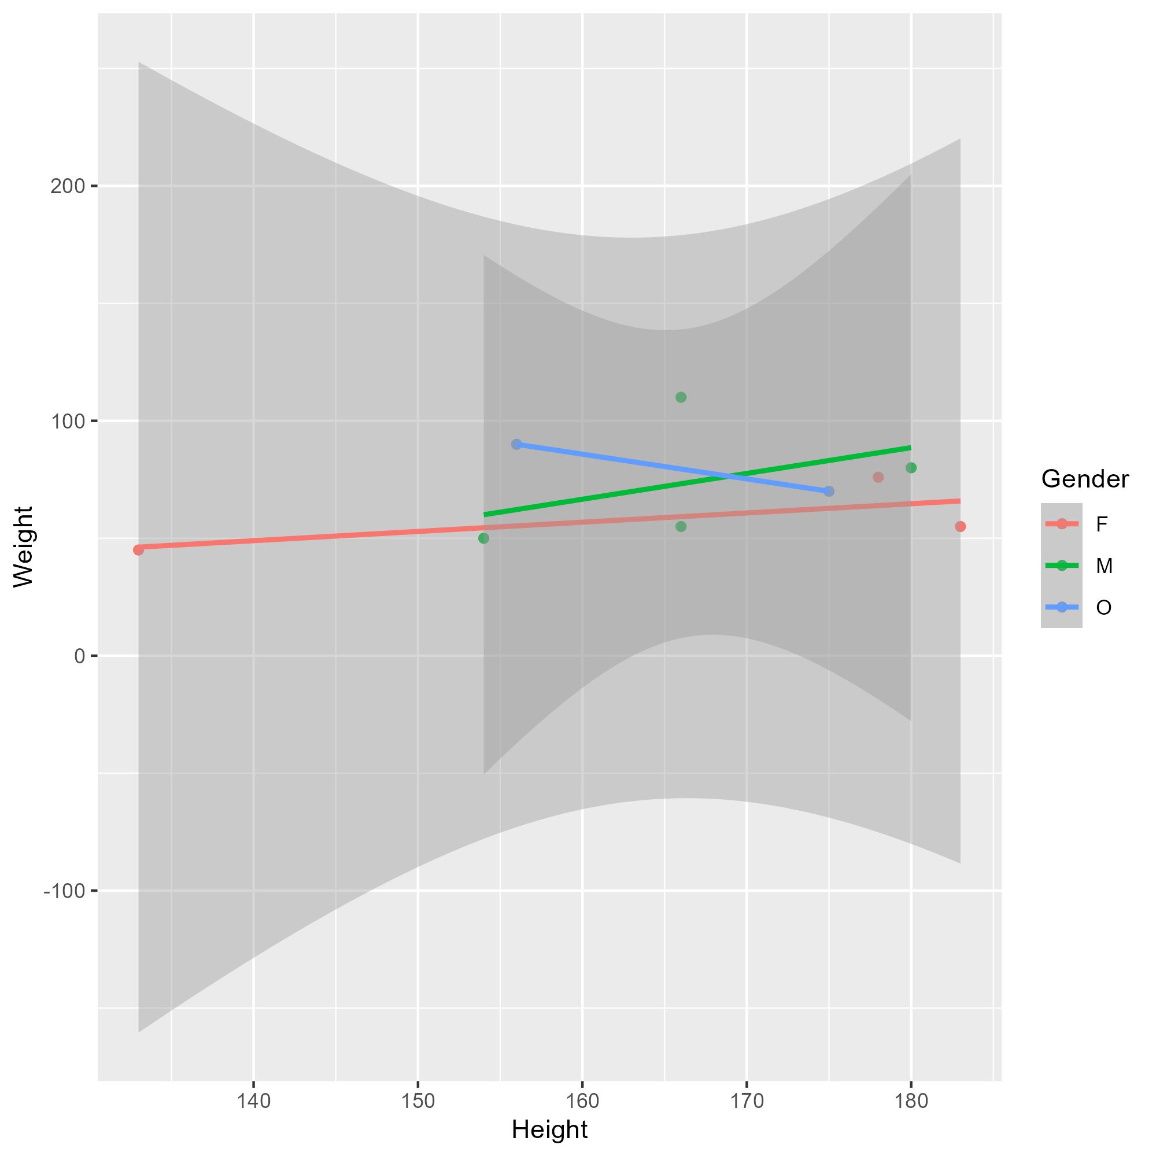
Figure 2: Height and weight stratified by gender.

5.3 Full analysis
Use one or several suitable statistical/machine learning methods to analyze your data and to produce meaningful figures, tables, etc. This might again be code that is best placed in one or several separate R scripts that need to be well documented. You want the code to produce figures and data ready for display as tables, and save those. Then you load them here.
Example Table 2 shows a summary of a linear model fit.
Table 2: Linear model fit table.
term | estimate | std.error | statistic | p.value
(Intercept) | 149.2726967 | 23.3823360 | 6.3839942 | 0.0013962
Weight | 0.2623972 | 0.3512436 | 0.7470519 | 0.4886517
GenderM | -2.1244913 | 15.5488953 | -0.1366329 | 0.8966520
GenderO | -4.7644739 | 19.0114155 | -0.2506112 | 0.8120871

6. Discussion

6.1 Summary and Interpretation
Summarize what you did, what you found and what it means.

6.2 Strengths and Limitations
Discuss what you perceive as strengths and limitations of your analysis.

6.3 Conclusions
What are the main take-home messages?
Include citations in your Qmd file using BibTeX, the list of references will automatically be placed at the end
This paper (3) discusses types of analyses.
These papers (1,2) are good examples of papers published using a fully reproducible setup similar to the one shown in this template.
Note that this cited reference will show up at the end of the document, the reference formatting is determined by the CSL file specified in the YAML header. Many more style files for almost any journal are available. You also specify the location of your BibTeX reference file in the YAML. You can call your reference file anything you like.

7. References
1. McKay B, Ebell M, Billings WZ, et al. Associations Between Relative Viral Load at Diagnosis and Influenza A Symptoms and Recovery. Open forum infectious diseases. 2020;7(11):ofaa494.
2. McKay B, Ebell M, Dale AP, et al. Virulence-mediated infectiousness and activity trade-offs and their impact on transmission potential of influenza patients. Proceedings. Biological sciences. 2020;287(1927):20200496.
3. Leek JT, Peng RD. Statistics. What is the question? Science (New York, N.Y.). 2015;347(6228):1314–1315.

