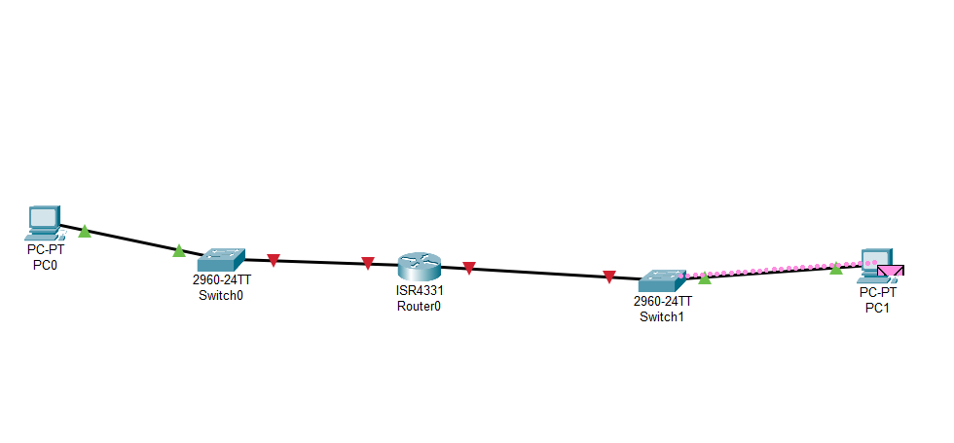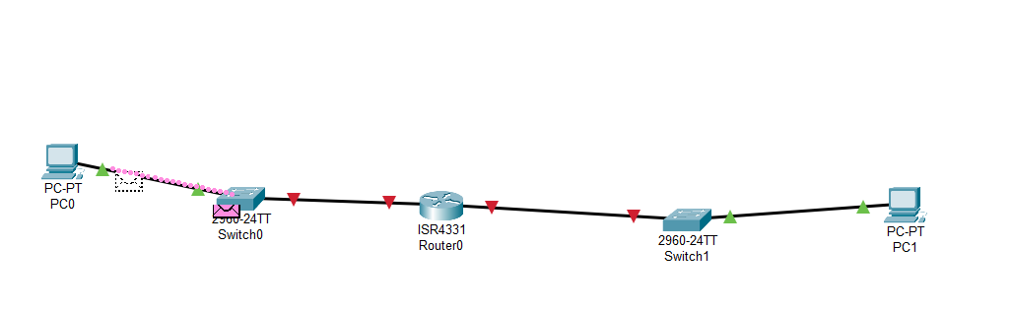

Explanation:

When PC1 pings PC2, the process begins at the **Application Layer**, where an ICMP message is created to check network connectivity. The **Network Layer** then adds the source and destination IP addresses so the packet knows where to go. Next, the **Data Link Layer** attaches the MAC addresses, allowing the packet to move between connected devices. At the **Physical Layer**, the data is transformed into electrical signals and transmitted through the cables. Once PC2 receives the packet, it removes the headers layer by layer, reads the ICMP message, and sends an echo reply back to PC1 to confirm that communication is successful..