TUGAS

PROGRAM JAVA 1



Nama : Aji Kurnia Saputra

NPM : 2016-804-309

**Running Program**

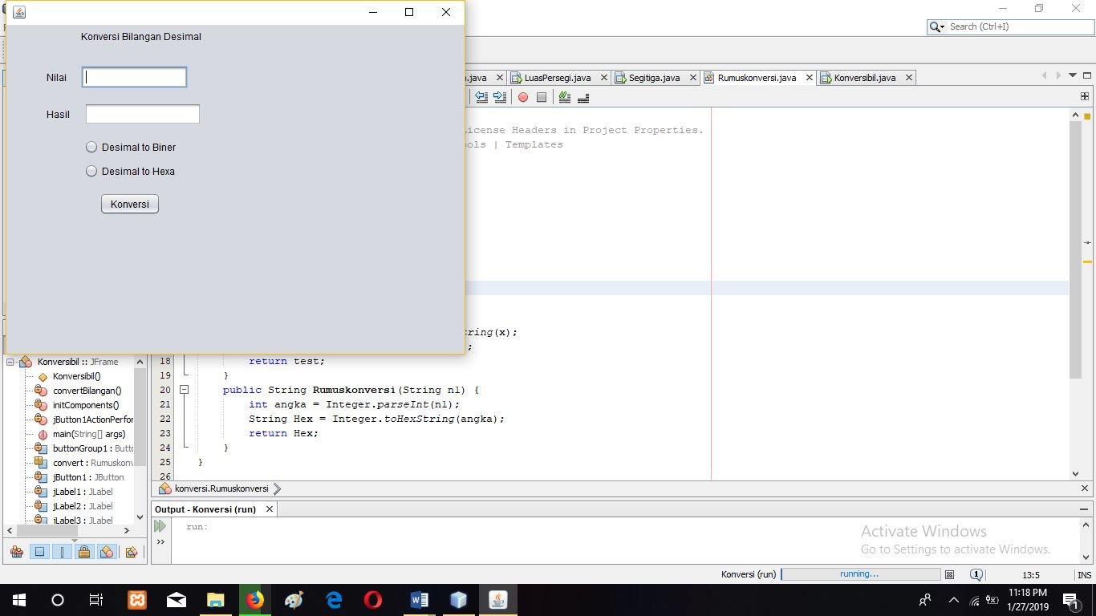

**Desimal to Biner**

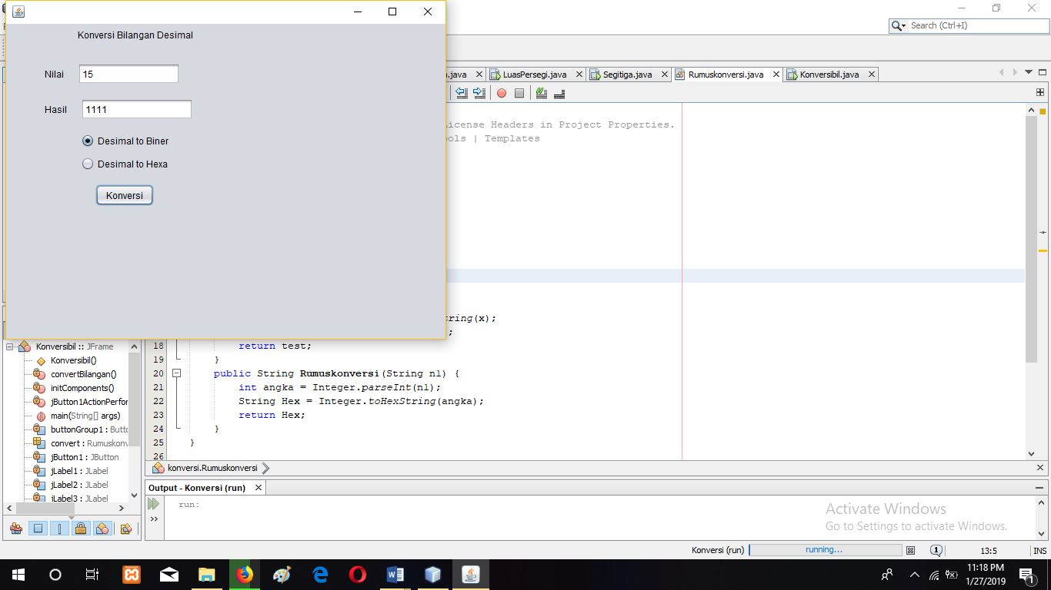

**Desimal to Hexa**

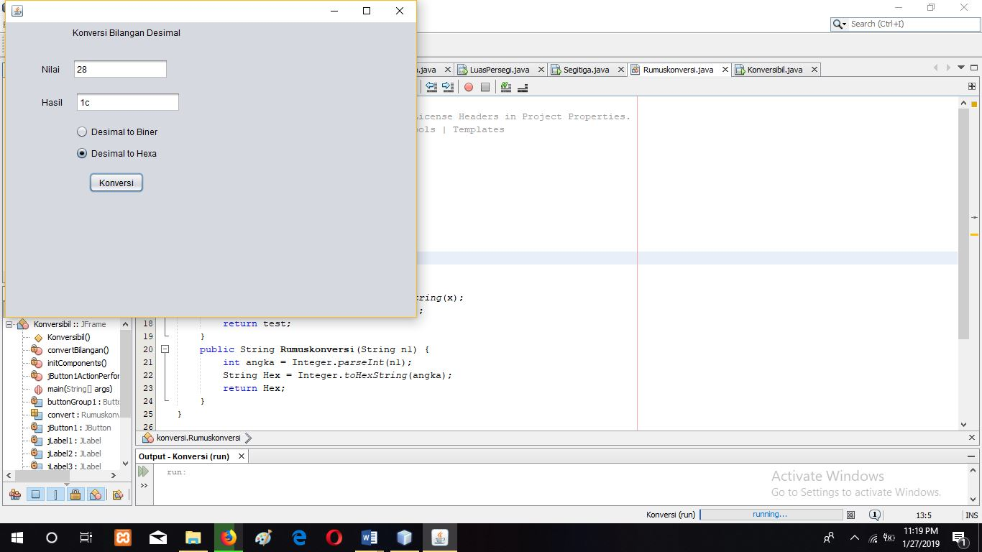

**Source Code :**

**Java Class :**

package konversi;

/**

*

* @author Aji

*/

public class Rumuskonversi {

public int Rumuskonversi(int n1) {

int x = Integer.valueOf(n1);

String Hitung = Integer.toBinaryString(x);

int test = Integer.valueOf(Hitung);

return test;

}

public String Rumuskonversi(String n1) {

int angka = Integer.parseInt(n1);

String Hex = Integer.toHexString(angka);

return Hex;

}

}

**Java jFrameForm :**

package hitung;

import konversi.Rumuskonversi;

import javax.swing.JOptionPane;

/**

*

* @author Aji

*/

public class Konversibil extends javax.swing.JFrame {

Rumuskonversi convert;

/**

* Creates new form Konversibil

*/

public Konversibil() {

initComponents();

convert = new Rumuskonversi();

jTextField2.setEditable(false);

}

/**

* This method is called from within the constructor to initialize the form.

* WARNING: Do NOT modify this code. The content of this method is always

* regenerated by the Form Editor.

*/

@SuppressWarnings("unchecked")

// <editor-fold defaultstate="collapsed" desc="Generated Code">

private void initComponents() {

buttonGroup1 = new javax.swing.ButtonGroup();

jPanel1 = new javax.swing.JPanel();

jLabel1 = new javax.swing.JLabel();

jLabel2 = new javax.swing.JLabel();

jLabel3 = new javax.swing.JLabel();

jTextField1 = new javax.swing.JTextField();

jTextField2 = new javax.swing.JTextField();

jRadioButton1 = new javax.swing.JRadioButton();

jRadioButton2 = new javax.swing.JRadioButton();

jButton1 = new javax.swing.JButton();

setDefaultCloseOperation(javax.swing.WindowConstants.EXIT_ON_CLOSE);

jLabel1.setText("Konversi Bilangan Desimal");

jLabel2.setText("Nilai");

jLabel3.setText("Hasil");

buttonGroup1.add(jRadioButton1);

jRadioButton1.setText("Desimal to Biner");

buttonGroup1.add(jRadioButton2);

jRadioButton2.setText("Desimal to Hexa");

jButton1.setText("Konversi");

jButton1.addActionListener(new java.awt.event.ActionListener() {

public void actionPerformed(java.awt.event.ActionEvent evt) {

jButton1ActionPerformed(evt);

}

});

javax.swing.GroupLayout jPanel1Layout = new javax.swing.GroupLayout(jPanel1);

jPanel1.setLayout(jPanel1Layout);

jPanel1Layout.setHorizontalGroup(

jPanel1Layout.createParallelGroup(javax.swing.GroupLayout.Alignment.LEADING)

.addGroup(jPanel1Layout.createSequentialGroup()

.addGap(44, 44, 44)

.addGroup(jPanel1Layout.createParallelGroup(javax.swing.GroupLayout.Alignment.LEADING, false)

.addGroup(jPanel1Layout.createSequentialGroup()

.addComponent(jLabel3)

.addGap(18, 18, 18)

.addGroup(jPanel1Layout.createParallelGroup(javax.swing.GroupLayout.Alignment.LEADING)

.addComponent(jTextField2)

.addGroup(jPanel1Layout.createSequentialGroup()

.addGroup(jPanel1Layout.createParallelGroup(javax.swing.GroupLayout.Alignment.LEADING)

.addComponent(jRadioButton1)

.addComponent(jRadioButton2)

.addGroup(jPanel1Layout.createSequentialGroup()

.addGap(19, 19, 19)

.addComponent(jButton1)))

.addGap(0, 0, Short.MAX_VALUE))))

.addGroup(jPanel1Layout.createSequentialGroup()

.addComponent(jLabel2)

.addGap(18, 18, 18)

.addGroup(jPanel1Layout.createParallelGroup(javax.swing.GroupLayout.Alignment.LEADING)

.addComponent(jLabel1)

.addComponent(jTextField1, javax.swing.GroupLayout.PREFERRED_SIZE, 133, javax.swing.GroupLayout.PREFERRED_SIZE))))

.addContainerGap(55, Short.MAX_VALUE))

);

jPanel1Layout.setVerticalGroup(

jPanel1Layout.createParallelGroup(javax.swing.GroupLayout.Alignment.LEADING)

.addGroup(jPanel1Layout.createSequentialGroup()

.addComponent(jLabel1)

.addGap(29, 29, 29)

.addGroup(jPanel1Layout.createParallelGroup(javax.swing.GroupLayout.Alignment.BASELINE)

.addComponent(jLabel2)

.addComponent(jTextField1, javax.swing.GroupLayout.PREFERRED_SIZE, javax.swing.GroupLayout.DEFAULT_SIZE, javax.swing.GroupLayout.PREFERRED_SIZE))

.addGap(18, 18, 18)

.addGroup(jPanel1Layout.createParallelGroup(javax.swing.GroupLayout.Alignment.BASELINE)

.addComponent(jLabel3)

.addComponent(jTextField2, javax.swing.GroupLayout.PREFERRED_SIZE, javax.swing.GroupLayout.DEFAULT_SIZE, javax.swing.GroupLayout.PREFERRED_SIZE))

.addGap(18, 18, 18)

.addComponent(jRadioButton1)

.addPreferredGap(javax.swing.LayoutStyle.ComponentPlacement.UNRELATED)

.addComponent(jRadioButton2)

.addGap(18, 18, 18)

.addComponent(jButton1)

.addContainerGap(103, Short.MAX_VALUE))

);

javax.swing.GroupLayout layout = new javax.swing.GroupLayout(getContentPane());

getContentPane().setLayout(layout);

layout.setHorizontalGroup(

layout.createParallelGroup(javax.swing.GroupLayout.Alignment.LEADING)

.addGroup(layout.createSequentialGroup()

.addContainerGap()

.addComponent(jPanel1, javax.swing.GroupLayout.PREFERRED_SIZE, javax.swing.GroupLayout.DEFAULT_SIZE, javax.swing.GroupLayout.PREFERRED_SIZE)

.addContainerGap(273, Short.MAX_VALUE))

);

layout.setVerticalGroup(

layout.createParallelGroup(javax.swing.GroupLayout.Alignment.LEADING)

.addGroup(layout.createSequentialGroup()

.addContainerGap()

.addComponent(jPanel1, javax.swing.GroupLayout.PREFERRED_SIZE, javax.swing.GroupLayout.DEFAULT_SIZE, javax.swing.GroupLayout.PREFERRED_SIZE)

.addContainerGap(70, Short.MAX_VALUE))

);

pack();

}// </editor-fold>

private void jButton1ActionPerformed(java.awt.event.ActionEvent evt) {

convertBilangan();

// TODO add your handling code here:

}

/**

* @param args the command line arguments

*/

public static void main(String args[]) {

/* Set the Nimbus look and feel */

//<editor-fold defaultstate="collapsed" desc=" Look and feel setting code (optional) ">

/* If Nimbus (introduced in Java SE 6) is not available, stay with the default look and feel.

* For details see http://download.oracle.com/javase/tutorial/uiswing/lookandfeel/plaf.html

*/

try {

for (javax.swing.UIManager.LookAndFeelInfo info : javax.swing.UIManager.getInstalledLookAndFeels()) {

if ("Nimbus".equals(info.getName())) {

javax.swing.UIManager.setLookAndFeel(info.getClassName());

break;

}

}

} catch (ClassNotFoundException ex) {

java.util.logging.Logger.getLogger(Konversibil.class.getName()).log(java.util.logging.Level.SEVERE, null, ex);

} catch (InstantiationException ex) {

java.util.logging.Logger.getLogger(Konversibil.class.getName()).log(java.util.logging.Level.SEVERE, null, ex);

} catch (IllegalAccessException ex) {

java.util.logging.Logger.getLogger(Konversibil.class.getName()).log(java.util.logging.Level.SEVERE, null, ex);

} catch (javax.swing.UnsupportedLookAndFeelException ex) {

java.util.logging.Logger.getLogger(Konversibil.class.getName()).log(java.util.logging.Level.SEVERE, null, ex);

}

//</editor-fold>

/* Create and display the form */

java.awt.EventQueue.invokeLater(() -> {

new Konversibil().setVisible(true);

});

}

// Variables declaration - do not modify

private javax.swing.ButtonGroup buttonGroup1;

private javax.swing.JButton jButton1;

private javax.swing.JLabel jLabel1;

private javax.swing.JLabel jLabel2;

private javax.swing.JLabel jLabel3;

private javax.swing.JPanel jPanel1;

private javax.swing.JRadioButton jRadioButton1;

private javax.swing.JRadioButton jRadioButton2;

private javax.swing.JTextField jTextField1;

private javax.swing.JTextField jTextField2;

// End of variables declaration

private void convertBilangan() {

String n1;

String x = jTextField1.getText();

n1 = jTextField1.getText();

if (jRadioButton1.isSelected()) {

int hasil = 0;

if (x != null && x.trim().isEmpty()) {

JOptionPane.showMessageDialog(null, "Masukan Angka");

} else {

int desi = Integer.parseInt(n1);

hasil = convert.Rumuskonversi(desi);

jTextField2.setEditable(false);

jTextField2.setText(String.valueOf(hasil));

}

} else if (jRadioButton2.isSelected()) {

String hasil = null;

if (x != null && x.trim().isEmpty()) {

JOptionPane.showMessageDialog(null, "Masukan Angka");

} else {

hasil = convert.Rumuskonversi(n1);

jTextField2.setEditable(false);

jTextField2.setText(String.valueOf(hasil));

}

}

}

}