**DO FILE**

log using "C:\Users\user\Desktop\aji\STATA.log", replace

use "C:\Users\user\Desktop\aji\STATA\ESS9GB.dta", clear

keep ctzcntr rlgdnm gndr polintr poltran stfdem lrscale prtvtcgb

rename ctzcntr citizenship

rename rlgdnm religion

rename gndr gender

rename polintr politics_interest

rename poltran transparency

rename stfdem democracy_satisfaction

rename lrscale self_placement

rename prtvtcgb vote_choice

drop if missing(citizenship) | missing(religion) | missing(gender) | missing(politics_interest) | missing(transparency) | missing(democracy_satisfaction) | missing(self_placement) | missing(vote_choice)

inspect

tabulate politics_interest

levelsof politics_interest

gen pol_interest_dummy = (politics_interest == 1)

label variable pol_interest_dummy "Very Interested in Politics (Dummy)"

label define pol_interest_labels 0 "Not Very Interested" 1 "Very Interested"

label values pol_interest_dummy pol_interest_labels

summarize

tabulate gender

graph bar (count), over(gender)

graph bar (count), over(pol_interest_dummy)

graph bar (count), over(politics_interest)

graph bar (count), over(citizenship)

save "C:\Users\user\Desktop\aji\STATA\new_data.dta"

histogram democracy_satisfaction

graph box religion

ttest politics_interest, by(citizenship)

tabulate religion gender, chi2

corr democracy_satisfaction self_placement

corr democracy_satisfaction transparency

corr self_placement gender

corr transparency politics_interest

corr politics_interest gender

corr gender pol_interest_dummy

log close

**LOG FILE**

**do "C:\Users\user\Desktop\aji\STATA\DoFile.do"**

**log using "C:\Users\user\Desktop\aji\STATA.log", replace**

name: <unnamed>

log: C:\Users\user\Desktop\aji\STATA.log

log type: text

opened on: 28 Oct 2023, 07:20:33

**use "C:\Users\user\Desktop\aji\STATA\ESS9GB.dta", clear**

**keep ctzcntr rlgdnm gndr polintr poltran stfdem lrscale prtvtcgb**

**rename ctzcntr citizenship**

**rename rlgdnm religion**

**rename gndr gender**

**rename polintr politics_interest**

**rename poltran transparency**

**rename stfdem democracy_satisfaction**

**rename lrscale self_placement**

**rename prtvtcgb vote_choice**

**drop if missing(citizenship) | missing(religion) | missing(gender) | missing(politics_interest) | missing(transparency) | missing(democracy_satisfaction) | missing(self_placement) | missing(vote_choice)**

(1,512 observations deleted)

**gen pol_interest_dummy = (politics_interest == 1)**

**label variable pol_interest_dummy "Very Interested in Politics (Dummy)"**

**label define pol_interest_labels 0 "Not Very Interested" 1 "Very Interested"**

**label values pol_interest_dummy pol_interest_labels**

**tabulate gender**

Gender | Freq. Percent Cum.

------------+-----------------------------------

Male | 291 42.05 42.05

Female | 401 57.95 100.00

------------+-----------------------------------

Total | 692 100.00

**graph bar (count), over(gender)**

**graph bar (count), over(pol_interest_dummy)**

**graph bar (count), over(politics_interest)**

**graph bar (count), over(citizenship)**

**histogram democracy_satisfaction**

(bin=26, start=0, width=.38461538)

**graph box religion**

**ttest politics_interest, by(citizenship)**

Two-sample t test with equal variances

------------------------------------------------------------------------------

Group Obs Mean Std. err. Std. dev. [95% conf. interval]

---------+--------------------------------------------------------------------

Yes | 671 2.19225 .0345998 .8962606 2.124313 2.260187

No | 21 2.428571 .2020305 .9258201 2.007143 2.85

---------+--------------------------------------------------------------------

Combined 692 2.199422 .034114 .8973992 2.132442 2.266401

---------+--------------------------------------------------------------------

diff | -.2363211 .1988099 -.6266661 .154024

------------------------------------------------------------------------------

diff = mean(Yes) - mean(No) t = -1.1887

H0: diff = 0 Degrees of freedom = 690

Ha: diff < 0 Ha: diff != 0 Ha: diff > 0

Pr(T < t) = 0.1175 Pr(|T| > |t|) = 0.2350 Pr(T > t) = 0.8825

**tabulate religion gender, chi2**

**corr democracy_satisfaction self_placement**

(obs=692) | democr~n self_p~t

-------------+------------------

democracy_~n | 1.0000

self_place~t | 0.2720 1.0000

**corr democracy_satisfaction transparency**

(obs=692)| democr~n transp~y

-------------+------------------

democracy_~n | 1.0000

transparency | 0.3616 1.0000

**corr self_placement gender**

(obs=692) | self_p~t gender

-------------+------------------

self_place~t | 1.0000

gender | -0.0741 1.0000

**corr transparency politics_interest**

(obs=692) | transp~y politi~t

-------------+------------------

transparency | 1.0000

politics_i~t | -0.0711 1.0000

**corr politics_interest gender**

(obs=692)| politi~t gender

-------------+------------------

politics_i~t | 1.0000

gender | 0.1927 1.0000

**corr gender pol_interest_dummy**

(obs=692) | gender pol_in~y

-------------+------------------

gender | 1.0000

pol_intere~y | -0.1919 1.0000

end of do-file

**Analysis of Figures**

**Histogram of Politics Interest in the country**

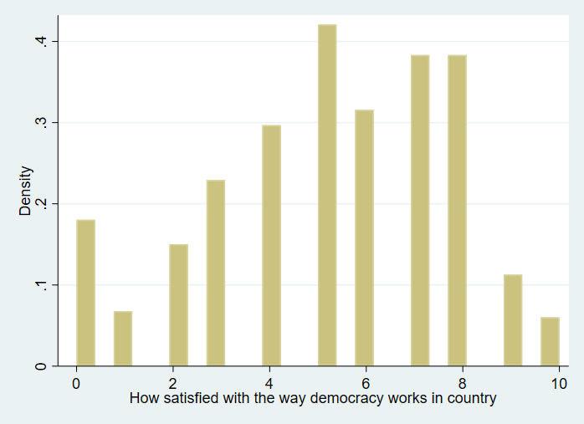

The histogram visually represents the distribution of satisfaction levels among residents of the country, measured on a scale of 0 to 10. Notably, the graph exhibits a peak between the 6 and 8 satisfaction range, signifying that a substantial proportion of the population is experiencing a growing sense of satisfaction with the state of democracy over time. This concentration in the 6-8 range suggests an overall positive trend in democratic satisfaction among respondents.

**Boxplot of Religion Distribution**

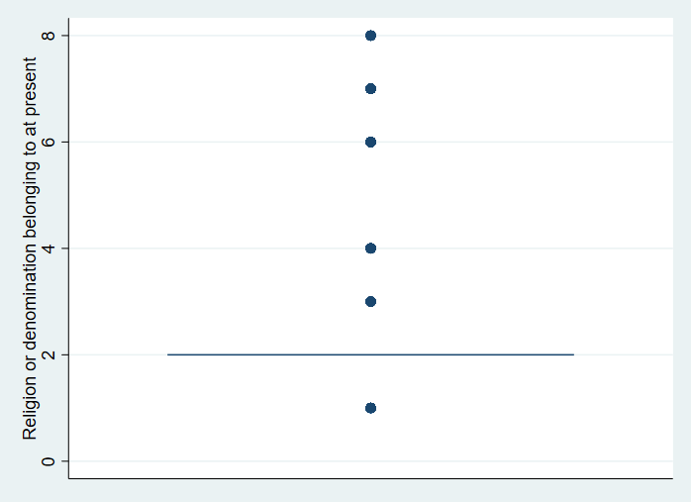

The depicted boxplot provides an overview of the distribution of religious affiliations within the population, highlighting the presence of seven distinct categories representing different religious perspectives. Notably, this plot illustrates that citizens in the country engage in a diverse array of religious practices, and these affiliations are dispersed evenly across the geographical regions, suggesting a random and widespread distribution of religious beliefs among the population.

**Analysis of Tables**

T-TEST of Politics Interest and Citizens

|  |  |  |  |  |  |  |
| --- | --- | --- | --- | --- | --- | --- |
| Group | Obs. | Mean | Std. error | Std. dev | 95% conf. | interval |
| Yes  No | 671  21 | 2.19225  2.428571 | .0345998  .2020305 | .8962606  .9258201 | 2.124313  2.007143 | 2.260187  2.85 |
| Combined | 692 | 2.199422 | .034114 | .8973992 | 2.132442 | 2.266401 |
| Diff |  | -.2363211 | .1988099 |  | -.6266661 | .154024 |

**Exploring the Influence of Citizenship on Politics Interest:**

In this analysis, we sought to investigate whether citizenship status has a significant impact on individuals' levels of interest in politics. To address this question, we performed a two-sample t-test, comparing the politics interest scores of citizens and non-citizens.

**Understanding the Test Results**

**Citizens (Yes)**: Our findings revealed that citizens, labeled as "Yes" in the dataset, exhibited an average politics interest score of approximately 2.192. This score was measured on a scale from 0 to 10, indicating a moderate level of interest in political matters.

**Non-Citizens (No)**: Conversely, non-citizens, designated as "No," had an average politics interest score of roughly 2.429. This score, also on the same 0-10 scale, suggests a slightly higher degree of interest in politics among this group.

**Interpreting the P-Value**

One of the critical aspects of the t-test is the associated p-value, which assists in drawing conclusions about the significance of the observed differences. In this case, the p-value computed was 0.1175.

A p-value provides insights into the likelihood of observing the observed differences (or more extreme differences) if there were no substantial distinction in politics interest between citizens and non-citizens. In essence, it tells us whether the differences we observed are likely due to chance or if they reflect a genuine difference.

**The Significance Level (Alpha)**: In hypothesis testing, a common significance level (alpha) is typically set at 0.05. If the p-value is less than alpha (0.05), it suggests that there is a compelling case to reject the null hypothesis, indicating a significant difference.

**Interpreting the Result**:

In our analysis, the p-value obtained was 0.1175, which is higher than the common alpha of 0.05. This outcome indicates that we do not have strong evidence to conclude that there is a significant difference in politics interest scores between citizens and non-citizens.

Therefore, it is reasonable to assert that the minor difference in average politics interest scores between the two groups is likely due to random variability rather than being a meaningful and statistically significant distinction. In other words, the data does not support the notion that citizenship status substantially influences one's level of interest in politics.

**CH2 TEST on Religion and Gender**

|  |  |  |  |
| --- | --- | --- | --- |
| Religion or  denomination  belonging to at  present | MALE | FEMALE | TOTAL |
| Roman Catholic | 57 | 72 | 129 |
| Protesteant | 192 | 276 | 489 |
| Eastern Orthodox | 2 | 4 | 6 |
| Other Christian Demon | 11 | 13 | 24 |
| Islam | 12 | 16 | 28 |
| Eastern Religions | 13 | 13 | 26 |
| Other Non-Christian Religion | 4 | 7 | 11 |
| Total | 291 | 401 | 692 |

The Pearson chi-squared test is a statistical method used to evaluate the relationship between two categorical variables, in this case, "religious denominations" and "gender." It aims to determine whether there is a significant association or independence between these two variables. The test generates a chi-squared statistic, which is used to calculate a p-value. In this particular test, the chi-squared statistic is 1.5989, and the associated p-value is 0.953.

To better understand the results of this chi-squared test, let's break it down step by step:

**Test Objective**

The primary goal of this chi-squared test is to investigate whether there is a significant connection between the religious denominations individuals belong to and their respective genders.

**Data Presentation**:

The data is presented in a contingency table that cross-tabulates "religious denominations" and "gender." This table displays the counts of individuals falling into different religious denominations (such as Roman Catholic, Protestant, and others) and their corresponding gender categories (Male and Female). It allows us to see how many individuals fall into each combination of religious denomination and gender.

**Key Observations**:

In the contingency table, we can observe specific counts within each category. For instance, we note that 57 males identify as Roman Catholic, and 72 females also identify with this religious denomination. This information gives us insights into the distribution of religious affiliations among both males and females.

**Chi-Squared Statistic**:

The chi-squared statistic (Pearson chi2) quantifies the difference between the observed and expected counts in the contingency table. It helps us understand whether the observed distribution of data significantly deviates from what we would expect if there were no association between religious denominations and gender.

**P-Value**:

The p-value is a crucial component of the chi-squared test results. It quantifies the probability of observing the observed data (or more extreme data) if there were no association between the variables (i.e., if they were independent). In this case, the p-value is calculated to be 0.953.

**Interpretation:**

The high p-value of 0.953 is a key takeaway from this test. It suggests that there is no strong evidence to support a significant association between an individual's religious denomination and their gender. In simpler terms, it indicates that an individual's gender does not appear to have a substantial influence on their choice of religious denomination, and conversely, religious denomination does not significantly impact an individual's gender.

In summary, the chi-squared test results indicate that, in this dataset, gender and religious denomination are not strongly linked or dependent on each other. This suggests that people's religious affiliations are not determined by their gender, and gender does not play a significant role in shaping one's religious choices.

**NOTABLE FIGURES AND INTERPRETATIONS:**

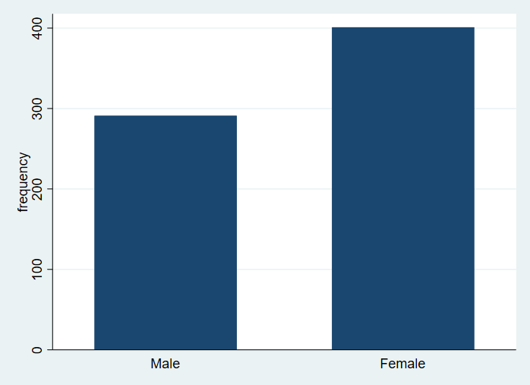

The bar chart above shows the frequency of male and female, it shows there are higher numbers of females in the data compared to male

Building on our earlier findings regarding politics and gender, the data suggests that gender does not significantly influence individuals' levels of political interest. This conclusion aligns with our previous observation that gender does not strongly affect one's choice of religious denomination, reaffirming the idea that both political interest and religious affiliation appear to be independent of an individual's gender in this dataset.

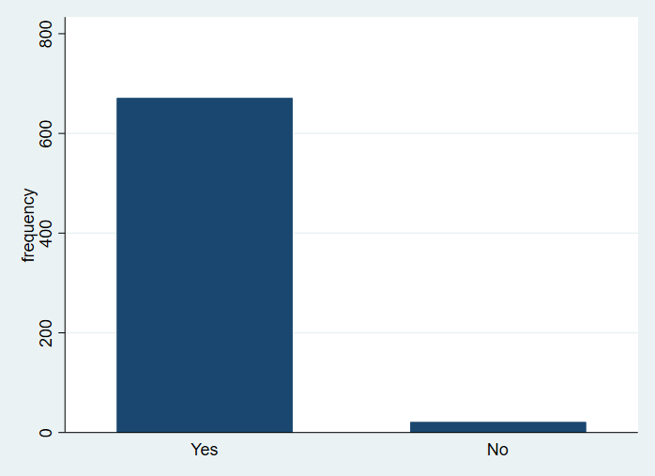

In connection to our earlier findings on politics and citizenship, the bar chart presents the distribution of citizenship status within the country. Notably, the chart reveals a relatively smaller number of non-citizens compared to a significantly higher percentage of citizens. This observation underscores the concept that citizenship status does not strongly affect an individual's political interest, further highlighting that citizenship and political engagement are distinct variables in this dataset.