Project Report


EduConnect: A Web-Based Platform for Academic Collaboration and Resource Sharing

SUBMITTED BY

Mohammad Ajij
Roll No: MUH2011023M
Session: 2019-2020
Year 04, Term 02
Department of ICE, NSTU

PROJECT SUPERVISOR

Md. Mahbubul Alam
Assistant Professor
Department of ICE, NSTU

DEPARTMENT OF INFORMATION AND COMMUNICATION ENGINEERING
NOAKHALI SCIENCE AND TECHNOLOGY UNIVERSITY
JULY 2025

DECLARATION
This project report is submitted to the Department of Information and Communication Engineering, Noakhali Science and Technology University. I declare that this project report has not been submitted for any kind of degree, diploma or publication.

Mohammad Ajij
ID: MUH2011023M
Session: 2019-20

ACCEPTANCE
This project report is presented to the Department of Information and Communication Engineering at Noakhali Science and Technology University, Noakhali, as a partial requirement for the completion of the Bachelor of Science (B.Sc.) degree in Information and Communication Engineering.

Md. Mahbubul Alam
Assistant Professor
Department of Information and Communication Engineering
Noakhali Science and Technology University

ACKNOWLEDGEMENT

I want to thank Allah Ta'ala for giving me the courage and chance to work on my project, which is titled "EduConnect: A Web-Based Platform for Academic Collaboration and Resource Sharing" I would like to express my gratitude to my supervisor, Md. Mahbubul Alam Sir, for all of his creative suggestions, insightful advice, constant inspiration, and steadfast support during this project. Completing my project would have been extremely challenging without his help. I also want to express my gratitude to all of my instructors at the Department of Information and Communication Engineering (ICE) for their wise counsel and help with my courses. Lastly, I express my deepest gratitude to my parents for their love, dreams, and sacrifices throughout my life.

ABSTRACT

A structured academic platform is crucial for minimizing distractions and promoting effective collaboration among students, teachers, and administrators. To address this, EduConnect was developed as a web-based academic environment offering centralized tools for discussion, resource sharing, schedule management, and AI-assisted study support. The platform incorporates features such as class and exam timetable systems, group collaboration spaces, real-time notifications, and user-specific dashboards. Developed using HTML, CSS, JavaScript, PHP, MySQL, and Bootstrap, the system follows an incremental model and includes four key user modules: Admin, Teacher, Student, and Visitor. Research methods involved functional analysis, requirement gathering, and iterative interface design. Academic users were selected as the sample population, and the system’s effectiveness was evaluated through testing, feedback, and usability validation. EduConnect ultimately fosters academic engagement, resource accessibility, and collaborative learning by combining educational functionality with an intuitive digital interface.

TABLE OF CONTENT
DECLARATION ii
ACCEPTANCE iii
ACKNOWLEDGEMENT iv
ABSTRACT v
TABLE OF CONTENT vii
LIST OF TABLES xii
LIST OF FIGURES xiii
CHAPTER 1
INTRODUCTION 1 - 4
1.1 Introduction 1
1.2 Background Study 1
1.3 Problem Statement 2
1.4 Objectives 3
1.5 Motivation of the work 3
1.6 Scope of the Study 4
CHAPTER 2
LITERATURE REVIEW 5 - 7
2.1 Introduction 5
2.2 Related Works 5
CHAPTER 3
METHODOLOGY 8 - 25
3.1 Introduction 8
3.1.1 Admin Module 8
3.1.2 Student Module 9
3.1.3 Teacher Module 9
3.1.4 Visitor Module 10
3.2 Requirement Specification 10
3.2.1 Functional Requirement 10
3.2.2 Non-Functional Requirements 11
3.3 Process Model 12
3.3.1 Waterfall Model 12
3.3.2 Iterative Model 13
3.3.3 Spiral Model 13
3.3.4 Incremental Process Model 13
3.4 System Design 14
3.4.1 Use-Case Diagram Design 15
3.4.2 E-R Diagram Design 16
3.5 Database Design 16
3.5.1 User Registration Table 17
3.5.2 Class Schedule Table 17
3.5.3 Exam Schedule Table 18
3.5.4 User Post Table 18
3.5.5 Class Note Table 18
3.5.6 Available Groups Table 19
3.5.7 Group Post Table 19
3.5.8 Group Members Table 19
3.5.9 Academic Syllabus Table 20
3.5.10 Notifications Table 20
3.5.11 Notices Table 20
3.5.12 Personal Note Table 21
3.5.13 Personal Task Lists Table 21
3.5.14 Teacher Class Schedule Table 21
3.5.15 Teacher Exam Schedule Table 22
3.6 System Implementation 22
3.6.1 Software Requirements 22
3.6.2 Hardware Requirements 23
3.7 Technologies and Tools 23
3.7.1 Technologies for Client-Side Scripting 23
3.7.2 Technologies Server-Side Scripting 23
3.7.3 Hosting and version control system 24
3.7.4 Database Related Tools 24
3.8 Testing 25
3.9 Conclusion 25
CHAPTER 4
RESULT AND DISCUSSION 26 - 57
4.1 Student Module 26
4.1.1 Home Page 26
4.1.2 Registration Page 27
4.1.3 Login Page 28
4.1.4 Academic Interaction Hub 29
4.1.5 Class Schedule Page 30
4.1.6 Exam Schedule Page 31
4.1.7 Smart User Finder Module 31
4.1.8 Note Sharing Page 32
4.1.9 Study Materials Explorer 32
4.1.10 Group Management Hub 35
4.1.11 Private Notes Archive 38
4.1.12 Smart Task Tracker 39
4.1.13 Notification Panel 40
4.1.14 Unified Profile Hub 40
4.1.15 View User Profile 42
4.2 Admin Module 43
4.2.1 Admin Dashboard 43
4.2.2 Class Schedule Management 43
4.2.3 Notice Management Panel 45
4.2.4 Exam Schedule Management 45
4.2.5 Academic Syllabus Management 47
4.2.6 Approve New Users 47
4.3 Teacher Module 48
4.3.1 Home Page 48
4.3.2 Login Page 49
4.3.3 Registration Page 50
4.3.4 Class Schedule Management 50
4.3.5 Exam Schedule Management 52
4.4 Visitor Module 54
4.4.1 Student Dashboard 54
4.4.2 Notice Board Overview 54
4.4.3 Academic Syllabus Overview 55
4.4.4 Academic AI Assistant Chat Module 56
4.4.5 Contact & Support Form 57
CHAPTER 5
CONCLUSION AND FUTURE WORK 58
5.1 Conclusion 58
5.2 Future Work 58
REFERENCES 59

LIST OF TABLES

Table No | Title | Page
3.1 | Tools used for Diagram Design | 15
3.2 | Software Requirement of the system | 22
3.3 | Hardware Requirements of the System | 23

LIST OF FIGURES

Figure No. | Title | Page
3.1 | Incremental Life Cycle Model | 13
3.2 | Use Case Diagram | 15
3.3 | E-R Diagram | 16
3.4 | User Registration Table | 17
3.5 | Class Schedule Table | 17
3.6 | Exam Schedule Table | 18
3.7 | User Post Table | 18
3.8 | Class Note Table | 18
3.9 | Available Groups Table | 19
3.10 | Group Post Table | 19
3.11 | Group Members Table | 19
3.12 | Academic Syllabus Table | 20
3.13 | Notifications Table | 20
3.14 | Notices Table | 20
3.15 | Personal Note Table | 21
3.16 | Personal Task Lists Table | 21
3.17 | Teacher Class Schedule Table | 21
3.18 | Teacher Exam Schedule Table | 22
4.1 | Home Page | 27
4.2 | Registration Page | 28
4.3 | Login Page | 28
4.4 | Post Creation Box | 29
4.5 | Shared Post with Comment Feature | 30
4.6 | Class Schedule Page | 30
4.7 | Exam Schedule Page | 31
4.8 | Smart User Finder Module | 31
4.9 | Semester Selection Page for Note Share Panel | 32
4.10 | Note Upload Page | 32
4.11 | Semester and Course Display Page | 33
4.12 | Course and Note Type Selection Page | 33
4.13 | Available Notes Viewer Page | 34
4.14 | Latest Uploaded Notes | 34
4.15 | Group Directory Page | 35
4.16 | Group Admin Panel | 35
4.17 | Group Creation Interface | 36
4.18 | My Groups Page | 36
4.19 | Collaborative Group Forum | 37
4.20 | Group Member Management | 38
4.22 | Note Upload Interface | 38
4.23 | Organized Note Management Panel | 39
4.24 | Smart Task Tracker Panel | 39
4.25 | Notification Panel | 40
4.26 | User Dashboard Page | 41
4.27 | Profile Edit Interface | 41
4.28 | View User Profile | 42
4.29 | Admin Dashboard Page | 43
4.30 | Update Class Schedule Page | 44
4.31 | Class Schedule Editing Panel | 44
4.32 | Notice Management Panel | 45
4.33 | Update Exam Schedule Page | 46
4.34 | Exam Schedule Editing Panel | 46
4.35 | Syllabus Management Panel | 47
4.36 | User Management Panel | 47
4.37 | Teacher Home Page | 49
4.38 | Teacher Login Page | 49
4.39 | Teacher Registration Page | 50
4.40 | Update Class Schedule Page (Teacher) | 51
4.41 | View Daily Teaching Schedule | 51
4.42 | Class Schedule Editing Panel (Teacher) | 52
4.43 | Exam Management Panel | 52
4.44 | Exam Schedule Editing Panel | 53
4.45 | Track Exam Schedules | 53
4.46 | Student Dashboard (Visitor) | 54
4.47 | Notice Board Overview | 54
4.48 | View Academic Syllabus | 55
4.49 | Filter Syllabus by Term | 56
4.50 | AI Query Panel | 56

CHAPTER 1

INTRODUCTION

Introduction
A Web-Based Platform for Academic Collaboration and Resource Sharing is a digital solution developed to streamline structured communication and academic engagement among students, teachers, and administrators. It provides a focused and distraction-free environment where users can participate in discussions, share educational materials, and stay updated with academic schedules replacing the fragmented experience of relying on general-purpose social media platforms.
The platform incorporates interactive features such as posts, comments, and reactions to create a familiar and user-friendly experience. However, it intentionally excludes non-academic elements like games, event sharing, or entertainment feeds. This ensures that all interactions within the system remain aligned with academic objectives and contribute to a productive learning ecosystem.
Key functionalities of EduConnect include AI-powered assistance, group study rooms, a smart search system, class and exam schedule displays, and real-time notifications. Built with technologies like HTML, CSS, PHP, and MySQL, the system is responsive and accessible across devices. By combining user-centric design with essential academic tools, EduConnect promotes efficiency, collaboration, and digital advancement within the educational environment.

Background Study

The concept for EduConnect originated from the growing reliance of students on unstructured social media channels like Facebook for academic discussions. While these platforms offer convenience, they often introduce distractions, reduce focus, and lack the organizational tools needed for effective academic engagement. Existing methods—such as sharing notes through group chats or relying on inconsistent class announcements—were found to be disorganized and inefficient. EduConnect addresses these challenges by offering a distraction-free, feature-rich digital solution focused solely on learning. Key elements like collaborative group spaces, AI tutors, academic wikis, and two-way notice boards are designed to replicate beneficial communication structures while minimizing off-topic disruptions. The goal is to replace fragmented communication practices with a unified, student-oriented system that enhances productivity and academic interaction.

Problem Statement

In today's academic environment, students and teachers frequently rely on general-purpose social media platforms—particularly Facebook—for the exchange of academic information. While these platforms enable communication, they also introduce distractions and lack features tailored to educational needs. The absence of a dedicated system for academic collaboration results in inefficiencies such as wasted time, unproductive engagement, and poor resource organization.

The key challenges faced within current systems include:

- Distractions caused by non-academic content on social platforms.
- Disorganized sharing of notes, resources, and study materials.
- Inconsistent delivery of class schedules and exam notification
- Fragmented and ineffective communication among students and faculty
- Limited tools that meet the structured needs of academic activities
- Heavy dependence on platforms not designed for instructional use.

These issues highlight the urgent need for a focused, distraction-free web platform that supports structured communication, timely scheduling, academic content management, and productive collaboration. To address these challenges, this project proposes EduConnect—a web-based academic platform specifically designed to enhance educational interaction, improve information flow, and support students and educators through integrated academic modules and smart collaboration tools. The system emphasizes user-specific access, ensuring that each stakeholder—whether student, teacher, or administrator—interacts with features tailored to their role. By fostering a centralized environment, EduConnect aims to bridge gaps in digital education and promote more effective academic engagement.

Objectives

The primary goal of this web-based platform is to create a focused and distraction-free academic environment that promotes student engagement, streamlines communication, and offers a suite of tools for effective learning. EduConnect serves as a centralized system for sharing academic content, managing class and exam schedules, receiving updates, and accessing collaborative resources—all tailored to meet the needs of modern learners.

The following are the objectives of the system:
- To create a distraction-free platform for academic collaboration.
- To enable sharing of posts, comments, and academic discussions.
- To replace social media with an education-focused system.
- To provide class and exam schedule updates in real time.
- To support group study with video rooms and screen sharing.
- To offer AI-based study recommendations and smart search functionality.
- To maintain organized access to class notes and learning materials.
- To allow users to manage personal profiles, schedules, and settings.
- To send instant notifications and alerts for timely academic updates.
EduConnect is a web-based academic platform designed to support students, teachers, and administrators in sharing resources, managing schedules, and collaborating in a focused, distraction-free environment. It includes features like academic posts, group study tools, AI assistance, and real-time notifications to enhance learning and streamline communication.

Motivation of the work

The motivation for developing EduConnect arises from the need to reduce distractions and time wastage caused by using general social media platforms like Facebook for academic purposes. While such platforms support communication, they often divert students from their studies due to non-academic content. EduConnect is designed to create a focused, education-oriented environment that enhances learning through features like AI-powered study assistance, group discussions, exam alerts, class schedules, and centralized sharing of study materials. Tools such as group video study rooms and personalized dashboards further support organization and collaboration. The platform aims to replace inefficient practices with a system that encourages productivity, academic engagement, and structured knowledge sharing. Moreover, many students face difficulties accessing class notes, schedules, and updates in an organized way. EduConnect solves this by offering a centralized platform, reducing reliance on informal channels and ensuring reliable, secure academic communication.

Scope of the Study
This project aims to develop a web-based platform that enhances collaborative learning among students while providing a distraction-free environment for academic resource sharing. The system is designed to support core academic functionalities, such as real-time communication, intelligent study tools, and organized information access. Key features include group video study rooms, AI-powered tutoring, exam and schedule notifications, and a structured note-sharing system.
- Develop a web platform for academic discussions and collaboration.
- Enable group video study rooms with whiteboard and screen sharing.
- Integrate AI for study suggestions, search, and exam support.
- Provide notifications for exams, class schedules, and semester updates.
- Allow users to share and access class notes by subject and term.
- Support profile, password, and calendar management.
- Reduce academic dependence on social media through a focused system.
This project focuses on building a web-based platform to enhance academic collaboration among students in a distraction-free environment. It includes features such as group video study rooms, AI-based learning support, real-time alerts, and organized note sharing. The system allows users to manage their profiles and schedules while promoting effective academic communication without relying on social media. Developed with HTML, CSS, and PHP, the platform is accessible, user-friendly, and scalable for future academic use.

CHAPTER 2

LITERATURE REVIEW

Introduction

In order to understand the information and concepts pertaining to web-based academic collaboration platforms it is important to read published work done by experts in the field. The purposes of this review are to review, examine, and gain knowledge regarding the design and operations of online systems that support educational communication and exchange of resources. This paper aims at discussing the principles of the web-based academic platform development and presents the main arguments of the scholars and practitioners of related disciplines. It relies with systematic literature review on similar known systems such as educational networking platforms and resource sharing tools to create ground for the proposed project.

Related Works

Several researchers have examined the impact of digital and social platforms on academic performance. The following literature highlights the need for structured academic environments that minimize distractions and enhance learning through focused, collaborative tools.

Academic platforms designed for focused learning, as discussed by Rosen et al. [1] in 2013 help reduce distractions and enhance students’ academic performance by providing an environment tailored to effective learning.

According to Manca and Ranieri [2] in 2016, the features of Computer-Mediated Communication (CMC) should be integrated with academic resources in educational platforms. Their findings emphasized that well-designed systems effectively capture students’ attention while minimizing distractions.

Greenhow et al. [3] in 2009 found that although students used social media for collaborative learning, they were often distracted. The study recommended the development of dedicated academic platforms to mitigate these distractions.

According to Selwyn [4] who explored the role of Social Networking Sites (SNS) in education, such platforms tend to divert learners from their academic objectives. He suggested that purpose-built educational platforms can better support collaborative learning by reducing complexity and unnecessary features in 2009.

Junco et al. [5] in 2011 revealed that frequent use of Facebook among university students leads to increased distractions and reduced academic performance. This underscores the importance of structured academic platforms that encourage productive collaboration.

Surowiecki [6] in 2005 take a look at collective intelligence and stressed that having shared stockpiling enhances collective learning. In enabling students to post information and seek information, platforms increase the scope of knowledge disbursement.

Pea [7] in 1993 reviewed how educational technology reduces cognitive load in the works flow review process managing the works flow tools such as class schedules and examination notification aids performance.

Kirschner and Karpinski [8] Studies show a negative correlation between social network use, especially Facebook, and student grades, highlighting how unstructured academic tools can become distractions in 2010.

Dabbagh and Kitsantas [9] in 2012 explored how Personal Learning Environments (PLEs) supported by social media can enhance self-regulated learning. However, they emphasized that without proper structure and guidance, these tools may overwhelm learners instead of supporting effective education.

Hrastinski and Aghaee [10] in 2012 examined student preferences in online learning environments and found that while learners valued interaction, they preferred platforms specifically designed for academic tasks over general-purpose social media, due to better alignment with their study goals.

Roblyer et al. [11] in 2010 found that while students were open to using social media for learning, faculty were concerned about its lack of structure and distractions. They highlighted the need for dedicated academic platforms aligned with curriculum goals.

Madge et al. [12] in 2009 investigated Facebook use among university students and found that although it supported social bonding, students were reluctant to use it for academic purposes due to its informal and distracting nature.

Veletsianos and Navarrete [13] in 2012 highlighted that while emerging technologies promote open and flexible learning, the absence of academic-oriented structure often leads to distractions and reduced focus, calling for platforms tailored to academic engagement.

Cain and Policastri [14] in 2011 studied pharmacy students’ use of Facebook and concluded that the social nature of the platform often conflicted with academic needs. They recommended separating social and academic interactions through dedicated platforms to ensure better learning outcomes.

According to Redecker et al. [15] in 2011, Socialmedia can aid learning and collaboration, but lacks structure. Researchers suggest creating academic platforms with social media features, including organized discussions and resource sharing.

Bosch [16] found that although Facebook facilitated student communication, it lacked academic structure and contributed to distraction. The study advocated for alternative platforms designed specifically to meet educational needs in 2009.
The reviewed studies highlight that while social media platforms support communication, they often distract students and reduce academic performance. Researchers agree that structured, purpose-built academic platforms are more effective for focused learning and collaboration. Therefore, developing a platform like EduConnect aligns with the need for a secure, organized, and distraction-free academic environment.

CHAPTER 3

METHODOLOGY

Introduction
The software development methodology is a process or collection of processes used in software development. This is the most important part of any project development. In this section, I will discuss the development process briefly of my system.
The project is divided in 4 modules.
- Admin module
- Student module
- Teacher module
- Visitor module

Admin Module

Admin module will have the following elements:
  - Admin Dashboard
  - User Management Panel
  - Class Schedule Management
  - Exam Schedule Management
  - Notice Management Panel
  - Academic Syllabus Management
The Admin Module provides centralized control for managing the platform. It allows administrators to approve new users, create and update class and exam schedules, publish academic notices, and manage the academic syllabus. This module ensures smooth coordination and efficient administration across all user levels. It also helps maintain data accuracy and platform integrity by allowing real-time updates and monitoring.

Student Module

Student module will have the following elements:
  - Home Dashboard
  - Registration and Login System
  - Class Schedule Viewer
  - Exam Schedule Viewer
  - Academic Interaction Hub
  - Note Sharing Panel
  - Study Materials Explorer
  - Smart User Finder
  - Group Management System
  - Private Notes Archive
  - Smart Task Tracker
  - Notification Panel
  - Unified Profile Hub
  - View User Profile
The Student Module offers access to schedules, study materials, note sharing, group interactions, and task tracking, all through a user-friendly dashboard.

Teacher Module

Teacher module will have the following elements:
  - Home Dashboard
  - Registration and Login System
  - Class Schedule Management
  - Exam Schedule Management
  - Resource Sharing Panel
  - Newsfeed Panel
  - Campus View Panel
The Teacher Module enables teachers to manage class and exam schedules, share resources, and interact with students through a dedicated dashboard.

Visitor Module

Visitor module will have the following elements:
- Student Dashboard
- Notice Board Overview
- AI Academic Assistant Module
- Contact & Support Form
The Visitor Module allows users to access notices, syllabus, routines, and results without login. It also includes AI academic assistance and a contact form for support.

Requirement Specification

Requirement Specification provides brief explanation about the goals that a system, product or project should pursue, taking into account both functional and non-functional requirements.

Functional Requirement

These define the services the system must provide, how it should handle inputs, and how it should behave in specific situations:

- Register / Sign Up
Students, teachers, and admins can register by providing required details.
- Authentication
System validates login credentials before granting access.
- Login
Users log in with email and password to access their dashboard.
- Profile Update
Users can update personal details from their dashboard.
- Class & Exam Schedule Management
Admins and teachers can create or edit schedules; students can view them.
- Post Creation and Interaction
Users can create posts, react, comment, and share academic content.
- Note Sharing
Users can upload and access notes based on course and semester.
- Study Material Search
Allows filtering and browsing of academic content.
- Group Management
Users can create, join, and manage academic discussion groups.
- Group Forum
Group members can post and interact in private forums.
- Private Notes
Users can upload and manage personal study materials.
- Task Tracker
Users can add and track academic or personal tasks.
- Notifications
Real-time alerts for schedules, posts, and updates.
- User Finder
Search for users by name, batch, location, or blood group.
- AI Assistant
Users can get academic help through the AI chat interface.
- Contact & Feedback
Visitors and users can contact admin or submit feedback.

Non-Functional Requirements

Non-functional requirements are those that outline the qualities, restrictions, and requirements that a system or product must possess in addition to its primary functionality.

- Usability Requirement
The system should be easy to use on both desktop and mobile, with a clean and intuitive interface requiring no special training.
- Availability Requirement
The platform must be accessible 24/7 throughout the academic year, ensuring no unexpected downtime.
- Efficiency Requirement
In case of system failure, recovery must be completed within one hour to minimize disruptions.
- Accuracy Requirement
All academic data, including schedules and notes, must be updated in real time with high accuracy and consistency.
- Performance Requirement
The system should respond to user actions within 2 seconds, with up to 5 seconds allowed for heavier operations.
- Error Handling
The system should handle both expected and unexpected errors smoothly while protecting data and guiding the user.
- Security Requirement
Sensitive data and administrative functions should only be accessible to authorized users, with role-based access control in place.

Process Model
A programming process model is a model which is an abstract depiction of a method from a specific viewpoint. There are a variety of broad software process models, including the waterfall model, evolutionary development, formal systems development, and reuse-based development, among others. This research will view the following four models:
- Waterfall model
- Iteration model
- Spiral model
- Incremental Model

Waterfall Model

The Waterfall model is similar to a step-by-step process for developing computer software. In this model, you must complete one phase before moving on to the next, similar to how water flows down a waterfall. So, it's a loop where you go through each step one after the other until you're finished [17].

Iterative Model

This model is based on a loop in the software development process. It starts with creating a small version of the software that takes into account all of the steps. Then, in each round, more elements, features are added. Each time this loop is completed [18].

Spiral Model

The Spiral Model is a risk-driven software development approach combining prototyping and the Waterfall model. Each loop represents a development phase, with risk evaluation being a key focus throughout [19].

Incremental Process Model

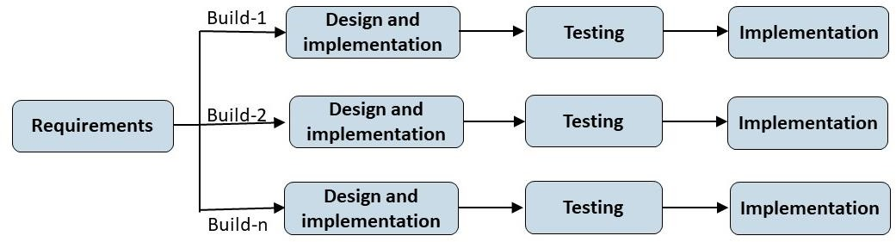
The Incremental Model breaks the project into smaller parts, developed in cycles with planning, building, and testing for each. It delivers usable software early and adds features over time. This model suits the project due to its structured, step-by-step approach [20].

Figure 3. 1: Incremental life cycle model

The Reason Why I used Incremental Process Model:

- The full system's requirements are well-defined and comprehended.
- Primary requirements are specified, though certain details may evolve over time.
- There's a necessity to launch the product in the market timely.
- Integration of new technology is underway.
- Resources with needed skill set are not available.
- There are specific high-risk features and objectives.

System Design
The system is design depends on the problem analysis and the requirements analysis. Based on this, I will try to design this system in such a way that will give users faster execution of the system.
The system design consists of 2 parts:

- Use case diagram design
- E-R diagram

Based on these designs, the system is developed using the selected programming languages and tools. This process transforms the design model into a functional web application. In the EduConnect academic platform, the system is divided into four main modules: Admin, Teacher, Student, and Visitor. A centralized user database is used to identify the role of each user and redirect them to their respective module. Each module provides role-specific features such as schedule management, academic collaboration, resource sharing, and profile handling to ensure a smooth and secure user experience.

I will use the following tools to design the Use-case diagram and E-R diagram.

Table 3.1 : Tools used for Use-Case Diagram, E-R diagram Design

Use-Case Diagram Designing Tool | Edrawmax
E-R Diagram Designing Tool | Draw.io

Use-Case Diagram Design

The use case diagram illustrates how different users interact with the system, highlighting the specific features and functionalities each user can access and operate within the platform.

The user interactions and system functionalities are illustrated in the following Use Case Diagram:

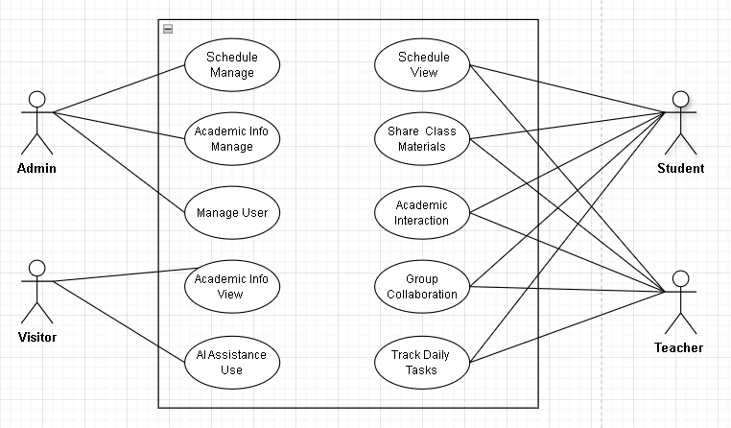

Figure 3. 2: Use case diagram for the system

The use case diagram illustrates how different users interact with the EduConnect system based on their roles. Admins manage users, schedules, and academic content; teachers and students can view schedules, share materials, collaborate in groups, and engage in academic discussions; while visitors have limited access, such as viewing public academic info and using AI tools. Each role is linked to specific functionalities to ensure a focused and organized academic environment. This visual representation helps developers and stakeholders understand system behavior clearly, defines role-based access control, and ensures all core interactions are addressed during the design and development phases.

E-R Diagram Design

The E-R diagram illustrates how entities and their associated attributes are interconnected within the system. It visually represents the structure of the database by showing the relationships between different entities and how they interact with each other.

The entity-relation of the database model is shown by the following E-R diagram:
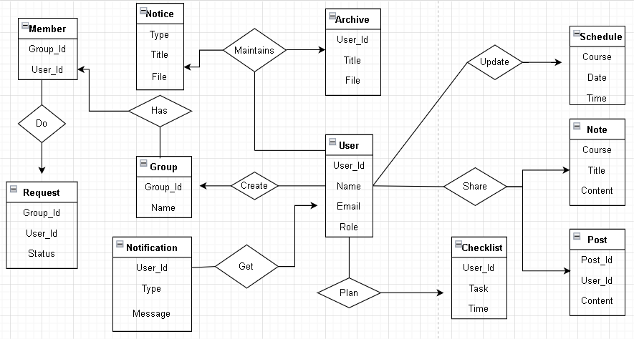
Figure 3. 3: E-R diagram for the system

This ER diagram outlines key entities in an academic platform. Users can create groups, share posts, notes, and archives, and manage schedules and checklists. Group members can request to join, receive notifications, and access notices; all relationships are mapped through user roles and interactions.

Database Design

The creation of a comprehensive data model for a database is referred to as database design. This logical data model includes all logical and physical design elements, along with the physical storage attributes necessary to develop a design using a data definition language, which can then be utilized to construct a database [21].

For this project, it involved identifying entities like students, teachers, and admins, along with their relationships, to build a structured data model. This model defines how data is stored, accessed, and managed using tables, forms, and queries within the DBMS, ensuring smooth interaction and functionality across all modules of the web application. The database used in my project is mentioned below, which ensures organized and efficient data management throughout the system.

User Registration Table
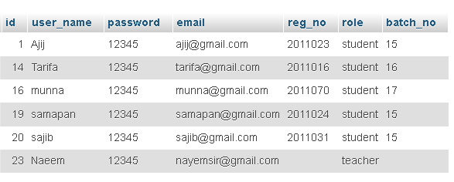

Figure 3.4: User Registration Table

Class Schedule Table
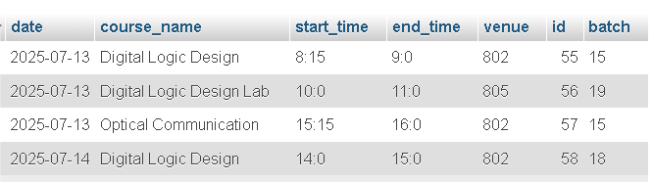

Figure 3.5: Class Schedule Table

Exam Schedule Table

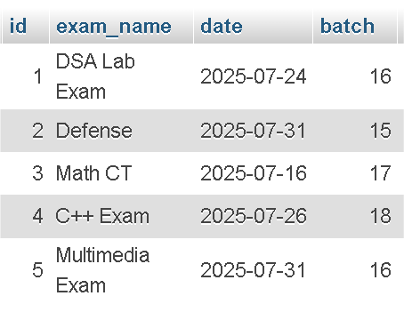

Figure 3.6: Exam Schedule Table

User Post Table

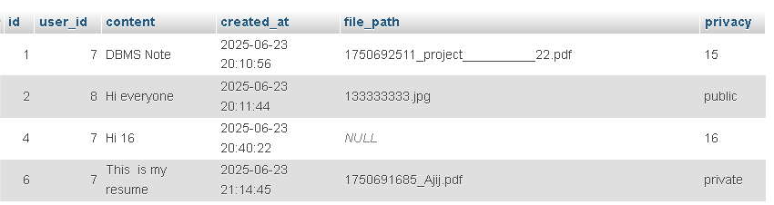

Figure 3.7: User Post Table

Class Note Table

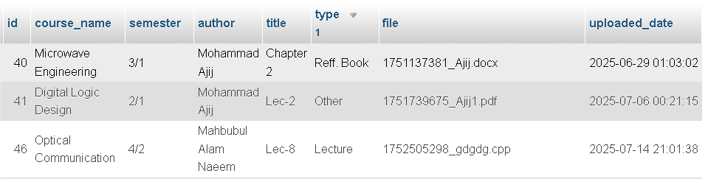

Figure 3.8: Class Note Table

Available Groups Table

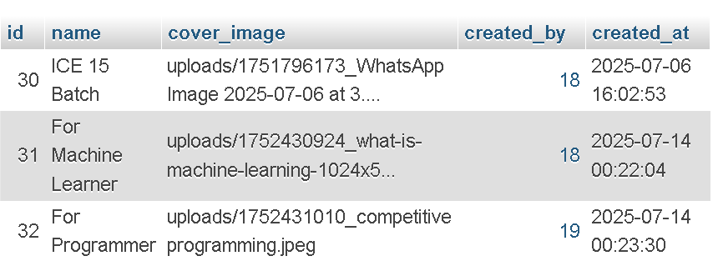

Figure 3.9: Available Groups Table

Group Post Table

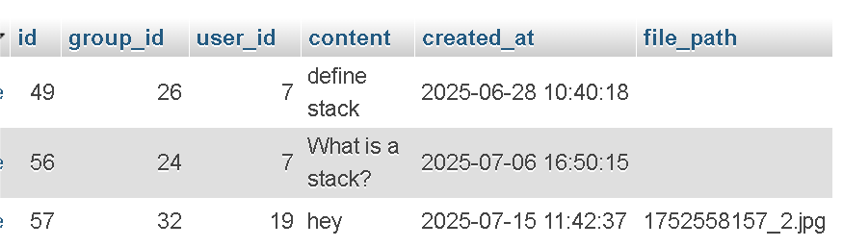

Figure 3.10: Group Post Table

Group Members Table

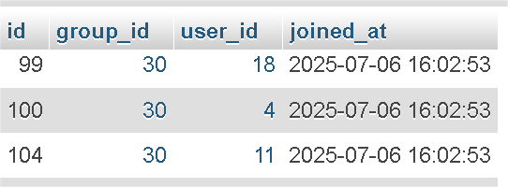

Figure 3.11: Group Members Table

Academic Syllabus Table

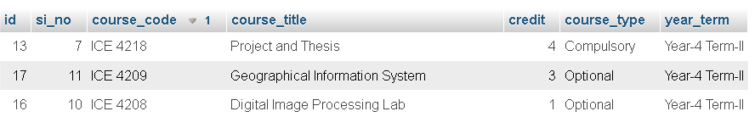

Figure 3.12: Academic Syllabus Table

Notifications Table

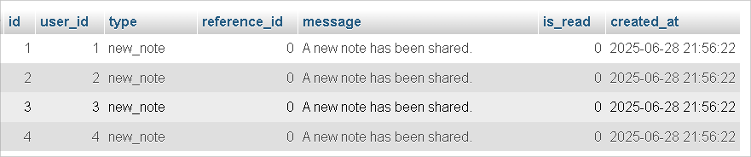

Figure 3.13: Notifications Table

Notices Table

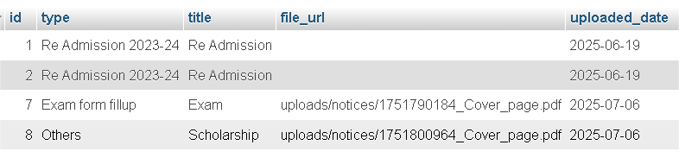

Figure 3.14: Notices Table

Personal Note Table

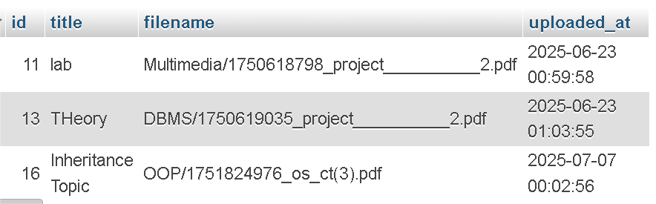

Figure 3.15: Personal Note Table

Personal Task Lists Table

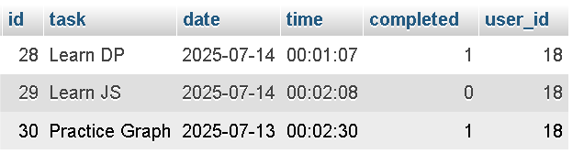

Figure 3.16: Personal Task Lists Table

Teacher Class Schedule Table

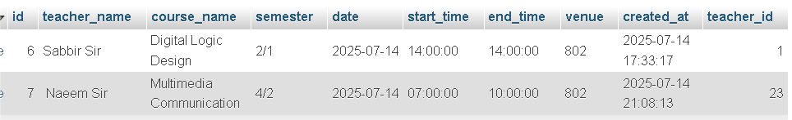

Figure 3.17: Teacher Class Schedule Table

Teacher Exam Schedule Table

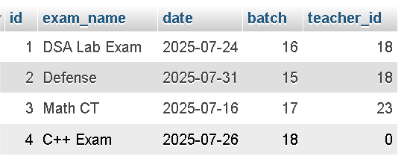

Figure 3.18: Teacher Exam Schedule Table

System Implementation

This process includes figuring out how the information system should look, making sure it works properly, and checking that it meets quality standards. It covers building the system, making it work, and ensuring it's of good quality.

Software Requirements

The following software will be used to complete the project:

Table 3. 2: Software Requirement of the system

Operating system | Linux, Windows XP or later
Browser | Google Chrome, Firefox
Editor | Notepad++, Visual Studio Code, Sublime Text or any text editor.

Hardware Requirements

The following hardware will be used to complete the project:

Table 3. 3 : Hardware Requirements of the System

Processor | Standard Processor
RAM | 2GB RAM or more
Hard Disk | 50 GB or more
Keyboard, Monitor, Mouse | Standard

Technologies and Tools

Basically, LAMP stack will be used for this project. In this client-server architecture, there are two categories of tools for creating this project. To develop this software project, I am going to use the following technologies.

Technologies for Client-Side Scripting

- HTML (Hypertext Markup Language)
- CSS (Cascading Style Sheets)
- Bootstrap (CSS Framework)
- JavaScript

Technologies Server-Side Scripting

- PHP (Hypertext Preprocessor)

Hosting and version control system

- Heroku (for free hosting)
- GIT (for version control system)
- XAMPP (for development and testing PHP applications)

Database Related Tools

- Mysql

(i) HTML:
HTML is the core language of the web, structuring and organizing online content. "Hypertext" refers to links connecting web pages across sites. While HTML builds the content, CSS styles it, and JavaScript adds interactivity. HTML enables sharing and linking content across the World Wide Web [22].

(ii) CSS:
CSS (Cascading Style Sheets) is a simple method for improving the visual aspects of web documents, such as fonts, colors, and spacing [23]. This stylesheet language is used to define the looks of HTML or XML documents by specifying how elements should be displayed across different mediums such as screens, print, speech, and other forms of media [24].

(iii) Bootstrap:
Bootstrap is an open-source CSS framework for developing responsive, mobile-first front-end web applications. It provides CSS-based design templates for components such as typography, forms, buttons, navigation, and various interface components, with the capability to include JavaScript [25].

(iv) Java Script:
JavaScript is a programming language that adds interactivity to websites. It makes static pages dynamic, enhancing user experience. Used in browsers, servers, and apps for actions like clicks, animations, and timers. [26].

(v) PHP (Hypertext Preprocessor):
PHP is a server-side scripting language ideal for dynamic, database-driven websites. It works efficiently with MySQL to handle CRUD operations and backend tasks. Supports user authentication, data submission, and complex queries. Connects to MySQL via native extensions like MySQL or PDO [27]

(vi) MySQL:
MySQL is a popular open-source RDBMS developed by Oracle, known for reliability, scalability, and performance. It uses SQL for data access and supports ACID transactions, making it ideal for web applications. Available under GPL and commercial licenses [28].

(vii) Git:
Git is an open-source distributed version control system designed to help developers manage and track changes to their code over time. Unlike older centralized version control systems, Git is distributed, allowing each developer to have a full copy of the code base on their local machine [29].

Testing
The project is extensively tested across multiple contexts, containing disparate browsers, operating systems, hardware, and data. Making ensuring the product satisfies user expectations and technical requirements is the aim of software testing. The software modules are subjected to testing. Software testing includes both validation and proofing. There are two methods used in software testing [30].

Conclusion
This chapter presented the step-by-step methodology for developing EduConnect, covering system design, tools, technologies, and testing. Using the Incremental Model, the platform was built module-wise with a focus on functionality, usability, and reliability.

CHAPTER 4

RESULT AND DISCUSSION

After implementing the academic web application titled “Web-Based Platform for Academic Discussions and Resource Sharing,” the system was structured into several integrated module– Student module, Teacher module, Visitor module and Admin module. The outcomes of this academic web application project are outlined below:

Student Module

The Student Module provides students with access to key features like the dashboard, class schedules, notes, study materials, and group interactions to manage their academic activities efficiently.

Home Page

The dashboard appears when a user visits the platform's main URL.

Top Navigation Bar
Provides access to the following sections:
- Home
- Profile
- Group
- Notifications
- Dashboard
- Logout

It also includes a user search bar for quickly finding users or posts.

Main Dashboard Sections

The Main Dashboard Consists of Four Key Sections for Streamlined Academic Management:

- Class Schedule Panel
Displays the current day's classes along with time and room details. Users can click the "Update" button to refresh the schedule.

- Newsfeed Panel
Allows users to post text or upload files. Users can also interact with posts through like, dislike, and comment options.

- Exam Panel
Lists upcoming exams with date and title. Includes an "Update" button for modifications.

- Note Sharing Panel
Enables users to browse existing class notes or upload and share their own.

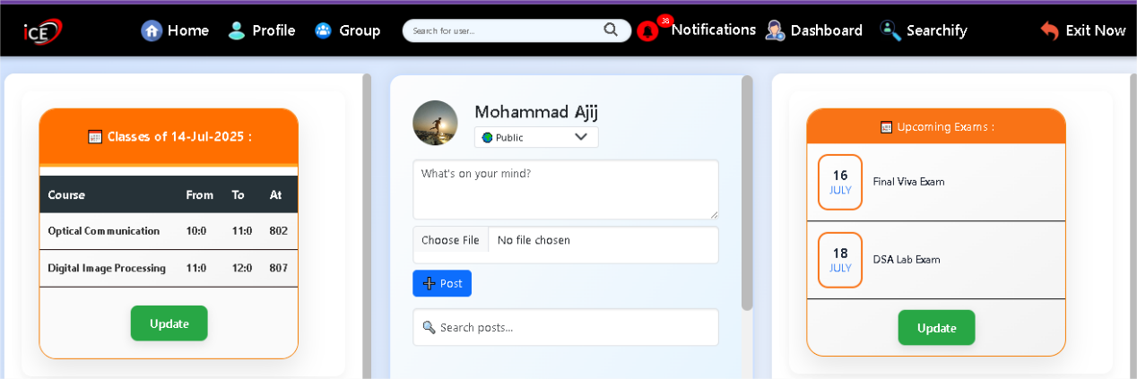
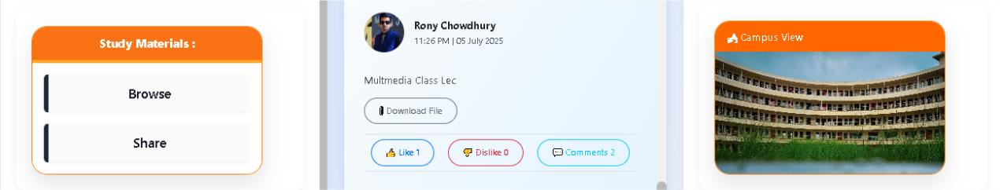

Figure 4.1: Home Page

Registration Page

This registration form allows new users to create an account by submitting personal, academic, and contact details. After signing up, the request goes to the admin for approval. Once approved, users can log in and access all platform features.
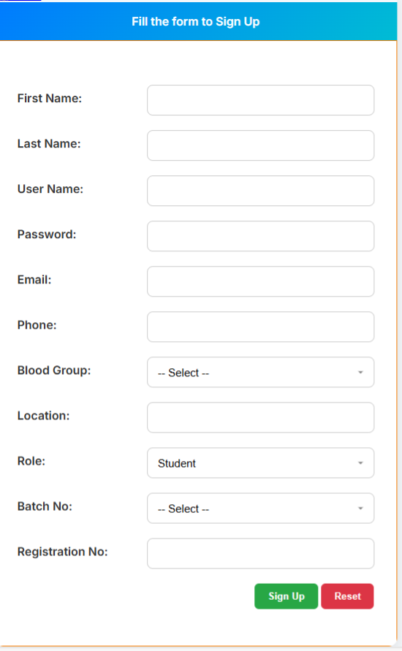
Figure 4.2: Registration Page

Login Page

After registration, user can login their account by inserting valid email address and password. The system also includes options for password recovery and keeps the login process secure to protect user information.
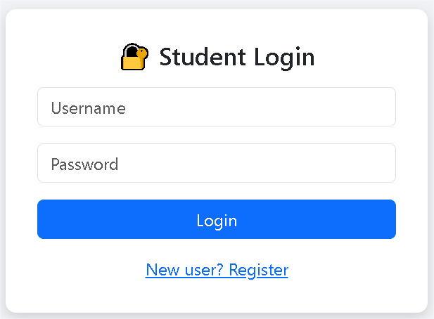
Figure 4.3: Login Page

Academic Interaction Hub

This module provides a centralized space for users to share academic posts, ask questions, upload files, and engage with others through comments and reactions. It fosters collaborative learning and communication within the platform. Users can easily contribute content, participate in discussions, and access valuable resources shared by peers or teachers, enhancing overall academic interaction.

Post Creation Box Page
Users use this section to share thoughts or academic content by typing a message and uploading files. Privacy can be managed by selecting the desired batch or section, allowing posts to be shared only with specific groups.

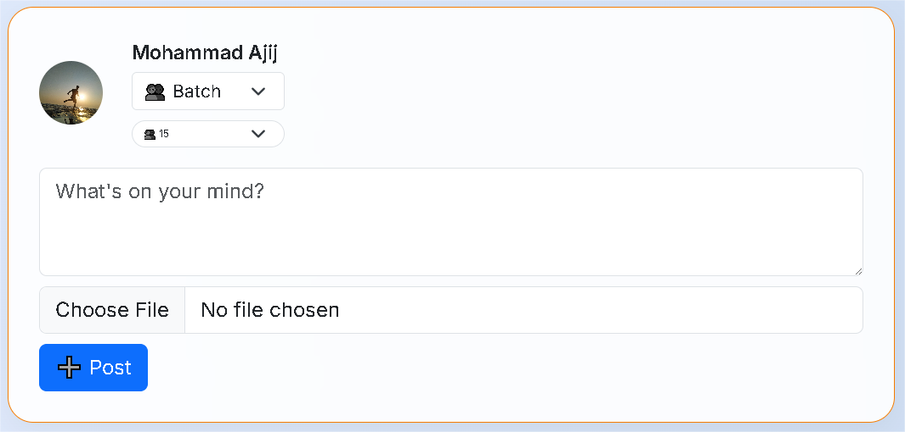

Figure 4.4: Post Creation Box

Shared Post with Comment Interaction Panel

This page displays a shared post along with options to like, dislike, and comment, enabling interactive engagement among users. Students can view and write comments, allowing for quick feedback and discussion. The “Download File” button ensures easy access to shared class materials or updates, streamlining resource distribution. These features collectively promote collaborative learning, real-time communication, and a more connected academic environment.

. 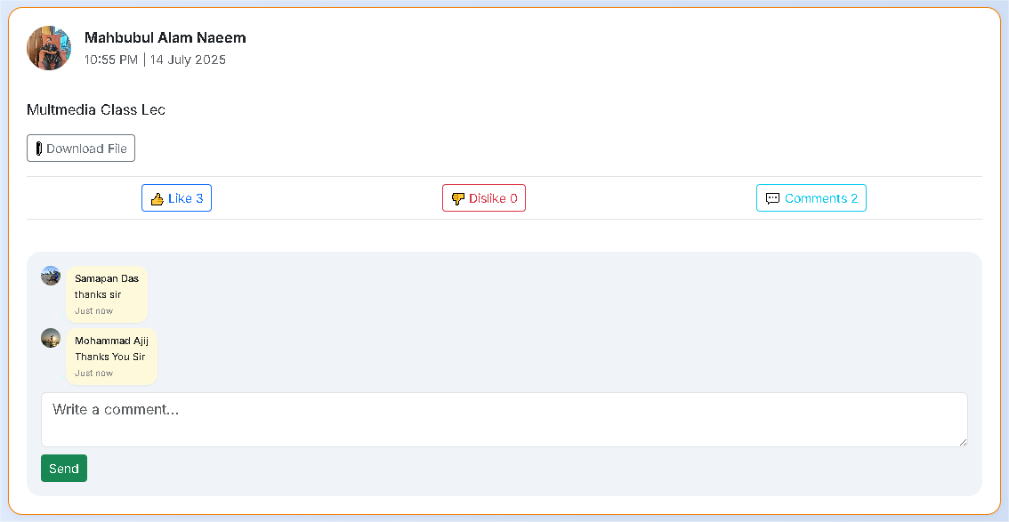
Figure 4.5: Shared Post with Comment Feature

Class Schedule Page

Users can see this type of class schedule to stay informed about their daily academic sessions, including course timing and room allocation. It ensures timely attendance and better class management.

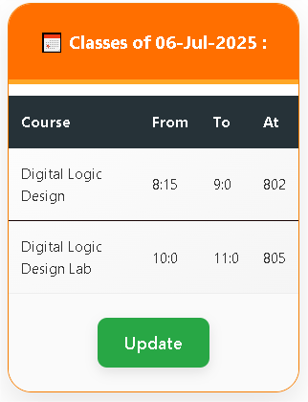
Figure 4.6: Class Schedule Page

Exam Schedule Page

Users can see this type of exam schedule page to stay updated about their upcoming exams. It helps them manage their preparation and plan accordingly.

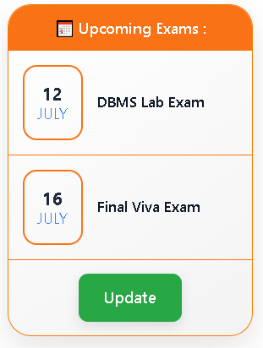
Figure 4.7: Exam Schedule Page

Smart User Finder Module

This module helps users quickly find others by filtering based on name, blood group, location, and batch, making academic connection and collaboration easier. It enhances networking opportunities by providing accurate and fast search results tailored to user needs.
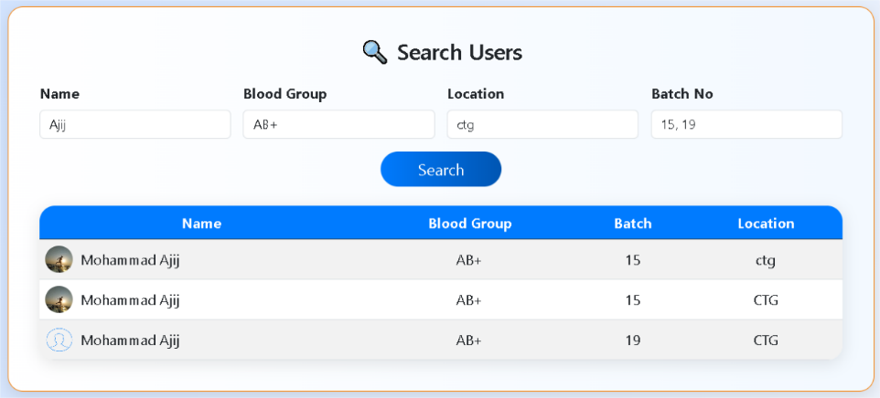

Figure 4.8: Smart User Finder Module

Note Sharing Page

These pages allow users to share their academic notes based on term and subject, upload files, and manage their academic syllabus entries efficiently.

Semester Selection Interface
This page allows users to choose their academic term for which they want to share notes. It acts as an entry point to categorize notes by batch and term.
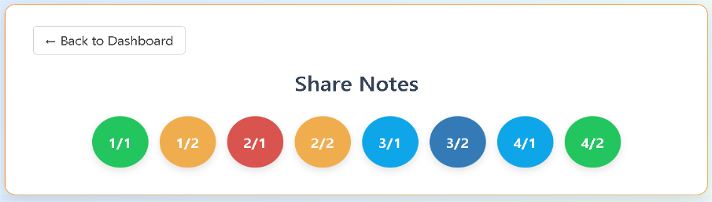
Figure 4.9: Semester Selection Page for Note Share Panel

Note Upload Page:
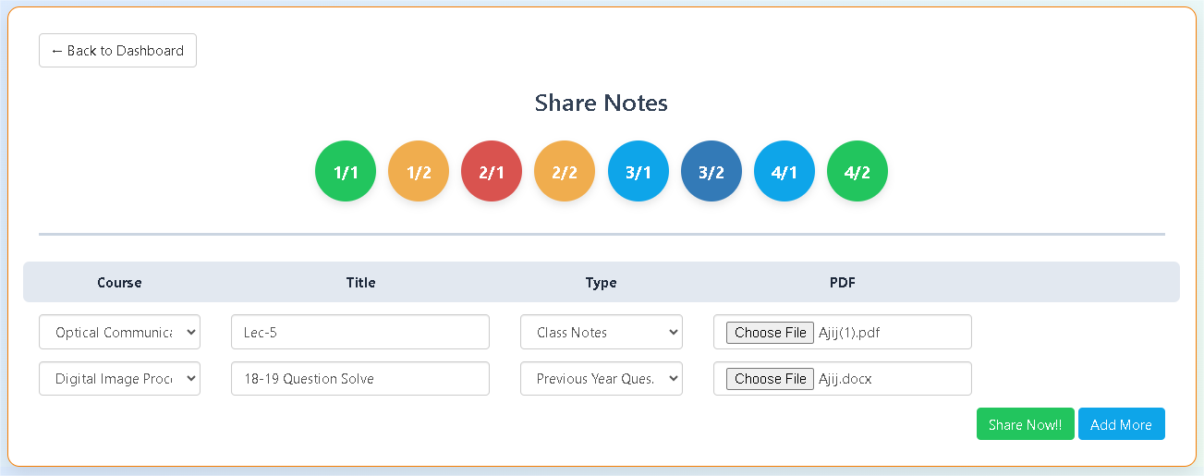
After selecting a term, users can upload notes by choosing a course, entering a title, selecting the note type, and uploading a file. Multiple entries can be added before final submission.
Figure 4.10: Note Upload Page

Study Materials Explorer

This section lets users easily browse academic notes by semester, course, and type for efficient study.

Semester and Course Display Page
Users first choose a semester, and based on that selection, the system displays the corresponding list of courses available for note browsing.

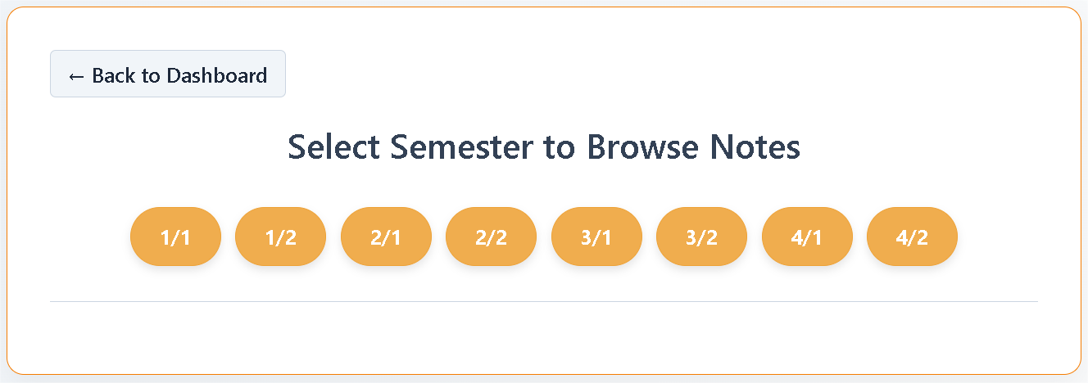Figure 4.11: Semester and Course Display Page

Course & Note Selection
Users can view available courses by semester and select specific note types for each course.
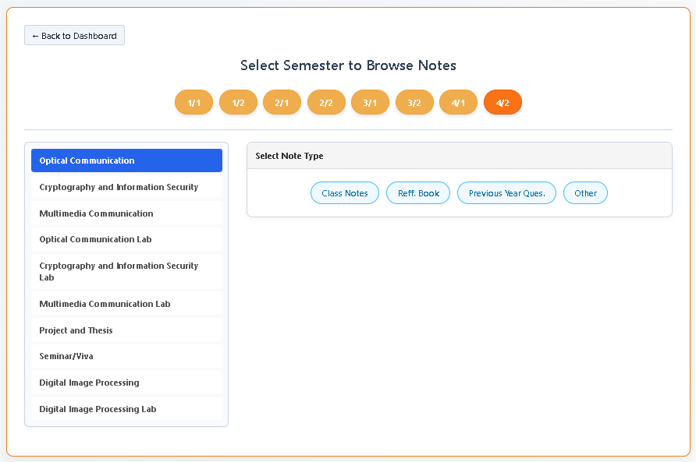
Figure 4.12: Course and Note Type Selection Page

Available Notes Viewer
Users view and manage uploaded notes, with options to view, save, or delete notes shared by others.

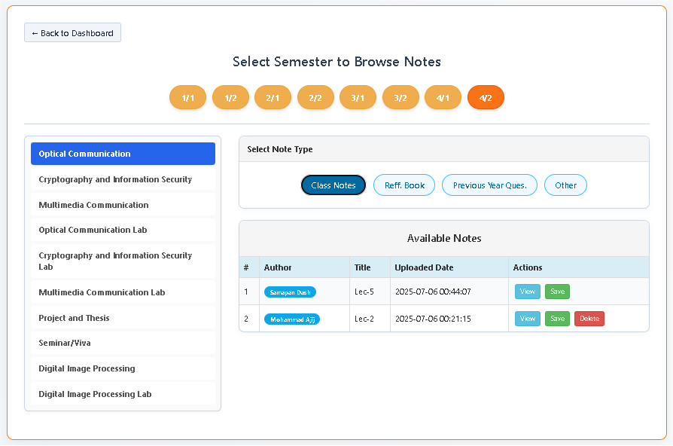
Figure 4.13: Available Notes Viewer Page

Latest Uploaded Notes
Displays the most recently shared academic notes for quick access and reference.

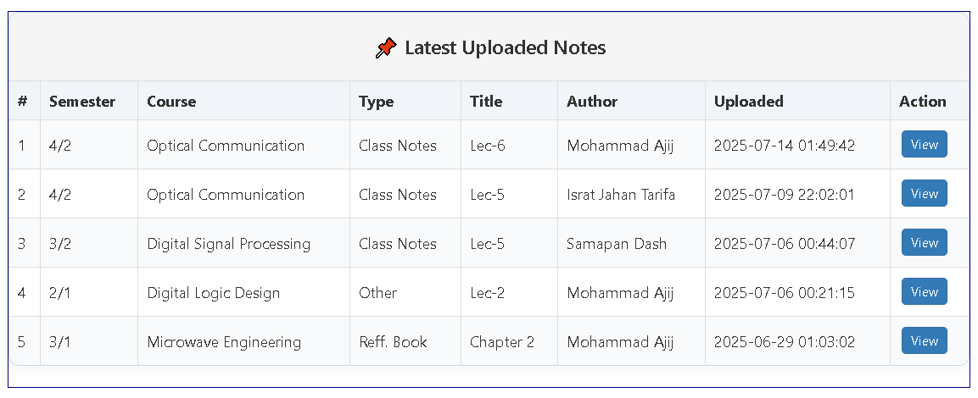
Figure 4.14: Latest Uploaded Notes

Group Management Hub

Users can explore, join, create, and manage groups by searching existing ones or defining new groups with selected members and cover images. Admins can handle join requests, assign members, and users can easily access groups they belong to or manage.

Group Directory Page
Explore and join available groups on the platform. Users can search for groups, see their membership status, and request to join public groups.
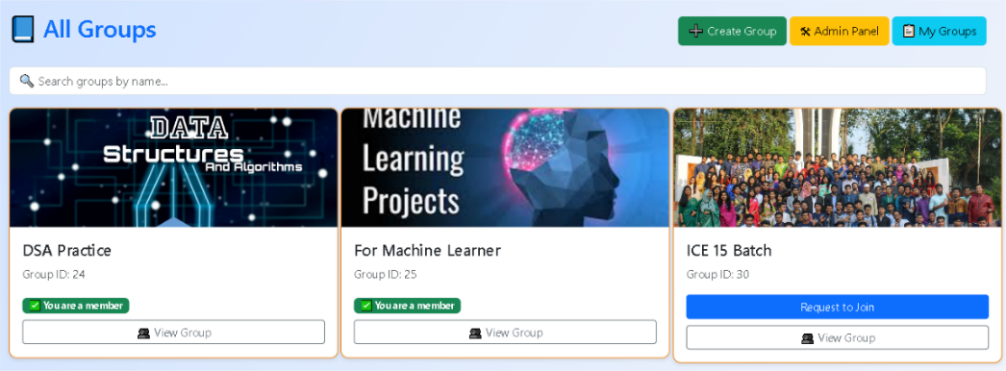

Figure 4.15: Group Directory Page

Group Admin Panel
Manage group join requests and manually add users to groups. Admins can accept join requests and assign multiple users to selected groups efficiently. This ensures controlled group membership and supports better collaboration within academic circles.

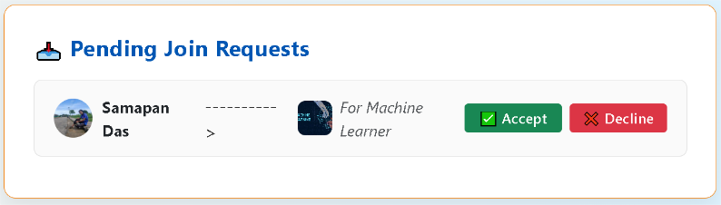
Figure 4.16: Group Admin Panel

Group Creation Interface
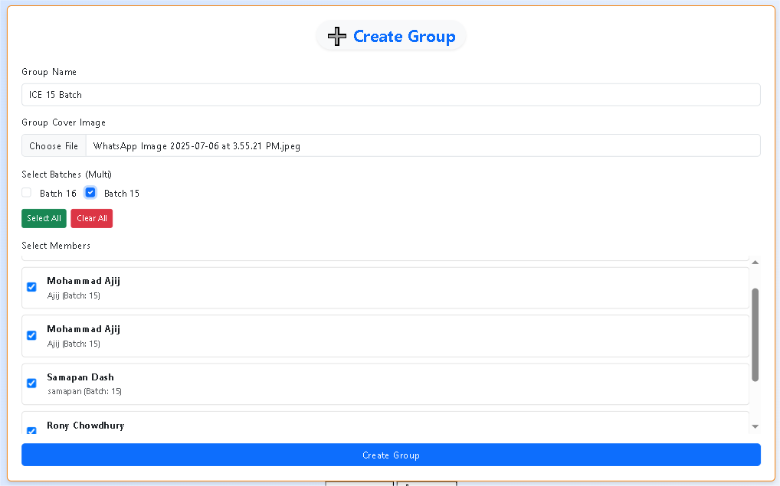
Create a new group and assign members. Users can define a group name, upload a cover image, select batches, and add members before creating the group.
`Figure 4.17: Group Creation Interface

My Groups Page
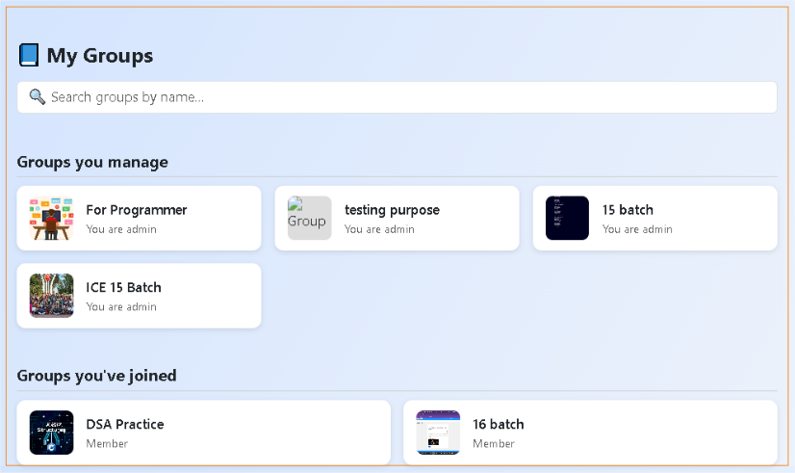
View and access groups you manage or belong to. This section allows users to quickly browse all their groups, distinguishing between admin roles and membership.

Figure 4.18: My Groups Page

Collaborative Group Forum
Groups are used instead of public posts to create a more targeted and structured environment for academic collaboration. They allow users to share content, ask questions, and engage in discussions with a specific set of members, ensuring that information remains relevant and context-specific.

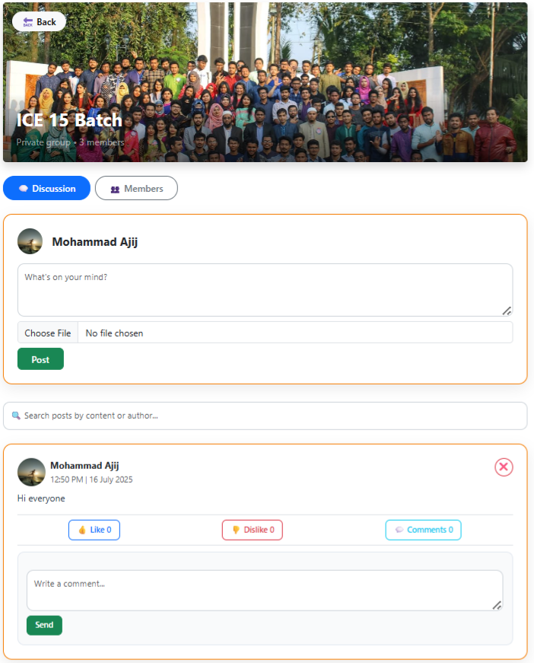
Figure 4.19: Collaborative Group Forum

Group Member Management
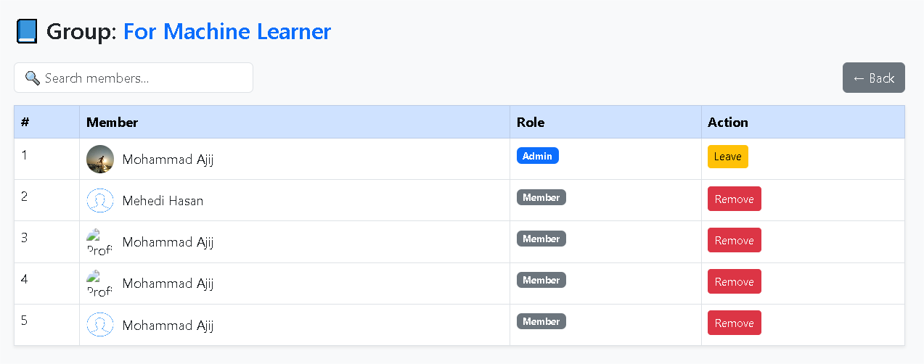
Displays group members with assigned roles. Admins have the authority to remove members, while users may remove themselves.

Figure 4.20: Group Member Management

Private Notes Archive

A secure space where users can upload, organize, and manage their personal study materials for easy access and future reference.

Note Upload Interface
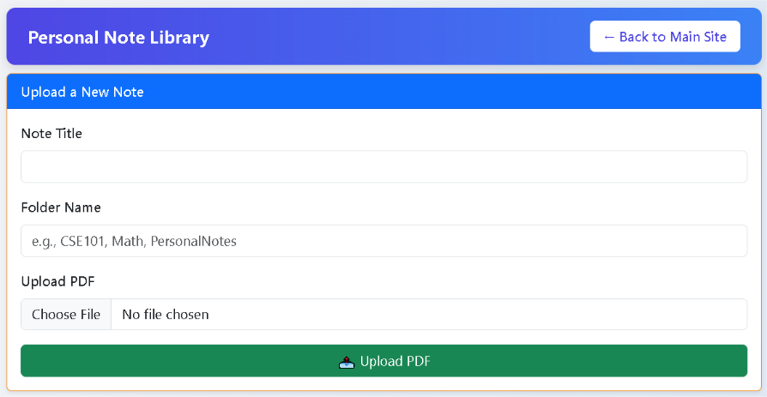
Enables users to upload and organize notes by title, folder, and file.

Figure 4.22: Note Upload Interface

Organized Note Management
Allows users to view, edit, or delete uploaded notes sorted by folders for easy access.

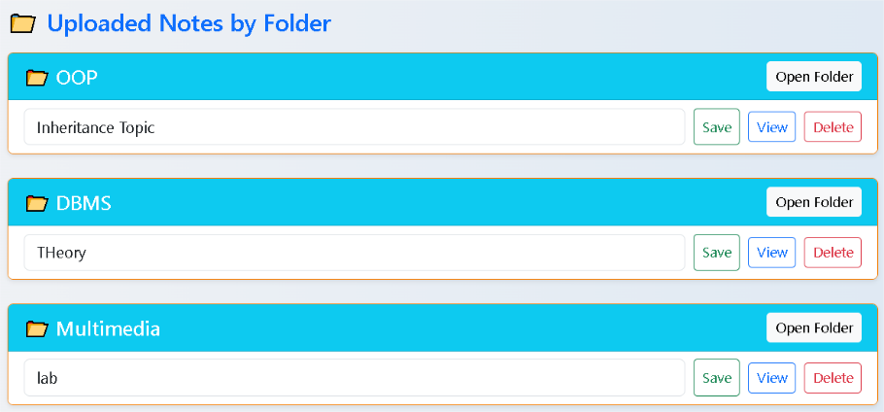
Figure 4.23: Organized Note Management Panel

Smart Task Tracker

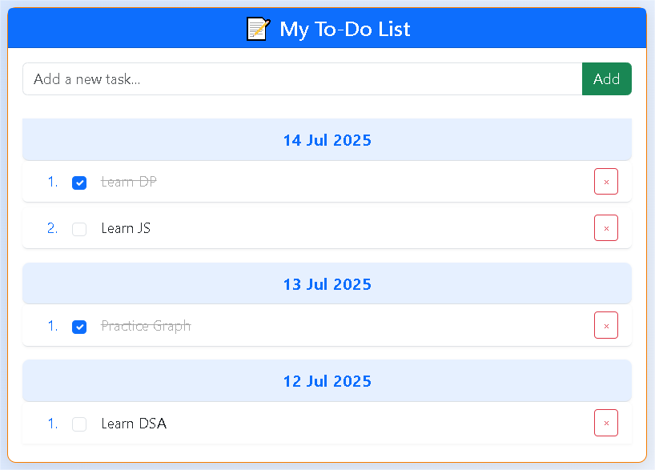
A simple module to add, manage, and track daily academic or personal tasks with completion status.
Figure 4.24: Smart Task Tracker Panel

Notification Panel

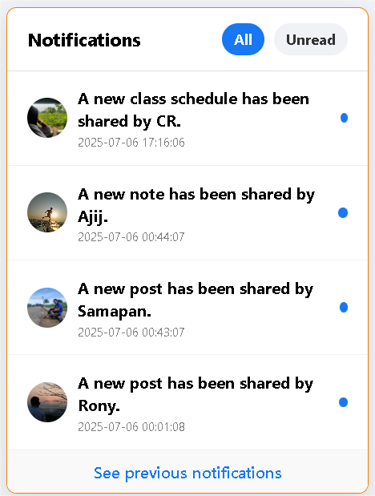
Displays real-time updates for new class schedules, shared posts, and uploaded notes from users.

Figure 4.25: Notification Panel

Unified Profile Hub

A centralized interface to view, update, and manage your personal profile, notes, and task activities efficiently.

User Dashboard
This dashboard provides a user-friendly overview of the student’s profile, displaying essential details such as name, registration number, contact information, blood group, and batch. It offers easy navigation to key features, including account editing. Additionally, the "My To-Do List" section helps in tracking and managing daily tasks, promoting better time management and productivity within the learning environment.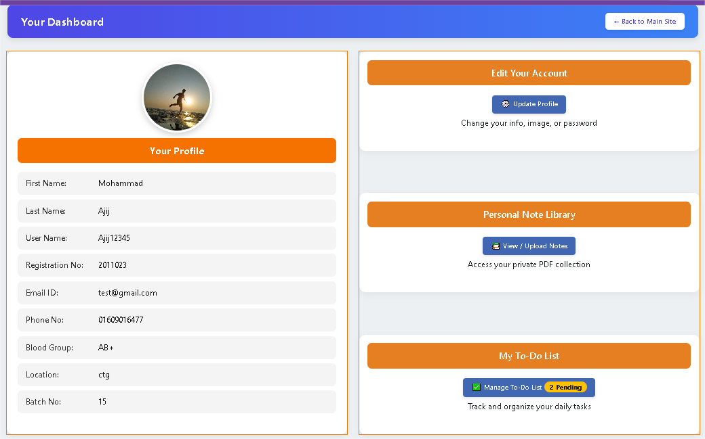
Figure 4.26: User Dashboard Page

Profile Edit Interface
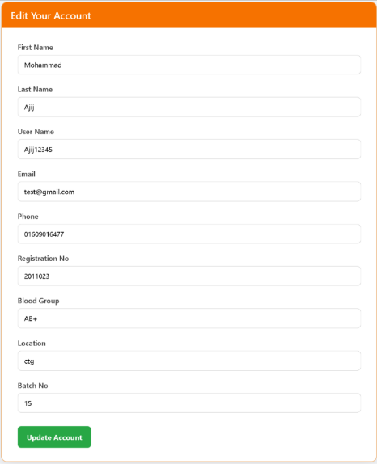
Allows users to update their personal information.

Figure 4.27: Profile Edit Interface

View User Profile

Displays detailed information of a selected user, including name, contact, academic details, and location for administrative or personal reference. The clean and simple layout ensures quick access to essential information such as registration number, batch, blood group, and email. This profile view helps teachers, administrators, or fellow students verify user identity and communicate as needed. The “Go Back” button allows smooth navigation, enhancing the overall user experience within the platform.

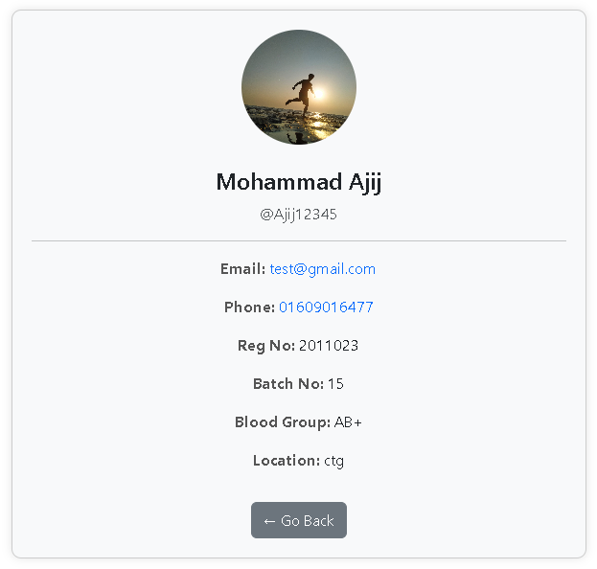

Figure 4.28: View User Profile

Admin Module

The Admin Module streamlines academic administration by allowing admins to approve users, manage schedules, publish notices, and maintain syllabus records—all from a unified interface.

Admin Dashboard

Allows verified admins to manage users, update syllabus, publish notices, and maintain student records from a central dashboard.

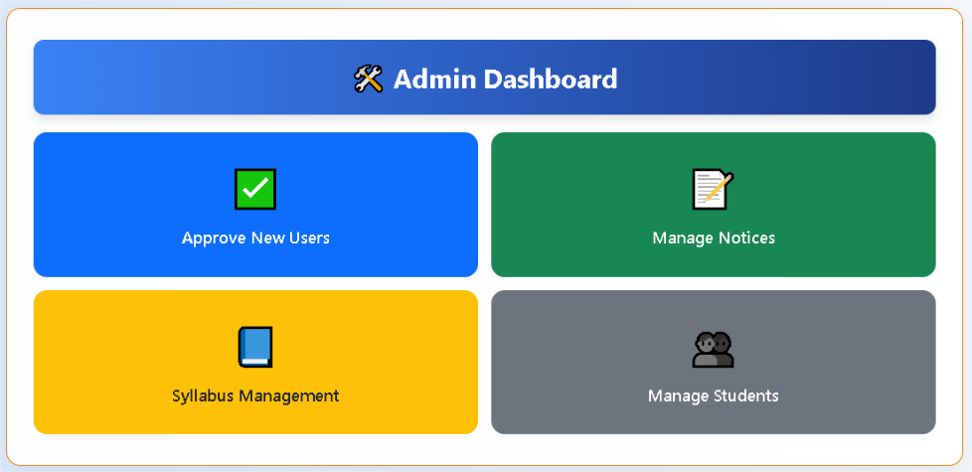
Figure 4.29: Admin Dashboard Page

Class Schedule Management

Admins can add or edit class schedules by selecting semester, batch, and date. It ensures smooth planning and quick updates for any changes in timing, venue, or faculty.

Update Class Schedule
Allows admins to create and assign class schedules by selecting semester, batch, date, time, and venue—ensuring clear, conflict-free planning and organized batch-wise routines. The feature also simplifies updates to existing schedules, improving overall timetable management.

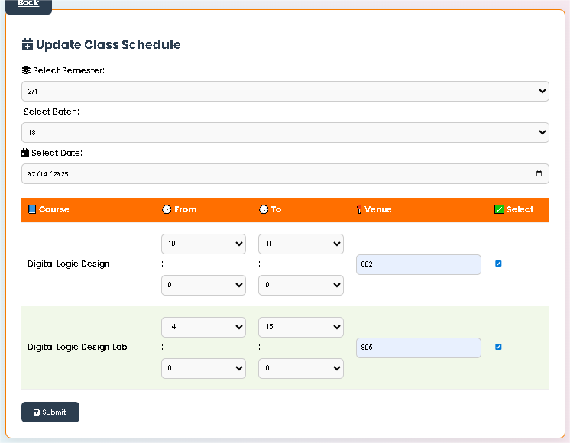
Figure 4.30: Update Class Schedule Page

Edit Class Schedule Panel
Admins can view and update schedules by batch and date to handle changes and avoid conflicts.
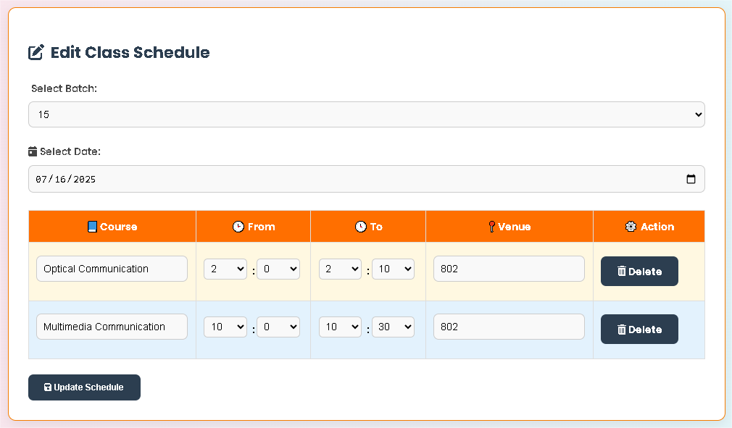
Figure 4.31: Class Schedule Editing Panel

Notice Management Panel

Enables admins to upload, view, and delete official notices. The system supports PDF uploads and displays all notice records in a manageable table format. Each notice includes details such as type, title, and upload date, helping ensure timely and organized communication with students and staff. With a clear layout, this feature enhances administrative efficiency and keeps important information accessible.

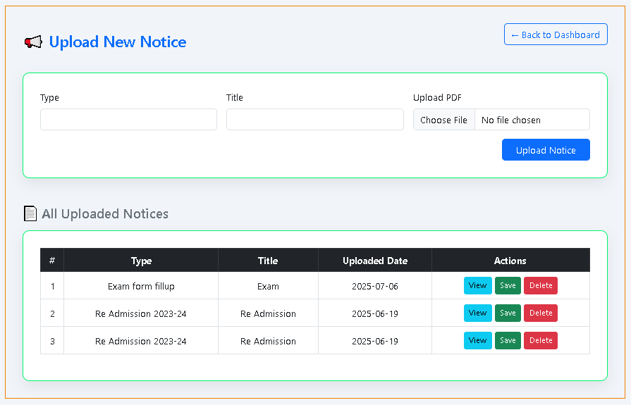
Figure 4.32: Notice Management Panel

Exam Schedule Management

The Exam Schedule Management feature provides admins with control over scheduling, editing, and deleting exam entries based on date, exam name, and batch. This functionality supports efficient academic planning and timely communication with students. Through the Edit Exam Schedule Panel, admins can make quick modifications or deletions, ensuring that any changes or rescheduling are accurately reflected across the system, enhancing overall academic preparedness.

Update Exam Schedule
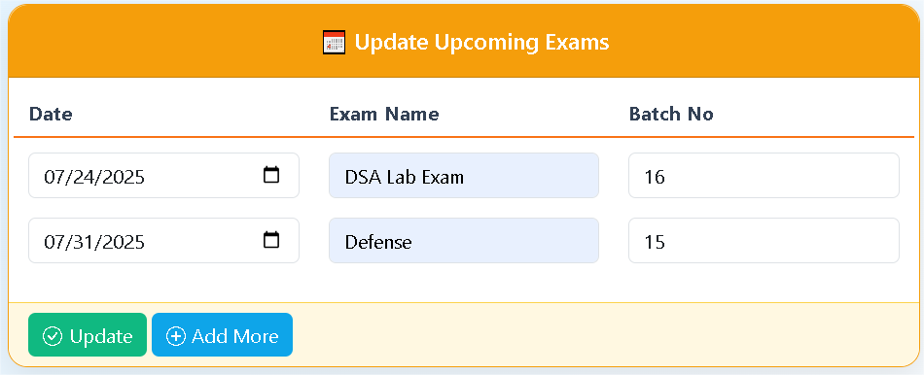
Admins can schedule exams by selecting date, entering exam name, and assigning a batch—supporting organized planning and timely communication. This panel streamlines the process of managing multiple upcoming exams, allowing easy additions and updates for efficient academic coordination.

Figure 4.33: Update Exam Schedule Page

Edit Exam Schedule Panel
Admins can quickly view, update, or delete scheduled exams for a batch, ensuring accurate and up-to-date exam planning. It provides a user-friendly interface to ensure timely scheduling and organization of exams for effective academic planning.
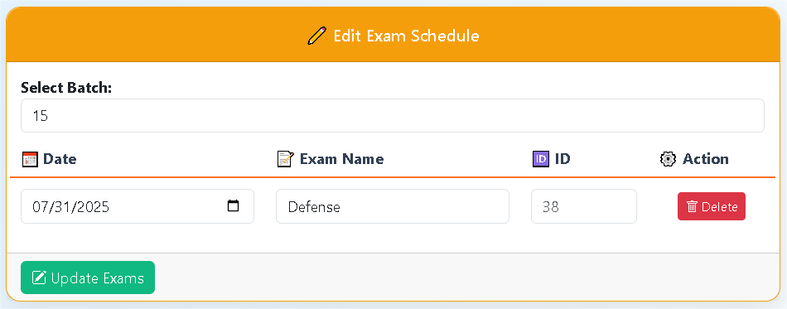

Figure 4.34: Exam Schedule Editing Panel

Academic Syllabus Management

A centralized interface for managing course syllabus entries—enabling admins to add new courses, filter by year-term, and update or delete existing course records efficiently.

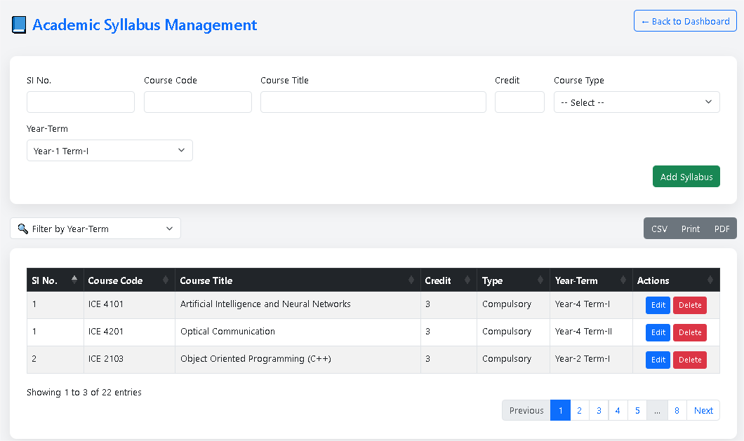
Figure 4.35: Syllabus Management Panel

Approve New Users

Allows the admin to review newly registered users and either approve or cancel their access, ensuring controlled user management. This helps maintain platform security and prevents unauthorized access.
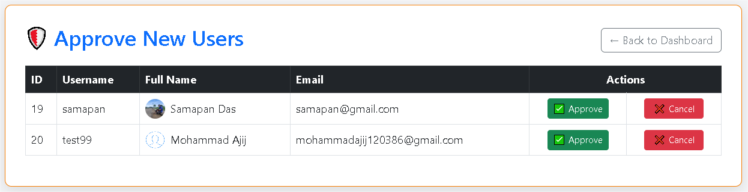

Figure 4.36: User Management Panel

Teacher Module

Enables teachers to manage class schedules, exams, and academic resources. It includes registration, login, a dashboard with panels for updates, resource sharing, and easy schedule tracking streamlining teaching and communication.

Home Page

The dashboard appears when a teacher visits the platform's main URL.

Main Dashboard Sections

The Main Dashboard Consists of Five Key Sections for Streamlined Academic Management:

- Class Schedule Panel
Helps teachers manage time and stay prepared with a clear view of daily tasks. Also assists in avoiding schedule conflicts and improving class preparedness.
- Newsfeed Panel
Enables teachers to share updates and resources for academic engagement. Facilitates interaction between teachers and students through posts and comments.
- Exam Panel
Centralizes exam schedules for effective planning and student coordination. Keeps both teachers and students aware of upcoming assessments at a glance.
- Resource Sharing Panel
Encourages resource sharing and academic support by enabling teachers to distribute lecture materials and assignments directly to students.
- Campus View Panel
Displays a featured image of the campus to provide a visual connection with the institution. Adds a welcoming and familiar touch to the user interface.

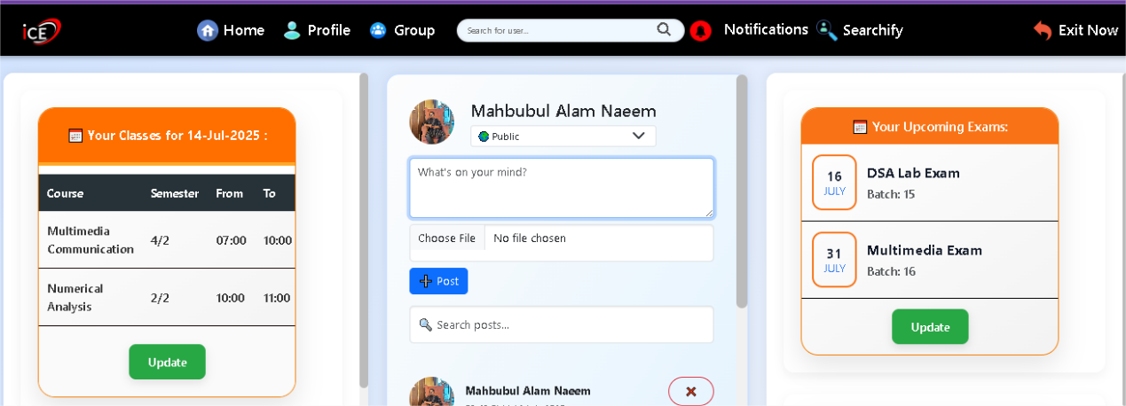
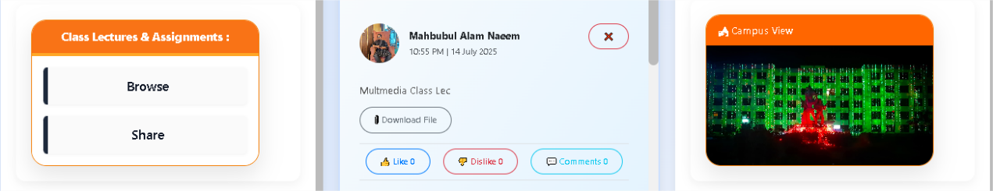

Figure 4.37: Home Page

Login Page

After registration, Teacher can login their account by inserting valid email address and password. The system verifies the credentials to grant secure access to the platform.

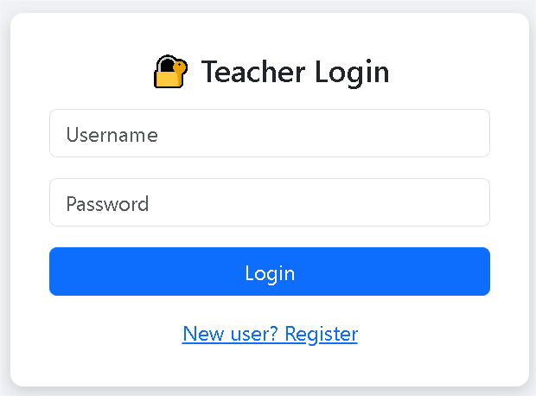
Figure 4.38: Login Page

Registration Page

Teachers can register by submitting their details. After admin approval, they can access schedules, share notes, and collaborate academically.

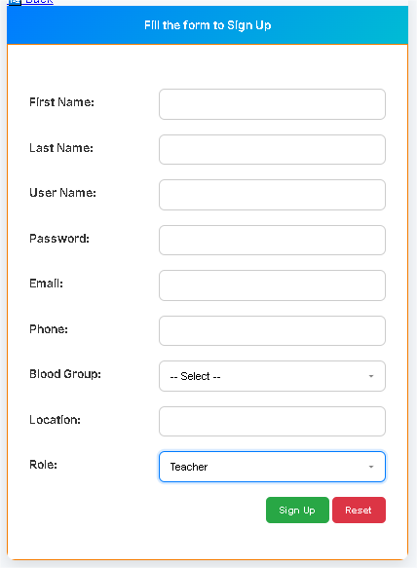
Figure 4.39: Registration Page

Class Schedule Management

Allows teachers to set, update, and view their daily class routines—ensuring accurate scheduling, better time management, and timely communication with students.

Update Class Schedule
Enables teachers to set or update their class times, dates, and batches. This feature is crucial for maintaining accurate routines and informing students of any changes.


Figure 4.40: Update Class Schedule Page

View Daily Teaching Schedule
Displays the teacher’s daily class schedule to help manage time and avoid overlaps. It ensures teachers are always prepared for their sessions and maintain punctuality.
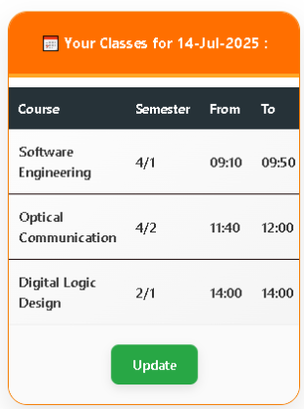

Figure 4.41: View Daily Teaching Schedule

Class Schedule Editing Panel
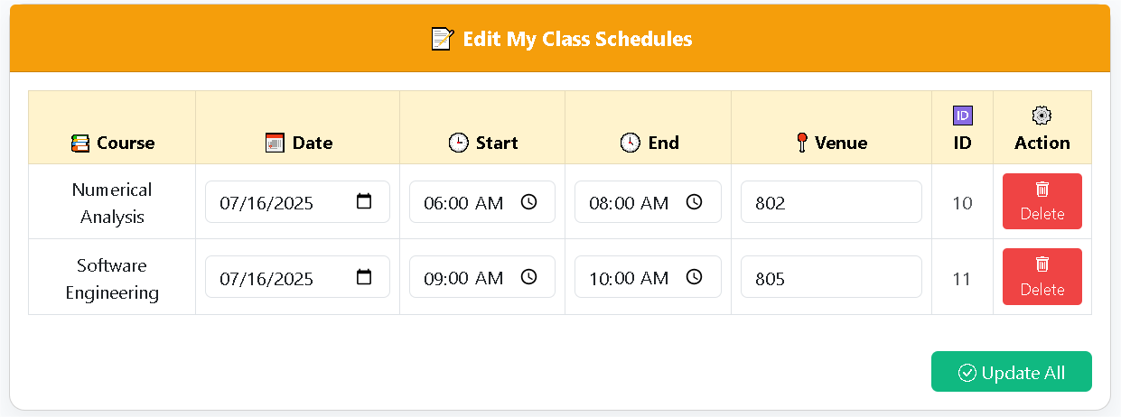
Allows teachers to update or delete class schedules, ensuring accurate and timely coordination with students.
Figure 4.42: Class Schedule Editing Panel

Exam Schedule Management

Helps teachers view, add, and update exam schedules for different batches—ensuring smooth coordination, avoiding conflicts, and supporting effective academic planning.

Update Exam Schedule

Allows teachers to add or change exam schedules easily. It helps in coordinating assessments, communicating with students, and maintaining a structured academic calendar.

Figure 4.43: Exam Management Panel

Exam Schedule Editing Panel
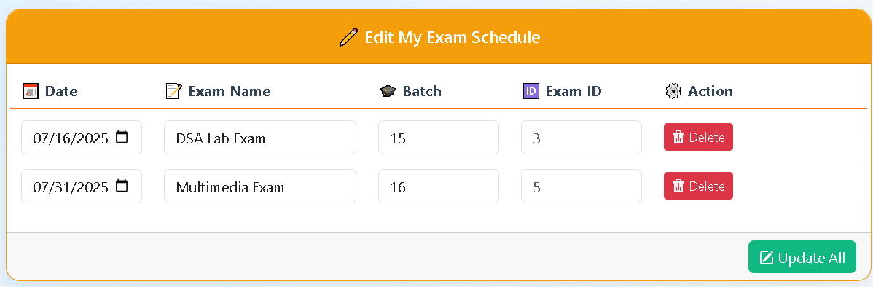
This panel enables teachers to edit and manage exam schedules for different batches efficiently. It ensures accurate exam planning, avoiding overlaps and keeping students and faculty informed about assessment dates.

Figure 4.44: Exam Schedule Editing Panel

Track Exam Schedules
This section helps teachers stay updated with upcoming exams for different batches. It ensures proper planning, avoids scheduling conflicts, and keeps teachers aware of their assessment responsibilities.
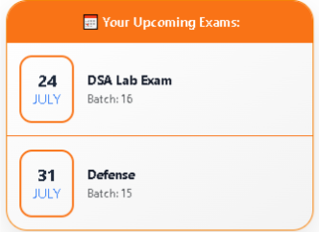

Figure 4.45: Track Exam Schedules

Visitor Module

The Visitor Module lets users access notices, syllabus, results, and routines without login. It also offers AI academic help and a contact form for support.

Student Dashboard

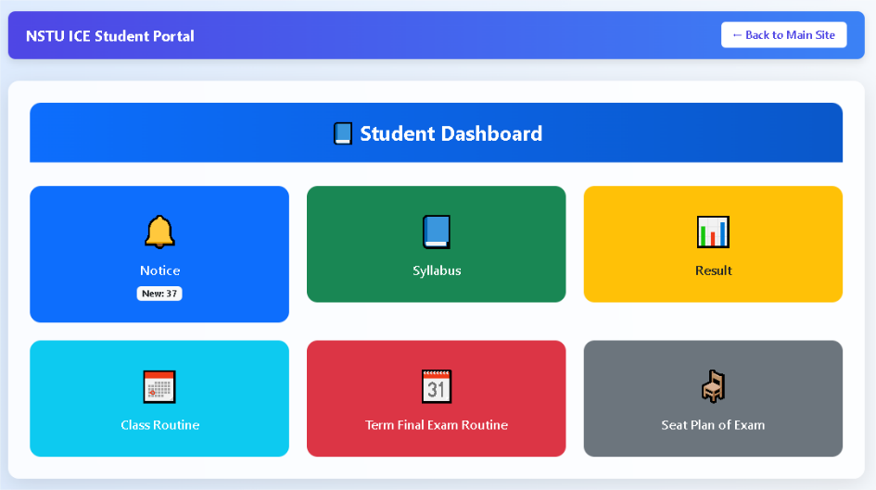
Allows visitors to preview available academic features such as notices, syllabus, results, class routines, exam routines, and seat plans without requiring login.
Figure 4.46: Student Dashboard

Notice Board Overview

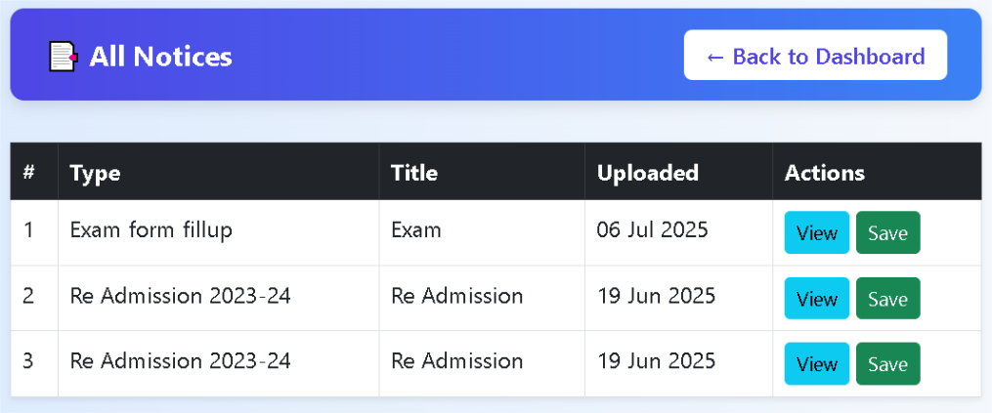
Displays a list of all uploaded notices with options to view or save each notice for future reference.
Figure 4.47: Notice Board Overview

Academic Syllabus Overview

View and filter course details by year and term for academic reference.

View Academic Syllabus
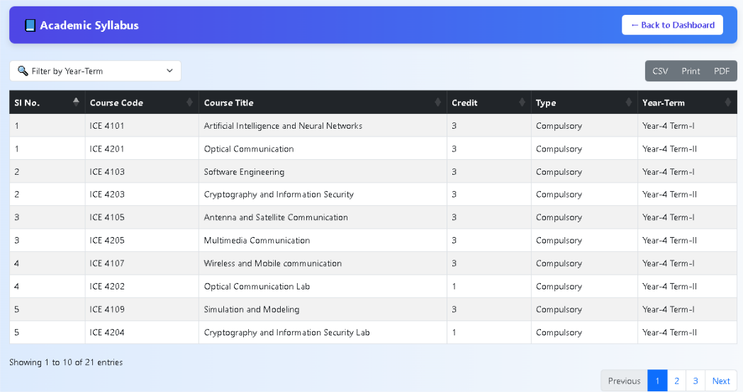
Displays a complete list of courses with code, credit, and type for a selected academic year and term. Helps users understand the course structure and requirements. It ensures easy access to official curriculum details for better academic planning.

Figure 4.48: View Academic Syllabus

Filter Syllabus by Term

Allows users to filter and view the syllabus based on selected academic terms, showing detailed course information for efficient academic planning. This feature helps students and teachers quickly access relevant course materials for a specific term. It enhances usability by minimizing clutter and focusing only on the selected academic timeframe. It also supports better preparation by aligning course content with the academic timeline.

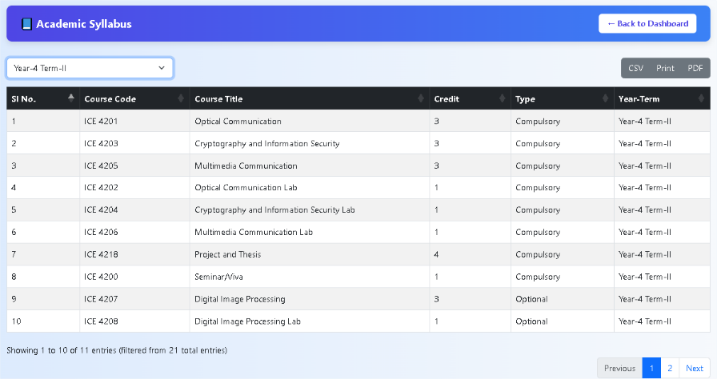

Figure 4.49: Filter Syllabus by Term

Academic AI Assistant Chat Module

Offers an interactive chat interface where users can ask academic questions and receive detailed AI-generated responses, such as code explanations and subject-specific help. Supports a wide range of topics including programming, mathematics, and theoretical concepts. Enhances self-learning by providing instant guidance and reducing dependency on external sources.

AI Query Panel
Allows users to input academic questions or code-related prompts. Enables students to engage in personalized learning through a conversational interface.

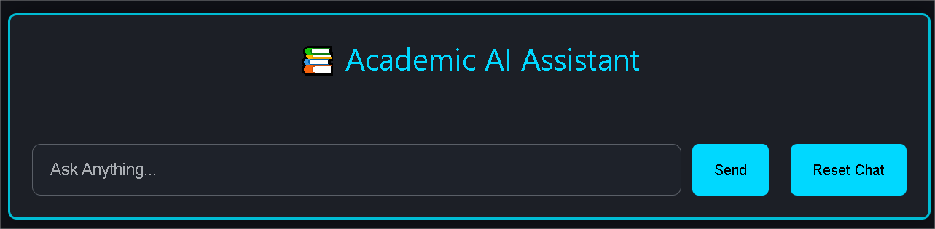

Figure 4.50: AI Query Panel

AI Response Viewer
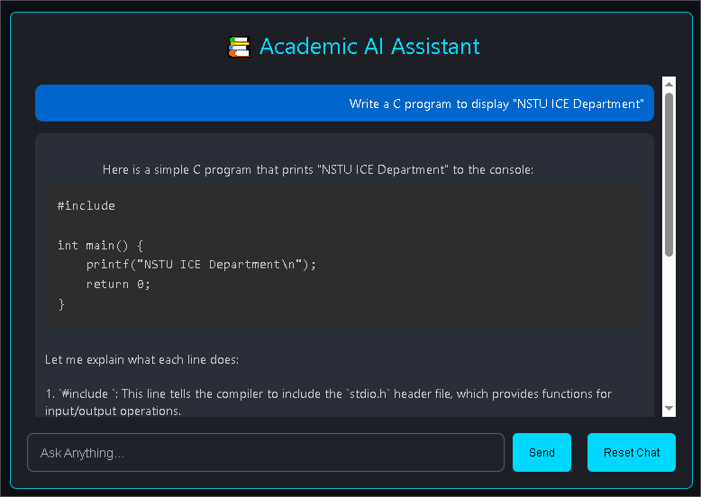
Displays the AI-generated answers, including code and explanation

Figure 4.51: AI Response Viewer

Contact & Support Form

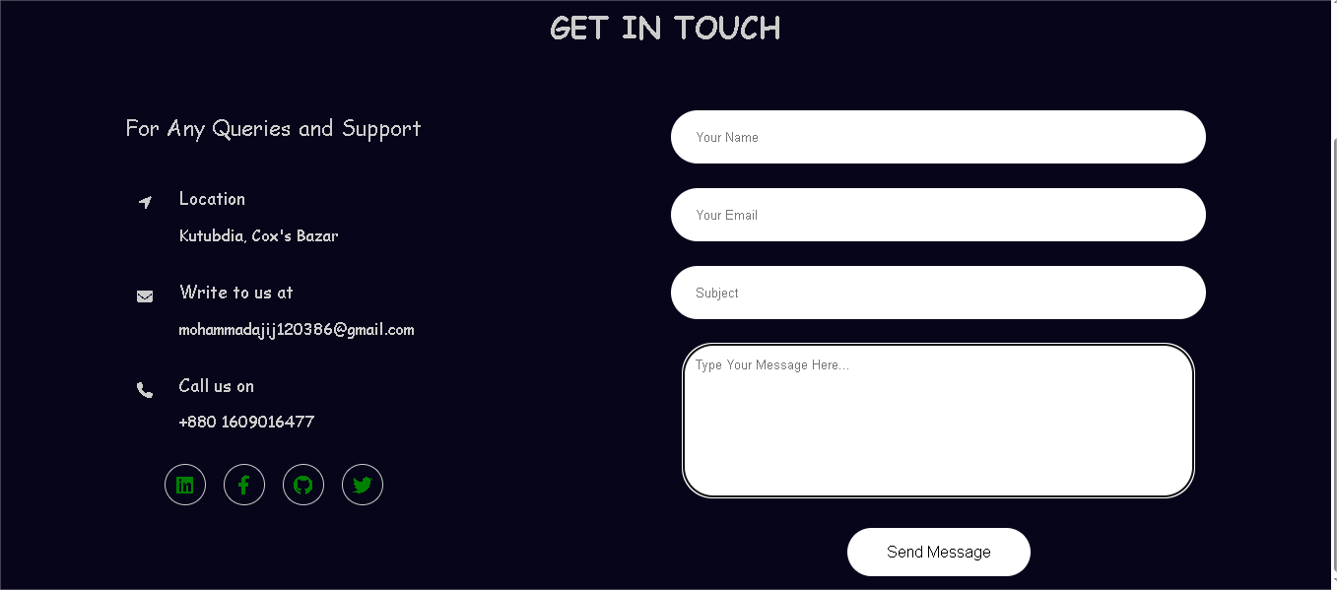
Allows visitors to send queries via form or contact through email, phone, or social links for quick support.

Figure 4.52: Contact & Support Form

CHAPTER 5

CONCLUSION AND FUTURE WORK

Conclusion

The Web-Based Platform for Academic Discussions and Resource Sharing aims to revolutionize the way students interact and collaborate academically. By offering a range of features that blend social networking functionalities with educational tools, this system promotes efficient knowledge sharing, time management, and academic organization. It enables students to engage in focused discussions, share resources, manage schedules, and receive personalized study tips, all within a distraction-free environment. Ultimately, the platform will replace many manual academic processes with a more efficient, digitalized approach, benefiting both students and faculty by saving time and enhancing communication.

Future Work

For the future of this project more aspects will be included to expand on all the already present features that help the academic setting. There is still room for improvements though, such as integrating a mobile application, to give the students the ability to use the platform even if not on the computer. Furthermore, there is the ability to offer even more specific using higher levels of Artificial Intelligence incorporated to the system. The system can also be extended to the other departments or institutions that would enhance its coverage area. Future work will also consist in guaranteeing that the platform advances in terms of scalability and security while answering the novel demands of academics and including new technologies.

REFERENCES

[1] Rosen, Larry D., Nancy Cheever, and L. Mark Carrier, eds. The Wiley handbook of psychology, technology, and society. John Wiley & Sons, 2015.

[2] Manca, Stefania, and Maria Ranieri. "Facebook and the others. Potentials and obstacles of social media for teaching in higher education." Computers & Education 95 (2016): 216–230.

[3] Greenhow, Christine, and Beth Robelia. "Old communication, new literacies: Social network sites as social learning resources." Journal of Computer-Mediated Communication 14.4 (2009): 1130–1161.

[4] Selwyn, Neil. "Faceworking: exploring students' education‐related use of Facebook." Learning, Media and Technology 34.2 (2009): 157–174.

[5] Junco, Reynol. "The relationship between frequency of Facebook use, participation in Facebook activities, and student engagement." Computers & Education 58.1 (2012): 162–171.

[6] Surowiecki, James. The wisdom of crowds/james surowiecki. NY.: Anchor, 2005.

[7] Pea, Roy D. "Practices of Distributed Intelligence and Designs for Education." Cognition and Instruction, vol. 10, no. 2/3, 1993, pp. 151–165.

[8] Kirschner, Paul A., and Aryn C. Karpinski. "Facebook® and academic performance." Computers in Human Behavior 26.6 (2010): 1237–1245.

[9] Dabbagh, Nada, and Anastasia Kitsantas. "Personal Learning Environments, social media, and self-regulated learning: A natural formula for connecting formal and informal learning." The Internet and Higher Education 15.1 (2012): 3–8.

[10] Hrastinski, Stefan, and Naghmeh Aghaee. "How are campus students using social media to support their studies? An explorative interview study." Education and Information Technologies 17 (2012): 451–464.

[11] Roblyer, M. D., McDaniel, M., Webb, M., Herman, J., & Witty, J. V. "Findings on Facebook in higher education: A comparison of college faculty uses and perceptions of social networking sites." The Internet and Higher Education, 13.3 (2010): 134–140.

[12] Madge, Clare, et al. "Facebook, social integration and informal learning at university: ‘It is more for socialising and talking to friends about work than for actually doing work’." Learning, Media and Technology 34.2 (2009): 141–155.

[13] Veletsianos, George, and Cesar C. Navarrete. "Online social networks as formal learning environments: Learner experiences and activities." The International Review of Research in Open and Distributed Learning 13.1 (2012): 144–166.

[14] Cain, Jeff, and Lisa Policastri. "Using Facebook as an informal learning environment." American Journal of Pharmaceutical Education 75.10 (2011): 207.

[15] Redecker, Christine, and Yves Punie. "The future of learning 2025: developing a vision for change." Future Learning 1.1 (2013): 3–17.

[16] Bosch, Tanja E. "Using online social networking for teaching and learning: Facebook use at the University of Cape Town." Communicatio: South African Journal for Communication Theory and Research 35.2 (2009): 185–200.

[17] Tutorialspoint. “SDLC Waterfall Model.” www.tutorialspoint.com, 2019. https://www.tutorialspoint.com/sdlc/sdlc_waterfall_model.htm (accessed Jan. 16, 2025).

[18] Tutorialspoint. “SDLC Iterative Model.” www.tutorialspoint.com, 2019. https://www.tutorialspoint.com/sdlc/sdlc_iterative_model.htm (accessed Jan. 16, 2025).

[19] S. Kumar Pal. “Software Engineering | Spiral Model - GeeksforGeeks.” GeeksforGeeks, May 28, 2018. https://www.geeksforgeeks.org/software-engineering-spiral-model (accessed Jan. 16, 2025).

[20] Javatpoint. “Incremental Model - javatpoint.” www.javatpoint.com, 2011. https://www.javatpoint.com/software-engineering-incremental-model (accessed Jan. 16, 2025).

[21] Omar Elgabry. “Database Introduction – Part 1.” Medium, Jul. 27, 2020. https://medium.com/omarelgabrys-blog/database-introduction-part-1-4844fada1fb0 (accessed Jan. 27, 2025).

[22] MDN Web Docs. “HTML: HyperText Markup Language.” MDN Web Docs, Dec. 10, 2018. https://developer.mozilla.org/en-US/docs/Web/HTML (accessed Jan. 16, 2025).

[23] “Cascading Style Sheets.” W3.org, 2019. https://www.w3.org/Style/CSS/Overview.en.html (accessed Jan. 16, 2025).

[24] Mozilla. “CSS: Cascading Style Sheets.” MDN Web Docs, Jun. 26, 2019. https://developer.mozilla.org/en-US/docs/Web/CSS (accessed Jan. 16, 2025).

[25] Wikipedia Contributors. “Bootstrap (front-end framework).” Wikipedia, Apr. 08, 2019. https://en.wikipedia.org/wiki/Bootstrap_(front-end_framework) (accessed Jan. 16, 2025).

[26] H. Reactor. “What is JavaScript Used For?” Medium, Nov. 01, 2018. https://medium.com/@hackreactor/what-is-javascript-used-for-d438f3e9ca39 (accessed Jan. 15, 2025).

[27] Michael Shashoua. “What Is PHP Used For?” codecademy, Sep. 30, 2021. https://www.codecademy.com/resources/blog/what-is-php-used-for (accessed Jan. 27, 2025).

[28] Aditya Ramadhana. “Introduction to MySQL?” Medium, Sep. 30, 2023. https://medium.com/@dithyapr/introduction-to-mysql-c0723ffc6c7b (accessed Jan. 27, 2025).

[29] Gurpreet Singh. “Git Tutorial for Beginners: A Comprehensive Guide to Mastering Version Control.” Medium, Sep. 15, 2023. https://medium.com/@igurpreetsingh/git-tutorial-for-beginners-a-comprehensive-guide-to-mastering-version-control-a0da3eb0b6e8 (accessed Jan. 27, 2025).

[30] W. Barillon. “Beginner’s Guide for Software Testing: Explicit Examples.” Medium, Jul. 15, 2021. https://wbarillon.medium.com/beginners-guide-for-software-testing-explicit-examples-9b02e2989da7 (accessed Jan. 27, 2025).

