Business Template

Subject areas
Logo / Image

Contents
Business Description 3
1.1 the Benefits of implementing a database. Project Vision 3
2 Model description 3
2.1 Definitions & Acronyms 3
2.2 Logical Scheme 3
2.3 Objects 3

Business Description

the Benefits of implementing a database. Project Vision
How will the database solve the problems listed in the description?
The database design isolates static data from dynamic data. By separating products from product_price_history and order_items, we avoid duplication and inconsistencies when prices change. The schema ensures that a product's current price in the catalog is independent of the price at which it was sold in the past.
How will it ensure data integrity, consistency, and traceability?
Data integrity is enforced through Foreign Keys (FKs) with ON DELETE RESTRICT (e.g., you cannot delete a user who has active orders). Traceability is guaranteed by dedicated transactional and history tables (inventory_transactions, order_status_history, product_price_history).
How does your model store the history of changes?
Instead of using UPDATE on existing records, the model uses append-only history tables. For instance, product_price_history uses valid_from and valid_to timestamps. Order states are tracked in order_status_history, and stock changes are logged in inventory_transactions. The order_items table permanently stores the unit_price at the exact moment of purchase.
How does your structure allow the system to scale without major redesign?
The model is highly scalable because it avoids transitive dependencies (it is in 3NF). categories supports infinite sub-categories via a self-referential parent_id. product_promotions acts as a bridge table, allowing any number of promotions to be applied to any number of products without altering the products table.
Which constraints and checks have you added to keep data correct as volume grows?
- UNIQUE constraints on users.email and categories.name.
- CHECK (rating >= 1 AND rating <= 5) on reviews.
- NOT NULL on all Primary Keys and mandatory Foreign Keys.
- DEFAULT CURRENT_TIMESTAMP for all created_at fields.
- CHECK (quantity >= 0) on inventory to prevent negative stock.

Model description

Definitions & Acronyms
- PK: Primary Key.
- FK: Foreign Key.
- SKU: Stock Keeping Unit (represented by product_id).
- Order Item: A specific product with a specific quantity purchased within a single order.
- Promotion: A temporary discount applied to a product.
- Historical Price: The exact price of a product when an order was placed, regardless of current catalog price.
- Self-referential relationship: A relationship where a table references itself (e.g., categories.parent_id referencing categories.category_id).
- Composite Key: A primary key consisting of two or more columns (e.g., in product_promotions).

Logical Scheme
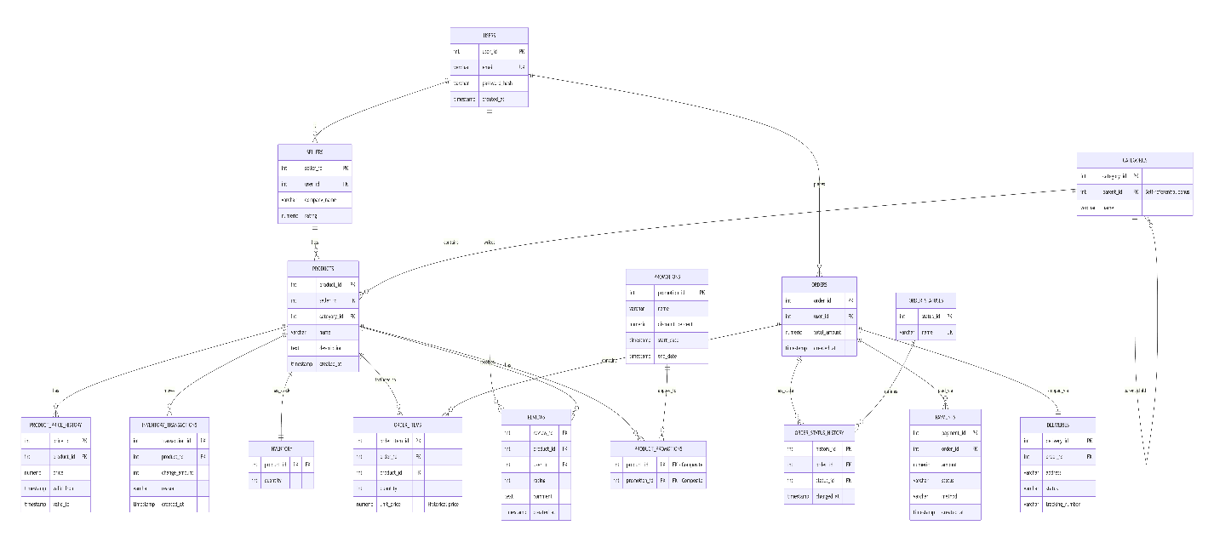

Which modeling decision was the most difficult and why?
The most difficult decision was handling price changes. A naive design would update the price directly in the products table. However, to preserve historical data, we had to normalize this into product_price_history and ensure that order_items copies the unit_price at the time of checkout. This prevents historical order totals from fluctuating if the seller changes the product price later.
Provide examples of potential data anomalies that your design prevents. Explain which constraints or structure elements prevent them.
- Update Anomaly: If a seller changes their company name, it only updates in the sellers table, not across thousands of orders (prevented by separating sellers).
- Insertion Anomaly: We can add a new category before any product is assigned to it.
- Deletion Anomaly: If we delete a promotion, the product_promotions records are deleted via ON DELETE CASCADE, but the products remain intact.
If you were to add new attributes or participants, would the model remain scalable and why?
Yes. The modular structure allows adding new entities (e.g., returns or suppliers) without altering existing tables. Adding new attributes to users (e.g., phone_number) will not impact orders or payments.
Which part of your model would most likely change if requirements expand?
The payments and deliveries tables might require expansion if the platform integrates multiple third-party logistics or payment gateways (e.g., adding a gateway_transaction_id or splitting deliveries into multiple packages per order).

Objects
Table Description:
- What real-world concept or event does this table represent?
- Why must this information be stored separately instead of inside another table?
- What is the normalization level of the table (1NF, 2NF, 3NF)? Explain your reasoning.
- Are there partial or transitive dependencies? How did you eliminate them? Which attributes depend only on the key, and which depend on other fields?
- Why did you choose this primary key (PK) for the table? Could a composite key work instead? Which foreign keys (FK) did you add and why?

Table Name | Field name | Field Description | Data Type
users | user_id | Unique user ID | SERIAL
users | email | User email | VARCHAR(255)
users | password_hash | Hashed password | VARCHAR(255)
users | created_at | Registration date | TIMESTAMP

Example with data (2-3 rows)

user_id | email | password_hash | created_at
1 | john@example.com | hash123 | 2023-10-01 10:00:00
2 | jane@example.com | hash456 | 2023-10-02 11:30:00

