**EXPERIMENT NO: 2**

**Date of Performance:   
Date of Submission:**

**AIM**: Mapping ER/EER to Relational schema model.  
  
**THEORY**:

After designing the ER diagram of system, designer need to convert it to Relational models which can directly be implemented by any RDBMS like Oracle, MySQL etc.  .

**Case 1:  Binary Relationship with 1:1 cardinality with total participation of an entity**

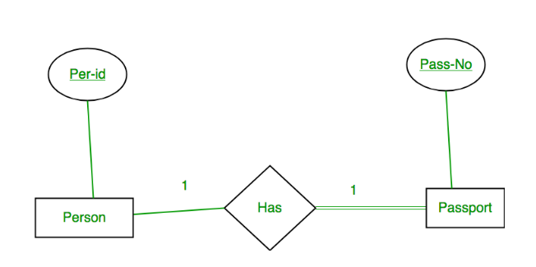

A person has 0 or 1 passport number and Passport is always owned by 1 person. So it is 1:1 cardinality with full participation constraint from Passport.

**First Convert each entity and relationship to tables.**  Person table corresponds to Person Entity with key as Per-Id. Similarly Passport table corresponds to Passport Entity with key as Pass-No. Has Table represents relationship between Person and Passport (Which person has which passport). So it will take attribute Per-Id from Person and Pass-No from Passport.

|  |  |  |  |  |  |  |  |
| --- | --- | --- | --- | --- | --- | --- | --- |
| **Person** | |  | **Has** | |  | **Passport** | |
| **Per-Id** | **Other Person Attribute** | **Per-Id** | **Pass-No** | **Pass-No** | **Other Passport Attribute** |
| PR1 | – | PR1 | PS1 | PS1 | – |
| PR2 | – | PR2 | PS2 | PS2 | – |

**Table 1**

As we can see from Table 1, each Per-Id and Pass-No has only one entry in Has Table. So we can merge all three tables into 1 with attributes shown in Table 2. Each Per-Id will be unique and not null. So it will be the key. Pass-No can’t be key because for some person, it can be NULL. 

|  |  |  |  |
| --- | --- | --- | --- |
| Per-Id | Other Person Attribute | Pass-No | Other Passport Attribute |

**Table 2**

**Case 2: Binary Relationship with 1:1 cardinality and partial participation of both entities**

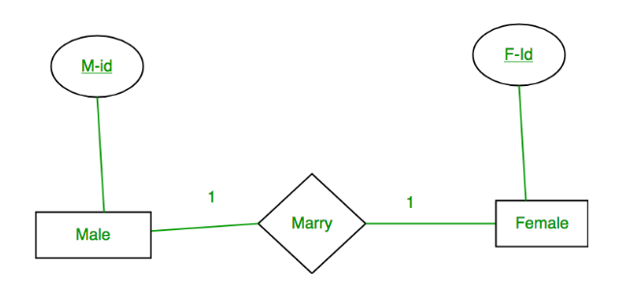

A male marries 0 or 1 female and vice versa as well. So it is 1:1 cardinality with partial participation constraint from both. First Convert each entity and relationship to tables.  Male table corresponds to Male Entity with key as M-Id. Similarly Female table corresponds to Female Entity with key as F-Id. Marry Table represents relationship between Male and Female (Which Male marries which female). So it will take attribute M-Id from Male and F-Id from Female.

|  |  |  |  |  |  |  |  |
| --- | --- | --- | --- | --- | --- | --- | --- |
| **Male** | |  | **Marry** | |  | **Female** | |
| M-Id | Other Male Attribute | M-Id | F-Id | F-Id | Other Female Attribute |
| M1 | – | M1 | F2 | F1 | – |
| M2 | – | M2 | F1 | F2 | – |
| M3 | – |  |  |  |  | F3 | – |

**Table 3**

From Table 3, some males and some females do not marry. If designer merge 3 tables into 1, for some M-Id, F-Id will be NULL. So there is no attribute which is always not NULL. So designer should not merge all three tables into 1. Designer should convert into 2 tables. In table 4, M-Id who are married will have F-Id associated. For others, it will be NULL. Table 5 will have information of all females. Primary Keys have been underlined.

|  |  |  |
| --- | --- | --- |
| M-Id | Other Male Attribute | F-Id |

**Table 4**

|  |  |
| --- | --- |
| F-Id | Other Female Attribute |

**Table 5**

Binary relationship with 1:1 cardinality will have 2 table if partial participation of both entities in the relationship. If at least 1 entity has total participation, no. of tables required will be 1.

**Case 3: Binary Relationship with n: 1 cardinality**

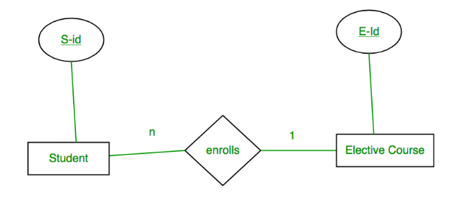

In this scenario, every student can enroll only in one elective course but for an elective course there can be more than one student. First Convert each entity and relationship to tables. Student table corresponds to Student Entity with key as S-Id.   
Similarly Elective_Course table corresponds to Elective_Course Entity with key as E-Id. Enrolls Table represents relationship between Student and Elective_Course. So it will take attribute S-Id from Student and E-Id from Elective_Course. 

|  |  |  |  |  |  |  |  |
| --- | --- | --- | --- | --- | --- | --- | --- |
| **Student** | |  | **Enrolls** | |  | **Elective_Course** | |
| S-Id | Other Student Attribute | S-Id | E-Id | E-Id | Other Elective Course Attribute |
| S1 | – | S1 | E1 | E1 | – |
| S2 | – | S2 | E2 | E2 | – |
| S3 | – |  | S3 | E1 |  | E3 | – |
| S4 | – |  | S4 | E1 |  |  |  |

**Table 6**

From Table 6, S-Id is not repeating in Enrolls Table. So it can be considered as a key of Enrolls table. Both Student and Enrolls Table’s key is same; we can merge it as a single table. The resultant tables are shown in Table 7 and Table 8. Primary Keys have been underlined.

|  |  |  |
| --- | --- | --- |
| S-Id | Other Student Attribute | E-Id |

**Table 7**

|  |  |
| --- | --- |
| E-Id | Other Elective Course Attribute |

**Table 8**

**Case 4: Binary Relationship with m: n cardinality**

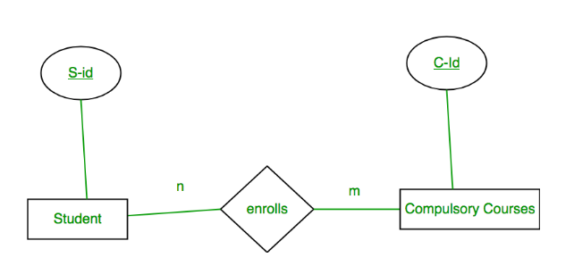

In this scenario, every student can enroll in more than 1 compulsory course and for a compulsory course there can be more than 1 student. First Convert each entity and relationship to tables.  Student table corresponds to Student Entity with key as S-Id. Similarly Compulsory_Courses table corresponds to Compulsory Courses Entity with key as C-Id. Enrolls Table represents relationship between Student and Compulsory_Courses (Which student enrolls in which course). So it will take attribute S-Id from Person and C-Id from Compulsory_Courses. 

|  |  |  |  |  |  |  |  |
| --- | --- | --- | --- | --- | --- | --- | --- |
| **Student** | |  | **Enrolls** | |  | **Compulsory_Courses** | |
| S-Id | Other Student Attribute | S-Id | C-Id | C-Id | Other Compulsory Course Attribute |
| S1 | – | S1 | C1 | C1 | – |
| S2 | – | S1 | C2 | C2 | – |
| S3 | – |  | S3 | C1 |  | C3 | – |
| S4 | – |  | S4 | C3 |  | C4 | – |
|  |  |  | S4 | C2 |  |  |  |
|  |  |  | S3 | C3 |  |  |  |

**Table 9**

From Table 9, S-Id and C-Id both are repeating in Enrolls Table. But its combination is unique; so it can be considered as a key of Enrolls table. All tables’ keys are different, these can’t be merged.  Primary Keys of all tables have been underlined.

**Case 5: Binary Relationship with weak entity**

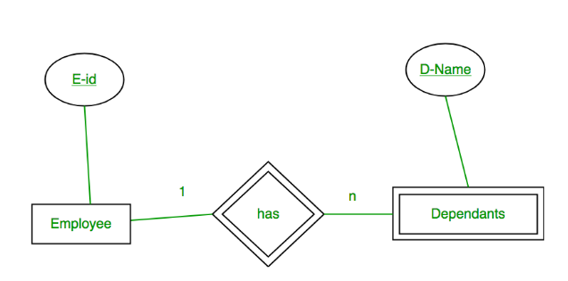

In this scenario, an employee can have many dependents and one dependent can depend on one employee. A dependent does not have any existence without an employee. So it will be a weak entity and its participation will always be total. Weak Entity does not have key of its own. So its key will be combination of key of its identifying entity (E-Id of Employee in this case) and its partial key (D-Name).

First Convert each entity and relationship to tables.  Employee table corresponds to Employee Entity with key as E-Id. Similarly Dependents table corresponds to Dependent Entity with key as D-Name and E-Id. Has Table represents relationship between Employee and Dependents. So it will take attribute E-Id from Employee and D-Name from Dependents.

|  |  |  |  |  |  |  |  |  |
| --- | --- | --- | --- | --- | --- | --- | --- | --- |
| **Employee** | |  | **Has** | |  | **Dependents** | | |
| E-Id | Other Employee Attribute | E-Id | D-Name | D-Name | E-Id | Other Dependents Attribute |
| E1 | – | E1 | RAM | RAM | E1 | – |
| E2 | – | E1 | SRINI | SRINI | E1 | – |
| E3 | – | E2 | RAM | RAM | E2 | – |
|  |  | E3 | ASHISH | ASHISH | E3 | – |

**Table 10**

From Table 10, E-Id, D-Name is key for Has as well as Dependents Table.   
So we can merge these two into 1. So the resultant tables are shown in Tables 11 and 12.   
Primary Keys of all tables have been underlined. 

|  |  |
| --- | --- |
| E-Id | Other Employee Attribute |

**Table 11**

|  |  |  |
| --- | --- | --- |
| D-Name | E-Id | Other Dependents Attribute |

**Table 12**

**CONCLUSION / OUTCOME**:

**MARKS & SIGNATURE:**

|  |  |  |  |  |  |
| --- | --- | --- | --- | --- | --- |
| **R1  (3 Marks)** | **R2  (5 Marks)** | **R3  (4 Marks)** | **R4  (3 Marks)** | **Total  (15 Marks)** | **Signature** |
|  |  |  |  |  |  |

**Relational Model**

USER

|  |  |
| --- | --- |
| Username | Password |

STAFF

|  |
| --- |
| Username |

STUDENT_FACULTY

|  |  |  |  |  |  |  |  |  |  |
| --- | --- | --- | --- | --- | --- | --- | --- | --- | --- |
| Username | Name | DOB | Email | IsDebarred | Gender | Address | IsFaculty | Penalty | Dept |

BOOK

|  |  |  |  |  |  |  |  |  |  |
| --- | --- | --- | --- | --- | --- | --- | --- | --- | --- |
| ISBN | Title | Cost | IsReserved | Edition | PubliPlace | Publisher | CopyYr | ShelfID | SubName |

BOOKCOPY

|  |  |  |  |  |  |
| --- | --- | --- | --- | --- | --- |
| ISBN | CopyID | IsChecked | IsHold | IsDamaged | FuRequester |

AUTHOR

|  |  |
| --- | --- |
| ISBN | Author |

ISSUE

|  |  |  |  |  |  |  |  |
| --- | --- | --- | --- | --- | --- | --- | --- |
| Username | ISBN | CopyID | IssueID | ExtenDate | IssueDate | ReturnDate | NumExten |

FLOOR

|  |  |  |
| --- | --- | --- |
| FloorID | NumAssistant | NumCopier |

SHELF

|  |  |  |
| --- | --- | --- |
| ShelfID | FloorID | AisleID |

SUBJECT

|  |  |  |
| --- | --- | --- |
| SubName | FloorID | NumJournal |

KEYWORD

|  |  |
| --- | --- |
| SName | Keyword |

USER (Username, Password)

STAFF (Username)

STUDENT_FACULTY (Username, Name, DOB, Email, IsDebarred, Gender, Address, IsFaculty, Penalty, Dept)

BOOK (ISBN, Title, Cost, IsReserved, Edition, PubliPlace, Publisher, Copy_Yr, ShelfID, SubName)

BOOKCOPY(ISBN, CopyID, IsChecked, IsHold, IsDamaged, FuRequester)

AUTHOR(ISBN, Author)

ISSUE(Username, ISBN, CopyID, IssueID, ExtenDate, IssueDate, ReturnDate, NumExten)

FLOOR(FloorID, NumAssistant, NumCopier)

SHELF(ShelfID, FloorID, AisleID)

SUBJECT(SubName, FloorID, NumJournal)

KEYWORD(SName, Keyword)