**EXPERIMENT NO: 3**

**Date of Performance:   
Date of Submission:**

**AIM**:   
Create a database using Data Definition Language (DDL) and apply integrity constraints for the specified System  
  
**THEORY**:

**DDL commands:**

✴ CREATE

✴ ALTER

✴ DROP

✴ RENAME

✴ TRUNCATE

**CREATE TABLE:**

To make a new database, table, index, or stored query. A create statement in SQL creates an object inside of a relational database management system (RDBMS).

CREATE TABLE <table_name> (

Column_name1 data_type ([size]), Column_name2 data_type ([size]),

.

.

.

Column_name-n data_type ([size])

);

**ALTER A TABLE:**

To modify an existing database object. Alter the structure of the database.

To add a column in a table

ALTER TABLE table_name ADD column_name datatype;

To delete a column in a table

ALTER TABLE table_name DROP column column_name;

**DROP TABLE:**

Delete Objects from the Database

DROP TABLE table_name;

**TRUNCATE TABLE:**

Remove all records from a table, including all spaces allocated for the records are removed.

TRUNCATE TABLE table_name;

**EXERCISE:**

**CREATE TABLE**

SQL> create table employee

2 (

3 empid varchar(10) primary key,

4 empname varchar2(20) not null,

5 gender varchar2(7) not null,

6 age number(3) not null,  
7 dept varchar2(15) not null,   
8 dob date not null,   
9 doj date not null   
10);

**Table created.**

SQL> create table salary

2 (

3 empid varchar(10) references employee(empid),

4 salary number(10) not null,

5 dept varchar(15) not null,   
6 branch varchar2(20) not null   
7 );

**Table created.**

SQL> create table branchtable

2 (

3 branch varchar2(20) not null,

4 city varchar2(20) not null

5 );

**Table created**

**DESCRIBE TABLE**

SQL> desc employee;

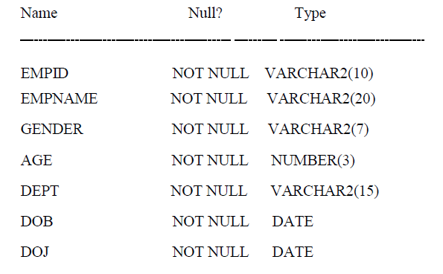

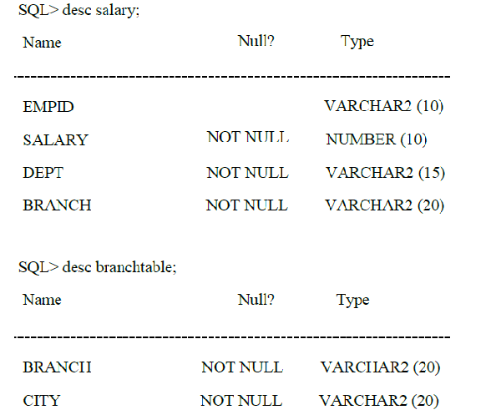

**ALTER TABLE**

* **ADD**

SQL> alter table employee add(designation varchar2(15));

**Table altered.**

SQL> alter table salary add(constraint nithi unique(empid));  
  
**Table altered.**

* **MODIFY**

SQL> alter table employee modify (designation varchar2(20));  
  
**Table altered**

**RENAME TABLE**

SQL> rename employee to emp;   
  
**Table renamed.**

SQL> desc employee;

ERROR:

ORA-04043: object employee does not exist   
  
**Table altered.**

**TRUNCATE TABLE DATA**

SQL> insert into emp values(&no,'&name','&dept',&age,'&sex');   
Enter value for no: 1

Enter value for name: arun

Enter value for dept: it   
Enter value for age: 22   
Enter value for sex: m

**1 row created.**

SQL> insert into emp values(&no,'&name','&dept',&age,'&sex');   
Enter value for no: 2

Enter value for name: bala   
Enter value for dept: service   
Enter value for age: 26   
Enter value for sex: m

**1 row created.**

SQL> insert into emp values(&no,'&name','&dept',&age,'&sex');   
Enter value for no: 3

Enter value for name: chitra   
Enter value for dept: sales   
Enter value for age: 25   
Enter value for sex: f

**1 row created.**

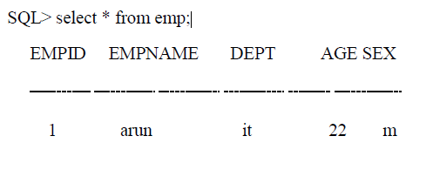

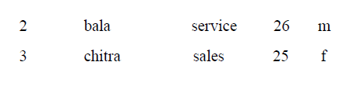

SQL> commit;  
  
**Commit complete.**

SQL> truncate table emp;   
  
**Table truncated.**

SQL> select * from emp;   
**no rows selected**

SQL> commit;

**Commit complete.**

**DROP TABLE**

SQL> drop table emp;   
  
Table dropped.

SQL> desc emp;   
  
ERROR:

ORA-04043: object emp does not exist

**CONCLUSION / OUTCOME**:

**MARKS & SIGNATURE:**

|  |  |  |  |  |  |
| --- | --- | --- | --- | --- | --- |
| **R1  (3 Marks)** | **R2  (5 Marks)** | **R3  (4 Marks)** | **R4  (3 Marks)** | **Total  (15 Marks)** | **Signature** |
|  |  |  |  |  |  |

**DDL COMMANDS FOR LIBRARY MANAGEMENT SYSTEM :**

CREATE TABLE `author` (

`ISBN` char(14) NOT NULL,

`Author` varchar(50) NOT NULL,

PRIMARY KEY (`ISBN`,`Author`)

) ;

CREATE TABLE `book` (

`ISBN` char(14) NOT NULL,

`Title` varchar(100) NOT NULL,

`Cost` decimal(5,2) NOT NULL,

`IsReserved` tinyint(1) NOT NULL,

`Edition` int(11) NOT NULL,

`PubliPlace` varchar(30) DEFAULT NULL,

`Publisher` varchar(30) NOT NULL,

`CopyYr` decimal(4,0) NOT NULL,

`ShelfID` int(11) DEFAULT NULL,

`SubName` varchar(30) DEFAULT NULL,

PRIMARY KEY (`ISBN`),

KEY `ShelfID` (`ShelfID`),

KEY `SubName` (`SubName`)

) ;

CREATE TABLE `bookcopy` (

`ISBN` char(14) NOT NULL,

`CopyID` int(11) NOT NULL,

`IsChecked` tinyint(1) NOT NULL DEFAULT '0',

`IsHold` tinyint(1) NOT NULL DEFAULT '0',

`IsDamaged` tinyint(1) NOT NULL DEFAULT '0',

`FuRequester` varchar(15) DEFAULT NULL,

PRIMARY KEY (`ISBN`,`CopyID`)

) ;

CREATE TABLE `floor` (

`FloorID` int(11) NOT NULL,

`NumAssistant` int(11) NOT NULL,

`NumCopier` int(11) NOT NULL,

PRIMARY KEY (`FloorID`)

) ;

CREATE TABLE `issue` (

`Username` varchar(15) NOT NULL,

`ISBN` char(14) NOT NULL,

`CopyID` int(11) NOT NULL,

`IssueID` int(4) NOT NULL,

`ExtenDate` date DEFAULT NULL,

`IssueDate` date NOT NULL,

`ReturnDate` date NOT NULL,

`NumExten` int(11) NOT NULL DEFAULT '0',

PRIMARY KEY (`Username`,`ISBN`,`CopyID`),

UNIQUE KEY `IssueID` (`IssueID`),

KEY `ISBN` (`ISBN`),

KEY `issue_ibfk_2` (`ISBN`,`CopyID`)

) ;

CREATE TABLE `keyword` (

`SName` varchar(30) NOT NULL,

`Keyword` varchar(25) NOT NULL,

PRIMARY KEY (`SName`,`Keyword`)

) ;

CREATE TABLE `keyword` (

`SName` varchar(30) NOT NULL,

`Keyword` varchar(25) NOT NULL,

PRIMARY KEY (`SName`,`Keyword`)

) ;

CREATE TABLE `shelf` (

`ShelfID` int(11) NOT NULL,

`FloorID` int(11) NOT NULL,

`AisleID` int(11) NOT NULL,

PRIMARY KEY (`ShelfID`),

KEY `FloorID` (`FloorID`)

) ;

CREATE TABLE `staff` (

`Username` varchar(15) NOT NULL,

PRIMARY KEY (`Username`)

) ;

CREATE TABLE `student_faculty` (

`Username` varchar(15) NOT NULL,

`Name` varchar(30) NOT NULL,

`DOB` date DEFAULT NULL,

`Email` varchar(30) NOT NULL,

`IsDebarred` tinyint(1) NOT NULL DEFAULT '0',

`Gender` char(1) NOT NULL,

`Address` varchar(50) DEFAULT NULL,

`IsFaculty` tinyint(1) NOT NULL,

`Penalty` decimal(5,2) NOT NULL DEFAULT '0.00',

`Dept` varchar(50) DEFAULT NULL,

PRIMARY KEY (`Username`)

) ;

CREATE TABLE `subject` (

`SubName` varchar(30) NOT NULL,

`FloorID` int(11) NOT NULL,

`NumJournal` int(11) NOT NULL,

PRIMARY KEY (`SubName`),

KEY `FloorID` (`FloorID`)

) ;

CREATE TABLE `user` (

`Username` varchar(15) NOT NULL,

`Password` varchar(20) NOT NULL,

PRIMARY KEY (`Username`)

) ;