**EXPERIMENT NO: 6**

**Date of Performance:   
Date of Submission:**

**AIM**:   
Implement various Join operations.

**THEORY**:

A Join operation combines related tuples from different relations, if and only if a given join condition is satisfied. It is denoted by ⋈.

**EMPLOYEE**

|  |  |
| --- | --- |
| **EMP_CODE** | **EMP_NAME** |
| 101 | Stephan |
| 102 | Jack |
| 103 | Harry |

**SALARY**

|  |  |
| --- | --- |
| **EMP_CODE** | **SALARY** |
| 101 | 50000 |
| 102 | 30000 |
| 103 | 25000 |

Operation: (EMPLOYEE ⋈ SALARY)

Result:

|  |  |  |
| --- | --- | --- |
| **EMP_CODE** | **EMP_NAME** | **SALARY** |
| 101 | Stephan | 50000 |
| 102 | Jack | 30000 |
| 103 | Harry | 25000 |

Types of Join operations:

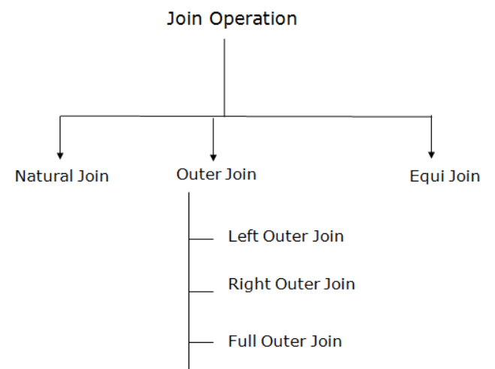

### Natural Join:

* A natural join is the set of tuples of all combinations in R and S that are equal on their common attribute names.
* It is denoted by ⋈.

**Example:** Refer EMPLOYEE table and SALARY table:

**Input:**

∏EMP_NAME, SALARY (EMPLOYEE ⋈ SALARY)

**Output:**

|  |  |
| --- | --- |
| **EMP_NAME** | **SALARY** |
| Stephan | 50000 |
| Jack | 30000 |
| Harry | 25000 |

### Outer Join:

The outer join operation is an extension of join operation. It is used to deal with missing information.

**Example:**

**EMPLOYEE**

|  |  |  |
| --- | --- | --- |
| **EMP_NAME** | **STREET** | **CITY** |
| Ram | Civil line | Mumbai |
| Shyam | Park street | Kolkata |
| Ravi | M.G. Street | Delhi |
| Hari | Nehru Nagar | Hyderabad |

**FACT_WORKERS**

|  |  |  |
| --- | --- | --- |
| **EMP_NAME** | **BRANCH** | **SALARY** |
| Ram | Infosys | 10000 |
| Shyam | Wipro | 20000 |
| Kuber | HCL | 30000 |
| Hari | TCS | 50000 |

**Input:**

(EMPLOYEE ⋈ FACT_WORKERS)

**Output:**

|  |  |  |  |  |
| --- | --- | --- | --- | --- |
| **EMP_NAME** | **STREET** | **CITY** | **BRANCH** | **SALARY** |
| Ram | Civil line | Mumbai | Infosys | 10000 |
| Shyam | Park street | Kolkata | Wipro | 20000 |
| Hari | Nehru Nagar | Hyderabad | TCS | 50000 |

### a. Left outer join:

* Left outer join contains the set of tuples of all combinations in R and S that are equal on their common attribute names.
* In the left outer join, tuples in R have no matching tuples in S.
* It is denoted by ⟕.

**Input:**

EMPLOYEE ⟕ FACT_WORKERS

**Output:**

|  |  |  |  |  |
| --- | --- | --- | --- | --- |
| **EMP_NAME** | **STREET** | **CITY** | **BRANCH** | **SALARY** |
| Ram | Civil line | Mumbai | Infosys | 10000 |
| Shyam | Park street | Kolkata | Wipro | 20000 |
| Hari | Nehru street | Hyderabad | TCS | 50000 |
| Ravi | M.G. Street | Delhi | NULL | NULL |

### b. Right outer join:

* Right outer join contains the set of tuples of all combinations in R and S that are equal on their common attribute names.
* In right outer join, tuples in S have no matching tuples in R.
* It is denoted by ⟖.

**Input:**

EMPLOYEE ⟖ FACT_WORKERS

**Output:**

|  |  |  |  |  |
| --- | --- | --- | --- | --- |
| **EMP_NAME** | **BRANCH** | **SALARY** | **STREET** | **CITY** |
| Ram | Infosys | 10000 | Civil line | Mumbai |
| Shyam | Wipro | 20000 | Park street | Kolkata |
| Hari | TCS | 50000 | Nehru street | Hyderabad |
| Kuber | HCL | 30000 | NULL | NULL |

### c. Full outer join:

* Full outer join is like a left or right join except that it contains all rows from both tables.
* In full outer join, tuples in R that have no matching tuples in S and tuples in S that have no matching tuples in R in their common attribute name.
* It is denoted by ⟗.

**Input:**

EMPLOYEE ⟗ FACT_WORKERS

**Output:**

|  |  |  |  |  |
| --- | --- | --- | --- | --- |
| **EMP_NAME** | **STREET** | **CITY** | **BRANCH** | **SALARY** |
| Ram | Civil line | Mumbai | Infosys | 10000 |
| Shyam | Park street | Kolkata | Wipro | 20000 |
| Hari | Nehru street | Hyderabad | TCS | 50000 |
| Ravi | M.G. Street | Delhi | NULL | NULL |
| Kuber | NULL | NULL | HCL | 30000 |

### Equi join:

It is also known as an inner join. It is the most common join. It is based on matched data as per the equality condition. The equi join uses the comparison operator(=).

**Example:**

**CUSTOMER RELATION**

|  |  |
| --- | --- |
| **CLASS_ID** | **NAME** |
| 1 | John |
| 2 | Harry |
| 3 | Jackson |

**PRODUCT RELATION**

|  |  |
| --- | --- |
| **PRODUCT_ID** | **CITY** |
| 1 | Delhi |
| 2 | Mumbai |
| 3 | Noida |

**Input:**

CUSTOMER ⋈ Customer.class_id = Product.product_idPRODUCT

**Output:**

|  |  |  |  |
| --- | --- | --- | --- |
| **CLASS_ID** | **NAME** | **PRODUCT_ID** | **CITY** |
| 1 | John | 1 | Delhi |
| 2 | Harry | 2 | Mumbai |
| 3 | Harry | 3 | Noida |

**STUDENT RELATION**

|  |  |  |
| --- | --- | --- |
| **SID** | **Name** | **Std** |
| 101 | Alex | 10 |
| 102 | Maria | 11 |

**SUBJECT RELATION**

|  |  |
| --- | --- |
| **Class** | **Subject** |
| 10 | Math |
| 10 | English |
| 11 | Music |
| 11 | Sports |

STUDENT ⋈Student.Std = Subject.Class SUBJECT

|  |  |  |  |  |
| --- | --- | --- | --- | --- |
| **SID** | **Name** | **Std** | **Class** | **Subject** |
| 101 | Alex | 10 | 10 | Math |
| 101 | Alex | 10 | 10 | English |
| 102 | Maria | 11 | 11 | Music |
| 102 | Maria | 11 | 11 | Sports |

**CONCLUSION / OUTCOME**:

**MARKS & SIGNATURE:**

|  |  |  |  |  |  |
| --- | --- | --- | --- | --- | --- |
| **R1  (3 Marks)** | **R2  (5 Marks)** | **R3  (4 Marks)** | **R4  (3 Marks)** | **Total  (15 Marks)** | **Signature** |
|  |  |  |  |  |  |

