**Q. What is mean by css?**

CSS or Cascading style sheet is the standard stylesheet language of web, used to style or formatting of an HTML document. With CSS, it is easier to build a website as css can style whole website using one single css file.

CSS is not a programming language or markup language. It is a stylesheet language used with HTML to change look of default html elements, like colors, backgrounds, font size, font family, width, height etc.

**Q. What are the advantages of css?**

Answer: There are some advantages while using css

1. css can save time:

2. css is very easy stylesheet language.

3. Platform independent: css can run on any browsers.

4. Easy for maintains:

* The first version of css was introduced in 1996. It is called css Level1.
* The second version of css was introduced in 1998. It is called css Level2.
* The css3 was introduced in 2009.

**Q. What is syntax to write css?**

The following is basic syntax to write css

**selector{property : value; property : value;}**

**What is mean by selector?**

CSS Selectors are used to select or target an HTML Element or group of elements based on the selector we are using. CSS Selectors are divided as Simple Selectors, Combinators Selectors and Pseudo Selectors. Selectors are backbone of css. The latest selectors in css are called CSS3 selectors introduced with HTML5.

Selectors are used in internal or external css. After selector name, a declaration block, i.e curly brackets {} are used. Within {}, css code for targeted element is written with key:value pair. Sometimes multiple values are there fro single key, so white space is used as separator. After Property:value, semi-colon ; is used to add next property and value.

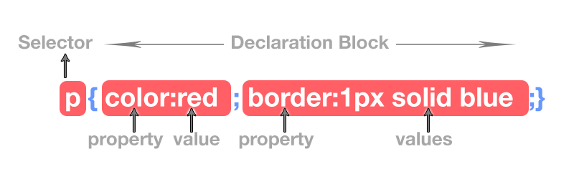

**Q. What is the different selector in css?**

There are 4 types of selector are present in css.

1. Tag Selector: Tag selector can be used with html tags like h1,p,ul etc....

**2. ID Selector:**

ID Selector is used to call an HTML Element by its unique id name. Id is always unique in a single web page. We cannot give same ID name to any other HTML Element in same webpage.

ID is basically an attribute used in opening or start tag of html element. Inside double quotation, the value of ID is given. ID value is single, means no white space separation

In css, id selector is called using HASH (#), followed by id name. See example.

<style>

#head1{ color:green}

#para{ color:red; background:yellow}

p{ color:blue}

</style>

<h3 id="head1">This heading will be green.</h3>

<p id="para”>This text will be red and background yellow.</p>

<p>i am a paragraph without id</p>

**Class Selectors**

Class Selector in css is used to call all html elements with same class name.

Class represents a group of different or same html elements. We can give same class name to two or more different HTML Elements.

Class is basically an attribute used in Opening or Start Tag. Inside double quotation, the value of class is given.

In css, class is called using DOT ( .), followed by class name. See example.

<style>

.head{ color:red}

.para{ color:white; background:blue}

.text-italic{ font-style:italic}

</style>

<body>

<h5 class="head">This heading will be red.</h5>

<h3 class="head">This heading will be red.</h3>

<p class="para">P tag with class para.</p>

<p class="para” text-italic">P tag with class para and text-italic.</p>

</body>

Example

<!DOCTYPE html>

<html lang="en">

<head>

    <meta charset="UTF-8">

    <meta name="viewport" content="width=device-width, initial-scale=1.0">

    <title>Document</title>

    <style>

         #id3

        {

            text-align: center;

            font-size: 100px;

            color: orange;

        }

        .id1

        {

            font-size: 50px;

            color: red;

            font-family: monotype corsiva;

            border: 2px solid green;

        }

        .id2

        {

            font-size: 80px;

            color: blue;

            font-family: monotype corsiva;

        }

       p.id2

       {

        font-size: 20px;

        color: blueviolet;

       }

    </style>

</head>

<body>

    <h1 id="id3" class="id1 id2" >Welcome to HTML CSS class.</h1>

    <h1 id="id2">Welcome to HTML CSS class.</h1>

</body>

</html>