**Project Synopsis**

**Project Name:** Find Flatmates

**Project Members:**

|  |  |
| --- | --- |
| **PRN No.** | **Name** |
| **220343120005** | **Ajinkya Bhosale** |
| **220343120113** | **Satnam Singh** |
| **220343120040** | **Kishor Janjal** |
| **220343120104** | **Snehal Deshmukh** |

**Introduction of Project:**

Problem Statement – Main problem faced by today’s youth is all about finding flats for bachelors when they travel away from their hometown to another city for purpose of job seeking and higher studies. The first step always comes is to find a proper and decent flat within the budget that too in the area one wanted.

Yes! There are many other sites where you can explore rental houses but most of all are third-party apps and sites also most of them only provide houses for families with big notice Bachelors Not Allowed!

That’s the biggest issue faced by bachelors nowadays.

**Objective and Scope of Project:**

* To get access to rental flats options according to preferences
* To save efforts and Hassle and precious time
* To save users money which he pays to the broker

**Modification and improvement over the existing Implementation:**

**Present State**

Presently very few options/platforms are available to the user for finding flats mates or finding flat hence the user cannot get the best available deal and the flat owner also has very limited user traffic

**After implementation of the project**

Users will get many options to choose between. These will benefit both user and owner/ads owner to save expenses

**Project Plan:**

No. of Users and Modules

* **Owner User –**

The owner can add Hostel/Flat/Pg details

* **Customer User=**

The customer can see the list of hostels/flats/pg.

* **Modules** -

1. Owner Management
2. Customer Management

**Technology:**

Frontend- React Js

Backend- Spring Boot

Database- MySQL

Others – Docker

**Roles and Responsibilities:**

|  |  |  |
| --- | --- | --- |
| **Roles And Responsibilities** | | |
| 1 | Role | Project Manager |
| Member Name | Ajinkya Bhosale |
| PRN No | 220343120005 |
| Description |  |
| 2 | Role | Front-END Developer |
| Member Name | Satnam Singh |
| PRN No | 220343120113 |
| Description |  |
| 3 | Role | Back-END Developer |
| Member Name | Kishor Janjal |
| PRN No | 220343120040 |
| Description |  |
| 4 | Role | Front-END Developer |
| Member Name | Snehal Deshmukh |
| PRN No | 220343120104 |
| Description |  |

**Data Flow Diagram (DFD):**

Level 0:

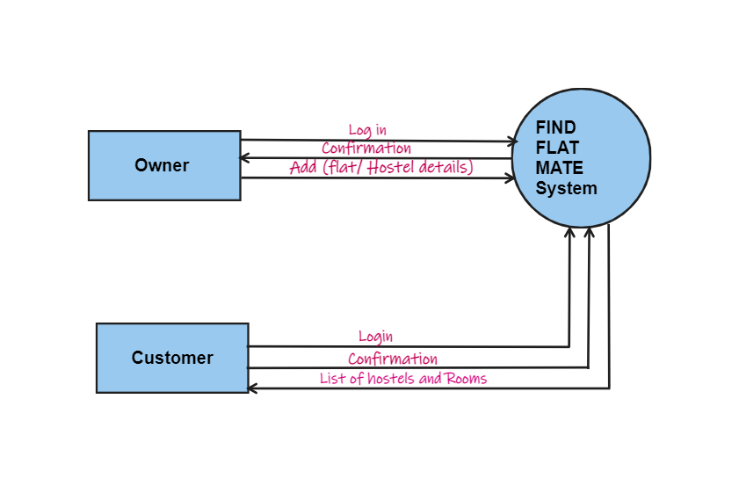

Level 1:

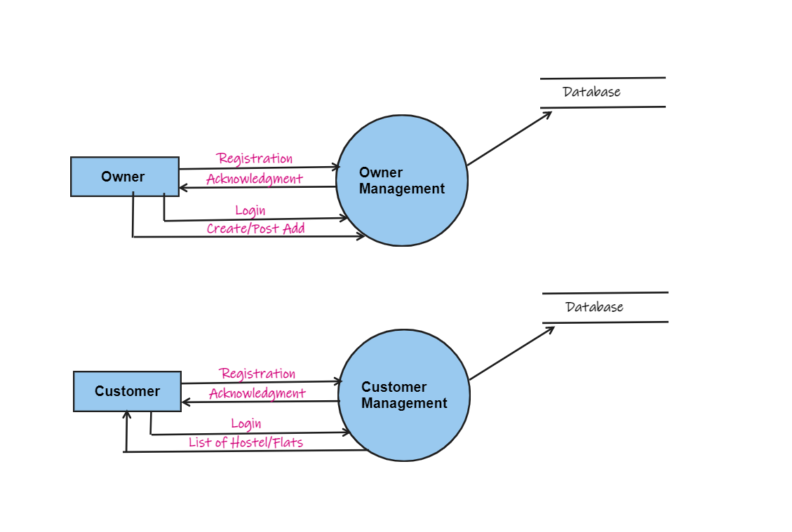

Level 2:

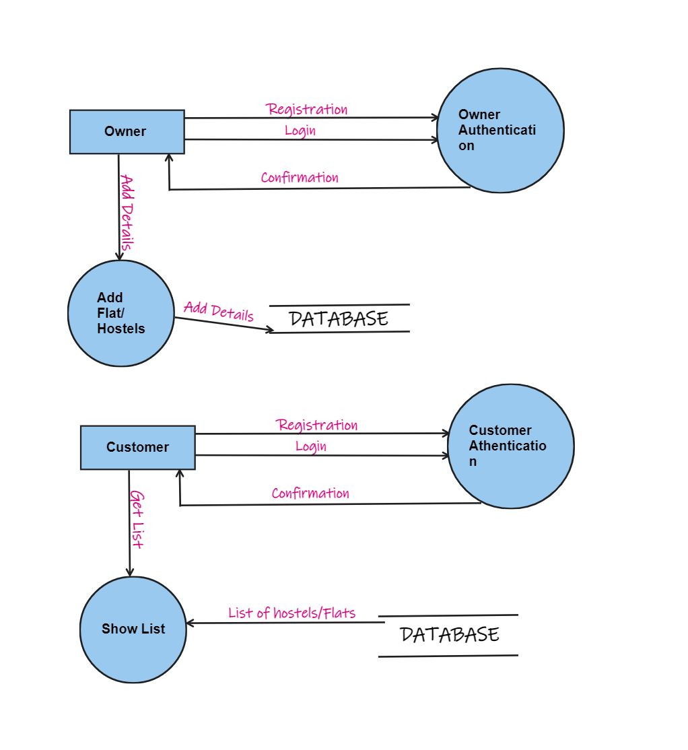

**ERD / Database Tables:**

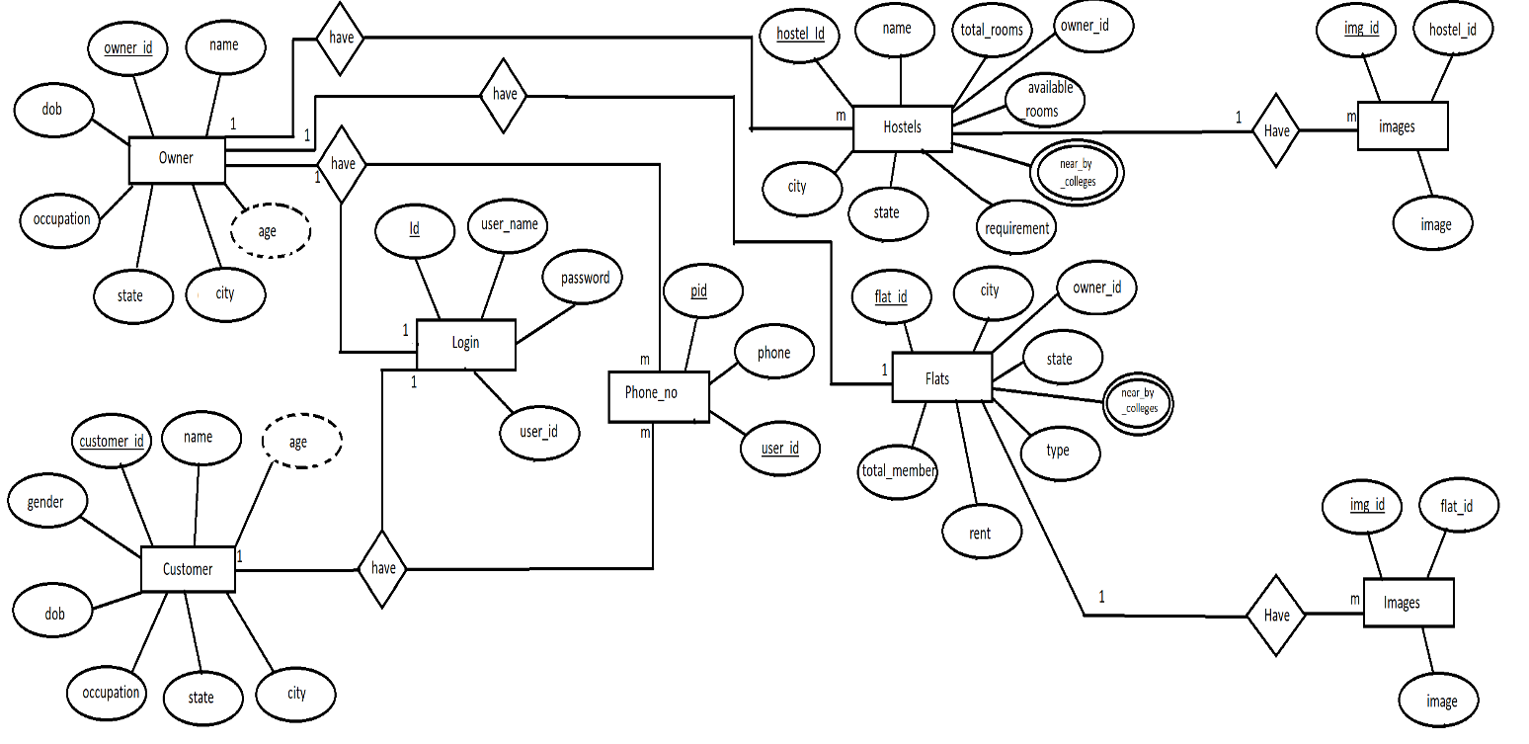

**Future Scope:**

* Adding features like to call packing & moving services.
* PG / Hostel management.
* Adding part-time jobs adds