Title: brain tumor classification

Detection

Segmentation=== images

Feature extraction==

Classification

Machine learning

features class

Deep learning class

Images/videos/text

Vgg16

Project has five parts

1. Dataset gathering/collection

Kaggle===466 images

Training===394=== model trained

Testing===72===accuracy measure

1. Dataset pre-processing

Image resize into===224\*224

1. Data augmentation

It increases the size of dataset

2000 images rotated

image zoom

brightness change

1. Model creation and training

Vgg16==model

1. Convolutional layer

Color, texture, edges, shapes

Kernel/filters

image

X feature vector

1. Max-pooling layer
2. Flattening
3. Fully connected layer

normal 20 images==features

Class2 Class 1

Class3 Class4

1. Accuracy
2. Color image===24 million shades(3 channels)RGB
3. Grayscale ====256 shades(1 channel)
4. Bw ===2 shades

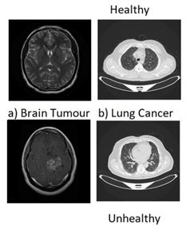

GUI

Websites

1. Front end===HTML,css
2. Backend===logical language(python)
3. Database===sqlite3

Django===framework