**For adding persistence xml which should be in our class path so create a source folder**

1. Right click on project

click on new

go to bottom, click on other

type in text box "Source folder"

name the source folder as resources

1. Right click on resources

New ->Folder

Give name as META-INF

And then click on finish

1. Copy persistence.xml into META-INF folder

**Add jars inside our project**

Right click on project

click on new

search for "folder"

name the folder as "jars"

copy all hibernate jars from common folders

**now refernced libraries would be blank**

**Add the newly added jars to classpath**

Right click on project

search for "build path" and click on it

last option "configure build path"

on the top right click on "Add jars"

search for our project and then jars folder inside it

select all the jars and add it our project

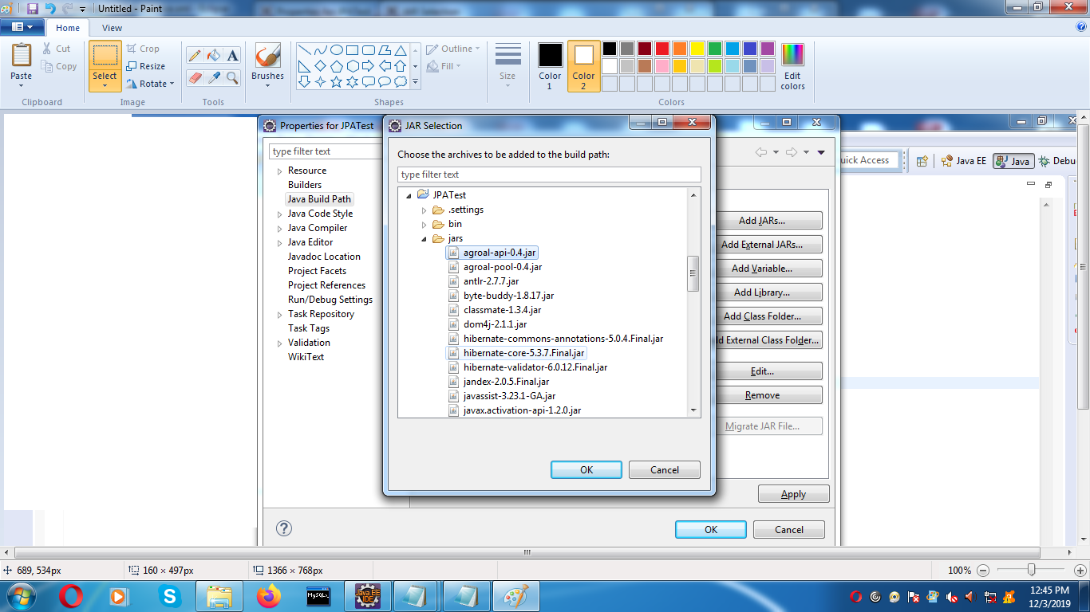

After this you could see all jatrs in ref lib

that means all the jarsa are added to project claspath

persistence xml is only for JPA