📘 DATA MODELING DOCUMENT — USAGE TRACKING SYSTEM

1. Business Case (Why this system exists)
Modern AI-enabled workflows involve multiple users running projects, creating batches, and consuming resources such as:
- Proxy API calls
- OpenAI API calls
- Other compute resources()
For companies running multiple AI automations, cost visibility, accountability, and consumption tracking become critical.

The organization needs:
- Visibility into how much each user, project, and batch is consuming.
- Ability to assign costs (OpenAI cost + Proxy cost) at a granular level.
- To reduce unnecessary usage and leakage by monitoring consumption.
- Multi-level reporting:
  - User-level usage
  - Project-level usage
  - Batch-level usage
  - Total cost over time
- An audit trail of:
  - Who created projects
  - Who created batches
  - Who created usage entries
  - When actions happened
- Support for future integrations like billing, alerts, budgets, and dashboards.

Problem this design solves:
✔ Tracks cost per user
✔ Tracks cost per project
✔ Tracks cost per batch
✔ Prevents unassigned cost leakage
✔ Enables analytics (daily/weekly/monthly usage)
✔ Enables leadership to identify:
- High consumption users
- Most expensive projects
- Inefficient batches
This data model becomes the core foundation of cost accountability for all AI automation inside the company.

2. Functional Requirements

2.1 User Management
The system must store:
- User identity
- Role (Admin, Developer, Viewer)
- Contact email
- Created/updated timestamps

2.2 Project Management
Users create projects, which will later contain batches:
- Project name
- Owner (created_by)
- Status (active, inactive, archived)
- Audit fields for updates

2.3 Batch Management
Within each project, users create batches for:
- Processing product data
- Running automation jobs
- Executing model calls
Each batch contains:
- Batch name
- Batch size
- Associated project
- Creator user
- Created timestamp

2.4 Usage Tracking
Every time an automation runs, a “usage entry” is stored:
- Who used the system
- Which project usage belongs to
- Which batch usage belongs to
- Cost incurred
- Timestamp

2.5 Reporting Requirements
The system should support:
- Total cost per user
- Total cost per project
- Cost per batch
- Combined cost breakdown:
  - Proxy cost
  - OpenAI cost
- Timeline-based reporting (daily/weekly/monthly)

2.6 Audit Requirements
The system must maintain:
- Who created a project
- Who created a batch
- Who incurred costs
- Full history of activities

3. Conceptual Data Model (High-level business model)

Core Business Entities
- User
- Project
- Batch
- Usage

Conceptual Relationships
User 1 ───< Project
User 1 ───< Batch
Project 1 ───< Batch
User 1 ───< Usage
Project 1 ───< Usage
Batch 1 ───< Usage

Business Description
- A User creates Projects.
- A User can create multiple Batches inside a project.
- A Batch represents a unit of work.
- Usage records cost at the lowest granularity.

4. Logical Data Model (Attributes + PK/FK, DB agnostic)

Users
- id (PK)
- username
- email_id
- role
- created_at

Projects
- project_id (PK)
- project_name
- created_by (FK → users.id)
- updated_by (FK → users.id)
- status
- created_at
- updated_at

Batches
- batch_id (PK)
- batch_name
- batch_size
- created_by (FK → users.id)
- batch_project_id (FK → projects.project_id)
- created_at

Usage
- usage_id (PK)
- usage_by (FK → users.id)
- usage_project (FK → projects.project_id)
- usage_batch (FK → batches.batch_id)
- proxy_cost
- openai_cost
- created_at

5. Physical Data Model (SQL-ready)

users
CREATE TABLE users (
id SERIAL PRIMARY KEY,
username VARCHAR(255) NOT NULL,
role VARCHAR(50),
email_id VARCHAR(255) UNIQUE,
created_at TIMESTAMP DEFAULT CURRENT_TIMESTAMP
);

projects
CREATE TABLE projects (
project_id SERIAL PRIMARY KEY,
project_name VARCHAR(255) NOT NULL,
created_by INTEGER NOT NULL REFERENCES users(id),
updated_by INTEGER REFERENCES users(id),
status VARCHAR(50),
created_at TIMESTAMP DEFAULT CURRENT_TIMESTAMP,
updated_at TIMESTAMP
);

batches
CREATE TABLE batches (
batch_id SERIAL PRIMARY KEY,
created_by INTEGER NOT NULL REFERENCES users(id),
batch_project_id INTEGER NOT NULL REFERENCES projects(project_id),
batch_name VARCHAR(255),
batch_size INTEGER,
created_at TIMESTAMP DEFAULT CURRENT_TIMESTAMP
);

usage
CREATE TABLE usage (
usage_id SERIAL PRIMARY KEY,
usage_by INTEGER NOT NULL REFERENCES users(id),
usage_project INTEGER NOT NULL REFERENCES projects(project_id),
usage_batch INTEGER NOT NULL REFERENCES batches(batch_id),
proxy_cost FLOAT,
openai_cost FLOAT,
created_at TIMESTAMP DEFAULT CURRENT_TIMESTAMP

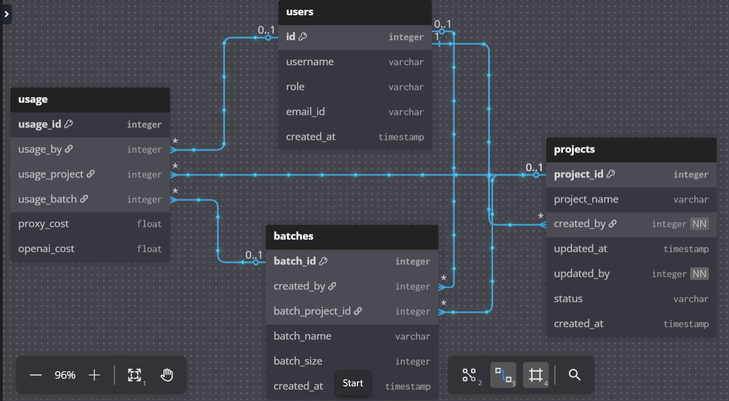

6. Normalization Approach
✔ Fully normalized (3rd Normal Form)
✔ No redundant data
✔ Strong foreign keys
✔ Granular tracking at user, project, batch level

7. Design Decisions & Justifications

Why a Usage table separate from Batch?
Because a single batch may generate:
- multiple API calls
- multiple cost points
- multiple timestamps
Granularity is mandatory for billing.

Why link usage → user/project/batch?
To support:
- user-wise reporting
- batch-wise breakdown
- project-level billing

Why maintain created_by & updated_by?
For audit trail and compliance.

Why store cost in FLOAT?
Proxy and OpenAI pricing are non-integer and continuously changing.

8. Future Extensibility
The system can easily expand to support:

8.1 Budgeting
- Set cost limits per user/project
- Email alerts when thresholds exceed

8.2 Billing
- Generate monthly invoices
- Chargeback to external clients
- Cost splitting

8.3 Analytics Dashboard
- Cost trends
- Top expensive users
- Project heatmaps
- Batch-level analytics

8.4 Resource Monitoring
- Token usage
- API retries
- Success/failure rates

8.5 Multi-Cloud Support
- AWS Bedrock
- Gemini
- Local inference

9. Summary
This document describes the complete data model for an end-to-end usage tracking platform that monitors:
- Users
- Projects
- Batches
- Costs
It ensures auditability, cost visibility, governance, scalability, and accurate billing.

