**Practical 2**

**Estimation of Project Metrics**

**Aim of the Experiment**

To estimate the cost, effort, and duration of a software project based on the identified requirements, and to select a suitable solution approach that fulfills the organizational goals.

**Problem Definition**

(Estimation of Project Metrics)

In this experiment, we aim to estimate project parameters like cost, time, and effort for developing an intelligent career-preparation system. The project will incorporate modern techniques like resume parsing using NLP, job role mapping, and chatbot-driven interview simulations. Proper estimation ensures the selected solution is feasible and delivers optimal results for users and institutions.

**Introduction**

After gathering all the system and functional requirements for IPCRA, the next step is evaluating various solution approaches. These may vary in development complexity, cost, and duration. Analysts must weigh trade-offs in performance, scalability, and implementation feasibility to select the best course forward using structured estimation models.

* **Purpose**: Improve interview readiness and resume quality using AI.
* **Overview**: Combines a Resume Analyzer and Interview Chatbot for feedback and performance evaluation.
* **Scope**: LAN-based academic tool with resume uploads, mock interviews, analytics, and admin access.

**General Description**

* **Functions:** Resume parsing, skill gap detection, chatbot interviews, feedback generation.
* **User Community:** Students, job seekers, and career counsellors.

**Functional Requirements**

* **Possible Outcomes**: Parsed resume insights, interview scores, improvement suggestions.
* **Ranked Order**: Resume upload → Role selection → Interview → Feedback.
* **Input-Output**: Input: Resume, user answers. Output: Evaluation reports.

**User Interface Requirements**

* **Interfaces**: Web dashboard for users and admin panel for analytics.
* **Examples**: Resume upload screen, chat window, report viewer.

**Performance Requirements**

* **Response Time**: < 3s per query.
* **Throughput**: Handle 20+ concurrent interview sessions.
* **Scalability**: Supports expanding question banks and user base.

**Non-Functional Attributes**

* **Usability**: Intuitive, form-based input, responsive UI.
* **Reliability**: >99% uptime expected.
* **Security**: User authentication, encrypted resume data.

**Schedule and Budget**

* **Timeline**: 4–6 weeks development; 1–2 weeks testing.
* **Cost Estimate**: Based on manpower, hosting, and integration tools.

**Appendices**

* **Supplementary Info**: NLP libraries, chatbot frameworks.
* **Glossary**: ATS – Applicant Tracking System, NLP – Natural Language Processing.

**THEORY**

**1. Objectives**

After completing this experiment, you will be able to:

(a) Estimate **cost**, **time**, and **effort** for the chatbot-based system using structured models.

(b) Choose the best-fit development strategy that satisfies stakeholder expectation

**2. Project Estimation Techniques**

We will study and apply the following techniques

COCOMO (Constructive Cost Model):

Estimates project effort and cost using size (LOC - lines of code) as input.

Types: Basic, Intermediate, and Detailed COCOMO.

**Types of Estimation Models:**

Algorithmic models (e.g., COCOMO)

Expert judgment

Analogy-based estimation

Machine learning approaches (in advanced settings)

**Halstead’s Complexity Metrics:**

Measures complexity using program operators and operands to estimate effort, time, and bugs.

**Metrics include:**

* Program vocabulary
* Program length
* Volume, Difficulty, and Effort

**Advantages:**

1. Ensures realistic planning
2. Supports risk management
3. Prevents overspending and timeline overruns

**Drawbacks:**

1. Sensitive to input accuracy (LOC estimate, team skill)
2. Challenging for innovative systems lacking precedent

**Simulation**

You’ll simulate the application of estimation techniques on a sample software project to practice calculating cost, effort, and schedule using formulas.

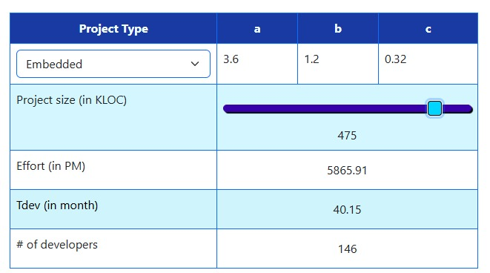

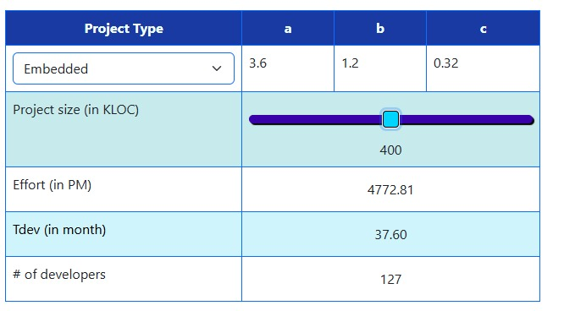

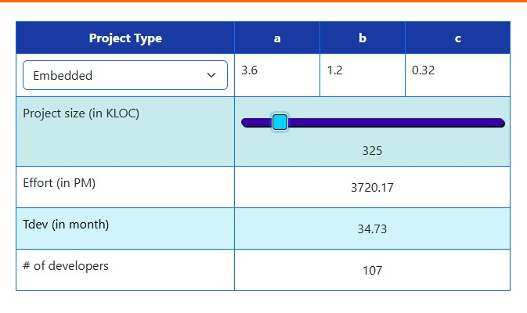

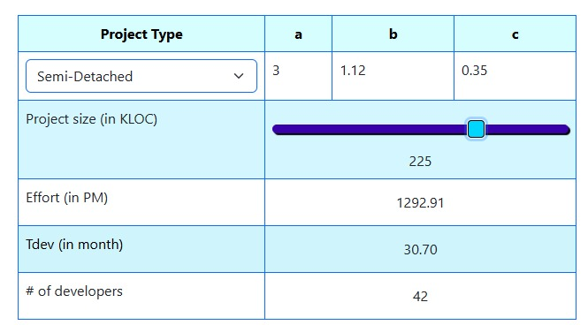

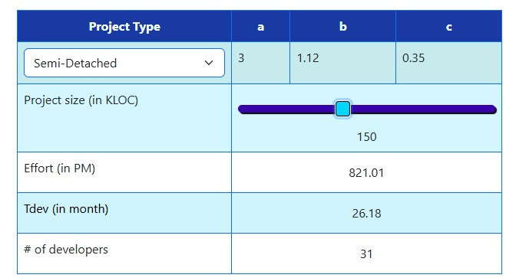

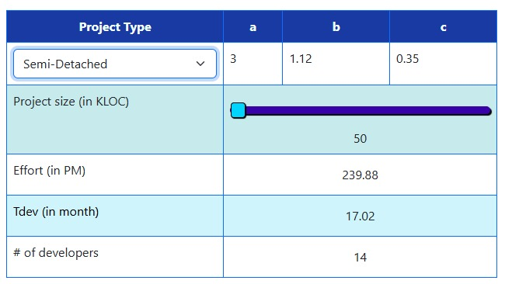

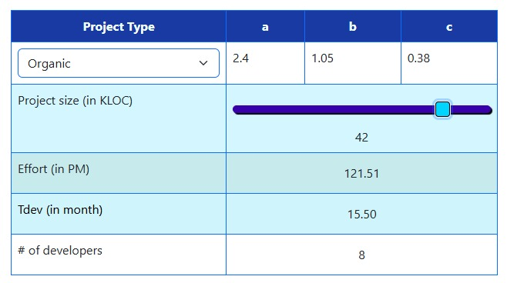

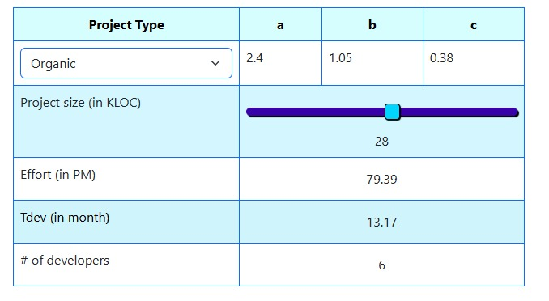



**Case Study**

SE VLabs Institute has launched a student-focused initiative aimed at enhancing employability and interview-readiness. As part of this effort, the institute proposes the development of a **smart system** that simulates personalized mock interviews and analyzes resumes using artificial intelligence techniques.

Apart from students, the system will be utilized by career counselors and academic advisors to guide students effectively toward job market expectations. The chatbot will simulate real-time interview sessions based on the applicant’s resume, targeting specific roles in various domains, while the resume analyzer will suggest improvements for better alignment with job descriptions.

The system will also include:

* Dynamic Role-Based Interview Simulation
* Natural Language Processing (NLP)–driven Resume Parsing
* Real-time Feedback Generation
* Secure Login with Session Tracking
* Downloadable Performance Reports

Authenticated users (students and faculty) can access full functionality. Unauthenticated visitors may preview system capabilities or request demo simulations. The final deliverable would be a web application (built using HTML5 and React) and hosted internally over the institute LAN. Although internal hosting limits exposure to external threats, the system will ensure strong encryption protocols and avoid storing sensitive data (e.g., passwords) in plain text.

SE VLabs has designated its internal IT team to carry out development. The project team includes one senior AI expert and a few experienced software engineers familiar with frontend development, NLP integration, and backend architecture. Given the team's maturity and compact size, the project qualifies as **Organic** under the COCOMO classification.

The development effort estimation is based on expert suggestions, assuming a total project size of **10 KLOC (approx.)**.

**🧮 COCOMO Estimation**

The estimated project size is ~10 KLOC.

➤ **Basic COCOMO Estimation:**

Organic mode constants:

a = 2.4, b = 1.05, c = 0.38

Effort = a × (KLOC)^b

→ Effort = 2.4 × (10)^1.05 ≈ 27 PM (Person-Months)

Development Time = 2.5 × (Effort)^c

→ Tdev = 2.5 × (27)^0.38 ≈ 8.7 Months

➤ **Intermediate COCOMO Estimation (using EAF):**

Based on discussions with the team, the following cost driver weights are assumed:

| **Cost Driver** | **Rating** | **Weight** |
| --- | --- | --- |
| Product Reliability | High | 1.15 |
| System Complexity | High | 1.15 |
| Use of Tools | High | 0.85 |
| Team Experience | High | 0.85 |
| Platform Experience | Very High | 0.7 |
| Development Schedule | Nominal | 1.0 |
| Real-Time Constraints | Nominal | 1.0 |

**Effort Adjustment Factor (EAF) =**  
1.15 × 1.15 × 0.85 × 0.85 × 0.7 × 1.0 × 1.0 = **~0.53**

**Refined Estimates**

* **Effort_corrected = 27 × 0.53 = 14.3 PM (approx)**
* **Tdev_corrected = 2.5 × (14.3)^0.38 ≈ 7 months (approx)**

**DIAGRAM**

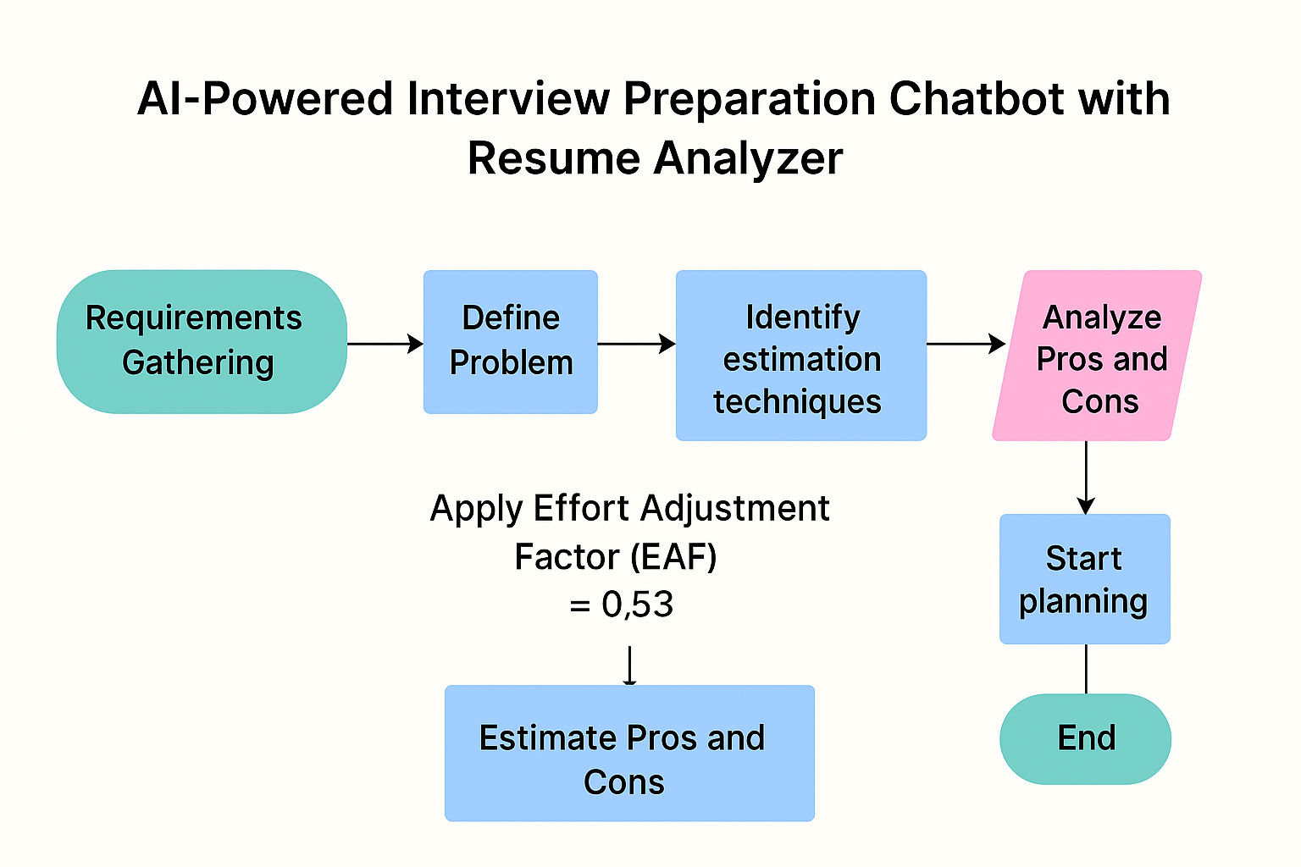

**REFERENCES**

**Interview Chatbot References**

* [**AI Bot for Interview Preparation – IJCRT**](https://ijcrt.org/papers/IJCRT2401845.pdf)
* [**AI-Powered Interview Assistant Chatbot – IJSRED**](https://ijsred.com/volume8/issue3/IJSRED-V8I3P17.pdf)
* [**AI Mock Interview Chatbot Using Gen AI – IJSET**](https://www.ijset.in/wp-content/uploads/IJSET_V13_issue2_242.pdf)
* [**Enhancing Interview Preparation – IJRSET**](https://www.ijrset.in/index.php/ijrset/article/view/654)
* [**Interviewy – GitHub Project**](https://github.com/kashafkhann/interviewy-ai-interview-preparation-chatbot)
* [**Bossed.ai – Voice Interview Practice**](https://bossed.ai/)
* [**GreetAI – AI Interview Practice**](https://www.greetai.co/practice)
* [**Interview Sidekick – AI Interview Bots**](https://interviewsidekick.com/blog/ai-interview-bot)

**Resume Analyzer References**

* [**AI Resume Analyzer – IJCRT**](https://ijcrt.org/papers/IJCRT2312507.pdf)
* [**Resume Analyzer Using NLP – RJPN**](https://rjpn.org/ijcspub/papers/IJCSP24A1150.pdf)
* [**Smart Resume Analyzer – IJRES**](https://www.ijres.org/papers/Volume-11/Issue-3/1103409418.pdf)
* [**Teal Resume Parser**](https://www.tealhq.com/tool/resume-parser)
* [**Resmume ATS Checker**](https://resmume.com/resume-ats-checker/)
* [**Enhancv Resume Checker**](https://enhancv.com/resources/resume-checker/)
* [**SkillSyncer Resume Scanner**](https://skillsyncer.com/)
* [**Naukri Resume Score Checker**](https://www.naukri.com/resume-score-checker)

**Conclusion**

By applying Basic and Intermediate COCOMO models, the development effort for the **Interview Preparation Chatbot with Resume Analyzer** is realistically estimated. Initially projected at **27 person-months**, the refined estimate considering team strengths and project characteristics brings it down to **14.3 person-months** with a timeline of **~7 months**. These insights guide efficient planning, reduce risks, and ensure the system is both feasible and impactful for career-readiness goals.