

Safety Plan Lane Assistance

**Document Version: 1.0**

**Template Version 1.0, Released on 2017-06-21**



# Document history

**[Instructions: Fill in the date, version and description fields. You can fill out the Editor field with your name if you want to do so. Keep track of your editing as if this were a real world project.**

**For example, if this were your first draft or first submission, you might say version 1.0. If this is a second submission attempt, then you'd add a second line with a new date and version 2.0]**

|  |  |  |  |
| --- | --- | --- | --- |
| Date | Version | Editor | Description |
| 8/9/2018 | 1.0 | Ajinkya Bhave | Safety Plan for Lane Assistance Item |
|  |  |  |  |
|  |  |  |  |
|  |  |  |  |
|  |  |  |  |

# Table of Contents

**[Instructions: We have provided a table of contents. If the table of contents is not showing up correctly in your word processor of choice, please update it. The table of contents should show each section of the document and page numbers or links. Most word processors can do this for you. In** [**Google Docs**](https://support.google.com/docs/answer/116338?co=GENIE.Platform%3DDesktop&hl=en)**, you can use headings for each section and then go to Insert > Table of Contents.** [**Microsoft Word**](https://support.microsoft.com/en-us/help/285059/how-to-create-a-table-of-contents-by-marking-text-in-word) **has similar capabilities]**

Document history

Table of Contents

Introduction

Purpose of the Safety Plan

Scope of the Project

Deliverables of the Project

Item Definition

Goals and Measures

Goals

Measures

Safety Culture

Safety Lifecycle Tailoring

Roles

Development Interface Agreement

Confirmation Measures

# Introduction

## Purpose of the Safety Plan

A safety plan provides an overall framework for a functional safety project. It also defines the responsibilities of the various actors involved in the project. The output of the design, implementation, and production phases are checked against the safety plan to ensure compliance.

## Scope of the Project

For the lane assistance project, the following safety lifecycle phases are in scope:

Concept phase

Product Development at the System Level

Product Development at the Software Level

The following phases are out of scope:

Product Development at the Hardware Level

Production and Operation

## Deliverables of the Project

The deliverables of the project are:

Safety Plan

Hazard Analysis and Risk Assessment

Functional Safety Concept

Technical Safety Concept

Software Safety Requirements and Architecture

# Item Definition

The Item to be analysed is the Lane Assistance System. This Item will have two functions:

1. Lane departure warning
2. Lane keeping assistance

When the driver drifts towards the edge of the lane, two things will happen:

* the lane departure warning function will vibrate the steering wheel
* the lane keeping assistance function will move the steering wheel so that the wheels turn towards the center of the lane

The architecture and boundary of the Item is shown in Fig. 1 below.

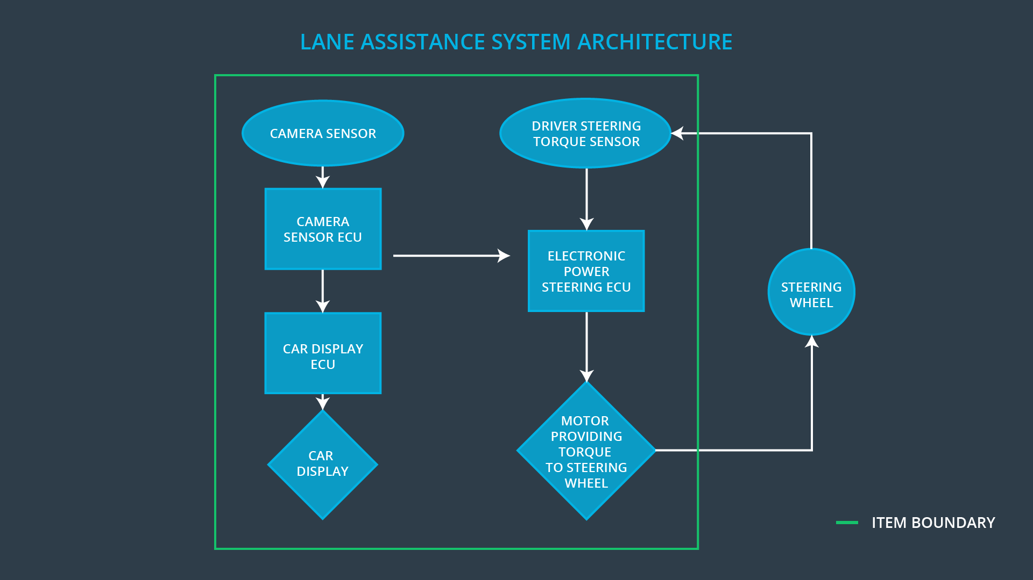

To state the lane departure warning engineering requirement more formally: "the lane departure warning function shall apply an oscillating steering torque to provide the driver a haptic feedback." In other words, the vehicle quickly moves the steering wheel back and forth to create a vibration. You can assume that the engineering requirement came from a product engineering team, and your job will be to add extra requirements to ensure functional safety.

The lane keeping assistance functionality will automatically assist the driver; the steering wheel turns towards the center of the lane. We will formally list the requirement as "the lane keeping assistance function shall apply the steering torque when active in order to stay in ego lane". Ego lane refers to the lane in which the vehicle currently drives.

When the camera senses that the vehicle is leaving the lane, the camera sends a signal to the electronic power steering system asking to turn and vibrate the steering wheel.

The camera sensor will also request that a warning light turn on in the car display dashboard. That way the driver knows that the lane assistance system is active.

If the driver uses a turn signal, then the lane assistance system deactivates so that the vehicle can leave the lane. The driver can also turn off the system completely with a button on the dashboard.

The driver is still expected to have both hands on the steering wheel at all times. The electronic power steering subsystem has a sensor to detect how much the driver is already turning. The lane keeping assistance function will merely add the extra torque required to get the car back towards center. The extra torque is applied directly to the steering wheel via a motor.

# Goals and Measures

## Goals

**[Instructions:**

**Describe the major goal of this project; what are we trying to accomplish by analyzing the lane assistance functions with ISO 26262?]**

## Measures

|  |  |  |
| --- | --- | --- |
| Measures and Activities | Responsibility | Timeline |
| Follow safety processes | All Team Members | Constantly |
| Create and sustain a safety culture | All Team Members | Constantly |
| Coordinate and document the planned safety activities | Safety Manager | Constantly |
| Allocate resources with adequate functional safety competency | Project Manager | Within 2 weeks of start of project |
| Tailor the safety lifecycle | Safety Manager | Within 4 weeks of start of project |
| Plan the safety activities of the safety lifecycle | Safety Manager | Within 4 weeks of start of project |
| Perform regular functional safety audits | Safety Auditor | Once every 2 months |
| Perform functional safety pre-assessment prior to audit by external functional safety assessor | Safety Manager | 3 months prior to main assessment |
| Perform functional safety assessment | Safety Assessor | Conclusion of functional safety activities |

# Safety Culture

**[Instructions:**

**Describe the characteristics of your company's safety culture. How do these characteristics help maintain your safety culture. Hint: See the lesson about Safety Culture**

**]**

In my company, the following characteristics describe the safety culture followed and how it is maintained:

1. Safety has the highest priority among competing constraints like cost and productivity.
2. Processes are in place that ensure accountability such that design decisions are documented and traceable back to the people and teams who made the decisions.
3. The company motivates and supports the achievement of functional safety.
4. The company penalizes shortcuts that jeopardize safety or quality.
5. Teams who design and develop a product are independent from the teams who audit the work.
6. Company design and management processes are clearly defined and accessible.
7. Each project has the necessary resources including people with appropriate skills.
8. Intellectual diversity is sought after, valued and integrated into processes.
9. Communication channels encourage disclosure of problems without fear of being called out.

# Safety Lifecycle Tailoring

For the lane assistance project, the following safety lifecycle phases are in scope:

Concept phase

Product Development at the System Level

Product Development at the Software Level

The following phases are out of scope:

Product Development at the Hardware Level

Production and Operation

# Roles

|  |  |
| --- | --- |
| Role | Org |
| Functional Safety Manager- Item Level | OEM |
| Functional Safety Engineer- Item Level | OEM |
| Project Manager - Item Level | OEM |
| Functional Safety Manager- Component Level | Tier-1 |
| Functional Safety Engineer- Component Level | Tier-1 |
| Functional Safety Auditor | OEM or external |
| Functional Safety Assessor | OEM or external |

# Development Interface Agreement

**[Instructions:**

**Assume in this project that you work for the tier-1 organization as described in the above roles table. You are taking on the role of both the functional safety manager and functional safety engineer.**

**Please answer the following questions:**

1. **What is the purpose of a development interface agreement?**

**A DIA (development interface agreement) defines the roles and responsibilities between companies involved in developing a product. All involved parties need to agree on the contents of the DIA before the project begins.**

**The DIA also specifies what evidence and work products each party will provide to prove that work was done according to the agreement. The ultimate goal is to ensure that all parties are developing safe vehicles in compliance with ISO 26262.**

1. **What will be the responsibilities of your company versus the responsibilities of the OEM? Hint: In this project, the OEM is supplying a functioning lane assistance system. Your company needs to analyze and modify the various sub-systems from a functional safety viewpoint.**

**]**

# Confirmation Measures

**[Instructions:**

**Please answer the following questions:**

1. **What is the main purpose of confirmation measures?**
2. **What is a confirmation review?**
3. **What is a functional safety audit?**
4. **What is a functional safety assessment?**

**]**

A safety plan could have other sections that we are not including here. For example, a safety plan would probably contain a complete project schedule.

There might also be a "Supporting Process Management" section that would cover "Part 8: Supporting Processes" of the ISO 26262 functional safety standard. This would include descriptions of how the company handles requirements management, change management, configuration management, documentation management, and software tool usage and confidence.

Similarly, a confirmation measures section would go into more detail about how each confirmation will be carried out.