

Technical Safety Concept Lane Assistance

**Document Version: 1.0**



# Document history

|  |  |  |  |
| --- | --- | --- | --- |
| Date | Version | Editor | Description |
| 13/9/2018 | 1.0 | Ajinkya Bhave | Technical Safety Concept for Lane Assistance Item |
|  |  |  |  |
|  |  |  |  |
|  |  |  |  |
|  |  |  |  |

# Table of Contents

Document history 2

Table of Contents 2

Purpose of the Technical Safety Concept 2

Inputs to the Technical Safety Concept 3

Functional Safety Requirements 3

Refined System Architecture from Functional Safety Concept 4

Functional overview of architecture elements 4

Technical Safety Concept 5

Technical Safety Requirements 5

Refinement of the System Architecture 12

Allocation of Technical Safety Requirements to Architecture Elements 12

Warning and Degradation Concept 12

# Purpose of the Technical Safety Concept

The Technical Safety Concept derives technical safety requirements at a more detailed product level from functional safety requirements, allocates each technical safety requirement to the right elements in the refined system architecture, and defines the warning and degradation concepts for each requirement.

# Inputs to the Technical Safety Concept

## Functional Safety Requirements

|  |  |  |  |  |
| --- | --- | --- | --- | --- |
| **ID** | **Functional Safety Requirement** | **ASIL** | **Fault Tolerant Time Interval** | **Safe State** |
| Functional  Safety  Requirement  01-01 | The LA Item shall ensure that the LDW oscillating torque amplitude is below *Max_Torque_Amplitude* | C | 50 ms | Turn off LDW |
| Functional  Safety  Requirement  01-02 | The LA Item shall ensure that the LDW oscillating torque frequency is below *Max_Torque_Frequency* | C | 50 ms | Turn off LDW |
| Functional  Safety  Requirement  01-03 | The LA Item shall ensure that the LDW oscillating torque is applied within *Max_ Delay* | C | 50 ms | Turn off LDW |
| Functional  Safety  Requirement  02-01 | The EPS ECU shall ensure that the LKA torque is applied for only *Max_Duration* | B | 500 ms | Turn off LKA |
| Functional  Safety  Requirement  02-02 | The EPS ECU shall ensure that the LKA torque amplitude is greater than *Min_Torque_Amplitude* | QM | 500 ms | Turn off LKA |

## Refined System Architecture from Functional Safety Concept

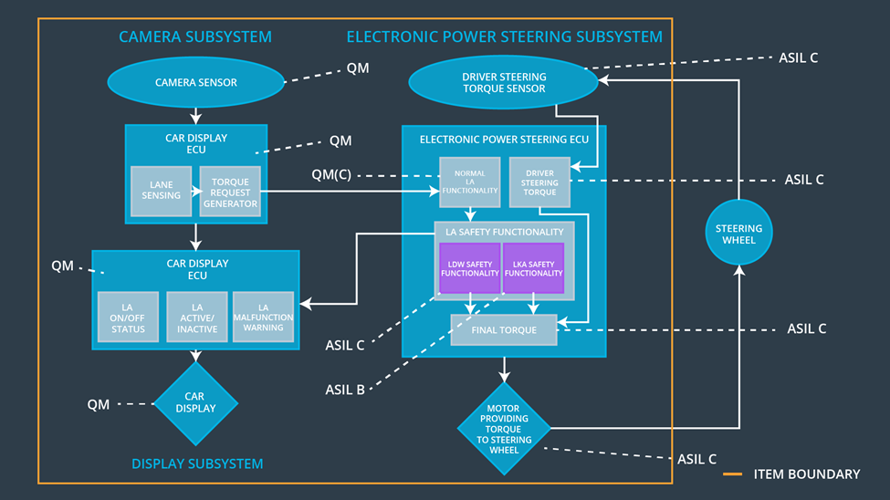

### 

### Functional overview of architecture elements

|  |  |
| --- | --- |
| **Element** | **Description** |
| Camera Sensor | Captures images of road in front of the vehicle |
| Camera Sensor ECU - Lane Sensing | Calculates when the vehicle is leaving the lane based on images from camera sensor |
| Camera Sensor ECU - Torque request generator | Sends a torque request to the Normal LA component when the vehicle is leaving the lane |
| Car Display | Displays warning and status lights for driver |
| Car Display ECU - Lane Assistance On/Off Status | Controls the status light on the car display based on whether the LA function is on/off |
| Car Display ECU - Lane Assistant Active/Inactive | Controls the status light on the car display based on whether LA function is currently active/inactive |
| Car Display ECU - Lane Assistance malfunction warning | Controls the malfunction warning light on the car display based on the error status of the LA function |
| Driver Steering Torque Sensor | Detects how much torque the driver is applying to the steering wheel |
| Electronic Power Steering (EPS) ECU - Driver Steering Torque | Calculates the driver demanded torque based on the input from the steering torque sensor |
| EPS ECU - Normal Lane Assistance Functionality | Generates torque requests for LDW and LKA functions based on input from the camera system |
| EPS ECU - Lane Departure Warning Safety Functionality | Checks torque request input against safe amplitude and frequency limits as well as maximum delay and outputs appropriate torque request and error signals |
| EPS ECU - Lane Keeping Assistant Safety Functionality | Checks the duration of the input torque request against safe maximum duration and outputs appropriate torque request and error signals |
| EPS ECU - Final Torque | Calculates the torque sent to the motor based on the driver torque demand and torque requests from the LDW and LKA safety components |
| Motor | Applies commanded torque directly to steering wheel |

# Technical Safety Concept

## Technical Safety Requirements

**Lane Departure Warning (LDW) Requirements:**

Functional Safety Requirement 01-01 with its associated system elements

(derived in the functional safety concept)

|  |  |  |  |  |
| --- | --- | --- | --- | --- |
| **ID** | **Functional Safety Requirement** | **Electronic Power Steering ECU** | **Camera ECU** | **Car Display ECU** |
| Functional  Safety  Requirement  01-01 | The LA Item shall ensure that the LDW oscillating torque amplitude is below *Max_Torque_Amplitude* | X |  |  |

Technical Safety Requirements related to Functional Safety Requirement 01-01 are:

|  |  |  |  |  |  |
| --- | --- | --- | --- | --- | --- |
| **ID** | **Technical Safety Requirement** | **ASIL** | **Fault Tolerant Time Interval** | **Architecture Allocation** | **Safe State** |
| Technical  Safety  Requirement  01 | The *LDW Safety* component shall ensure that the amplitude of the *LDW_Torque_Request* sent to the *Final Torque* component is below *Max_Torque_Amplitude* | C | 50 ms | LDW Safety | *LDW_Torque_Request* is set to zero |
| Technical  Safety  Requirement  02 | As soon as the LDW function deactivates the LDW feature, the *LDW Safety* component shall send a signal to the car display ECU to turn on a warning light | C | 50 ms | LDW Safety | *LDW_Torque_Request* is set to zero |
| Technical  Safety  Requirement  03 | As soon as a failure is detected by the LDW function, it shall deactivate the LDW feature and the *LDW_Torque_Request* shall be set to zero | C | 50 ms | LDW Safety | *LDW_Torque_Request* is set to zero |
| Technical  Safety  Requirement  04 | The validity and integrity of the data transmission for *LDW_Torque_Request* signal shall be ensured | C | 50 ms | Data Transmission Integrity Check | *LDW_Torque_Request* is set to zero |
| Technical  Safety  Requirement  05 | Memory test shall be conducted at start up of the EPS ECU to check for any faults in memory | A | Ignition Cycle | Memory Test | *LDW_Torque_Request* is set to zero |

Functional Safety Requirement 01-2 with its associated system elements

(derived in the functional safety concept)

|  |  |  |  |  |
| --- | --- | --- | --- | --- |
| **ID** | **Functional Safety Requirement** | **Electronic Power Steering ECU** | **Camera ECU** | **Car Display ECU** |
| Functional  Safety  Requirement  01-02 | The LA Item shall ensure that the LDW oscillating torque amplitude is below *Max_Torque_Frequency* | X |  |  |

Technical Safety Requirements related to Functional Safety Requirement 01-02 are:

|  |  |  |  |  |  |
| --- | --- | --- | --- | --- | --- |
| **ID** | **Technical Safety Requirement** | **ASIL** | **Fault Tolerant Time Interval** | **Architecture Allocation** | **Safe State** |
| Technical  Safety  Requirement  01 | The *LDW Safety* component shall ensure that the frequency of the *LDW_Torque_Request* sent to the *Final Torque* component is below *Max_Torque_Frequency* | C | 50 ms | LDW Safety | *LDW_Torque_Request* is set to zero |
| Technical  Safety  Requirement  02 | As soon as the LDW function deactivates the LDW feature, the *LDW Safety* component shall send a signal to the car display ECU to turn on a warning light | C | 50 ms | LDW Safety | *LDW_Torque_Request* is set to zero |
| Technical  Safety  Requirement  03 | As soon as a failure is detected by the LDW function, it shall deactivate the LDW feature and the *LDW_Torque_Request* shall be set to zero | C | 50 ms | LDW Safety | *LDW_Torque_Request* is set to zero |
| Technical  Safety  Requirement  04 | The validity and integrity of the data transmission for *LDW_Torque_Request* signal shall be ensured | C | 50 ms | Data Transmission Integrity Check | *LDW_Torque_Request* is set to zero |
| Technical  Safety  Requirement  05 | Memory test shall be conducted at start up of the EPS ECU to check for any faults in memory | A | Ignition Cycle | Memory Test | *LDW_Torque_Request* is set to zero |

Functional Safety Requirement 01-3 with its associated system elements

(derived in the functional safety concept)

|  |  |  |  |  |
| --- | --- | --- | --- | --- |
| **ID** | **Functional Safety Requirement** | **Electronic Power Steering ECU** | **Camera ECU** | **Car Display ECU** |
| Functional  Safety  Requirement  01-02 | The LA Item shall ensure that the LDW oscillating torque is applied within *Max_ Delay* | X |  |  |

Technical Safety Requirements related to Functional Safety Requirement 01-03 are:

|  |  |  |  |  |  |
| --- | --- | --- | --- | --- | --- |
| **ID** | **Technical Safety Requirement** | **ASIL** | **Fault Tolerant Time Interval** | **Architecture Allocation** | **Safe State** |
| Technical  Safety  Requirement  01 | The *LDW Safety* component shall ensure that the *LDW_Torque_Request* issent to the *Final Torque* component within *Max_Delay* of the *Camera_Torque_Request* signal being received from the *Torque Request Generator* component | C | 50 ms | LDW Safety | *LDW_Torque_Request* is set to zero |
| Technical  Safety  Requirement  02 | As soon as the LDW function deactivates the LDW feature, the *LDW Safety* component shall send a signal to the car display ECU to turn on a warning light | C | 50 ms | LDW Safety | *LDW_Torque_Request* is set to zero |
| Technical  Safety  Requirement  03 | As soon as a failure is detected by the LDW function, it shall deactivate the LDW feature and the *LDW_Torque_Request* shall be set to zero | C | 50 ms | LDW Safety | *LDW_Torque_Request* is set to zero |
| Technical  Safety  Requirement  04 | The validity and integrity of the data transmission for *LDW_Torque_Request* signal shall be ensured | C | 50 ms | Data Transmission Integrity Check | *LDW_Torque_Request* is set to zero |
| Technical  Safety  Requirement  05 | Memory test shall be conducted at start up of the EPS ECU to check for any faults in memory | A | Ignition Cycle | Memory Test | *LDW_Torque_Request* is set to zero |

**Lane Departure Warning (LDW) Verification and Validation Acceptance Criteria:**

**[OPTIONAL]**

**Lane Keeping Assistance (LKA) Requirements:**

Functional Safety Requirement 02-1 with its associated system elements

(derived in the functional safety concept)

|  |  |  |  |  |
| --- | --- | --- | --- | --- |
| **ID** | **Functional Safety Requirement** | **Electronic Power Steering ECU** | **Camera ECU** | **Car Display ECU** |
| Functional  Safety  Requirement  02-01 | The LA Item shall ensure that the LKA torque is applied for only *Max_Duration* | X |  |  |

Technical Safety Requirements related to Functional Safety Requirement 02-01 are:

|  |  |  |  |  |  |
| --- | --- | --- | --- | --- | --- |
| **ID** | **Technical Safety Requirement** | **ASIL** | **Fault Tolerant Time Interval** | **Allocation to Architecture** | **Safe State** |
| Technical  Safety  Requirement  01 | The *LKA Safety* component shall ensure that the *LKA_Torque_Request* is sent to the *Final Torque* component for not more than *Max_Duration* | B | 500 ms | LKA Safety | *LKA_Torque_Request* is set to zero |
| Technical  Safety  Requirement  02 | As soon as the LKA function deactivates the LKA feature, the *LKA Safety* component shall send a signal to the car display ECU to turn on a warning light | B | 500 ms | LKA Safety | *LKA_Torque_Request* is set to zero |
| Technical  Safety  Requirement  03 | As soon as a failure is detected by the LKA function, it shall deactivate the LKA feature and the *LKA_Torque_Request* shall be set to zero | B | 500 ms | LKA Safety | *LKA_Torque_Request* is set to zero |
| Technical  Safety  Requirement  04 | The validity and integrity of the data transmission for *LKA_Torque_Request* signal shall be ensured | B | 500 ms | Data Transmission Integrity Check | *LKA_Torque_Request* is set to zero |
| Technical  Safety  Requirement  05 | Memory test shall be conducted at start up of the EPS ECU to check for any faults in memory | B | Ignition Cycle | Memory Test | *LKA_Torque_Request* is set to zero |

Functional Safety Requirement 02-2 with its associated system elements

(derived in the functional safety concept)

|  |  |  |  |  |
| --- | --- | --- | --- | --- |
| **ID** | **Functional Safety Requirement** | **Electronic Power Steering ECU** | **Camera ECU** | **Car Display ECU** |
| Functional  Safety  Requirement  02-02 | The LA Item shall ensure that the LKA torque amplitude is greater than *Min_Torque_Amplitude* | X |  |  |

Technical Safety Requirements related to Functional Safety Requirement 02-01 are:

|  |  |  |  |  |  |
| --- | --- | --- | --- | --- | --- |
| **ID** | **Technical Safety Requirement** | **ASIL** | **Fault Tolerant Time Interval** | **Allocation to Architecture** | **Safe State** |
| Technical  Safety  Requirement  01 | The *LKA Safety* component shall ensure that the amplitude of the *LKA_Torque_Request*  sent to the *Final Torque* component is greater than *Min_Torque_Amplitude* | QM | 500 ms | LKA Safety | *LKA_Torque_Request* is set to zero |
| Technical  Safety  Requirement  02 | As soon as the LKA function deactivates the LKA feature, the *LKA Safety* component shall send a signal to the car display ECU to turn on a warning light | QM | 500 ms | LKA Safety | *LKA_Torque_Request* is set to zero |
| Technical  Safety  Requirement  03 | As soon as a failure is detected by the LKA function, it shall deactivate the LKA feature and the *LKA_Torque_Request* shall be set to zero | QM | 500 ms | LKA Safety | *LKA_Torque_Request* is set to zero |
| Technical  Safety  Requirement  04 | The validity and integrity of the data transmission for *LKA_Torque_Request* signal shall be ensured | QM | 500 ms | Data Transmission Integrity Check | *LKA_Torque_Request* is set to zero |
| Technical  Safety  Requirement  05 | Memory test shall be conducted at start up of the EPS ECU to check for any faults in memory | QM | Ignition Cycle | Memory Test | *LKA_Torque_Request* is set to zero |

**Lane Keeping Assistance (LKA) Verification and Validation Acceptance Criteria:**

**[OPTIONAL]**

## Refinement of the System Architecture

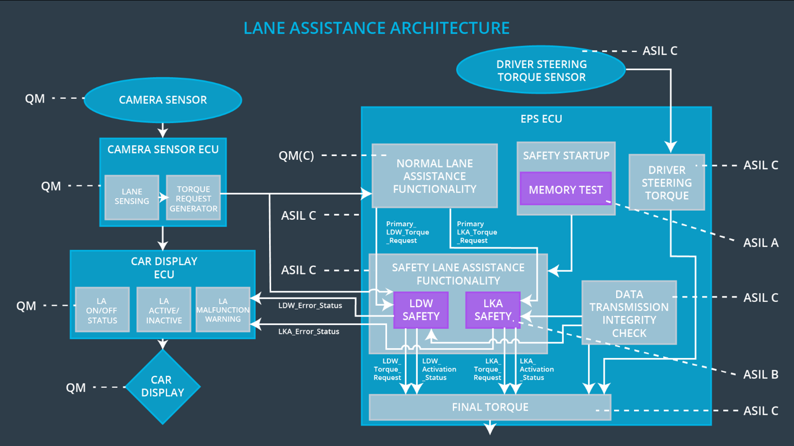

## Allocation of Technical Safety Requirements to Architecture Elements

For the Lane Assistance Item, all technical safety requirements are allocated to the Electronic Power Steering ECU.

## Warning and Degradation Concept

|  |  |  |  |  |
| --- | --- | --- | --- | --- |
| **ID** | **Degradation Mode** | **Trigger for Degradation Mode** | **Safe State invoked?** | **Driver Warning** |
| WDC-01 | Turn off LDW functionality | Malfunction_01, Malfunction_02, Malfunction_03 | YES | Warning light on car display |
| WDC-02 | Turn off LKA functionality | Malfunction_04, Malfunction_05 | YES | Warning light on car display |