**DAY – 3**

AND GATE

**Theory : -**

An AND gate is a basic digital logic gate that performs a logical AND operation. In electronics and digital logic, it takes two binary inputs (0 and 1) and produces a single binary output. The output is high (1) only when both of its inputs are high (1).

Symbol : -

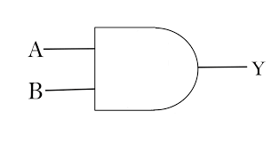

Truth Table :

|  |  |  |
| --- | --- | --- |
| INPUT A | INPUT B | OUTPUT  Y |
| 0 | 0 | 0 |
| 0 | 1 | 0 |
| 1 | 0 | 0 |
| 1 | 1 | 1 |