# Jenkins Fundamentals

## Jenkins Fundamentals:

**Objectives:**

* Understand what Jenkins is and how it works
* Set up Jenkins on an EC2 instance
* Run basic Freestyle and Pipeline jobs

**1. What is Jenkins?**

Jenkins is an **open-source automation server** used to:

* Build, test, and deploy applications
* Automate any part of your software delivery process (CI/CD)
* Integrate with hundreds of tools (GitHub, Docker, AWS, Terraform, etc.)

**Key Features:**

| **Feature** | **Purpose** |
| --- | --- |
| Freestyle Jobs | GUI-based jobs with basic logic |
| Pipeline Jobs | Code-defined pipelines using Jenkinsfile |
| Plugins | Extend Jenkins (e.g., Git, Docker, AWS CLI, Slack) |
| Distributed Builds | Run builds on multiple agents (Jenkins master/agent) |
| Webhook Integration | Trigger jobs automatically from GitHub/GitLab etc. |

**2. Provision Jenkins on AWS EC2**

We’ll use an **Ubuntu-based EC2 instance** to host Jenkins.

**Step-by-Step Setup**

1. **Launch EC2 Instance**:
   * AMI: Ubuntu
   * Instance type: t2.micro(free-tier)
   * Key pair: Use an existing one or create a new one
   * Security Group:
     + Allow: **SSH (22)**, **HTTP (80)**, **Jenkins UI (8080)**
     + Optional later: **HTTPS (443)**

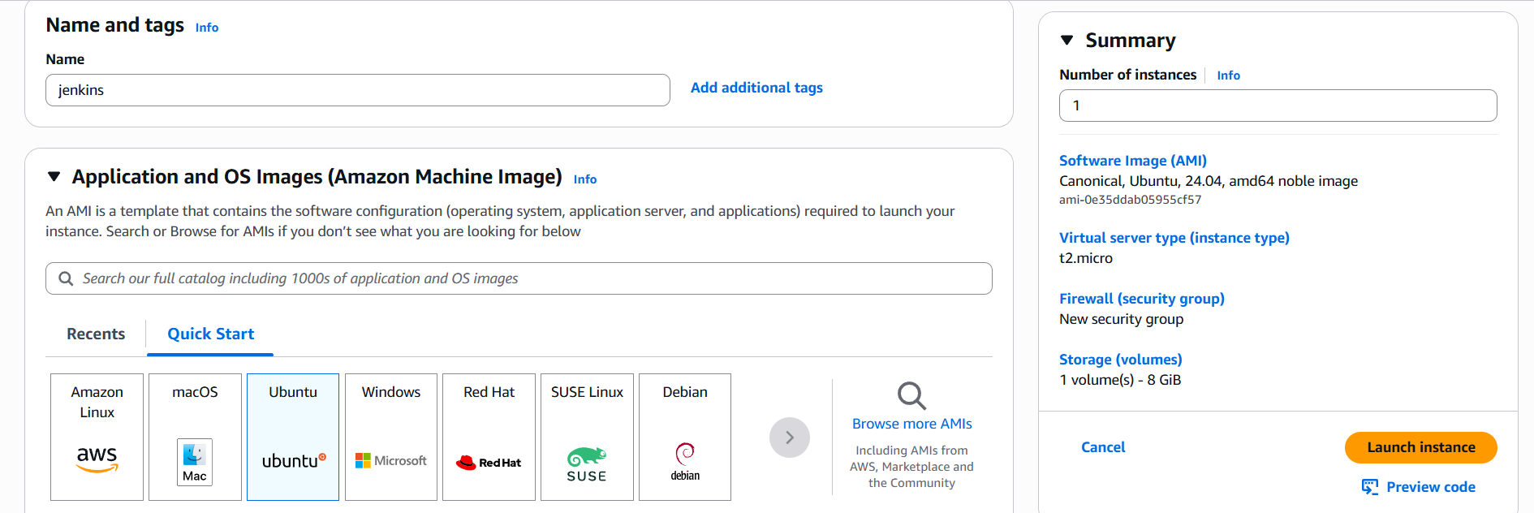

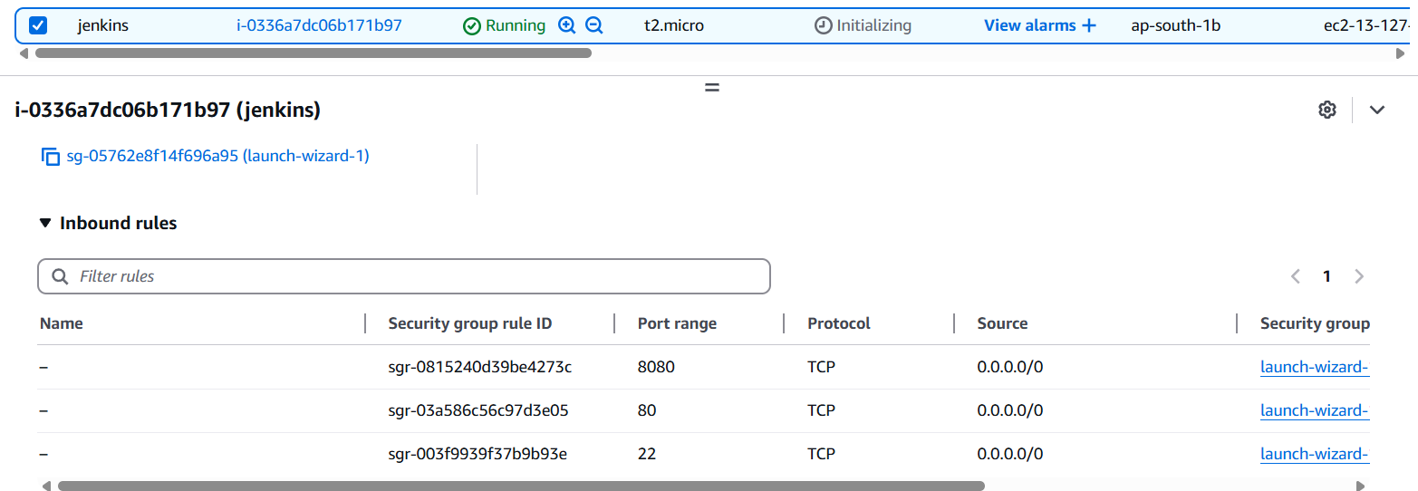

1. **Connect via SSH**:

ssh -i /path/to/your-key.pem ubuntu@<your-ec2-public-ip>

1. **Install Java (Jenkins dependency)**:

sudo apt update

sudo apt install -y openjdk-17-jdk

1. **Install Jenkins**:

-> curl -fsSL https://pkg.jenkins.io/debian-stable/jenkins.io-2023.key | sudo tee \

/usr/share/keyrings/jenkins-keyring.asc > /dev/null

-> echo deb [signed-by=/usr/share/keyrings/jenkins-keyring.asc] \

https://pkg.jenkins.io/debian-stable binary/ | sudo tee \

/etc/apt/sources.list.d/jenkins.list > /dev/null

-> sudo apt update

-> sudo apt install -y jenkins

1. **Start and enable Jenkins**:

sudo systemctl enable jenkins

sudo systemctl start jenkins

1. **Access Jenkins UI**:
   * Go to: http://<your-ec2-public-ip>:8080
   * Unlock Jenkins with:

sudo cat /var/lib/jenkins/secrets/initialAdminPassword

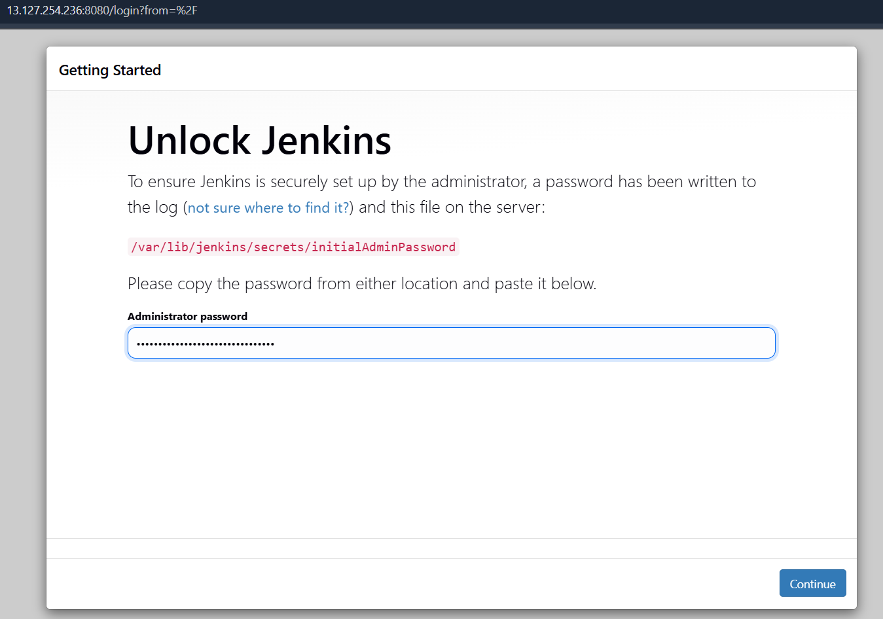

* Install **Suggested Plugins**
* Create **admin user**

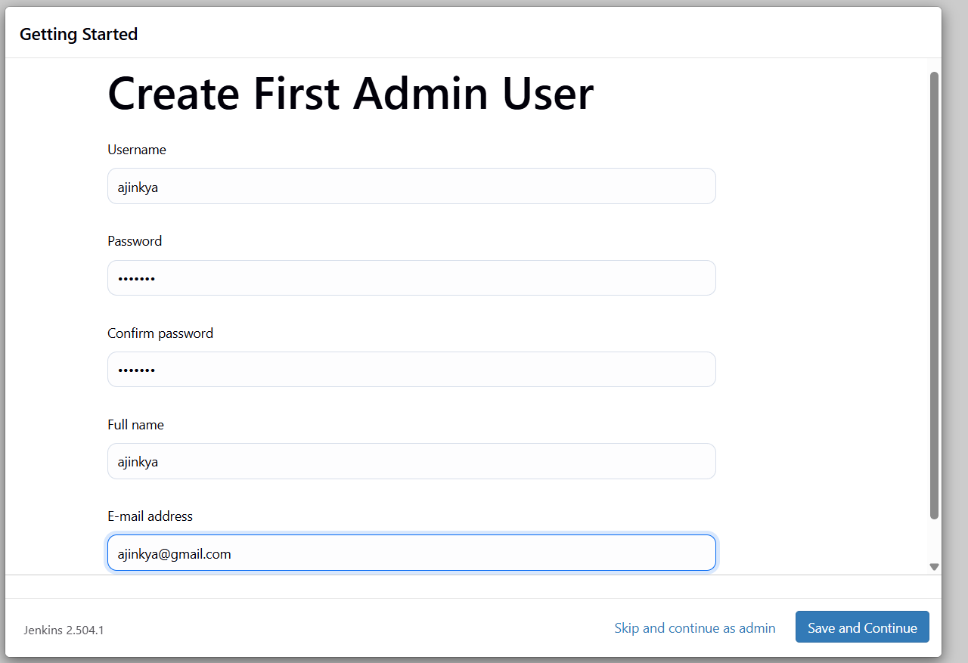

1. **Jenkins UI Concepts**

| **Component** | **Description** |
| --- | --- |
| Dashboard | View and manage all jobs |
| New Item | Create jobs (freestyle, pipeline, multi-branch, etc.) |
| Build Now | Trigger a job manually |
| Build History | See past builds (logs, console output, status) |
| Configure | Set up job details (SCM, build steps, triggers) |
| Manage Jenkins | Global settings, plugins, nodes, security, etc. |

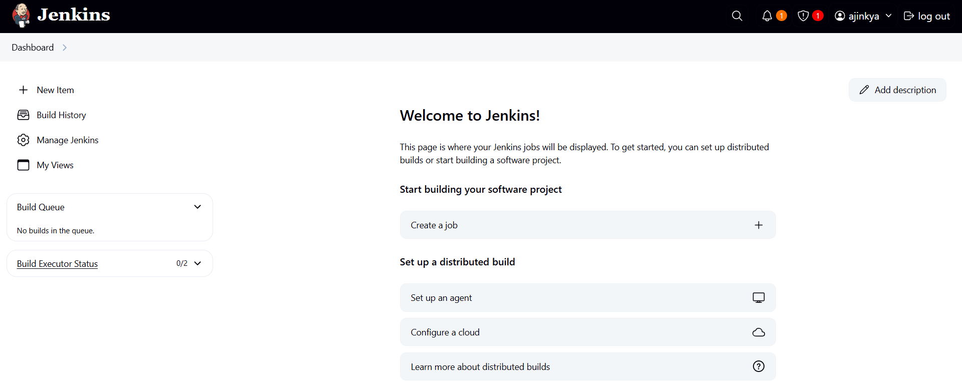

**Practical 01: First Jenkins job using freestyle and pipeline**

**a) Freestyle Job**

* Create job → “Freestyle Project”

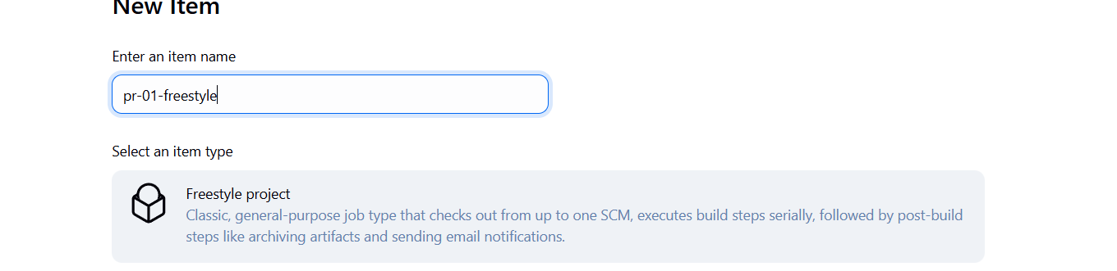

* Add a **Build Step** → Execute Shell
* Example script:

echo "Hello from Jenkins!"

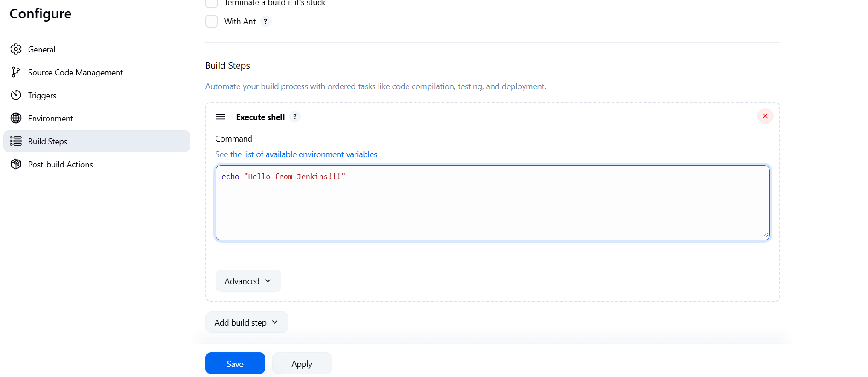

* Save and build the job using build now.
* Go to build #1 to see console output and our message.

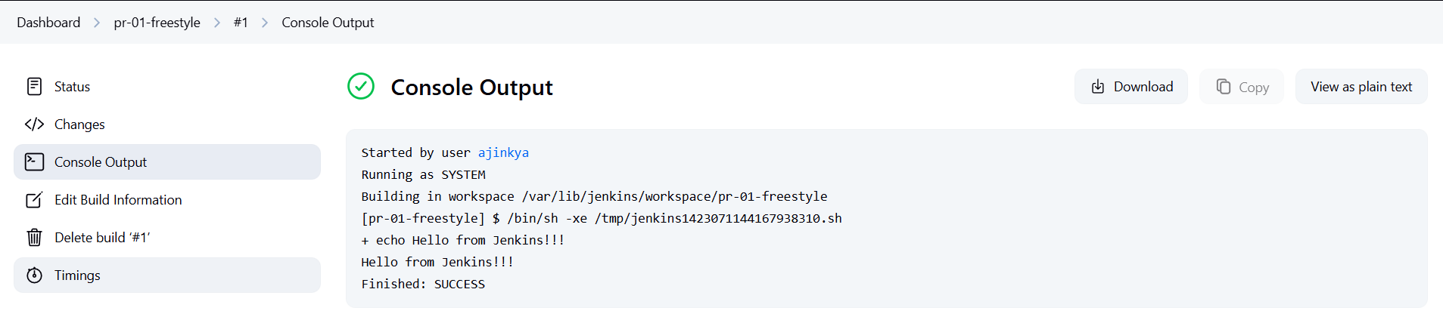

**b) Pipeline Job**

* Create job → “Pipeline”

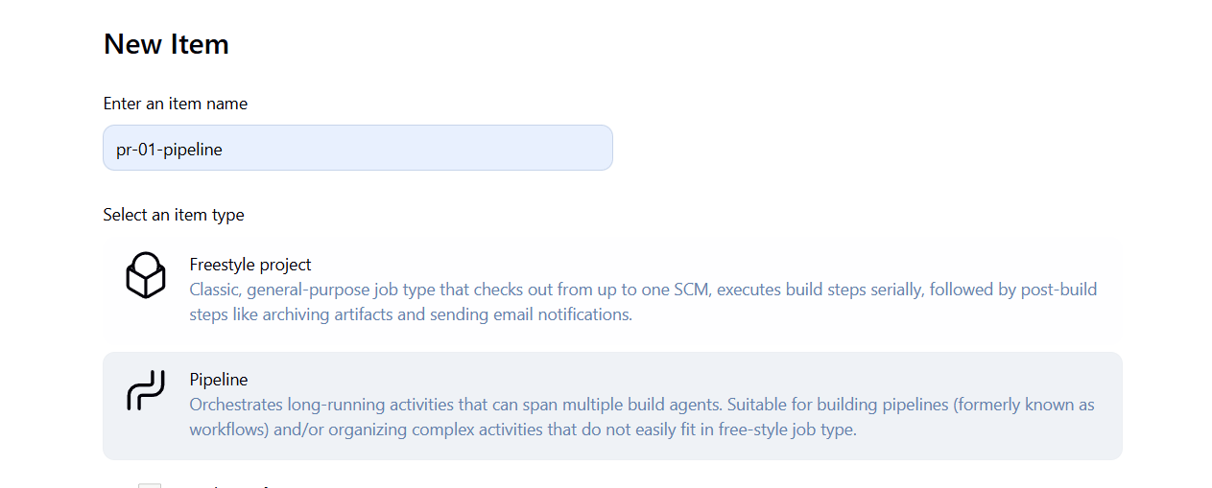

* Paste in this example Jenkinsfile:

pipeline {

agent any

stages {

stage('Greet') {

steps {

echo 'Hello from a pipeline!'

}

}

}

}

* Save and build the job using build now.
* Go to build #1 to see console output and our message.

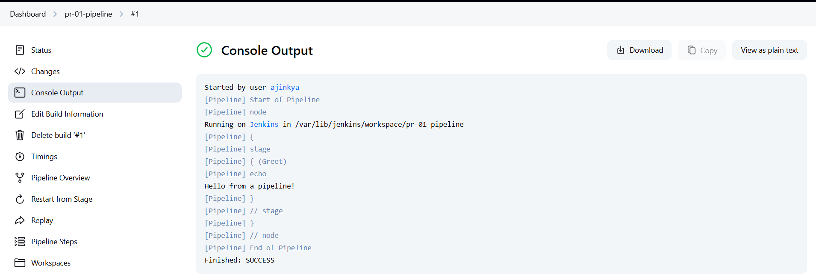

We will see below things further,

**Core Jenkins Skills for DevOps Jobs**

**Goals:**

* Master pipeline scripting (Declarative + Scripted)
* Use Git, GitHub, Docker, and AWS CLI in Jenkins
* Automate builds, tests, and deployments

**Projects:**

1. **CI/CD for a Node.js or Python app**
   * GitHub integration (webhook)
   * Build → Test → Dockerize → Deploy (to EC2 or ECS)
2. **Use Jenkins Shared Libraries**
   * Write reusable pipeline functions

♣♣♣