# User & File Management and vi Shortcuts

## User Management:

User management refers to the creation, modification, and deletion of user accounts and groups, and the configuration of their permissions and access controls.

**User:** A user is an individual account on a Linux system that can log in and perform tasks with assigned permissions.

**Group:** A group is a collection of users that share the same access rights to files, directories, or system resources.

* Even when we start our windows laptop for the first time, we create an Admin user and use our laptop.
* We do not create another user as we are the only ones who will be using that password.
* While in the industry environments, various users work on same server/instance, in that case users need to be created.
* It is done to provide limited access to specified person.
* Example:
  + Developer is provided access to /sbin or /bin.
  + Manager is provided access to just read the files.
* It helps to track the activity of each person using log files.
* Access to resources is also made available user specific.
* It avoids unauthorized access to users who do not have sudo permissions.

### Common commands in user management:

#### useradd username:

* This command adds a user to the system.
* It can be done by only root user or the user with administrator permissions.
* This user is of no use until we create a password for it.
* When we create user using this command there is no password set at that time and the user is not created in /home directory too.
* Generally this command is used during scripting when we need to create a temporary user to just perform the operations that are mentioned in the script.

#### /etc/passwd:

* To view the users in the system we can read the file /etc/passwd.
* It contains all the users list with username, password placeholder, User ID, Group ID, GECOS (comment field) means basic info of user, default directory of the user and the login shell that user gets on login.

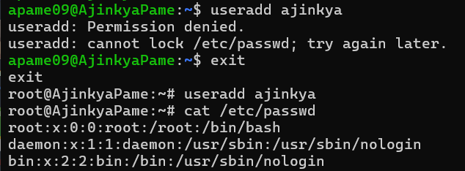

#### passwd:

* As mentioned earlier a user is of no use until it has a password.
* To create a password for that user we use command “passwd username”.
* Enter the password and retype it to confirm the password.
* Once the password is set and if user forgets it then it can never be retrieved not even by the root user.
* Users should never forget the password.

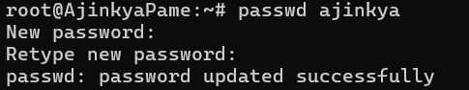

#### /etc/shadow:

* The passwords are saved at /etc/shadow location in the encrypted form and it cannot be decrypted.
* We can view this file to check if password is set or not for a user.

#### userdel:

* the command “userdel username” is used to delete a user.
* If a person leaves the company and there is no use of that person’s user then its deleted.
* We can cross check that by trying to login as that user or checking /etc/passwd file.

#### adduser:

* As discussed earlier ‘useradd’ command just creates user but password creation and that user’s creation in home directory is not done there explicitly.
* But when we use “adduser” command, at that time only it will prompt to create password and also put some information that we got to see in ‘/etc/passwd’. You can just put name and skip other information at the moment while creating the user.
* This user created but it does not have permissions as root user and if we try to delete something that relates to root user then it won’t happen.

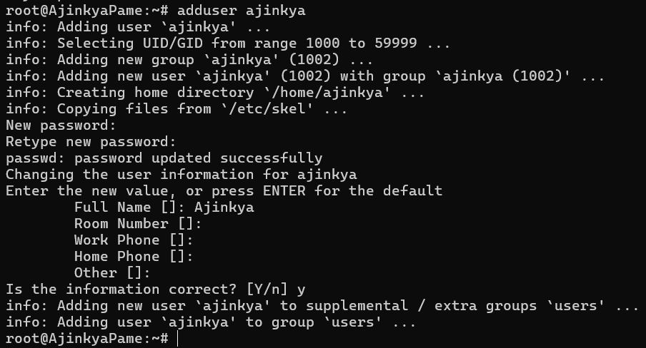

* Now if we check the /home directory then the user named ‘ajinkya’ will be present there.



#### su:

* “su – username” command is used to switch to that user. su stands for switch user.

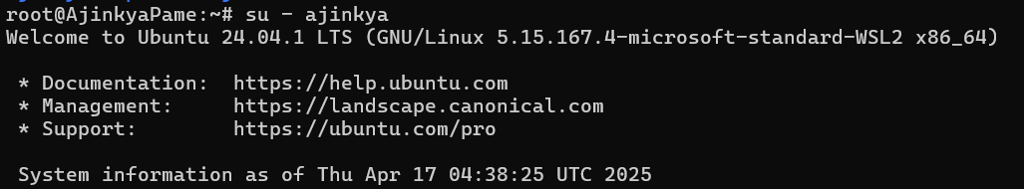

#### whoami:

* This command tells which user has logged in.



* We can also see that it shows “ajinkya@AjinkyaPame” means user named ‘ajinkya’ is using the WSL2 system of AjinkyaPame.

#### groupadd & /etc/group:

* groupadd command is used to add the group same as useradd.
* We can check if group is created or not by checking /etc/group.

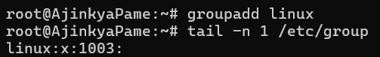

#### usermod:

* If we currently see at the details there is no user present in that group.
* To add a user to that group, we use command “usermod -aG groupname username”.
* If we check /etc/group we will be able to see username in front of the group.

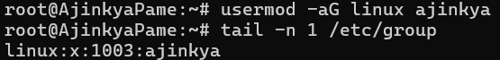

* In this way we can add multiple users to a group and change permissions of the group to collectively change the permissions of multiple users using single group.

When in the company, users are asked to login to the server using ssh command via terminal using the username and password set by admin (ssh username@publicIP).

## File Management:

File management in Linux is centered around working with files and directories using the command line interface (CLI).

### Commands that come under file management:

1. ls => List the items in the folder.
2. cd (change directory) => Change directory to given path.
3. pwd (present working directory) => Check the directory in which you are presently working.
4. mkdir (make directory) => Create the directory with the mentioned name.
5. rmdir (remove directory) => Remove the directory with the mentioned name.
6. touch => Create a file of that name.
7. rm => Remove the mentioned file.
8. cp => Copy the file.
9. mv => Move or rename the file.
10. cat => Read the content of the file.

Let’s see all commands:

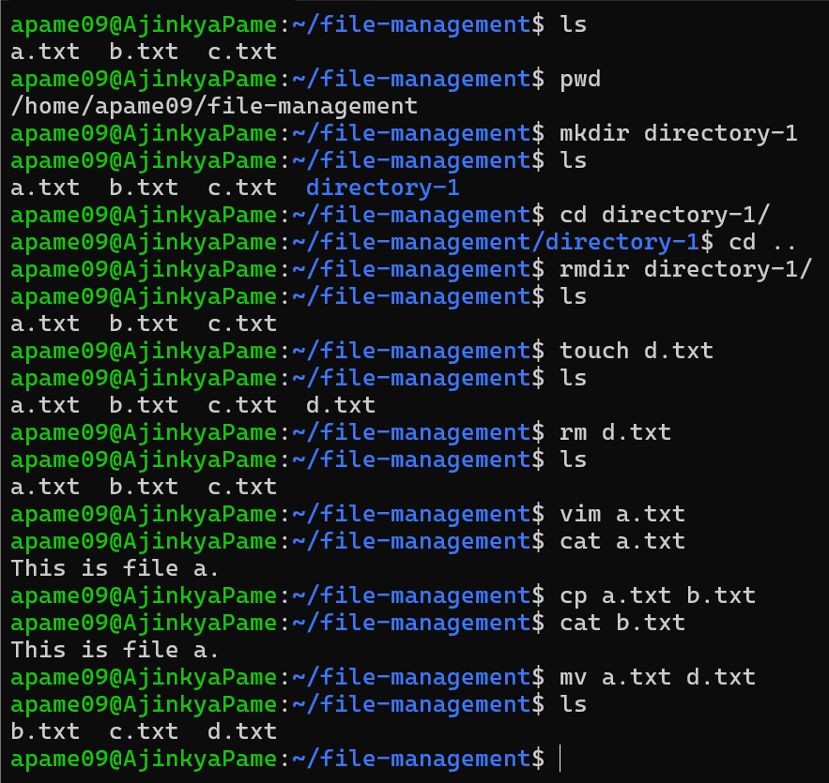

## vi/vim editor:

**vi (Visual Editor):** is a text editor in Unix and Linux systems used to create and modify text files. It operates entirely in the terminal and is known for being lightweight and available by default on nearly all Unix-based systems.

**vim (Vi Improved):** is an enhanced version of vi, offering:

* Syntax highlighting
* More powerful search and replace
* Multi-level undo
* Plugins and scripting support
* Easier navigation and customization

Both editors are modal, meaning they have different modes for different tasks:

* Normal mode (for navigating and issuing commands)
* Insert mode (for writing/editing text)
* Command mode (for saving, quitting, searching, etc.)

### Getting Started:

Open a file:

* vi filename.txt
* vim filename.txt

### Modes in Vim:

Vim has three primary modes:

| **Mode** | **Purpose** | **Enter it by...** |
| --- | --- | --- |
| Normal | Navigate, delete, copy, etc. | Default mode |
| Insert | Type/edit text | Press i, a, o, etc. |
| Command | Save, quit, etc. | Press “:” in Normal mode |

### Insert Mode (Editing Text):

| **Command** | **Action** |
| --- | --- |
| i | Insert before cursor |
| a | Insert after cursor |
| o | Open a new line below |
| O | Open a new line above |
| Esc | Exit to Normal mode |

### Navigation (Normal Mode):

| **Key** | **Move...** |
| --- | --- |
| h | Left |
| j | Down |
| k | Up |
| l | Right |
| w | Next word |
| b | Previous word |
| 0 | Start of line |
| $ | End of line |
| gg | Top of file |
| G | Bottom of file |
| :n | Move to line number n |

### Editing (Normal Mode):

| **Command** | **Action** |
| --- | --- |
| x | Delete character |
| dd | Delete current line |
| yy | Yank (copy) current line |
| p | Paste after cursor |
| u | Undo |
| Ctrl + r | Redo |
| r<char> | Replace a single character |

### Saving & Quitting (Command Mode):

Press “:” to enter Command mode from Normal mode:

| **Command** | **Action** |
| --- | --- |
| :w | Save (write) |
| :q | Quit |
| :wq | Save and quit |
| :q! | Quit without save |
| :x | Save and quit |

### Search:

* /text – Search for text
* n – Next match
* N – Previous match