Number of EV Models Manufactured by a Brand:

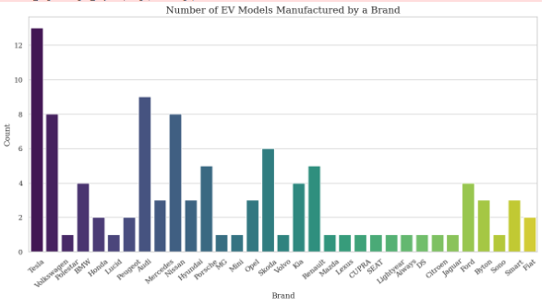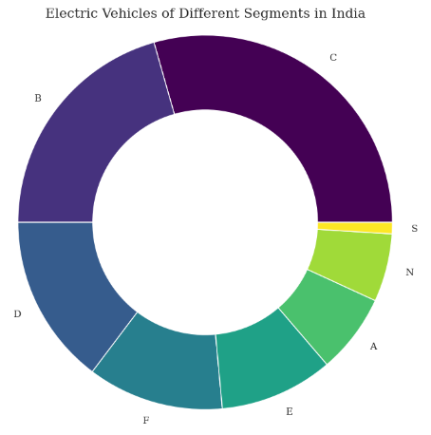

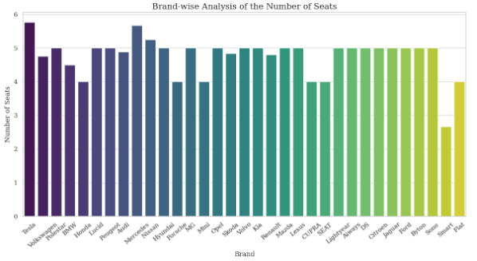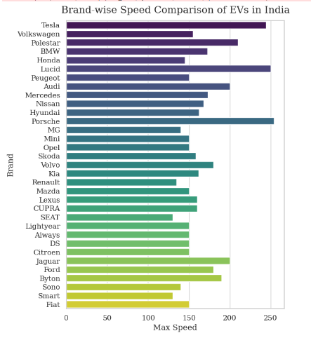

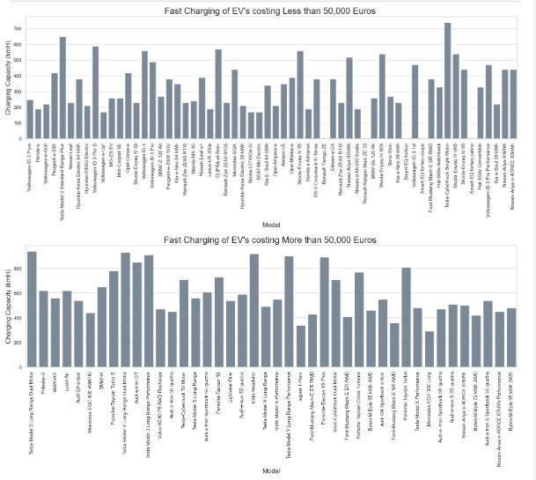 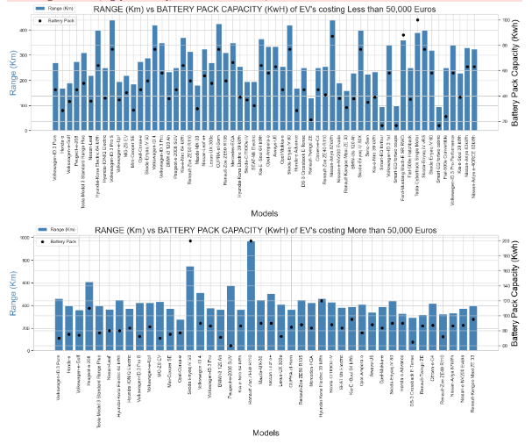

Range(Km) of EV's costing Less than 50,000 Euros (Rs. 4506200.00)

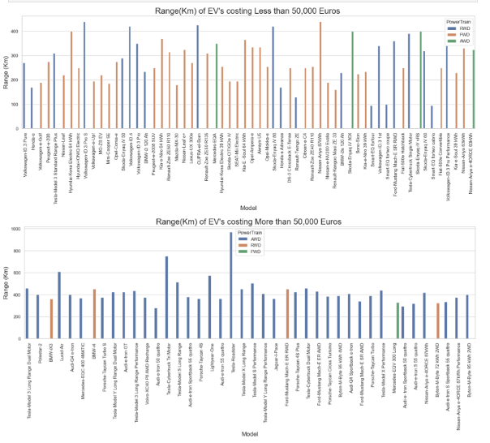

Range(Km) of EV's costing More than 50,000 Euros (Rs. 4506200.00

**K-means Clustering:**

Unsupervised machine learning method known as clustering groups comparable data points into clusters. This method's sole goal is to group datapoints with comparable characteristics together into distinct clusters. Several techniques, including k-means clustering, hierarchical clustering, density-based clustering, etc., can be used to conduct clustering on data.

K-Means The task of clustering, an unsupervised learning process, is to divide the unlabeled dataset into distinct clusters, each of which contains only one data point. K is the required number of clusters to be produced in this case. Numerous use cases, such as market segmentation, picture segmentation, image compression, document clustering, etc., are applicable to the algorithm. One of our datasets' clustering produced the image below.

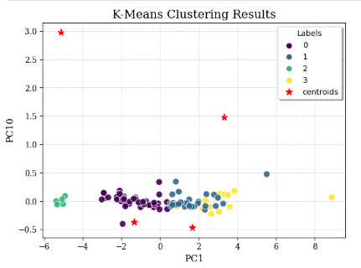

The following is how the K-Means Algorithm operates:

* State the number of clusters, in this case K.
* Pick K randomly chosen points from the dataset. These locations represent the centroids (centres) of all K clusters.
* Based on the distance from each of the K centroids, assign each data point in the dataset to one of the centroids.
* Assign the Centroids to the mean of these clusters and accept that this clustering is accurate.
* Continue Step 3. Continue until step 4 if any of the points change clusters. Step 6 is next.
* Determine the variance of every cluster.
* Continue this clustering process 'n' times more until the total variance of each cluster is at its lowest point.

**PCA:**

A linear dimensionality-reduction technique called principal component analysis (PCA) is used to reduce the dimensionality of big data sets by condensing a large collection of variables into a smaller set while retaining the majority of the data in the larger set.

**Elbow Approach:**

In K-Means Clustering, the ideal number of clusters (k) can be found using the Elbow approach. It works by computing the Within Cluster Sum of Squared Errors (WCSS) for various cluster counts (k) and choosing the k for which the change in WCSS first begins to decline. The Elbow Point, which is where the line begins to parallel the X-axis when you plot its graph, is regarded as the optimal value for the k (shown in the below picture as 4).

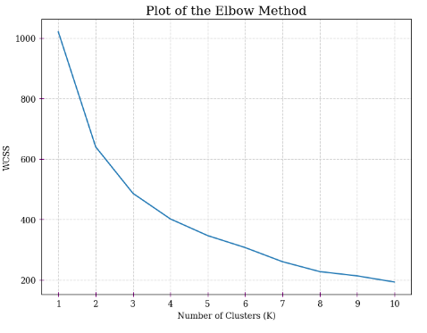

**Density Plot for Battery Pack Capacity in Different Segments:**

The distribution of battery pack capacity among various segments is seen in the density graph displayed for battery pack capacity (measured in kWh) in different electric vehicle segments. The graph provides an understanding of the charging capacity of electric vehicles across various market segments by displaying the probability density of battery pack capacity values within each market segment.

Each category covers a certain group of electric vehicles with comparable specs, such as powertrain, performance, or price range. We can observe the following things by examining the density graph:

* Battery Pack Capacity Distribution: The density map shows the battery pack capacity values distributed throughout each section. Higher density peaks point to a concentration of electric vehicles in that sector with certain battery pack capacity.
* Segment-Specific Charging Capacity: Using the density graph, we can assess how well electric vehicles can charge in various market sectors. While segments with lower density peaks may have more diversity in battery pack capacity, sectors with higher density peaks typically include more electric vehicles with comparable battery pack sizes.
* Determining High-Capacity Segments: The graph identifies markets that are dominated by electric cars with larger battery packs. These market segments probably correspond to luxury or long-range electric automobiles.
* Determining Low-Capacity Segments: Similarly, segments with lower density peaks would point to electric vehicles with smaller battery packs, possibly reflecting entry-level or more reasonably priced electric vehicles.
* Segment Size and Composition: Information about the market composition can be gleaned from the relative size of each segment's density plot. More electric vehicles fall into that category, as indicated by larger sectors with higher densities.
* Market Trends and Demands: We may determine market trends and shifting consumer demands for various battery pack sizes in electric vehicles by comparing the density plots over time or across several datasets.

