***A PROJECT REPORT***

***ON***

***“ATTENDANCE MANAGEMENT SYSTEM”***

**Submitted By**

**Akash P. Bhad**

**Suraj R. Sawalkar**

**Neha D. Sonar**

**Under The Guidance**

**Of**

**Prof .A. D. Shah Sir**



**SIPNA COLLEGE OF ENGINEERING AND TECHNOLOGY , AMRAVATI**

DEPARTMENT OF COMPUTER SCIENCE ENGINEERNG

**ACKNOWLEDGEMENT**

With great pleasure we hereby acknowledge the help given to us by various individuals throughout the project. This Project itself is an acknowledgement to the inspiration, drive and technical assistance contributed by many individuals. This project would have never seen the light of this day without the help and guidance we have received.

We would like to express our profound thanks to **Prof.A. D. Shah Sir** for their guidance regarding the theoretical aspects of project. We would also like to express our gratitude towards **Prof. A. V. Gawande** (Head of Computer Science and Engineering Department), for encouraging us for our betterment. We owe an incalculable debt to all staffs of the Department of Computer Science & Engineering for their direct and indirect help.

Our thanks and appreciations also go to our colleague in developing the project and people who have willingly helped us out with their abilities.

We extend our heartfelt thanks to our parents, friends and well wishers for their support and timely help. Last but not the least; we thank the God Almighty for guiding us in every step of the way.

Akash P. Bhad

Suraj R. Sawalkar

Neha D. Sonar

**1. ABSTRACT**

Student attendance management system deals with the maintenance of the student’s attendance details. It is generates the attendance of the student on basis of presence in class. It is maintained on the daily basis of their attendance. the staffs will be provided with the separate username & password to make the student’s status. The staffs handling the particular subjects responsible to make the attendance for all students. Only if the student present on that particular period, the attendance will be calculated. The students attendance reports based on weekly and consolidate will be generated.

The system being developed is economic with respect to School or Collage’s point of view. It is cost effective in the sense that has eliminated the paper work completely. The system is also time effective because the calculations are automated which are made at the end of the month or as per the user requirement. The result obtained contains minimum errors and are highly accurate as the data is required.

2. **INTRODUCTION:**

Attendance Management System is software developed for daily student attendance in schools, colleges and institutes**.** If facilitates to access the attendance information of a particular student in a particular class. The information **is** sorted by the operators, which will be provided by the teacher for a particular class. This system will also help in evaluating attendance eligibility criteria of a student.

**3. PURPOSED SYSTEM:**

The purpose of developing attendance management system is to computerized the tradition way of taking attendance. Another purpose for developing this software is to generate the report automatically at the end of the session or in the between of the session

**4. SCOPE:**

The scope of the project is the system on which the software is installed, i.e. the project is developed as a desktop application, and it will work for a particular institute, But later on the project can be modified to operate it online.Attendance Management System

**5. TECHNOLOGY USED:**

**1. Front end:** Java, JDBC ,JSP , Servlet, HTML, CSS

**2. Back end**: MySQL

**6. EXISTING SYSTEM:**

The existing system is doing all the processes manually. The personnel should refer all the records kept for years ago to simply to know the details . this is so tedious and time consuming this process is so difficult when the number of user increases.

**7. OVERVIEW:**

Attendance Management System basically has two main modules for proper functioning space for new batch. Any entry of new faculty, updating in subject if necessary, and sending notice, faulty or an operator. User has a right of making daily attendance, generating report.

**8. CHAREACTERSTIC OF THE PROPOSED SYSTEM**

• **User Friendly**:- The proposed system is user friendly because the retrieval and storing of data is fast and data is maintained efficiently. Moreover the graphical user interface is provided in the proposed system, which provides user to deal with the system very easily.

• **Reports are easily generated**: reports can be easily generated in the proposed system so user can generate the report as per the requirement (monthly) or in the middle of the session. User can give the notice to the students so he/she become regular.

• **Very less paper work**: The proposed system requires very less paper work. All the data is feted into the computer immediately and reports can be generated through computers. Moreover work become very easy because there is no need to keep data on papers.

• **Computer operator control**: Computer operator control will be there so no chance of errors. Moreover storing and retrieving of information is easy. So work can be done speedily and in time**.**

**9. SYSTEM DESIGN:**

**9.1 Index.html:**

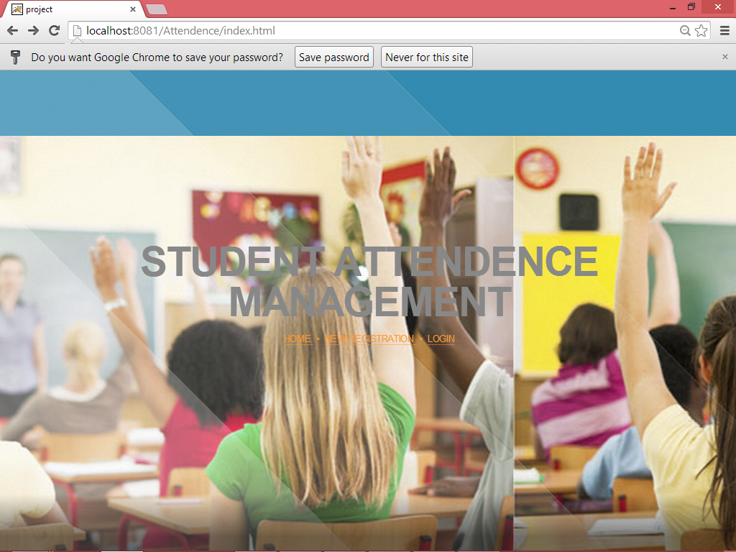

9.2 Home.jsp:

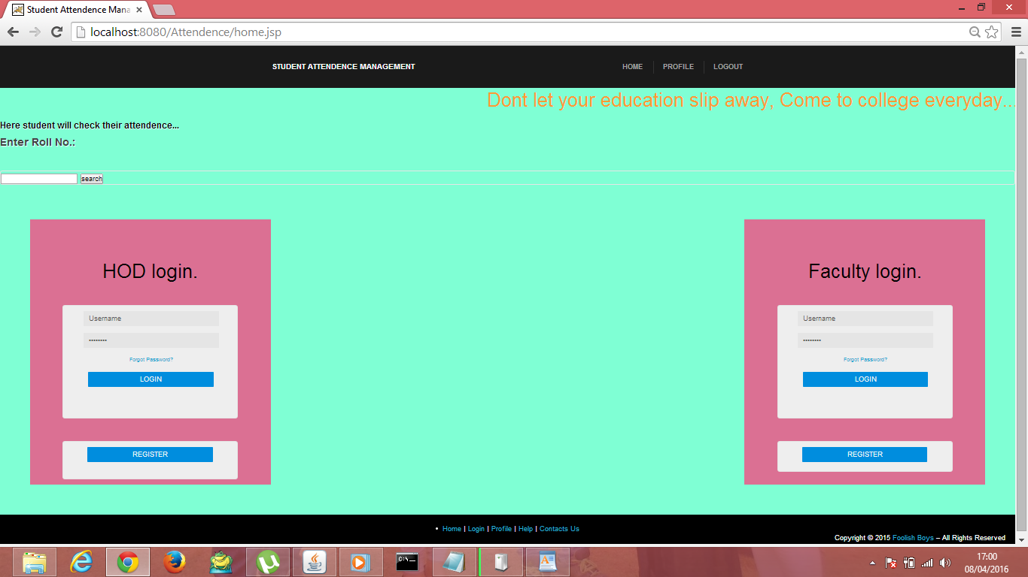

**9.3 Faculty Registration**

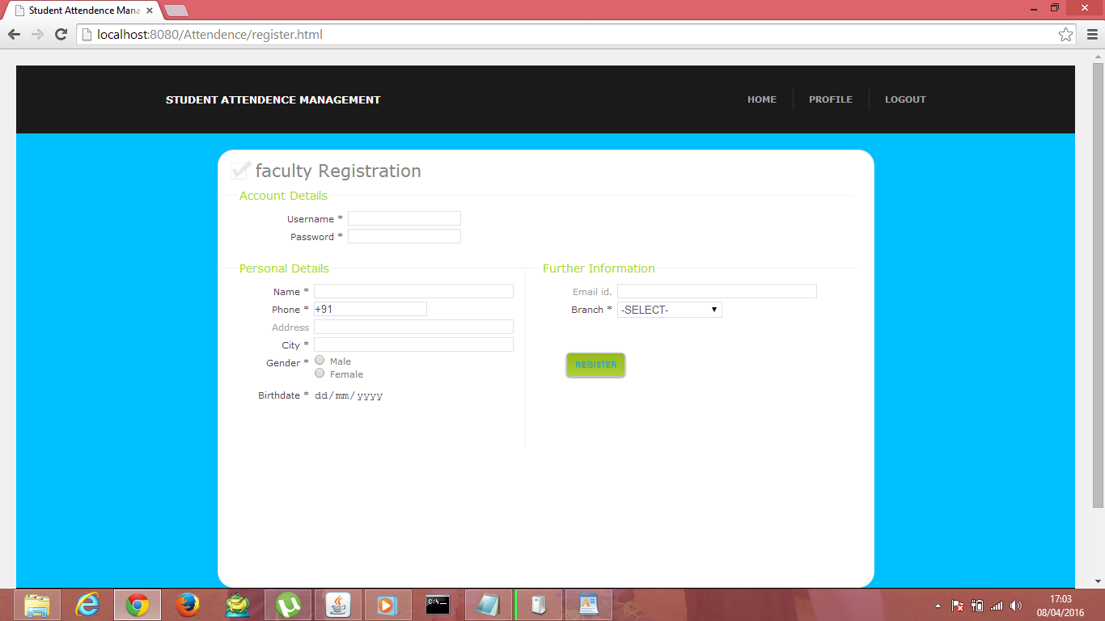

**9.4 HOD Registration**

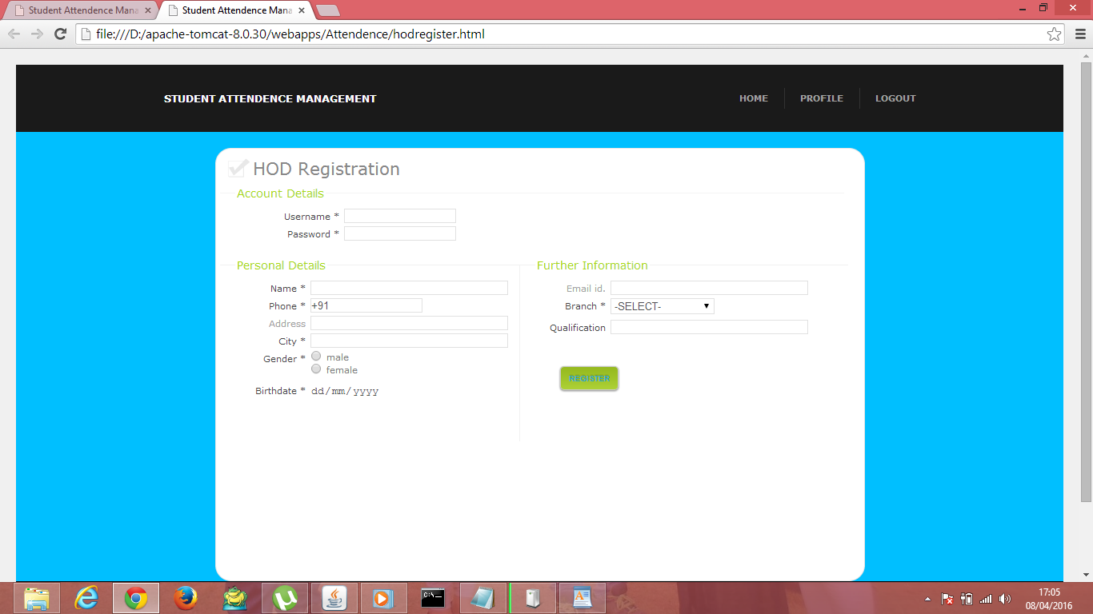

**9.5 hodunderlogin.html**

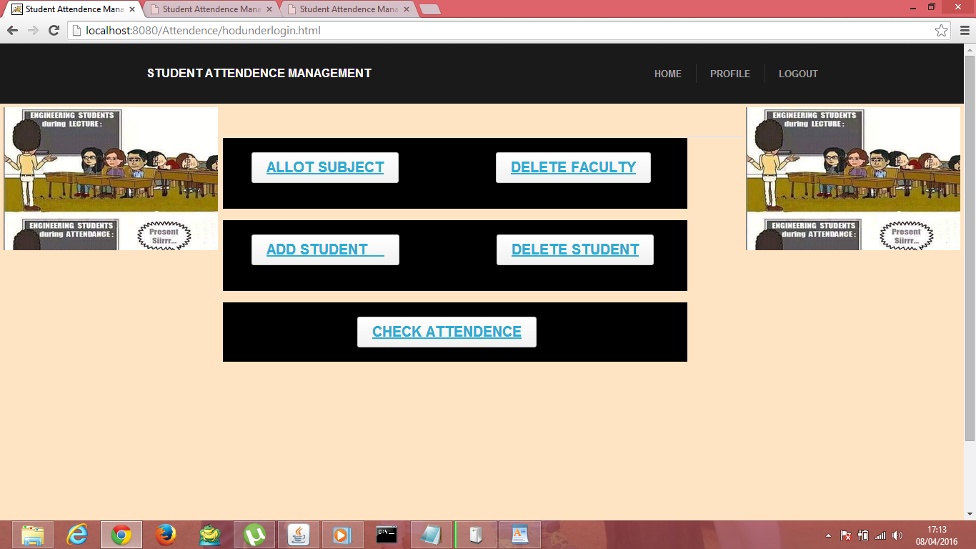

**9.6 sdtdel.html**

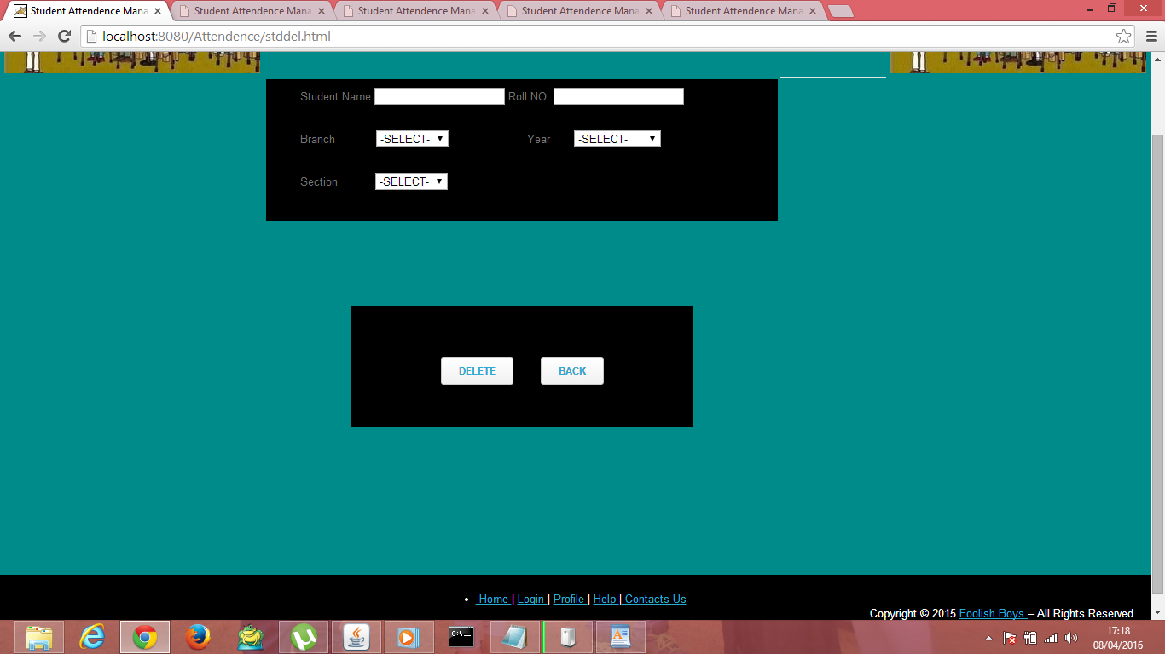

**9.7 stdadd.html**

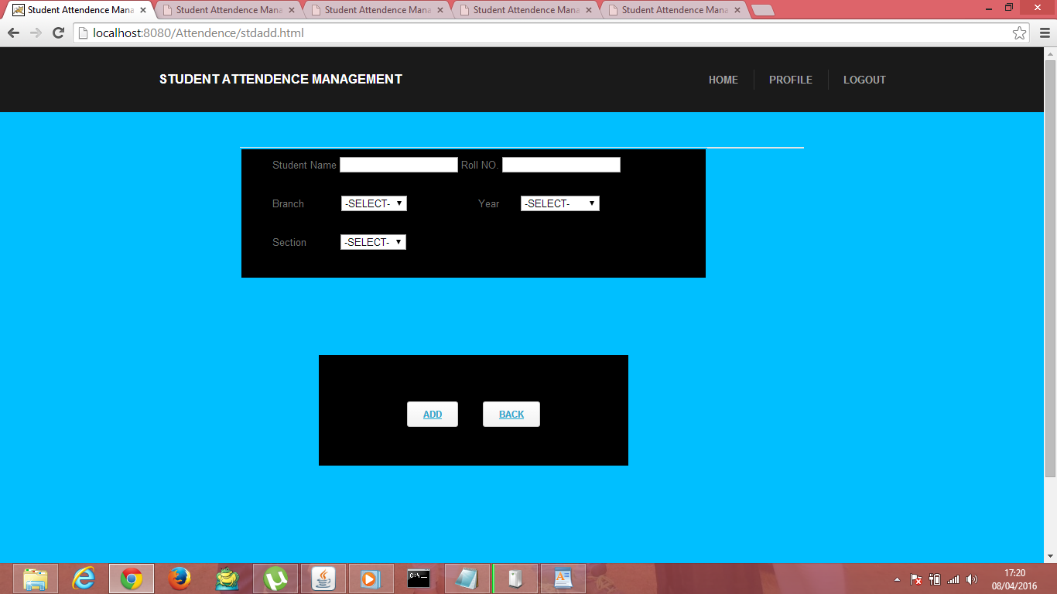

**9.8 checkatd.html**

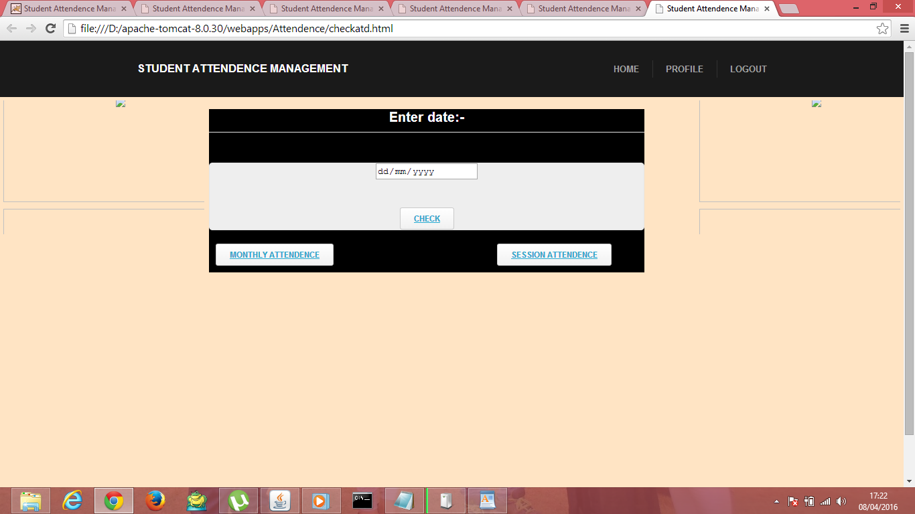

**9.9 Suballot.html**

**­­­­­**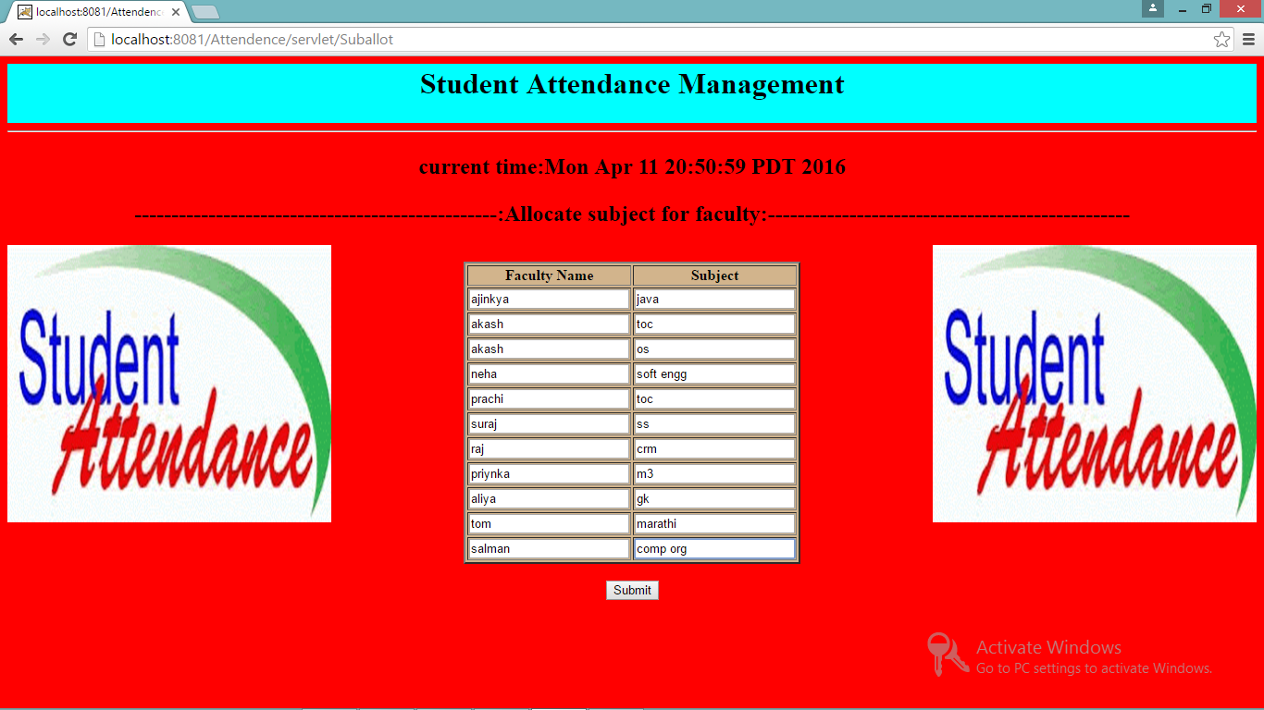

**9.10 Chkadt.html**

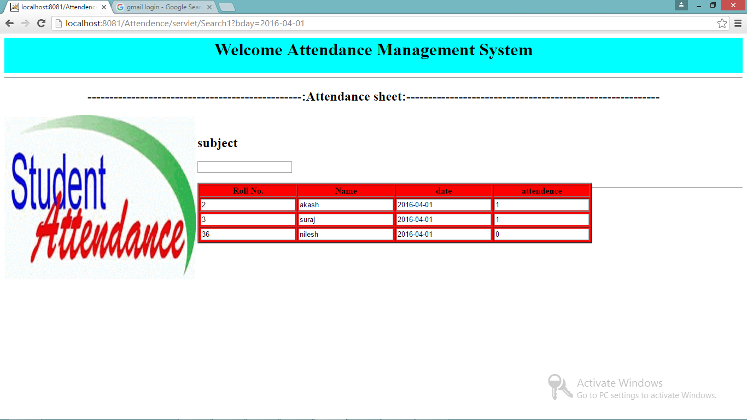

**9.11 facdel.html**

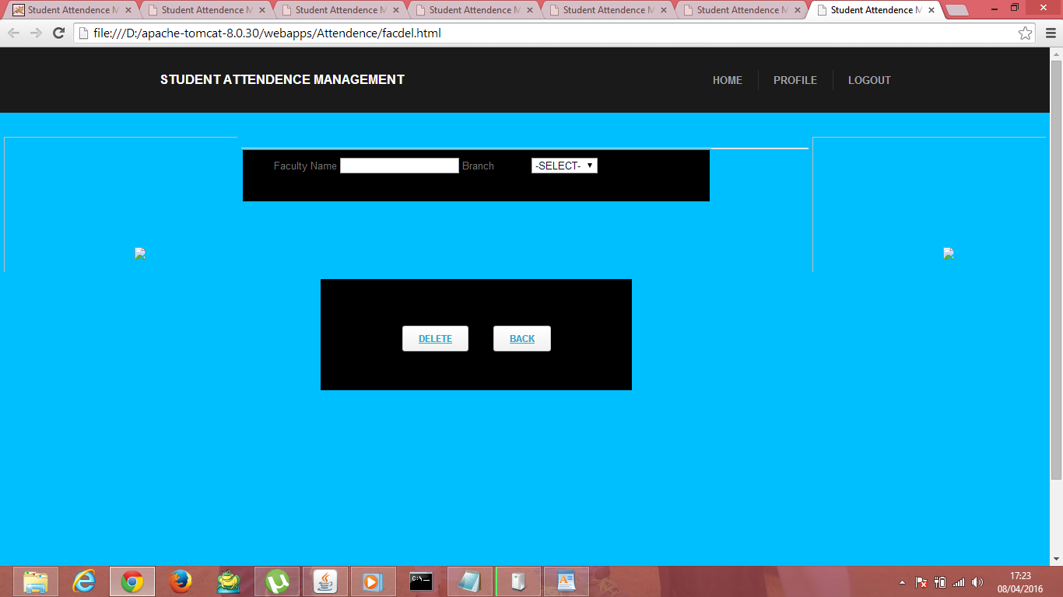

**9.12 Underlogin.html**

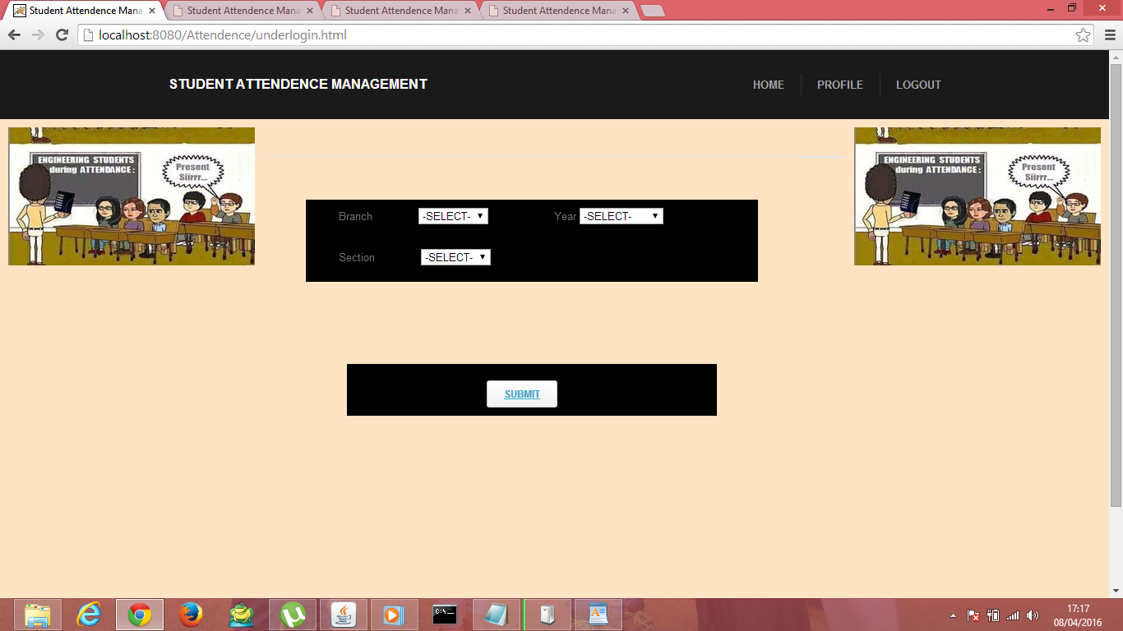

**9.13 Attend.html**

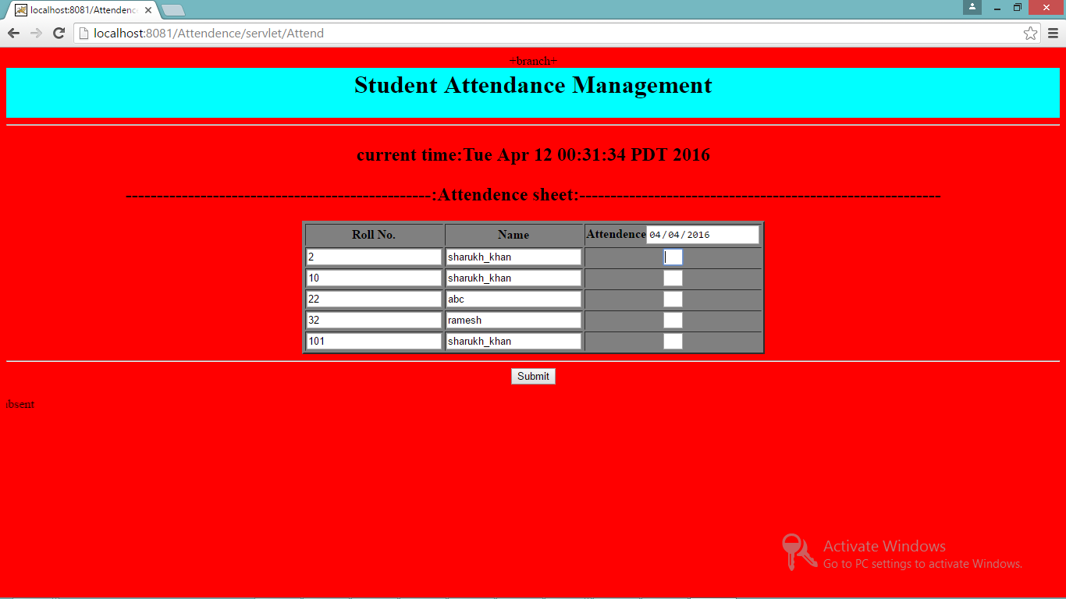

**9.14 monthly attendance**

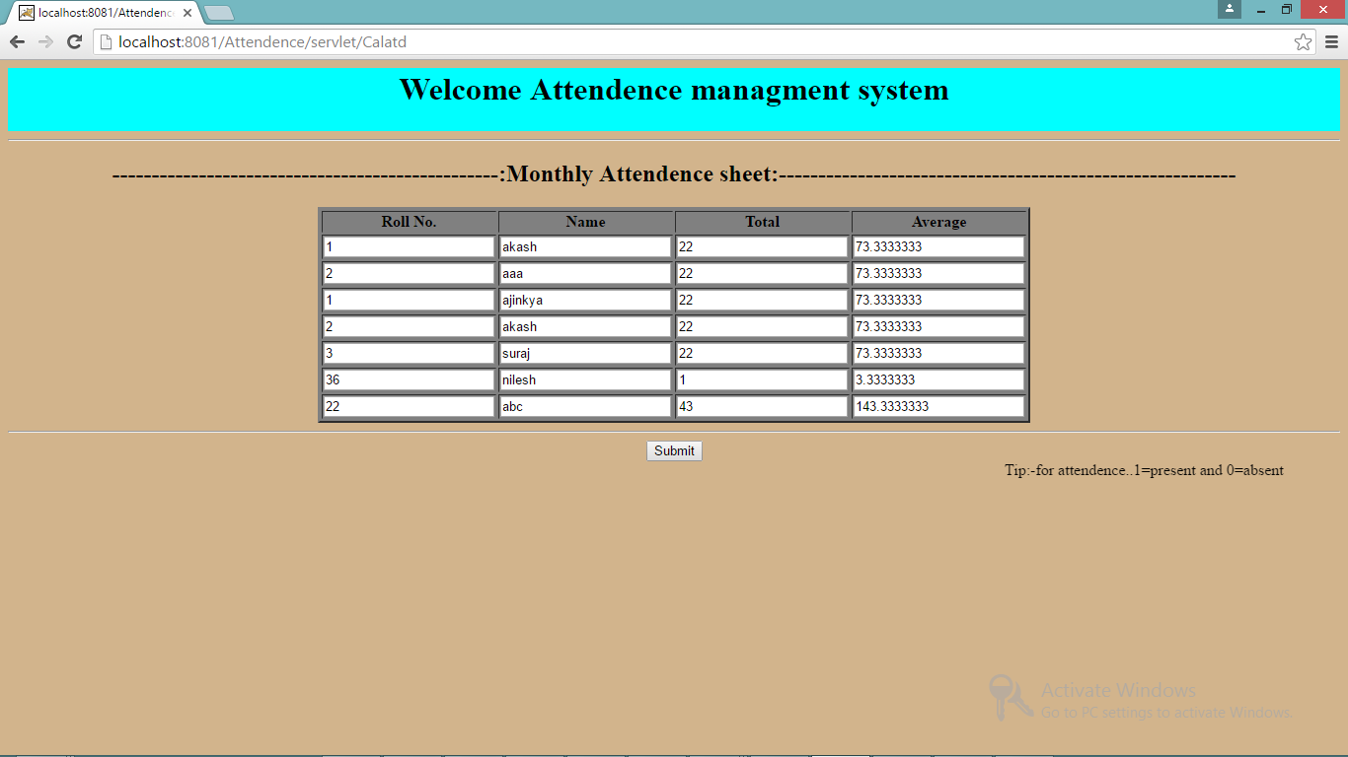

**10: CONCLUSION:**

This system is developed in html css and javascript as font end tool and java and SQL server as back end tools. The system is developed after studying the requirement and necessities of the system. Large data can be securely stored and accessed through SQL server Database using queries. As the system is created in a user friendly manner with appropriate message guiding the server, even a person with minicomputer knowledge will be able to use the system.

`