**ASYNCHRONOUS ONLINE DISCUSSION FORUMS FOR COLLEGES**

**Ajinkya Palaskar**

Anantrao Pawar College of Engineering & Research, Pune

**Shreyas Bhand**

Anantrao Pawar College of Engineering & Research, Pune

**Vaibhav Bhalerao**

Anantrao Pawar College of Engineering & Research, Pune

**Onkar Kshirsagar**

Anantrao Pawar College of Engineering & Research, Pune

# Abstract - Online Discussion Forum is a platform where students can start a conversation with their peers & teachers in the form of posts. Other members can voluntarily respond to these posts via Asynchronous discussion which allows them to read and respond “out-of-time.” Which means, not every member of the forum has to be logged on at the same time for the discussion to proceed unlike platforms like Zoom & Google Meet. Our study found that participation in online discussion forums has a positive impact on student’s academic & social growth. Hence, our work focuses on providing for students with fewer resources or students with introverted personalities, the ability to engage in discussions with their peers as well as their teachers in order to get accurate information about their college activities with an option of an anonymous environment. Our emphasis is on building a Community Question Answering (CQA) based web application that will enable students to access particular information/resources with an optional anonymous environment with the assistance of other students as well teachers to find appropriate information/resources in order to achieve cognitive and social growth using efficient development tools for developing a user friendly and fully responsive platform that is compatible with all modern devices while using cloud services for safely storing all of user data.

Keywords - Asynchronous online discussion forum, Community Question Answering, Web Application, Cognitive growth, Social growth, User interface, Anonymous environment, Responsive Web Design.

# **I. INTRODUCTION**

It is often said that students learn best from their peers, thus it is beneficial to promote student-to-student interactions inside and outside of the classroom. Especially in modern times like today, when there is a lot of information being thrown at students which can be overwhelming & confusing at times. A Web based discussion forum is one way of facilitating these interactions.

Online Discussion Forum is a Community Question Answering (CQA) platform where students can start a conversation with their peers & teachers in the form of posts. Other members can voluntarily respond to these posts via Asynchronous discussion.

Asynchronous discussions are online discussions that occur independent of time and space. Participants do not have to be online simultaneously, and can read and contribute to the conversation on their own schedules. Asynchronous discussion allows students to read and respond “out-of-time” i.e. not every member of the forum has to be logged on at the same time for the discussion to proceed unlike platforms like Zoom & Google Meet.

Study has suggested that participation in online discussion forums can improve a student’s academic performance & social skills [1]. This platform encourages introverted students to take part in college related discussion & clear their doubts thanks to the anonymous environment provided in the forum.

Similar existing systems include Quora, Google Classroom, Facebook Groups and Reddit. Although Quora provides a platform for asking questions to other members, it is not helpful in terms of specific college matters where students can communicate with their fellow college peers and teachers because of its large scale of users. The very clear limitation of Google Classroom in this context is the lack of student participation. Majority of google classroom posts are created by teachers and there is very little scope for students to provide feedback. In Addition, it is not suitable for non-academic applications as it is just a Learning Management System. It does not provide an anonymous environment which results in decrease of student participation which is already low. The limitations of Facebook groups in our context are that there is no anonymous environment and posting documents/files is a complicated process. Although it is perfect for non-academic discussions, it is not suitable for academic discussions. As Reddit is a link aggregator, it is not possible to directly post documents/files in the group. Additionally, Reddit’s interface may prove to be complicated for non-experienced users. A common limitation of both these applications is the presence of too many advertisements which can annoy users. Additionally, as the user feed of these applications consists of other posts of pages/communities followed by the users, it is very unlikely that every college post will appear in the feed.

# **II. OBJECTIVES**

The objectives of this study are as follows:

* To allow users to post questions, information or other resources including multimedia resources.
* To allow other users to respond to posts with appropriate answers/replies as well as upvote/downvote posts.
* To provide users with a comfortable environment for asking doubts anonymously i.e. without revealing identity or openly as themselves.
* To provide the ability to message other users privately to discuss a topic.
* To allow users to use the web application on all devices such as Desktops, Tablets, Mobiles etc.
* To Notify users of any activity involving them on the forum.
* To Boost Student-to-Student & Student-to-Teacher interaction.

# **III. SCOPE**

To build a Community Question Answering (CQA) based web application that will enable students to access particular information/resources with an optional anonymous environment with the assistance of other students and teachers to find appropriate information/resources in order to achieve cognitive as well as social growth using efficient development tools for developing a user friendly and fully responsive platform that is compatible with all modern devices while using cloud services for safely storing all of user data.

# **IV. LITERATURE REVIEW**

During our research of existing systems & previously implemented online discussion forums we found the following factors/reasons leading to success or failure of those systems:

* Challenging and non-redundant discussion threads encourage better online participation among students. Students with their limited time resources, have higher order cognitive contributions and a reasonable amount of social posts in online discussion forums [1].
* Effective design of the forum helps to sustain the interest in students. Feedback from students suggests further improvement on design of the forum on organizing the content & sending notifications to the students [1].
* Difficulties reported by students & teachers include difficulties with forum structure, lack of visualization tools and flexibility, difficulty sending files, difficulty with forum interface, lack of social media-like features etc. [2].
* Students have positive attitudes towards educational CQA systems. In contrast with standard discussion forums, CQA systems seem to be better prepared for large numbers of students/questions and for long-term deployment when valuable knowledge stored in discussions from the previous academic years can be efficiently reused [3].
* Teachers’ presence in the system is perceived by students positively and significantly encourages their participation [3].
* Small-group discussion can lead to increased learner participation in asynchronous online discussion, and self-selected small groups comprising mostly friends and acquaintances were more likely to witness strong social interactions and active participants during the online discussion process [3].

# **V. RESEARCH METHODOLOGY**

**RESEARCH DESIGN**

This study adopted convenience sampling. Sampling was done by interviewing randomly selected respondents. A structured questionnaire was used for data collection. The questionnaire was divided into three sections, the first section was about the personal profile of respondents and second, were designed to evaluate using overall experiences with the quality of services they had received from similar existing technologies and the last was dealing with additional features they desired in the systems.

# **VI. METHODOLOGY**

The application starts by displaying the home page, making it clear to the potential users what purpose it serves. The name of our web application will be ‘CampusTalk’. The homepage will contain calls to actions for login or registration. If the user is logging in for the first time, he/she has to first join the forum of his/her institute. If the institute’s forum is not present then the user will have an option to create a new forum for his/her institute. If it’s not their first time then they will be redirected to their personalized feed containing posts from the forums they have joined. Keep in mind that a user can be a member of a maximum of 3 forums at a given time. Below are Data Flow Diagrams (DFD) that are used to construct this application.

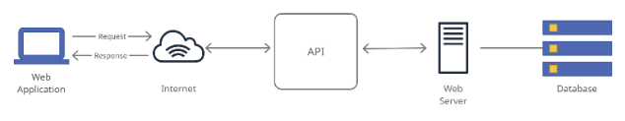

*Fig 1.1: Methodology of how an API based system works*

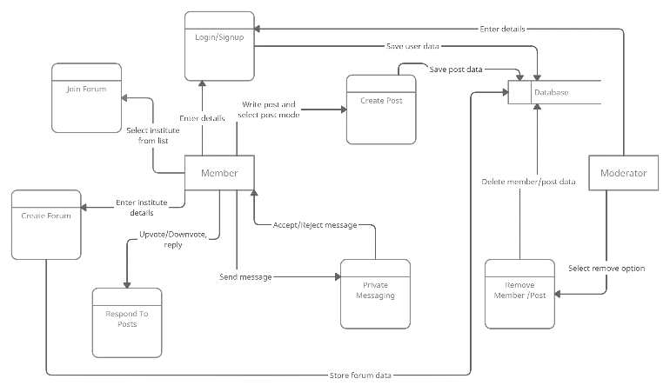

*Fig. 1.1: Level-1 Data Flow Diagram of the system*

**Components:**

Here users can interact with the application through any device like mobile, computer, tablet etc. and many other devices making it fully responsive.

**User Interface of the system:**

This section includes Homepage, Login & Signup section, Join Forums section, Create New Forum section.

## **A. Homepage**

Here users can find out the purpose & details of how the web application works along with call to action buttons for Sign up & Log in.

## **B. Login & Signup Page**

Here the users can log in to their account using their email & password or create a new account. Users can also sign in with google

## **C*.* Join Forum**

Here the users will be shown a list of existing forums. Users can join their institute’s forum by finding it in the list or they can click on the ‘Create New Forum’ button if their institute’s forum is not present in the lis

## **D. Create New Forum**

Here the users can create a new forum for their institute by filling out a form with details of their institute.

# **VII. SOFTWARE REQUIREMENTS**

Below mentioned are the technologies that we have used to develop this web application:

1. **HTML** (Hypertext Markup Language) is the most basic building block of the Web. It defines the meaning and structure of web content. Each page contains a series of connections to other pages called hyperlinks. Every web page you see on the Internet is written using one version of HTML code or another.
2. **Cascading Style Sheets** (CSS) is a simple mechanism for adding styles (e.g., fonts, colors, spaces) to Web documents. CSS defines how HTML elements are to be presented on screen, paper, or in other media. CSS saves a lot of work. It can control the layout of multiple web pages all at once.
3. **JavaScript,** often abbreviated JS, is a programming language that is one of the core technologies of the World Wide Web, alongside HTML and CSS. Over 97% of websites use JavaScript on the client side for web page behavior, often incorporating third-party libraries.
4. **React.js** was developed at Facebook to fix code maintainability issues due to the constant addition of features in the app. An open-source framework now, React stands out because of its virtual Document Object Model (DOM), which offers its exceptional functionality. An ideal framework for those who anticipate high traffic and need a stable platform to handle it.
5. **Node.js** is an open-source, cross-platform, back-end JavaScript runtime environment that runs on the V8 engine and executes JavaScript code outside a web browser. Node.js brings event-driven programming to web servers, enabling development of fast web servers in JavaScript. Developers can create scalable servers without using threading, by using a simplified model of event-driven programming that uses callbacks to signal the completion of a task.
6. **Express** is a back end, open-source framework for Node.js. It is designed for building web applications and APIs. It has been called the de facto standard server framework for Node.js.
7. **MongoDB** is a source-available cross-platform document-oriented database, classified as a NoSQL database program which uses JSON-like documents with optional schemas. It means you can store your records without worrying about the data structure such as the number of fields or types of fields to store values.

# **VIII. HARDWARE REQUIREMENTS**

* Hardware - Pentium
* Speed - 1.1 GHz
* RAM - 1GB
* Hard Disk - 20 GB
* Key Board - Standard Keyboard
* Monitor - SVGA

# **IX. RESULT**

Below are some of the results/consequences obtained from this web application:

* Asynchronous Communication provides more flexibility to users.
* It is easily scalable.
* Asynchronous learning is usually more cost-effective than classroom learning.
* It provides geographical freedom.
* Easier access to supplementary materials.
* It is self-paced, users can learn at their own pace.
* More clarity regarding extra-curricular activities.
* Boosts participation of introverted users.

Here are some of the snapshots of ‘CampusTalk’

**SCREENSHOTS**

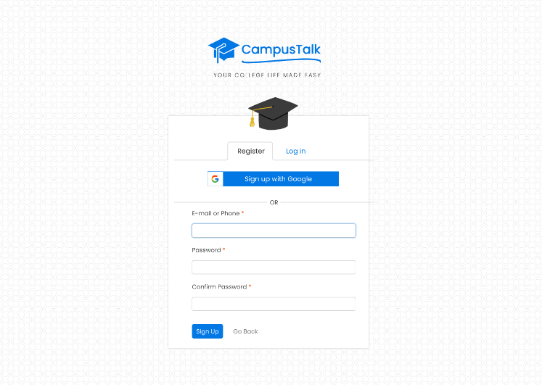

***Fig 2.1*** *Login/Registration page of 'CampusTalk.*

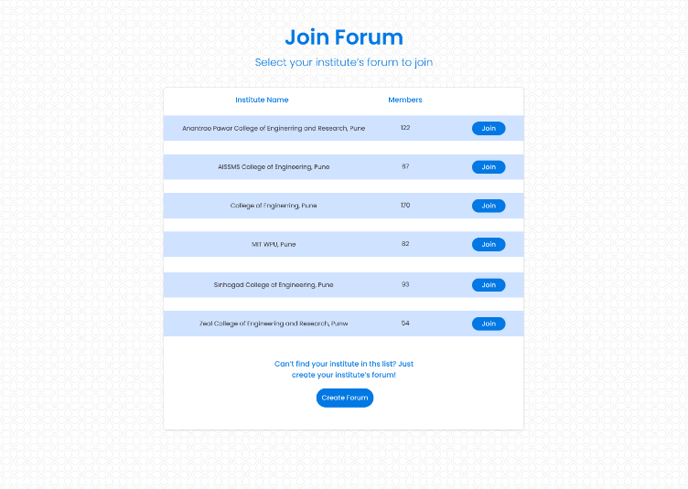***Fig 2.2*** *Users can join a forum by selecting one of the forums from the list.*

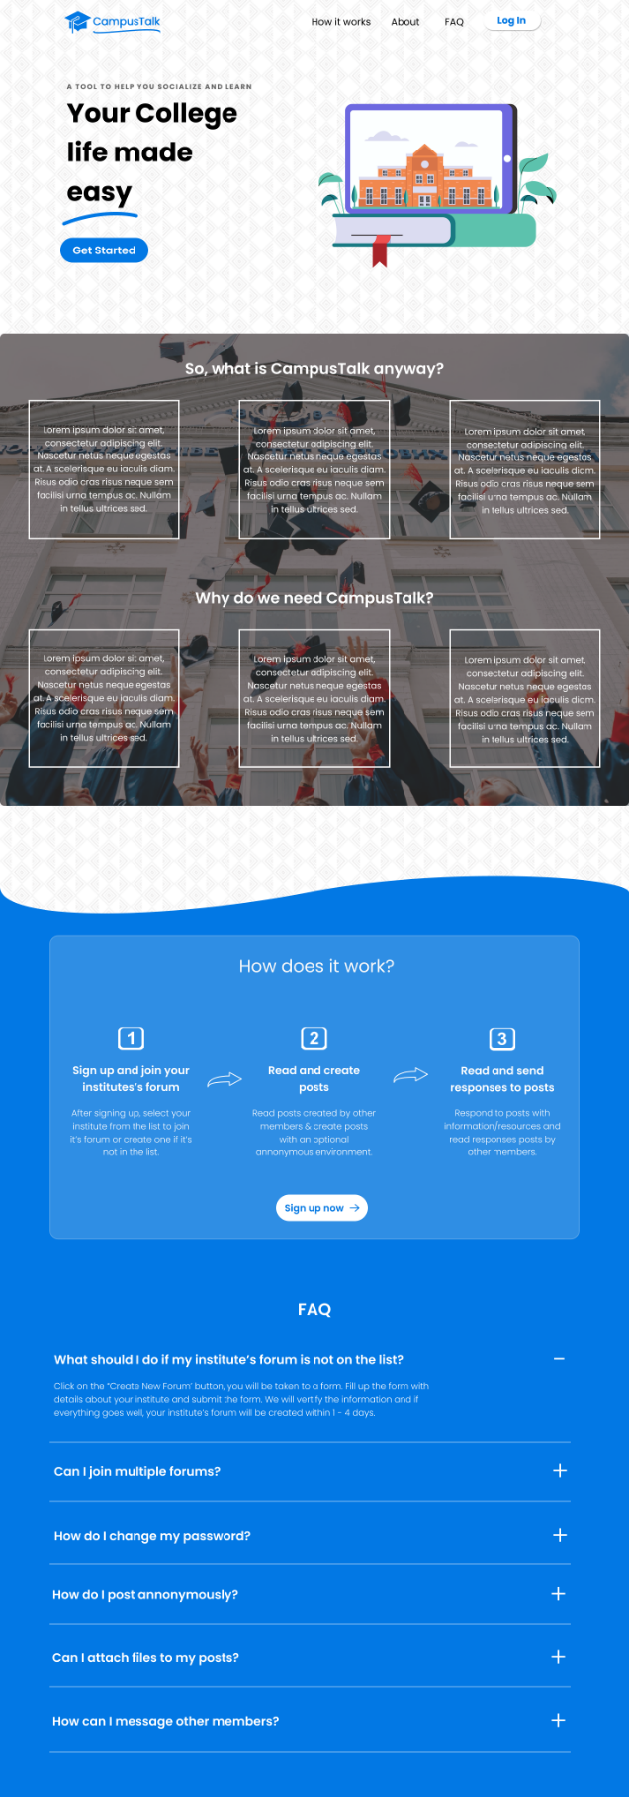

***Fig 2.3*** *The above snap is of the Home Page of CampusTalk.*

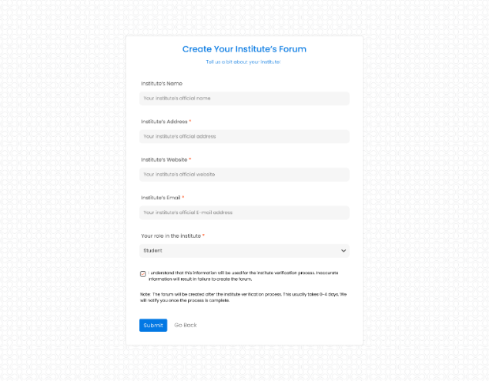

***Fig 2.4*** *The above snap is of the ‘Create New Forum’ page.*

# **X*.* DISCUSSION:**

A college student’s life is already complicated as it is, the least we can do is to provide them a platform to make it a tiny bit easier. There are students of all kinds of personalities in colleges (introverts, extroverts, hybrids etc.) but there is no single platform or tool where all of them can feel comfortable to reach out for help. CampusTalk will provide them with an environment for them where they can ask & share without having to worry about what others will think about them. The socially enthusiastic students will have social media features like ‘upvotes’ and ‘downvotes’, the introverts will have the anonymous mode, the busy ones will have the notifications to remind them of important posts. To sum it all, we have tried to make the user experience as smooth as possible in order to help students achieve cognitive and social growth.

# **XI. CONCLUSION:**

In this paper we studied the benefits offered by Asynchronous Online Discussion Forum for students at institute level, along with further improvements that can make it more effective than any of the already existing technologies. This study has found out that Discussion Forums tend to have a positive impact on students course & exam performance as well as their social skills. It was found that the complexity of the structure of the forum has a major impact on the student participation in the forum. It is necessary to implement this web application to be accessible and easily usable in all modern devices. The work offered in this study would be implemented in our web application ‘CampusTalk’ with a combination of web development technologies & frameworks to improve students’ college life.

# **ACKNOWLEDGMENT**

We would like to express gratitude to Prof. A.N. Kalal, Department of Information Technology, Anantrao Pawar College of Engineering for guiding us to prepare this research paper.

**REFERENCES**

1. Mallika Nitin Gokarn, Swapna Gottipati, Venky Shankararaman –“Cognitive and Social Interaction Analysis in Graduate Discussion Forums”, IEEE, 2019.
2. Dhanielly P. R. de Lima, Marco A. Gerosa, Tayana U. Conte and José Francisco de M. Netto - “What to expect, and how to improve online discussion forums: the instructor’s perspective”, Springer 2019
3. Ivan Srba, Milos Savic, Maria Bielikova, Mirjana Ivanovic, Cesare Pautasso – “Employing community question answering for online discussions in university courses - Students’ perspective”**,** Elsevier 2019
4. Mingwei Li, Ying Chen, Heng Luo – “Effects of Grouping Strategies on Asynchronous Online Discussion - Evidence From Learning Analytics and Social Network Analysis” **,** IEEE 2020