
SuSTAINABLE FINANCE
A MAJOR PROJECT BY TEAM DETROIT
Abstract
The Sustainable Finance system is an AI-driven platform for evaluating and managing sustainability-focused loan applications.
Ajin Varughese
Fahim Shamim Aziz
Midhun Sunil
Muhammed Aslam

Sustainable Finance
- Team Detroit
Sustainable Finance is an AI-driven financial decision-support system designed to evaluate sustainability-linked loan applications for individuals, enterprises, and government bodies. The system adopts a cloud-based architecture with React as the frontend, Java Spring Boot as the backend REST API layer, and Python FastAPI for AI-powered services. This system enables banks to create or generate sustainability assessment questionnaires using AI. Applicant responses and the uploaded project reports are analysed contextually using Artificial Intelligence (AI) and Natural Language Processing (NLP) to assess environmental sustainability, project feasibility, and compliance with sustainability-focused loan criteria.
The platform evaluates applications across key sustainability domains such as climate mitigation, water management, circular economy, and biodiversity by combining regulatory rule validation with AI-based reasoning. The AI service interprets the semantic meaning of user responses to determine eligibility and risk, while providing meaningful feedback on approval or rejection. This approach improves transparency, adaptability, and decision accuracy in sustainable lending. By integrating AI-powered evaluation, dynamic questionnaires, and a modular service-oriented architecture, the Sustainable Finance system offers a scalable and future-ready solution for modern green and sustainability-focused financial ecosystems.
The system is composed of three core modules:
- Questionnaire Service
The Questionnaire Service is responsible for creating and managing sustainability assessment questionnaires for different loan categories. Banks can either manually design questionnaires or generate them using AI based on selected sustainability domains such as renewable energy, eco-friendly housing, climate mitigation, or water conservation. The service dynamically adapts questions to the applicant’s project type and profile. Questions may include structured options as well as descriptive inputs, enabling comprehensive data collection for AI-based analysis. The module ensures a flexible and scalable questionnaire structure that supports evolving sustainability standards and regulatory needs.
- Rules Service
The Rules Service performs regulatory and policy-based validation of loan applications. It enforces mandatory eligibility conditions such as compliance with sustainability regulations, document completeness, and non-negotiable environmental constraints. These rules act as a foundational validation layer before AI assessment. Administrators can dynamically manage and update rules through an intuitive interface without requiring code changes, ensuring that bank policies remain adaptable to new sustainable finance regulations, taxonomy updates, and institutional priorities.
- Sustainable Finance Service
The Sustainable Finance Service functions as a secure internal ledger and transaction management system. It maintains complete records of loan applications, approvals, disbursements, repayments, and sustainability-linked financial data. This module ensures data integrity, consistency, and traceability across all financial operations. By utilizing an internal ledger architecture, the service enables banks to monitor green loan portfolios efficiently while eliminating reliance on external transaction systems, thereby maintaining high standards of security and auditability.

Tools and Technologies:
The development of the Sustainable Finance system leverages modern, scalable, and industry-standard technologies to deliver a secure and intelligent platform for sustainability-linked loan management.
- Java Spring Boot: Implements the backend REST APIs, business logic, security, and integration with databases and AI services.
- Python with FastAPI: Powers the AI and Natural Language Processing services responsible for questionnaire generation, response analysis, and sustainability assessment.
- ReactJS: Provides a responsive and interactive frontend for applicants, banks, and administrators.
- MySQL: Manages structured relational data including users, questionnaires, loans, transactions, and rules.
- IntelliJ IDEA & Visual Studio Code: Used as integrated development environments for efficient backend, frontend, and AI service development.
- Google Cloud Platform (GCP): Used for cloud hosting, scalability, and reliable deployment of application and AI services.
- Maven: Handles dependency management, build automation, and project configuration.

The Sustainable Finance system integrates these technologies into a modular, service-oriented architecture that enhances flexibility, scalability, and maintainability. By combining AI-powered assessment with dynamic questionnaires and secure financial processing, the platform simplifies loan evaluation while promoting environmentally responsible investments. Its robust architecture, adaptable rule management, and cloud-ready design make it a future-ready solution for financial institutions seeking to advance sustainable and green finance initiatives.

🌱 1. Green Loans
- Purpose: Finance environmental projects.
- Examples: Renewable energy, green buildings, energy efficiency, clean transportation.

🤝 2. Social Loans
- Purpose: Address social issues and improve livelihoods.
- Examples: Affordable housing, education, healthcare, financial inclusion.

♻️ 3. Sustainability-Linked Loans (SLLs)
- Purpose: Tie interest rates to a borrower's sustainability performance.
- Examples: Emissions reduction targets, water usage efficiency, diversity goals.

🌍 4. Climate Adaptation Loans
- Purpose: Help projects adapt to climate change.
- Examples: Flood defences, drought-resistant agriculture.

🏞️ 5. Biodiversity & Conservation Loans
- Purpose: Preserve or restore ecosystems.
- Examples: Reforestation, marine protection, wildlife conservation.

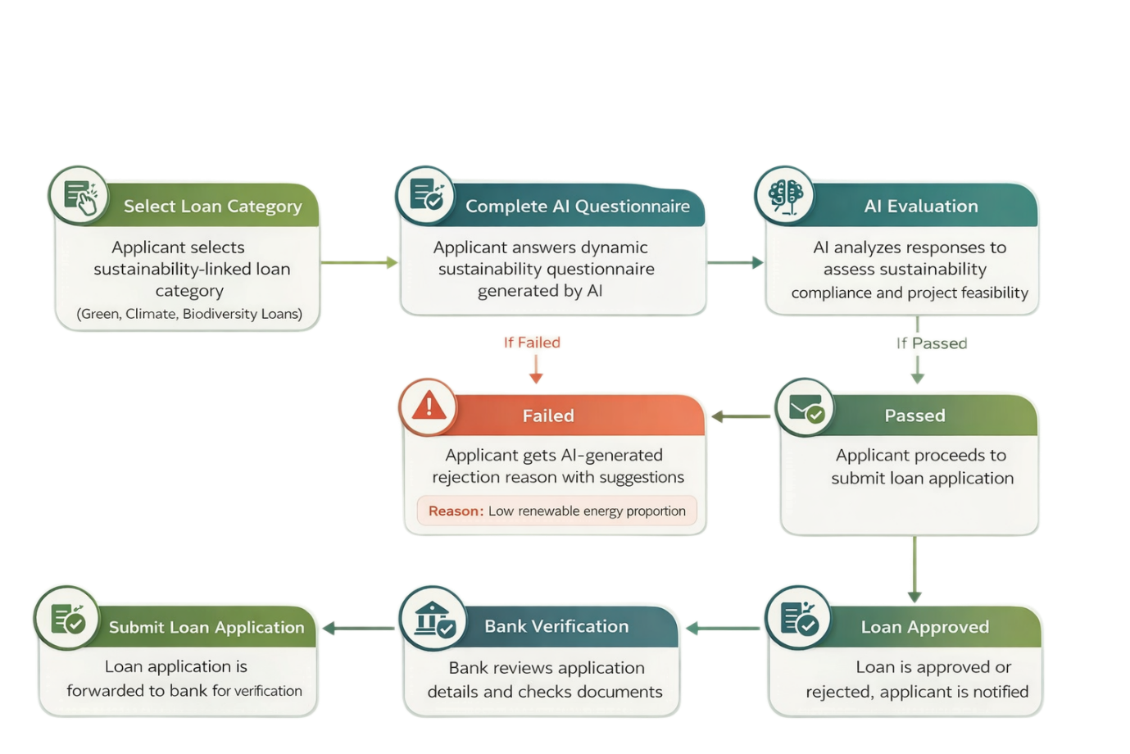
Applicant Point of View Workflow
AI-Driven Sustainable Finance Loan Application Process
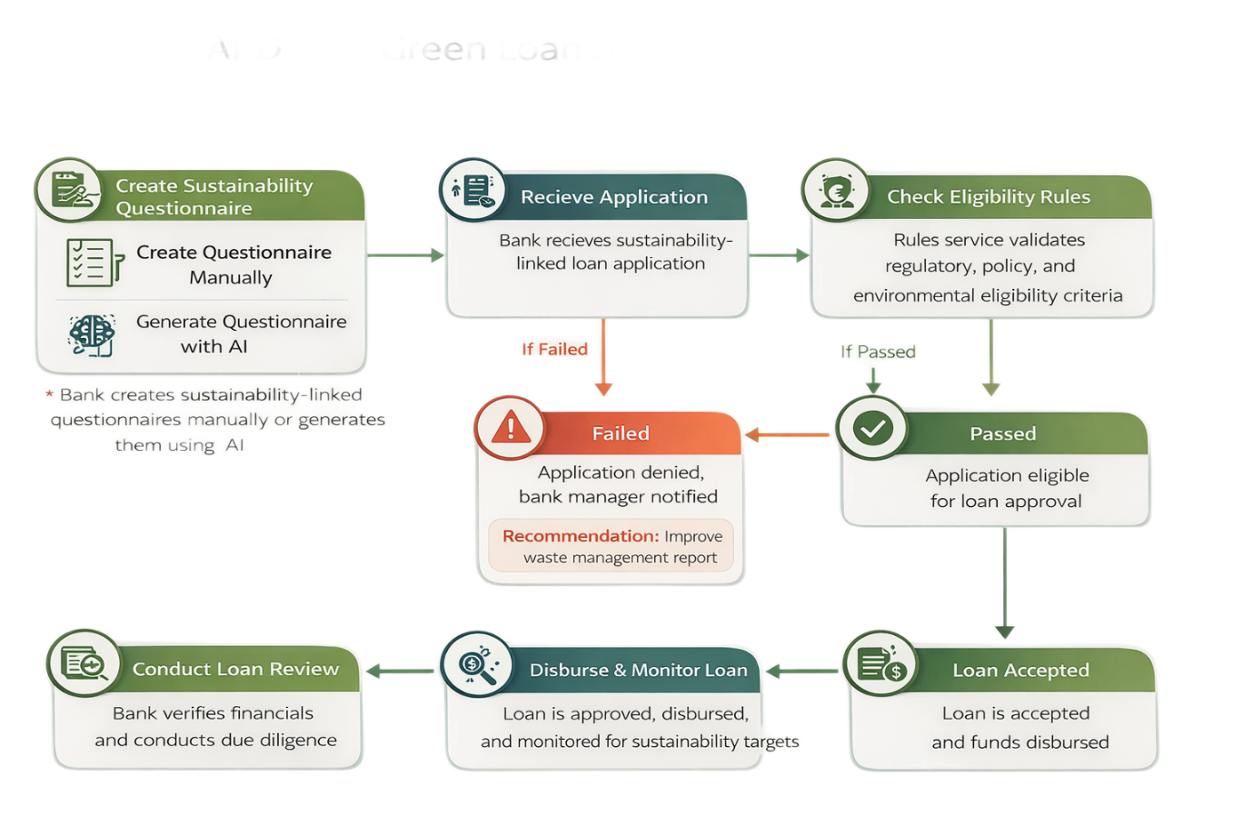
Bank Point of View Workflow

Final List of Required Entities
Entity Class | Why It's Needed
User | Represents applicants and administrators. Required for login, responses, loans.
Questionnaire | Template of questions (admin-created). Used for eligibility assessments.
Question | Dynamically created questions in a questionnaire.
Choice | Used for multiple/single choice type questions.
Answer | Stores user responses to questions.
Loan | Represents the loan itself (applying, status, amount, etc.).
Transaction | Loan disbursement and repayment tracking.
SustainabilityMetric | Tracks sustainability impact of projects (e.g., carbon reduction).
Rule | Dynamic eligibility rules applied to applications.
RuleApplicationLog | Logs results of rules applied to user responses.
LoanCategory | 📌 NEW: Required to group questions, rules, and loans by type (e.g., Eco Housing).
EligibilityResponse or Feedback | 📌 NEW: Optional, but useful for showing eligibility results/feedback per user.

Required Enums
Enum |  | Description
QuestionType |  | TEXT, MULTIPLE_CHOICE, SINGLE_CHOICE, RATING, BOOLEAN
LoanStatus |  | PENDING, APPROVED, REPAID
TransactionType |  | DISBURSEMENT, REPAYMENT
RuleApplicationResult |  | PASS, FAIL

