GIT RELATED TASK – GRAD HIRES

--------------------------------------------

1. Create a repo on GitHub
2. Clone it into your local system
3. Add a file in that directory
4. Add, Commit and Push it to the remote repo
5. Execute these commands - git status, git diff and git log
6. Create a branch
7. Checkout to that branch and make some code modifications
8. Then add and commit the changes while you are in the new branch
9. Checkout to the master branch and merge both the branches
10. Add, commit and push the changes to remote repo
11. Create another branch and delete it

Tasks

--------

1. Execute the commands
2. Please take screenshots of the commands you have executed
3. Add them to a doc
4. Upload that doc to GitHub by Monday (22-05-2023)

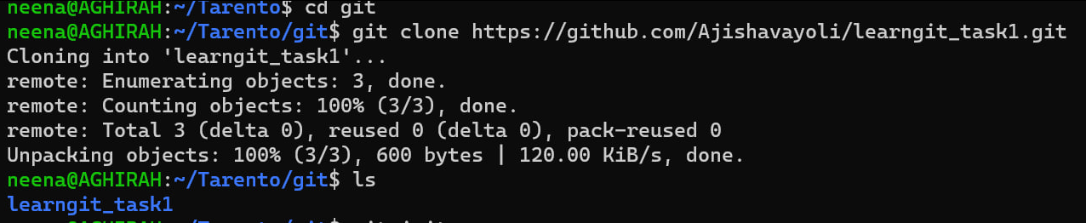

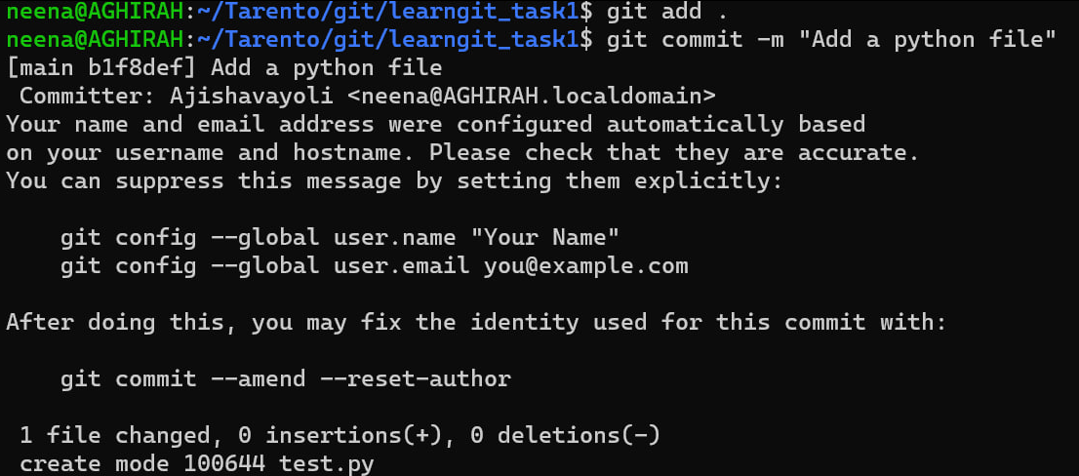

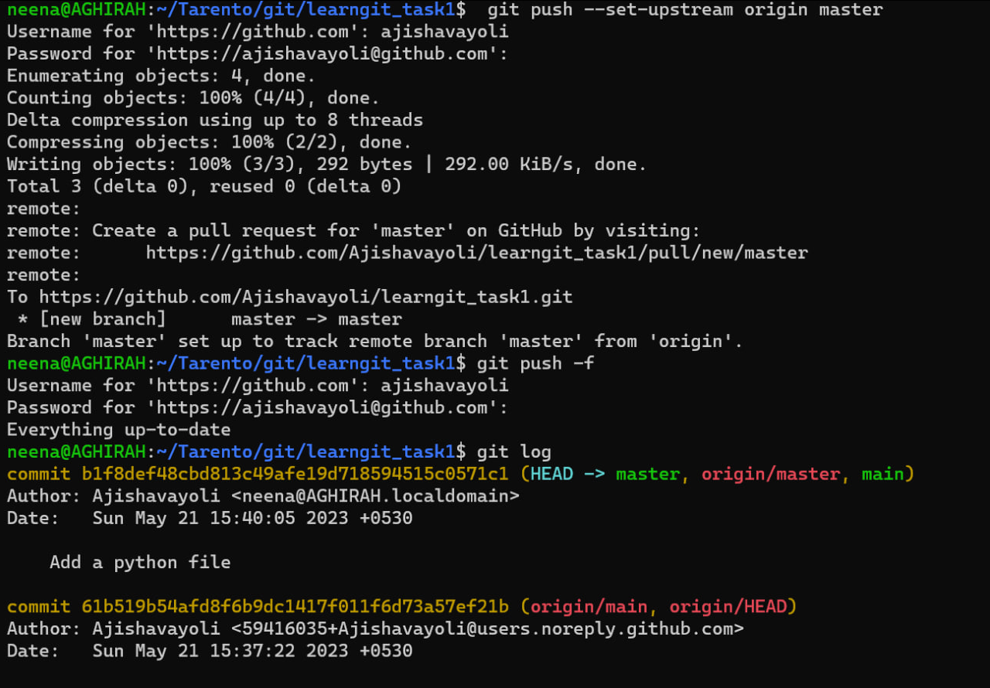

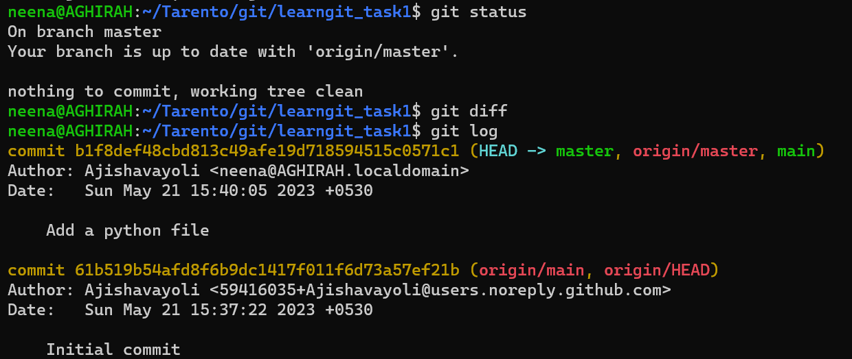

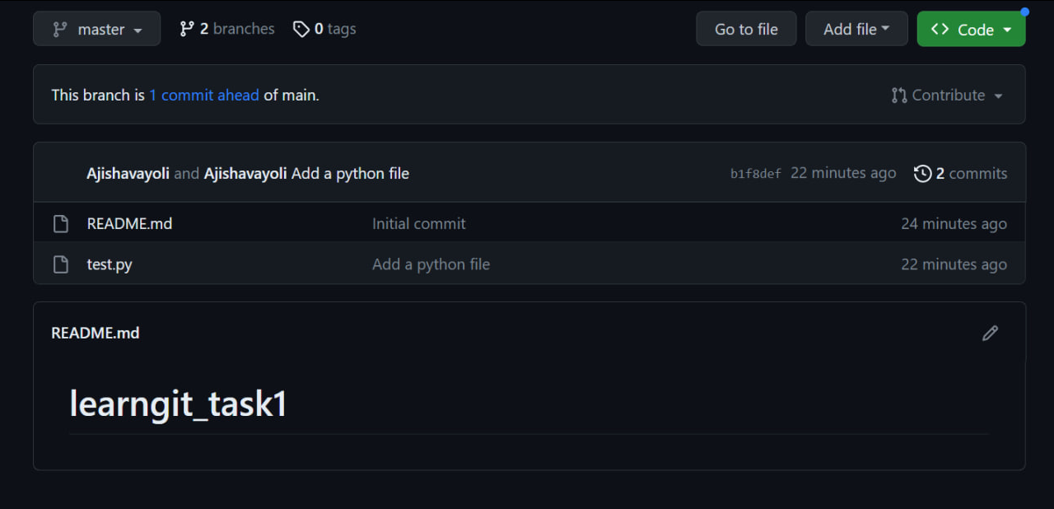

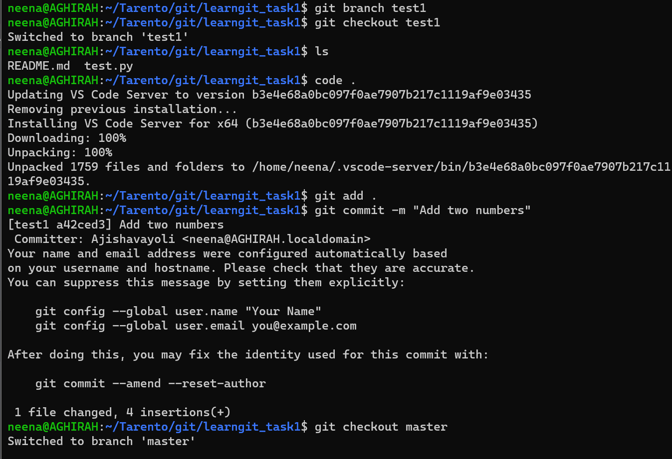

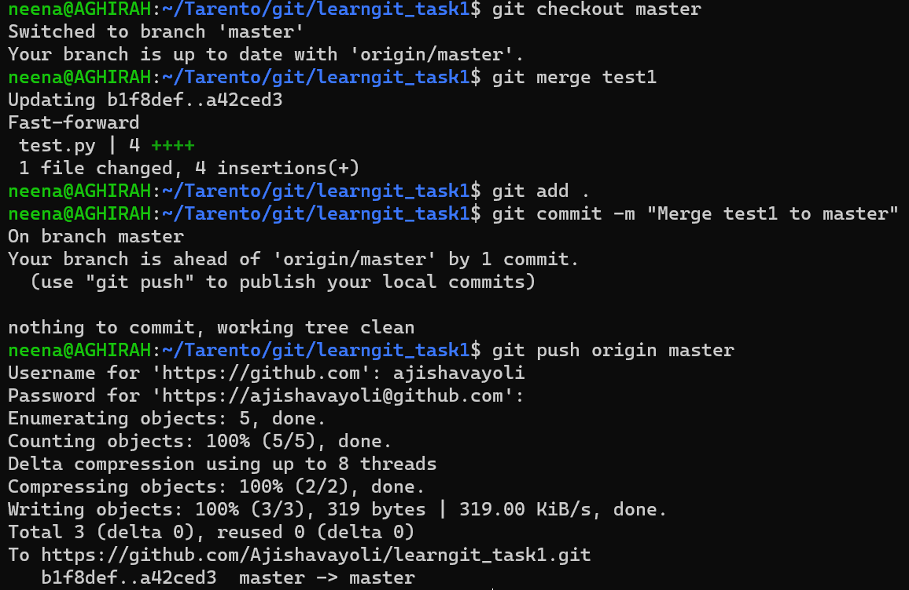

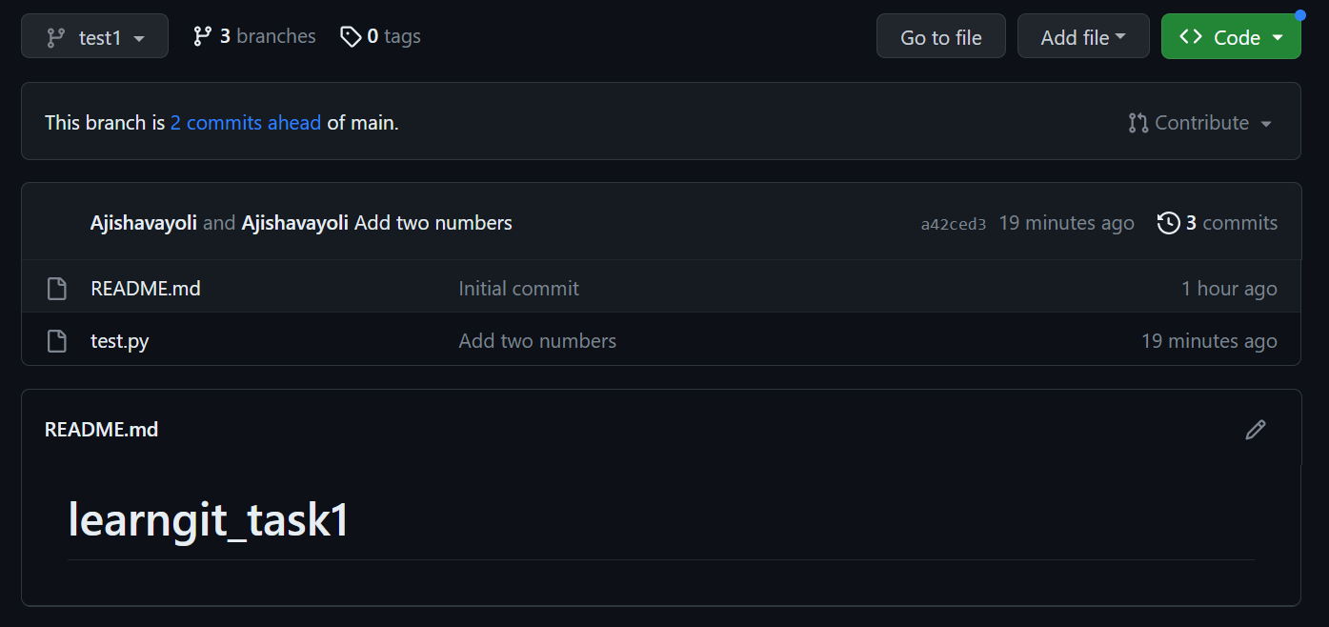

Add and delete branch

