

NAME-AJIT YADAV UID-23BCA10602

BRANCH-BCA/UIC SECTION/GROUP-23BCA-5_B

SEMESTER-3rd DATE OF PERFORMANCE-

SUBJECT NAME-Desktop publishing

SUBJECT CODE-23-CAP-204

AIM-Designing a portfolio of your.

PROCEDURE:-

1. Plan Your Portfolio Layout

* Decide on the type of portfolio (digital or print).
* Determine the size and orientation. Common sizes include A4 (8.27 x 11.69 inches) or Letter (8.5 x 11 inches) for print. For digital, consider a 1920x1080 pixel canvas.
* Sketch out a rough idea of each page layout, especially for portfolios with multiple pages.

2. Set Up the Document in Photoshop

* Open Photoshop and go to File > New.
* Set the dimensions, resolution, and color mode:
  + For Print Portfolios, set the resolution to 300 PPI and color mode to CMYK.
  + For Digital Portfolios, set the resolution to 72 PPI and color mode to RGB.
* Choose the number of pages (create each page as a separate file or organize them in the same document as separate artboards for ease).

3. Design a Consistent Layout

* Add Guides for alignment: Go to View > New Guide Layout. Set up margins, gutters, and columns as per your design.
* Keep consistent fonts, colors, and style throughout to maintain a cohesive look.
* Use shape layers (like rectangles) to create placeholders for images and text.

4. Add Images and Artwork

* Import Images: Go to File > Place Embedded to insert images. This keeps images as Smart Objects, allowing for easy scaling without quality loss.
* Resize and Position images within each page layout. Use the Transform Tool (Ctrl+T or Command+T) to adjust the size and placement.
* Use Layer Masks to create custom shapes or to fit images within specific shapes. This helps you avoid non-destructive cropping.

5. Add Text and Details

* Use the Text Tool (T) to add descriptions, titles, and captions.
* Use a consistent font family and sizes for headers, body text, and captions.
* For readability, keep text size above 10 pt for print and above 12 px for digital.
* Add contact information or a logo on each page or at the end of the portfolio.

6. Organize Layers

* Use layer folders to organize each section or page for easy navigation and editing.
* Name each layer or folder appropriately to avoid confusion, especially if your portfolio has multiple pages.

7. Add Visual Elements for Interest

* Shapes and Lines: Use lines or shape tools to divide sections, emphasize headings, or add design flair.
* Backgrounds: Keep backgrounds clean or lightly textured. Subtle gradients or solid colors work well without overpowering the content.
* Consistent Margins and padding around elements keep everything looking professional.

8. Apply Adjustments and Filters as Needed

* Adjust image brightness, contrast, and color to ensure consistency.
* Avoid over-processing images; subtle adjustments work best for a professional look.

9. Add Page Transitions or Section Dividers (Optional)

* If it’s a multi-page portfolio, you can create transitional pages with simple text like "Photography," "Graphic Design," or any category name.
* This helps the viewer transition smoothly between sections.

10. Review and Proof Your Portfolio

* Check for any alignment issues, spelling mistakes, or color inconsistencies.
* View the document at 100% zoom to ensure quality for digital. For print, use Print Proof mode (View > Proof Setup) to simulate the CMYK output.

11. Export Your Portfolio

* For digital portfolios:
  + Go to File > Export > Export As and choose PDF, JPEG, or PNG depending on your preference.
  + Adjust the quality to High if it’s a PDF, and set 100% quality for JPEG/PNG.
* For print portfolios:
  + Go to File > Save As and select PDF. Choose High Quality Print or Press Quality settings for optimal print output.
  + Double-check bleed settings if you’ll be printing with a bleed.

12. Compile (if Multi-Page)

* If using multiple pages, you can compile everything into a single PDF file using Photoshop or other software like Adobe Acrobat or InDesign.
* For easy navigation, add hyperlinks if the portfolio will be viewed digitally.

LEARNING OUTCOMES

Master Document Setup: Understand how to set up a document with the correct dimensions, resolution, and color mode for both print and digital outputs.

Layer Management: Learn how to effectively organize and manage layers for complex projects, improving workflow efficiency and editability.

Use of Guides and Grids: Gain skills in using guides and grids to create a clean, well-aligned, and visually balanced design layout.

Gain the confidence to present a high-quality, professional portfolio that effectively showcases work to potential clients, employers, or collaborators.

By understanding the basics of portfolio design, develop the adaptability to create different styles of portfolios for various fields (e.g., photography, graphic design, illustration).

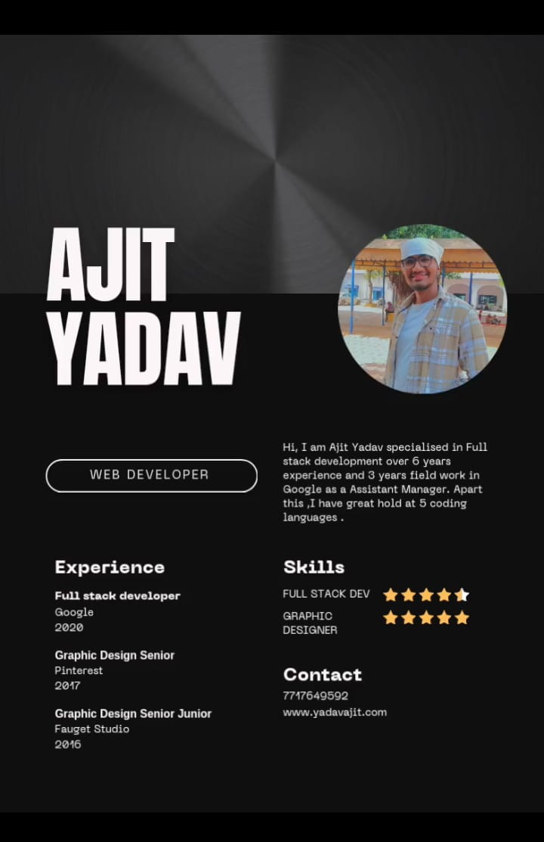

Evaluation grid:

|  |  |  |  |
| --- | --- | --- | --- |
| Sr. No | Parameters | Mark Obtained | Maximum Marks |
| 1. | Demonstration and performance(Pre Lab and Quiz) |  | 5 |
| 2. | Worksheet |  | 10 |
| 3. | Post Lab Quiz |  | 5 |