Sample Screen shots

1. User Form : to Add users into database

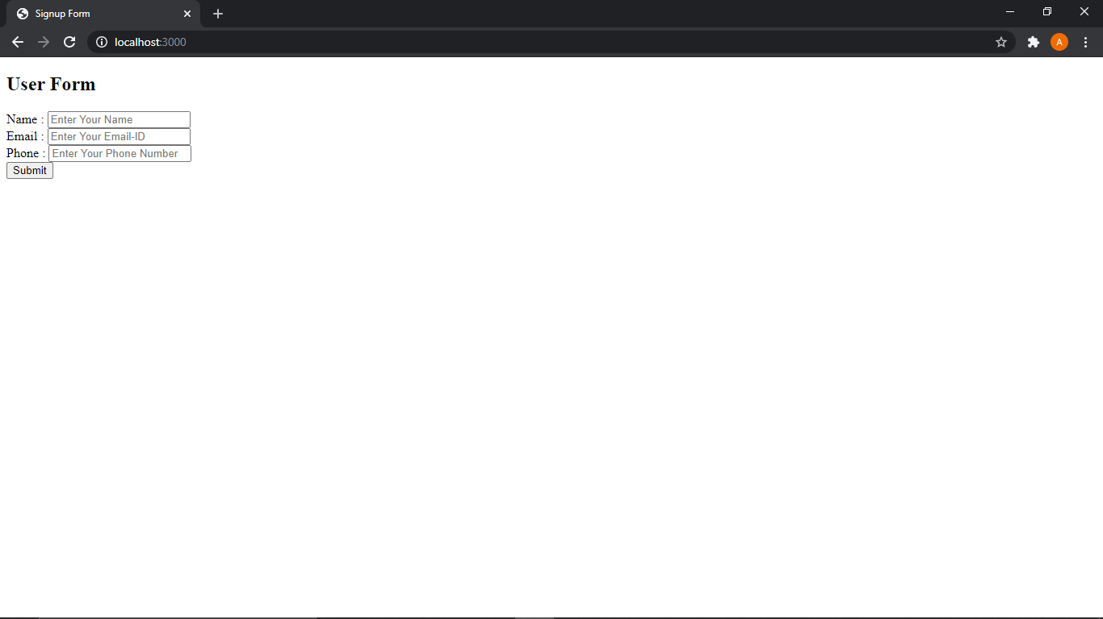

1. Email and Phone are verified with regular expression

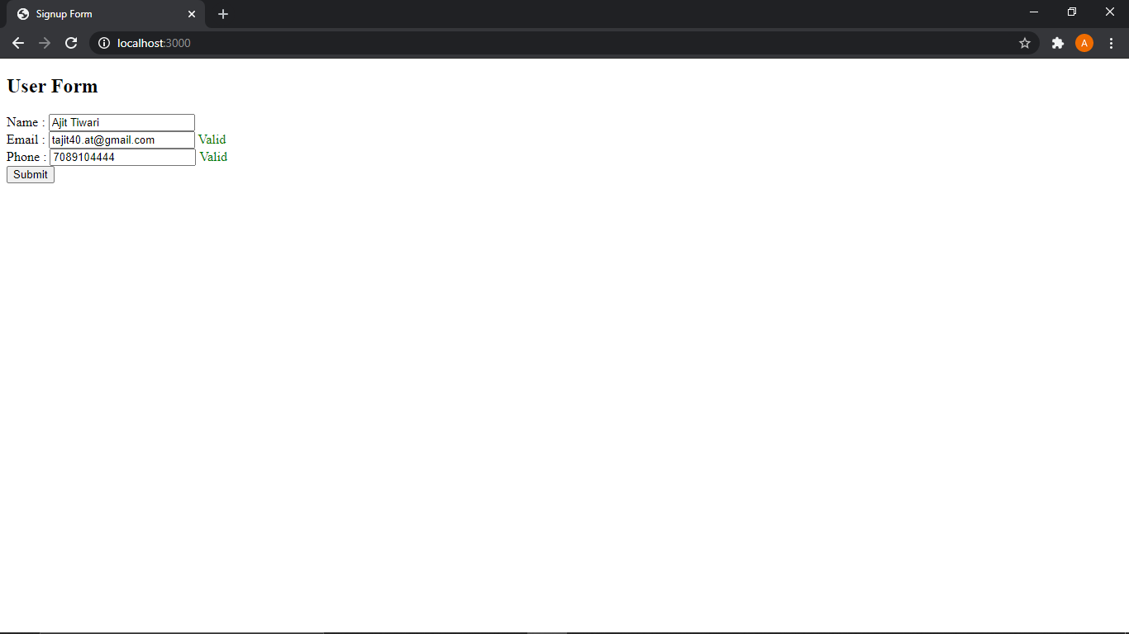

1. Fetched user name from user database and displayed on drop down list

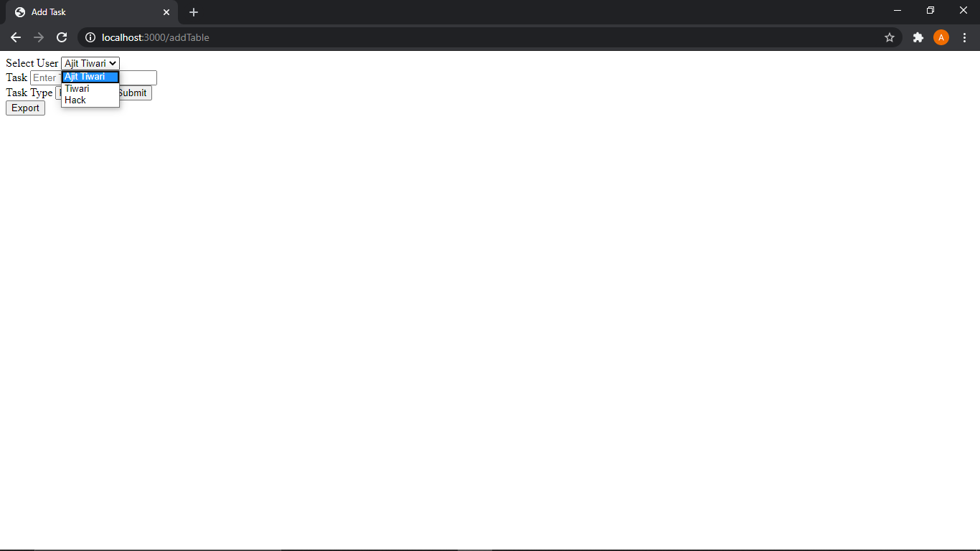

1. Added task to the user and setting status

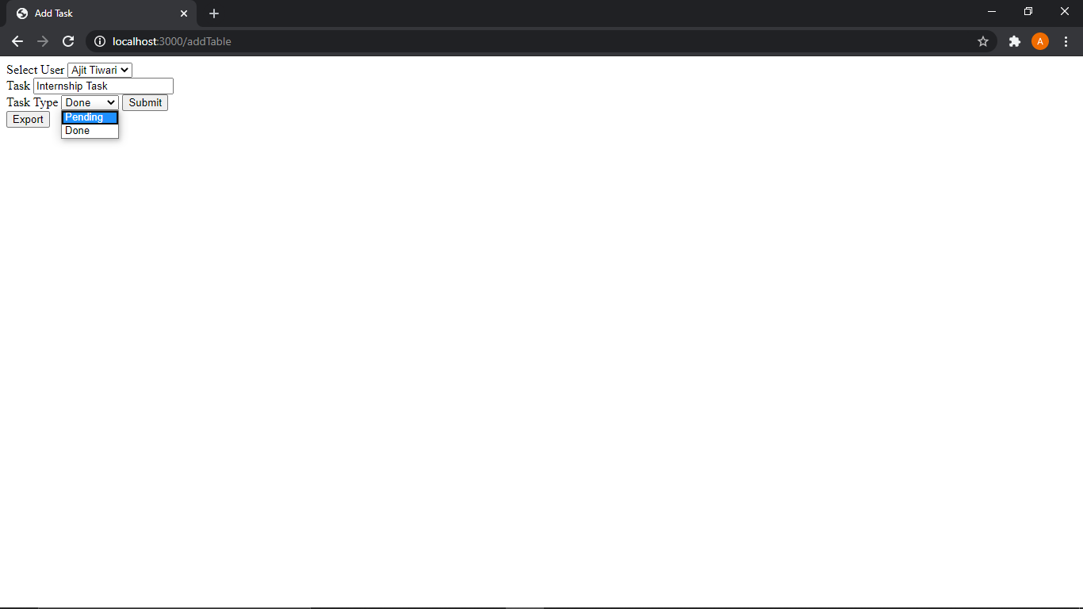

1. Downloaded Excel file to client directory

Here in my case : “C:\users\Ajit Tiwari\Downloads”

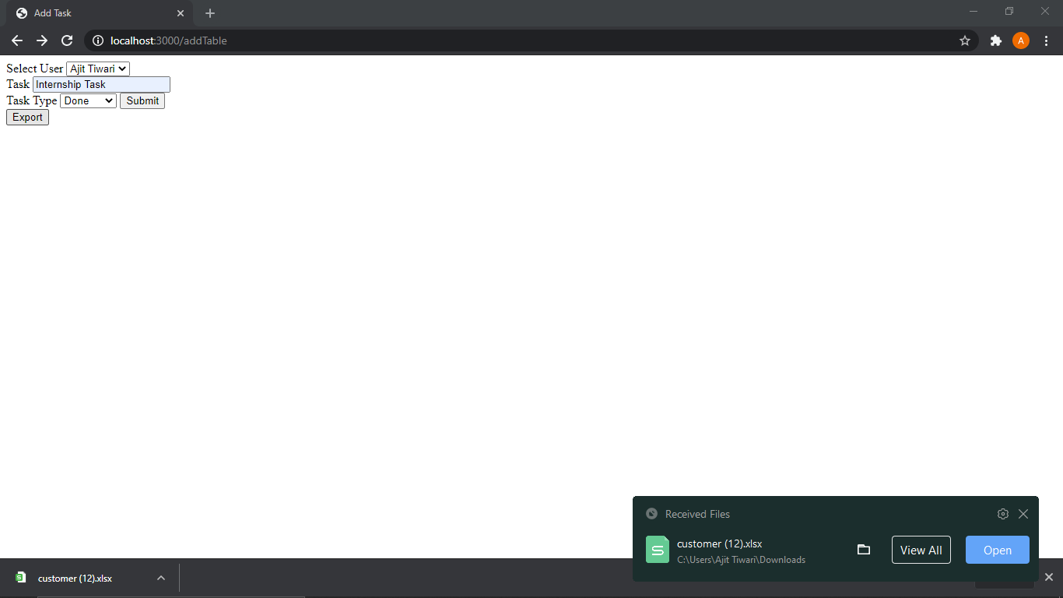

1. Opening the downloaded file : users tab

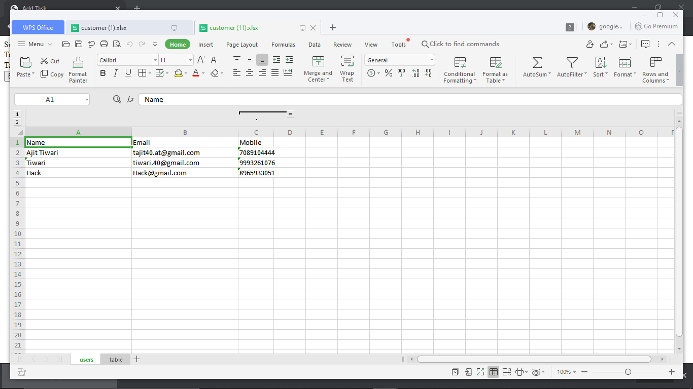

1. Opening the downloaded file : table tab

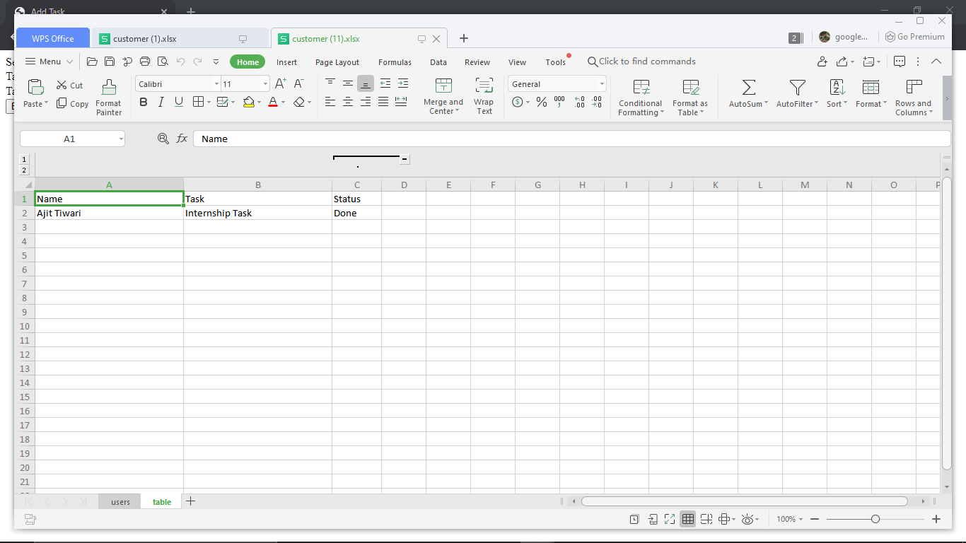

Database Screens :

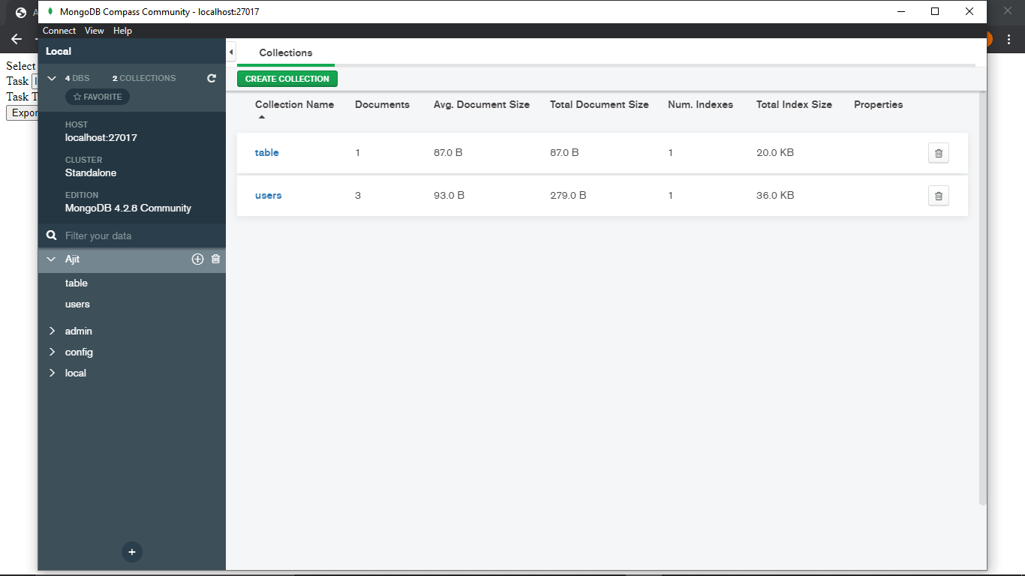

User

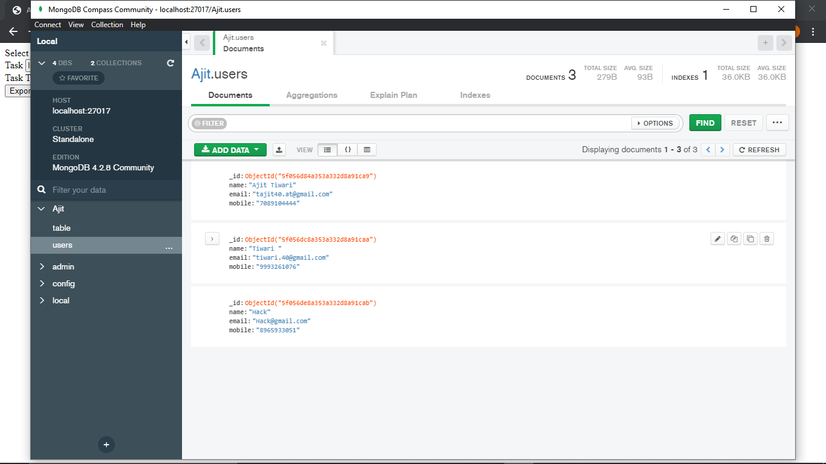

Table

