*A MINORR PROJECT REPORT*

*ON*

Real Time Gas Detection and Smart Monitoring for Sewage Workers

*SUBMITTED*

*BY*

AJIT (22104009)

&

AMIT (22104012)

&

NAVNEET(22104071)

*B.TECH VI SEM (ECE)*

*UNDER THE SUPERVISION OF*

**DR.BALWINDER RAJ**

**Designation**



DEPARTMENT OF ELECTRONICS & COMMUNICATION

ENGINEERING

Dr. B. R. AMBEDKAR NATIONAL INSTITUTE OF TECHNOLOGY,

JALANDHAR

**CANDIDATES’S DECLARATION**

I hereby declared that the work which is being presented in the minor project report entitled, “**Real Time Gas Detection and Smart Monitoring for Sewage Workers**” being submitted by us in the partial fulfillment of the requirement for the award of degree of ***Bachelor of Technology in Electronics and Communication Engineering*** to ***Dr. B R AMBEDKAR NATIONAL INSTITUTE OF TECHNOLOGY, JALANDHAR*** is an authentic record of our own work carried out under guidance of ***Dr. Balwinder raj,*** Department of Electronics & Communication Engineering.

The matters embodied in this record have not being submitted by us for the award of any other degree or diploma.

**DATE: 7/5/2025**

**AJIT (22104009)**

**AMIT (22104012)**

**NAVNEET (22104071)**

# 

# CERTIFICATE

This is to certify that the minor project work entitled, ***“*Real Time Gas**

**Detection and Smart Monitoring for Sewage Workers*”*** submitted by ***NAVNEET (22104071), AJIT (22104009), AMIT SAMOTA (22104012)*** in partial fulfillment for the award of degree of ***Bachelor of Technology in Electronics and Communication Engineering*** to ***Dr. B R AMBEDKAR NATIONAL INSTITUTE OF TECHNOLOGY, JALANDHAR*** has been

carried out under my supervision. This work has not been submitted partially or in full to any other University or Institute for the award of this or any other degree or diploma.

Signature of Supervisor ……………………..

Name of Supervisor :DR. Balwinder Raj

Date :7/5/2025

# 

# ACKNOWLEDGEMENT

We would like to acknowledge the support provided by **Dr. Balwinder RAJ** in guiding and correcting us at all stages of development of this project with utmost attention and care. We express our thanks to **Dr.** **Balwinder Raj**, of the Department Electronics and Communication Engineering, for extending her support and providing us necessary facilities. We would in particular give our regards to our guide, **Dr. Balwinder Raj** for his insightful advice, invaluable guidance, help, support in successful completion of this project and his consistent encouragement, advices throughout our project work. It was a great learning experience for us and we sincerely thank you for giving us this opportunity.

# 

# ABSTRACT

This report presents the design and implementation of a real-time gas detection and smart monitoring system tailored for enhancing the safety of sewage workers. The system utilizes ESP32 microcontroller and a arduino uno to continuously monitor gas concentrations in sewage environments and facilitate immediate alerts to workers and supervisors in case of hazardous conditions. Gas sensors integrated with the ESP32 enable real-time detection of gases like methane, hydrogen sulfide, and carbon monoxide, crucial for identifying potential health risks to workers. The GSM module enables wireless communication, allowing for prompt notifications via SMS or calls to ensure rapid response and evacuation if necessary. This project highlights the feasibility and effectiveness to improve occupational safety standards in challenging work environments and proposes avenues for future enhancements to optimize system accuracy, reliability, and usability in real-world sewage maintenance operations.

# LIST OF FIGURES

1. **COMPONENTS**………………………………………………………..…..3,4,5
   1. - 3.9 Elements

1. **CIRCUIT DIAGRAM**…………………………………………………..…..6
   1. Block Diagram

1. **MODEL**……………………………………………………………………..7
   1. Connections on PCB board
   2. Soldering of wires on the back of PCB board

## CONTENTS

*Page No.*

CANDIDATE DECLERATION II

CERTIFICA II

ACKNOWLEDGEMENT IV

ABSTRACT V

LIST OF FIGURES VI

LIST OF TABLES VII

1. **INTRODUCTION…………………………………………………………...**1
   1. NECESSITY OF THIS PROJECT
   2. AIM
   3. TRADITIONAL METHODS
   4. NEW TECHNOLOGY
2. **LITERATURE SURVEY…………………………………………………...**2
3. **BUILDING BLOCKS OF OUR PROJECT…………………………....**3,4,5
4. **. OBJECTIVES AND METHODOLOGY…………………………………..**6
   1. OBJECTIVES
   2. CIRCUIT DIAGRAM
5. **MODEL OVERVIEW………………………………………………….…..**7
6. **INTEGRATION INTERFACE( INTERCONNECTIONS)………….…**.8
7. **WORKING(DISCUSSION**)**……………………………………………..…**9
8. **APPLICATION……………………………………………………………..**10
9. **FUTURE SCOPE………………………………………………….…..…...**11
10. **CONCLUSION…………………………………………….…………..…**12

**REFERENCES……………………………………………………….………**

### 1.INTRODUCTION

1.1 A large number of sanitation workers face life threatening situations every year due to erratic and lack of facilities available, and harmful toxic gases released while cleaning the sewage. Sewage maintenance tasks often expose workers to hazardous gases, highlighting the critical need for effective monitoring solutions to ensure worker safety. Real time gas level detection systems and alert messages for such workers will help for this cause. The developed system incorporates gas sensors capable of detecting multiple gases commonly found in sewage environments, such as methane, hydrogen sulfide, and carbon monoxide. These sensors along with a microcontroller and wireless communication device such as antenna constitute our project. Data from the gas sensors are transmitted in real-time to a centralized monitoring station, providing continuous updates on gas concentration levels within the sewage environment.

1.2 The implementation of this system aims to revolutionize safety protocols in sewage maintenance, enabling proactive monitoring of hazardous gas levels and empowering supervisors with real-time data for informed decision-making. By leveraging the capabilities of modern sensor technologies, ESP32's capabilities for sensor interfacing and data processing, combined with Arduino Uno for wireless communication,this project seeks to bridge the gap between traditional safety practices and cutting-edge advancements in monitoring and data analytics.

1.3 Traditional gas detection systems often rely on manual monitoring or wired communication, which can be labor-intensive and prone to errors.The integration of GSM modules into gas detection systems emerges as a cost-effective and reliable solution for real-time monitoring and alerts.

1.4 The incorporation of arduino uno technology into gas detection systems not only facilitates remote monitoring and control but also offers redundancy and resilience. Unlike systems dependent on local infrastructure such as Wi-Fi networks or landline connections, GSM-based solutions operate autonomously, ensuring continuous functionality even in the absence of local resources. This report illuminates the development and deployment of a gas detection system harnessing GSM technology to bolster safety and security across varied environments.

### 2. LITERATURE SURVEY

Literature surveys, books, and case studies provide valuable insights and background information relevant to the development and implementation of real-time gas detection and smart monitoring systems for sewage workers and similar hazardous environments. They serve as essential references for understanding the current state of the art, best practices, and future directions in this field.

*FEW STUDIES RELATED TO THIS PROJECT

1. **Development of a Real-Time Monitoring System for Sewer Workers' Safety" by Kim et al. (2018):** This study focuses on the development of a real-time monitoring system for sewer workers' safety using wireless sensor networks.
2. **Wireless Gas Detection and Monitoring System for Industrial Environments" by Li et al. (2017):** Although not specific to sewage systems, this study presents a wireless gas detection and monitoring system for industrial environments.

1. Some books related to this project:

**"Gas Detection in Industrial Processes"** by John S. Nriagu

**"Occupational Safety and Health for Technologists, Engineers, and Managers**" by

David L. Goetsch and Eugene R. Seely(2017)

**"Smart Sensors for Industrial Applications"** edited by Krzysztof Iniewski(2017)

**"Internet of Things (IoT) Technologies for Industrial Applications**" edited by J.

Ramírez-Hernández and M. A. Pérez-Arancibia(2018)

**"Wireless Sensor Networks: Concepts, Applications, Experimentation and Analysis"** by Hossam Mahmoud Ahmad Fahmy.(2010)

1. Some case studies related to this project:

**"IoT-Based Gas Detection System for Sewage Workers"** by Gupta et al.

**"Smart Monitoring System for Sewer Networks"** by Singh et al.

**"Development of a Portable Gas Detection System for Sewer Workers' Safety"** by

Patel et al.

### 3.BUILDING BLOCKS OF OUR PROJECT

3.1 MQ-135 AIR quality and Hazardous Gas detector sensors

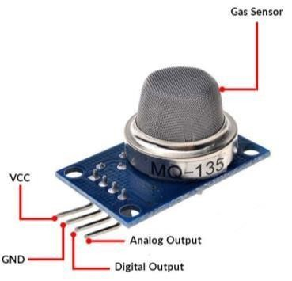The MQ-135 Gas sensors are used in air quality control equipments and are suitable for detecting or measuring of NH3, NOx, Alcohol, Benzene, Smoke, CO2. The MQ-135 sensor module comes with a Digital Pin which makes this sensor to operate even without a microcontroller and that comes in handy when you are only trying to detect one particular gas. If you need to measure the gases in PPM the analog pin need to be used. The analog pin is TTL driven and

Figure 1.1 works on 5V and so can be used with most common microcontrollers

3.2 ARDUINO UNO

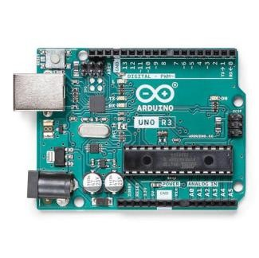Arduino Uno is a microcontroller board based on the ATmega328P chip.

It provides digital and analog I/O pins for connecting sensors and devices.

Programming is done via USB using the Arduino IDE.

Unlike ESP32, it doesn’t have built-in Wi-Fi or Bluetooth

Figure 1.2  3.3 GSM MODULE SIM900A

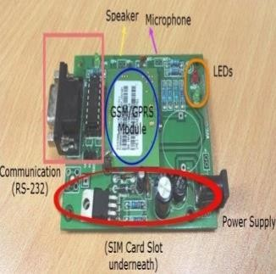A GSM module or a GPRS module is a chip or circuit that will be used to establish communication between a computing machine and a GSM or GPRS

system.GSM/GPRS Modem-RS232 is built with Dual Band GSM/GPRS engine- SIM900, works on frequencies 900/

1800 MHz. Using this modem, you can make audio calls, SMS, Read

SMS, attend the incoming calls and internet

Figure 1.3 through simple AT commands

3.4 1kohm & 10kohm Resistance

10k and 1k resistors are embedded on the pcb board.

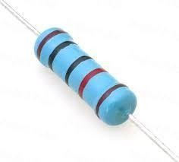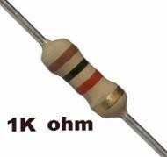

Figure 1.4

3.5 Push button

|  |  |
| --- | --- |
| Figure 1.5    **3.6 Zero PCB** | momentarily.  Zero PCB (Printed Circuit Board): In this interpretation, completes an electrical circuit |

|  |  |
| --- | --- |
|  | the PCB itself does not contribute to the |
| Figure 1.6 | system's functionality but is essential for its operation. |

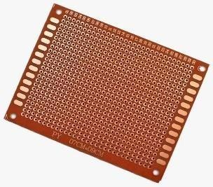Push buttons are commonly used as input devices in

electronic systems to initiate specific actions or trigger events.They typically consist of a mechanical switch that,when pressed,

"zero PCB" might refer to a PCB that serves as a base or foundation for a system but does not have any specific functionality of its own. Instead, it provides the physical platform for mounting and interconnecting electronic components that perform the actual functions of the system. In this context, the "zero PCB function" would simply mean that

3.7 Connecting Wires

The function of a connecting wire is to establish electrical connections between different components or points within an electrical circuit. These wires conduct electrical signals,current, or power from one location to another, allowing for the transmission of data, control signals, or power supply.

Figure 1.7

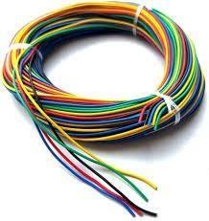

### 4. OBJECTIVES AND METHODOLOGY

4.1 Objectives

The primary objective of this project is to develop a real-time gas detection and smart monitoring system based on a GSM module. Specific objectives include:

3.1.1 Designing a gas sensor module capable of detecting various gases commonly found in industrial and domestic environments, such as methane, carbon monoxide, and propane.

3.1.2 Integrating a GSM module for wireless communication and remote monitoring, enabling users to receive alerts via SMS or calls.

3.1.3 Developing a user-friendly interface for configuring the system settings and receiving alerts in real-time.

3.1.4 Testing the system under different environmental conditions to evaluate its performance, reliability, and accuracy in detecting gas leaks and sending timely alerts.

**4.2 Methodology**

### Circuit Diagram

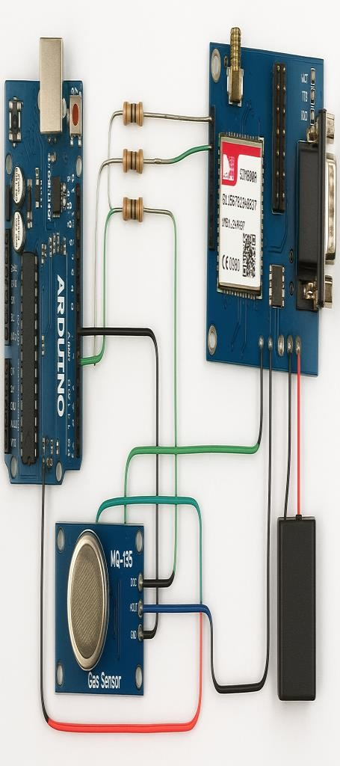

Figure 4.1 Block Diagram

XII

### 5. MODEL OVERVIEW

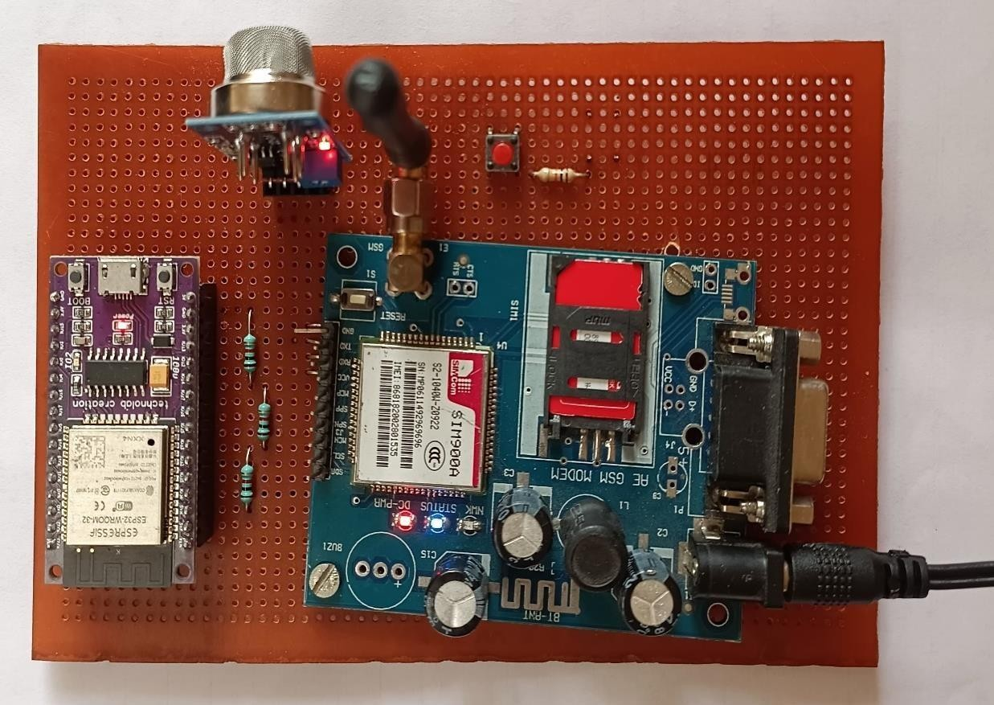

Figure 5.1 Connections on pcb board

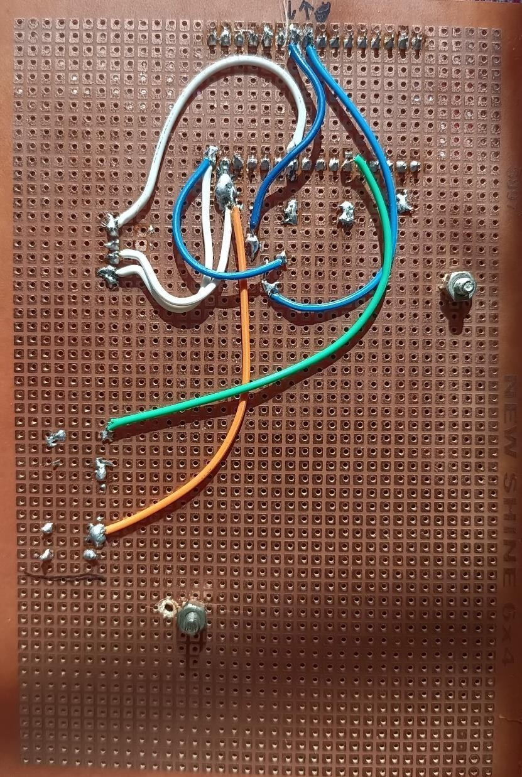

Figure 5.2 Soldering of wires on the back of pcb board

#### XIII

6. INTEGRATION INTERFACE (INTERCONNECTIONS)

As per the connections shown in figure 4.1 and 4.2, the ESP32 microcontroller, GSM900A module, and MQ-132 gas detector forms the core infrastructure for monitoring and transmitting gas data in real-time. Here's how these components are interconnected and function together:-

**ESP32 Microcontroller:** The ESP32 serves as the central processing unit in our project, responsible for collecting data from the gas detector, processing it, and transmitting it to a remote monitoring station via the GSM module. It interfaces with the gas detector using digital or analog pins to read gas sensor data and controls the Arduino Uno for data transmission.

ARDUINO UNO : Arduino Uno is a microcontroller board based on the ATmega328P chip It provides digital and analog I/O pins for connecting sensors and devices. Programming is done via USB using the Arduino IDE. Unlike ESP32, it doesn’t have built-in Wi-Fi or Bluetooth

**MQ-132 Gas Detector:** The MQ-132 gas detector is a gas sensor module designed to detect hazardous gas in the environment. It consists of a sensing element that changes its electrical conductivity in the presence of gas. The MQ-132 module typically provides analog output voltage proportional to the gas concentration, which is read by the ESP32's analog-to-digital converter (ADC) pins. The ESP32 processes the gas sensor data, performs calibration and compensation if necessary, and sends the data to the remote monitoring station via the Arduino Uno.

Overall, the **ESP32 microcontroller acts as the brain of the system, collecting gas sensor data from the MQ-132 detector, processing it, and transmitting it wirelessly using the** Arduino Uno. This setup enables real-time gas detection and smart monitoring for sewage workers, providing timely alerts and ensuring their safety in hazardous environments.

### 7. WORKING(DISCUSSION)

1. **Gas Detection by MQ-132 Gas Detector:**

•The MQ-132 gas detector continuously monitors the surrounding environment for the presence gas.

•When a certain gas is detected, the gas sensor's sensing element undergoes a change in electrical conductivity, resulting in a corresponding change in the analog output voltage.

1. **Signal Processing by ESP32 Microcontroller:**

•The analog output voltage from the MQ-132 gas detector is read by the analog-to-digital converter (ADC) pins of the ESP32 microcontroller. •The ESP32 processes the raw sensor data, which may include calibration, compensation, and threshold detection algorithms to determine the gas concentration level.

1. Data Transmission via Arduino Uno: •Once the gas concentration level is determined, the ESP32 triggers the Arduino Uno to establish a connection to the cellular network using a SIM card.

•The ESP32 then formats the gas concentration data into a suitable message format, such as a text message or SMS payload, to be transmitted via the Arduino Uno.

•The Arduino Uno sends the formatted message containing the gas concentration data to a designated recipient, such as a monitoring station or a predefined phone number, using the cellular network.

1. **Reception and Interpretation of SMS Message:**  •The SMS message containing the gas concentration data is received by the recipient's mobile phone or a dedicated monitoring station equipped to receive SMS messages.

•The recipient's device or monitoring station decodes the received SMS message and extracts the gas concentration data from the message payload. •The gas concentration data is then displayed or logged for further analysis, alerting the recipient to the presence of hazardous gas in the monitored environment.

XV

### 8. APPLICATIONS

The application of a real-time gas detection and smart monitoring system, based on ESP32 and a Arduino Uno, presents a comprehensive solution for enhancing the safety of sewage workers. By leveraging ESP32's capabilities for sensor interfacing and data processing, combined with a GSM module for wireless communication, the system enables continuous monitoring of gas levels in sewage environments. The primary application of this system is to provide instant alerts via SMS or calls to workers and supervisors when hazardous gas concentrations are detected, ensuring swift response and evacuation if necessary. Additionally, the integration of Arduino Uno allows for remote monitoring and data transmission, enabling supervisors to monitor multiple workers' conditions simultaneously and facilitating proactive decision-making. Some applications can be:-

1. **Sewage Treatment Plants**: In sewage treatment plants, where workers are exposed to hazardous gases such as ammonia (NH3) during the treatment process, this system can alert workers and supervisors to the presence of dangerous gas concentrations, allowing for timely evacuation or implementation of safety protocols.
2. **Industrial Facilities**: Industrial facilities, such as chemical plants, refineries, and manufacturing plants, often have areas where toxic gases are present. Implementing this system in such environments can help mitigate the risk of gas-related accidents by continuously monitoring gas levels and providing early warning alerts to personnel.
3. **Mining Operations**: Mines are inherently hazardous environments with the presence of gases such as methane (CH4) and hydrogen sulfide (H2S). By deploying this system in mining operations, workers can be better protected from exposure to dangerous gases. **4. Wastewater Treatment Vehicles**: Vehicles used for wastewater collection and transport, such as sewer inspection trucks, can benefit from onboard gas detection and monitoring systems.

**5. Environmental Monitoring**: By deploying gas detectors equipped with this system in strategic locations, authorities can monitor air quality, detect pollution hotspots, and take corrective actions to mitigate environmental risks.

### 9. FUTURE SCOPE

Some potential future directions and areas of expansion include:

1. **Enhanced Sensor Integration:** Explore the integration of additional gas sensors to detect a wider range of hazardous gases commonly found in sewage environments. This could include sensors for methane (CH4), hydrogen sulfide (H2S), carbon dioxide (CO2), and volatile organic compounds (VOCs), enabling comprehensive gas monitoring capabilities.
2. **Integration with Wearable Devices**: Explore the integration of gas detection capabilities into wearable devices worn by sewage workers, such as smart helmets or vests. This would provide workers with real-time feedback on gas levels in their immediate vicinity, enhancing situational awareness and safety in the field.
3. **Heart Rate monitoring along with Oxygen level detection**: monitoring of the pulse rate of the person using a Heart beat sensor and the concentration of gaswith respect to atmospheric O2 can provide alert to the worker and exterior unit when parameters deviate from the safe range. This outcome will promptly alert the worker to stay safe and detect the toxic gases before any harm.
4. **Location-Based Alerts**: Utilize GPS tracking to provide location-based alerts to sewage workers and supervisors in the event of gas detection events or emergencies. Monitoring the real-time positions of sewage workers as they navigate through sewage systems and perform maintenance tasks.
5. **Refinement of sensor calibration and data analytics** to improve the accuracy and reliability of gas concentration measurements. This would involve conducting extensive field tests to validate sensor performance under various environmental conditions commonly encountered in sewage systems.
6. **Enhancing the system's user interface and connectivity features** to enable real-time visualization of data through mobile applications or web portals would empower supervisors with more intuitive monitoring and decision-making tools. Finally, exploring energy optimization strategies to prolong battery life and implementing predictive maintenance algorithms to anticipate sensor failures could enhance the system's reliability and reduce operational downtime. These future directions aim to elevate the system's performance, usability, and overall impact on sewage worker safety and operational efficiency.

### 10. CONCLUSION

In conclusion, the development and implementation of the real-time gas detection and smart monitoring system for sewage workers based on ESP32 and Arduino Uno have demonstrated significant progress towards enhancing workplace safety in sewage maintenance operations. The integration of ESP32 allowed for efficient sensor interfacing and data processing, enabling continuous monitoring of gas levels in sewage environments. The Arduino Uno facilitated wireless communication, ensuring prompt dissemination of alerts to workers and supervisors when hazardous gas concentrations were detected, thus enabling swift response and mitigation of potential health risks.

Moving forward, there are several opportunities for future work to enhance the effectiveness and usability of the system. Firstly, further refinement of the sensor calibration and data processing algorithms could improve the accuracy and reliability of gas detection, ensuring early and precise identification of hazardous conditions. Additionally, exploring the integration of additional sensors to monitor environmental parameters beyond gas concentrations, such as temperature and humidity, could provide a more comprehensive understanding of workplace conditions. Furthermore, incorporating advanced features such as predictive analytics and machine learning algorithms could enable proactive hazard detection and optimize maintenance schedules. Conducting field trials and usability studies in real-world sewage maintenance settings would also be essential to validate the system's performance and gather user feedback for iterative improvements. Ultimately, this project underscores the potential of IoT-based solutions to revolutionize safety protocols in hazardous work environments and sets the stage for further innovation and adoption of technology-driven approaches to safeguarding the well-being of sewage workers.

### REFERENCES

1.Smart safety monitoring system for sewage workers using IOT

[(https://www.ijrpr.com/uploads/V2ISSUE7/IJRPR571.pdf)](https://www.ijrpr.com/uploads/V2ISSUE7/IJRPR571.pdf)

2.269_45S_BE_2528.pdf[(https://www.kscst.org.in/spp/45_series/SPP45S/02_Exhibitio n_Projects/269_45S_BE_2528.pdf)](https://www.kscst.org.in/spp/45_series/SPP45S/02_Exhibition_Projects/269_45S_BE_2528.pdf)

1. IJNRD2307267.pdf [(https://www.ijnrd.org/papers/IJNRD2307267.pdf)](https://www.ijnrd.org/papers/IJNRD2307267.pdf)
2. Intelligent Sustainable Systems: Selected Papers of WorldS4 2022, Volume 2Front Cover Atulya K. Nagar, Dharm Singh Jat, Durgesh Kumar Mishra, Amit JoshiSpringer Nature, 24 Jan 2023 - Technology & Engineering.
3. Proceedings of International Conference on Recent Innovations in ComputingICRIC

2022, Volume 2 · Volume 2 Editors:Chaman Verma, Illés Zoltán, Jitender Kumar Chhabra, Pradeep Kumar Singh, Yashwant Singh

1. [https://youtu.be/7ew6a5sBUf4?si=PwxBAt3tRR2XTpNP.](https://youtu.be/7ew6a5sBUf4?si=PwxBAt3tRR2XTpNP)

7.https://www.researchgate.net/publication/353220406_Safety_Monitoring_Of_Sewage

_Workers_Using_IOT_and_Machine_Learning

8.International Journal of Scientific Research in Science, Engineering [(https://ijsrset.com/paper/8750.pdf)](https://ijsrset.com/paper/8750.pdf)

9. <https://www.irjet.net/archives/V8/i12/IRJET-V8I12265.pdf>