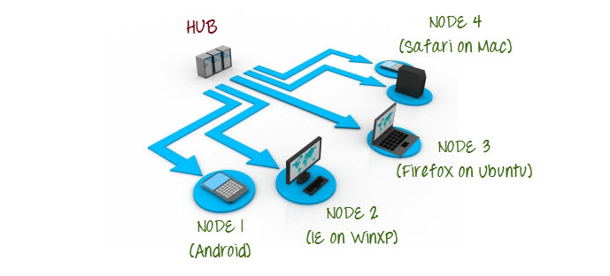

Commands in Hub Machine

1.Setting Up Hub:

**java -jar selenium-server-standalone-2.44.0.jar -role hub**

**2.Validating Hub started**

[**http://localhost:4444/grid/console**](http://localhost:4444/grid/console)

Commands in Node Machine

**3.Accessing Hub from Node Machine**

[**http://iporhostnameofHub:4444/grid/console**](http://iporhostnameofmachinea:4444/grid/console)

**4.Registering Node with Hub**

**Java –jar selenium-server-standalone-2.44.0.jar –role webdriver –hub** <http://iporhostnameofHub:4444/grid/register -port 5566>

**5. From node reg browser: java -Dwebdriver.chrome.driver "browser .exe path" -jar jarName -role webdriver -hub hub_URL**

**Code in Hub Machine**

**import java.io.File;**

**import java.net.MalformedURLException;**

**import java.net.URL;**

**import java.util.concurrent.TimeUnit;**

**import org.junit.Test;**

**import org.openqa.selenium.Platform;**

**import org.openqa.selenium.WebDriver;**

**import org.openqa.selenium.firefox.FirefoxDriver;**

**import org.openqa.selenium.firefox.FirefoxProfile;**

**import org.openqa.selenium.remote.DesiredCapabilities;**

**import org.openqa.selenium.remote.RemoteWebDriver;**

**import org.testng.annotations.AfterMethod;**

**import org.testng.annotations.BeforeMethod;**

**public class Testparallel {**

**//protected ThreadLocal<RemoteWebDriver> threadDriver = null;**

**public static void main(String[] args) throws MalformedURLException {**

**WebDriver driver;**

**DesiredCapabilities capabilities = DesiredCapabilities.firefox();**

**capabilities.setCapability(FirefoxDriver.BINARY,new File("C:\\Program Files (x86)\\Mozilla Firefox\\firefox.exe").getAbsolutePath());**

**driver = new RemoteWebDriver(new URL("http://192.168.0.106:5566/wd/hub"), capabilities);**

**driver.get("http://google.com");**

**System.out.println(driver.getTitle());**

**}**

**}**

**------Chrome Code----------------------**

**import java.net.MalformedURLException;  
import java.net.URL;**

import org.openqa.selenium.Platform;  
import org.openqa.selenium.WebDriver;  
import org.openqa.selenium.remote.DesiredCapabilities;  
import org.openqa.selenium.remote.RemoteWebDriver;

public class remotetest {

public static void main(String[] args) throws MalformedURLException {  
// TODO Auto-generated method stub  
//Automated- chrome,firefox,ie,safari  
  
DesiredCapabilities dc= new DesiredCapabilities();  
dc.setBrowserName("chrome");  
dc.setPlatform(Platform.WINDOWS);  
//dc.se  
  
//Webdriver driver=new ChromeDriver();  
WebDriver driver= new RemoteWebDriver(new URL("http://localhost:4444/wd/hub"),dc);  
driver.get("http://rediff.com");  
  
  
  
//   
}

}