1. Write a program to insert and retrieve the data from database using JDBC

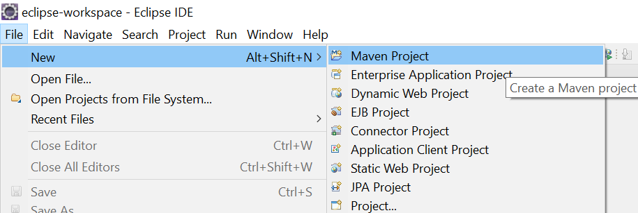

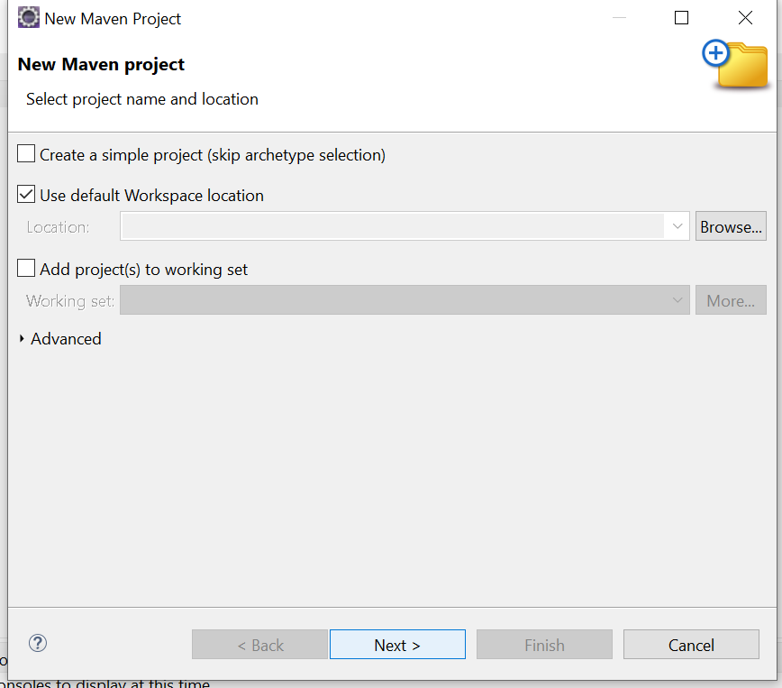

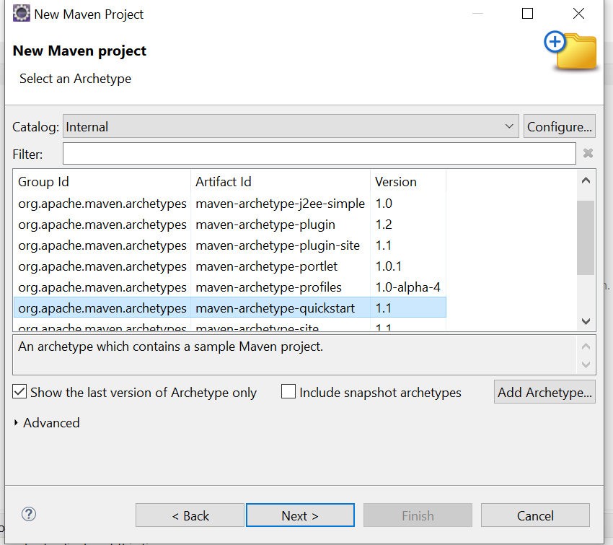

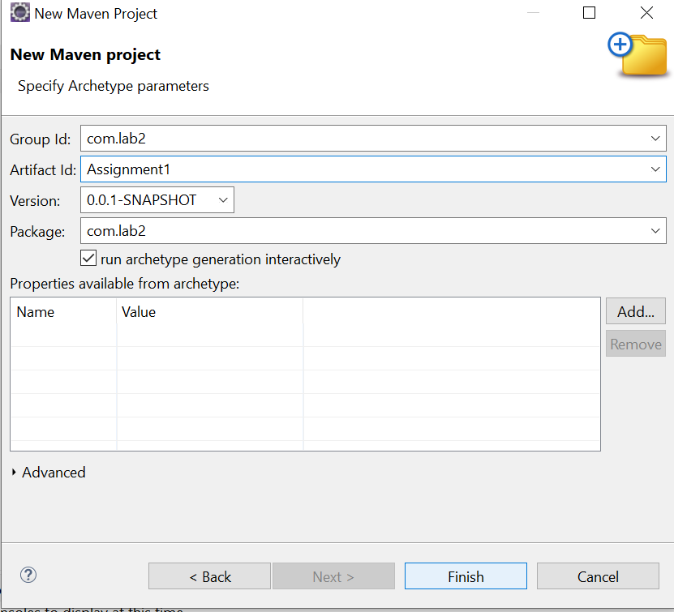

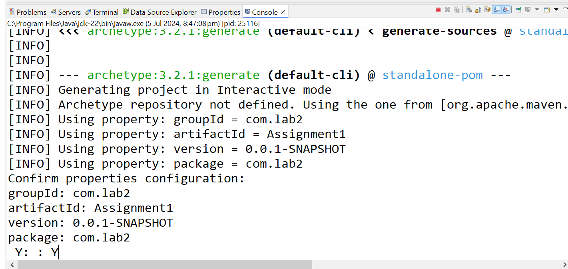

ConClass.java

=================

package com.lab2;

import java.sql.Connection;

import java.sql.DriverManager;

public class ConClass {

public static Connection getCon()

{

Connection con =null;

try {

// Class.forName("com.mysql.cj.jdbc.Driver");

con = DriverManager.getConnection("jdbc:mysql://localhost:3306/db01?allowPublicKeyRetrieval=true&useSSL=False","root","admin@123");

} catch (Exception e)

{

e.printStackTrace();

}

return con;

}

}

Main Application

package com.lab2;

import java.sql.\*;

class DbOperation // create and read record

{

public static void createRecord()

{

String rollno = "1212";

String sname = "Amit2 Kumar";

String course = "Java";

String fees = "23000";

Connection con =null;

try {

con = ConClass.getCon();

Statement st = con.createStatement();

String insSql = "insert into student values (";

insSql = insSql + rollno + ",'" ;

insSql = insSql + sname + "','" ;

insSql = insSql + course + "'," ;

insSql = insSql + fees + ")" ;

st.execute(insSql);

System.out.println("Record saved - ");

} catch (Exception e)

{

e.printStackTrace();

}

}

public static void readRecord()

{

try

{

Connection con = ConClass.getCon();

Statement st = con.createStatement();

ResultSet rs = st.executeQuery("select \* from student");

while (rs.next())

{

System.out.println(rs.getInt(1));

System.out.println(rs.getString(2));

System.out.println(rs.getString(3));

System.out.println(rs.getInt(4));

}

} catch(Exception e) {}

}

}

public class App

{

public static void main( String[] args )

{

DbOperation.createRecord();

DbOperation.readRecord();

}

}

POM.xml file

<project xmlns="http://maven.apache.org/POM/4.0.0"

xmlns:xsi="http://www.w3.org/2001/XMLSchema-instance"

xsi:schemaLocation="http://maven.apache.org/POM/4.0.0 http://maven.apache.org/xsd/maven-4.0.0.xsd">

<modelVersion>4.0.0</modelVersion>

<groupId>com.lab2</groupId>

<artifactId>Assignment1</artifactId>

<version>0.0.1-SNAPSHOT</version>

<packaging>jar</packaging>

<name>FirstAssignment</name>

<url>http://maven.apache.org</url>

<properties>

<project.build.sourceEncoding>UTF-8</project.build.sourceEncoding>

</properties>

<dependencies>

<!-- https://mvnrepository.com/artifact/com.mysql/mysql-connector-j -->

<dependency>

<groupId>com.mysql</groupId>

<artifactId>mysql-connector-j</artifactId>

<version>8.1.0</version>

</dependency>

<dependency>

<groupId>junit</groupId>

<artifactId>junit</artifactId>

<version>3.8.1</version>

<scope>test</scope>

</dependency>

</dependencies>

</project>

Output:

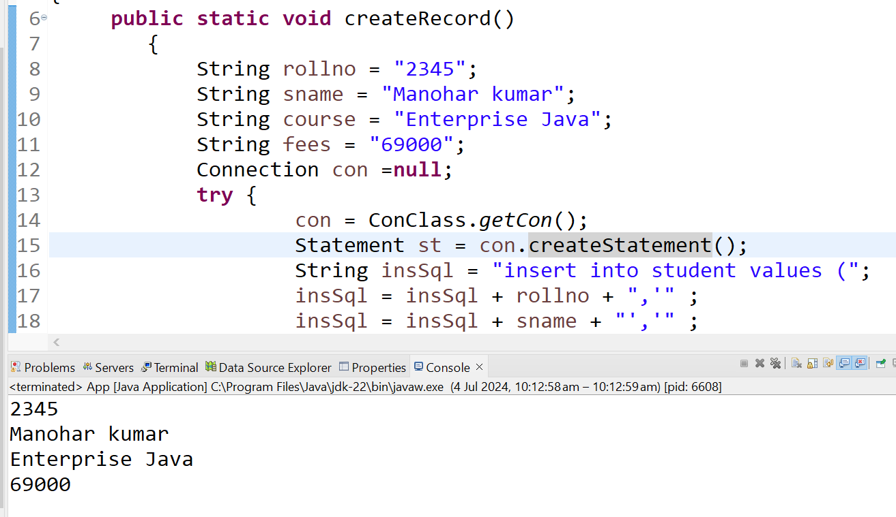

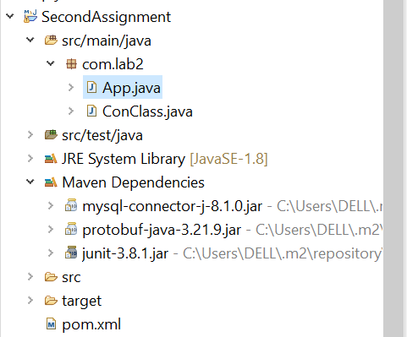

Create following table in mysql under db01 database.

Create table student

(

rollno int,

sname varchar(20),

course varchar(20),

fees int

)