**DC Drive with chopper control for EV**

**Name : Ajit Dadasaheb Hukkie**

**Unique ID: 2005065**

Contents

Circuit Diagram 2

Circuit Specification 2

Differential Equations 3

Working Operation 3

Motoring operation 3

Regenerative braking operation 3

Simulink Model 4

Output 5

# Circuit Diagram

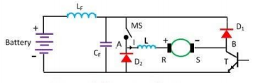

# Circuit Specification

V: applied voltage (V)

Ia : motor current (A)

Iin : Load current (A)

i : Supply current (A)

Vc : Capacitor Voltage (V)

La : Armature Inductor (H)

L : Series Inductor (H)

Lf : Source Inductor (H)

Cf : Capacitor voltage (F)

Ra : Armature Resistance (Ω)

ωn : Motor output speed (rps)

# Differential Equations

Motoring Operation Regenerative Breaking

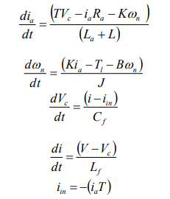 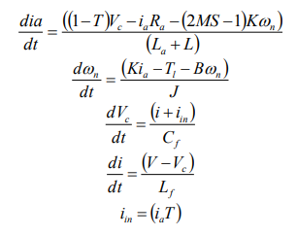

# Working Operation

Motoring operation**:-** In motoring mode, the machine works as a motor and converts the electrical energy into mechanical energy, supporting its motion. For motoring operation MS is kept closed[6]. Transistors switch T is operated at a constant frequency with variable on time to obtain variable dc voltage for starting and speed control. When T is on, the current flows through the source, Lf , MS, L, R, armature, S and T. when T is off, the armature current freewheels through S, D1, MS, L and R

Regenerative braking operation**:** for regenerative braking operation MS is kept open and motor armature is reversed with the help of the reversing switch RS making B positive with respect to A. when T is on, the armature current builds up through the path consisting of T, D2 and L. when T is off, the armature current flows against the battery voltage through the path consisting of D1, Lf , battery, D2 and L and the energy feedback is utilized to charge the battery

# Simulink Model

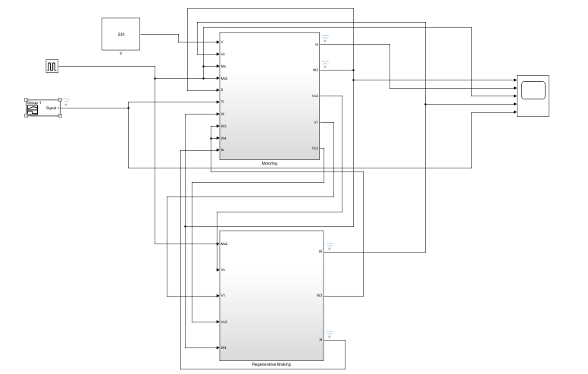

# Output

