To Run the program. Go to path containing the jar and run

Java –jar Runner.jar testdata.csv

Since there was no instrcutions about the arguments. So having more than 1 argument will throw exception and using diff file name will load the file present in application.

You can input your own file by placing it in the same directory where jar is present if the file is in diff directory enter the full path. Check the below screenshots

NOTE: Appliation has been developed using Java8 so please make sure Java8 installed in system and classpath is set

Keep the testdata.csv file with entries in the directory where ever jar is present

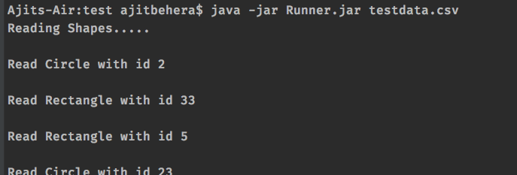

File exists but naming is invalid so will load default file

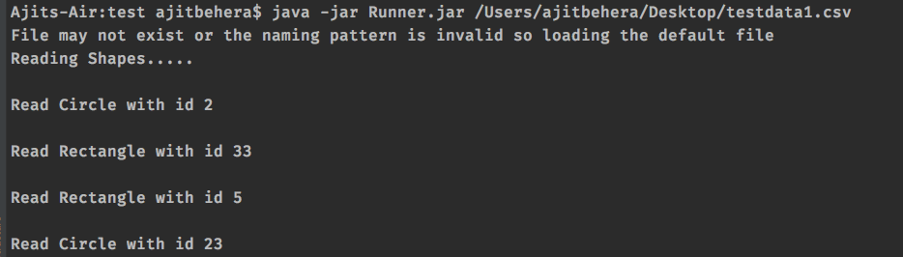

can also give path to the file present in some other directory

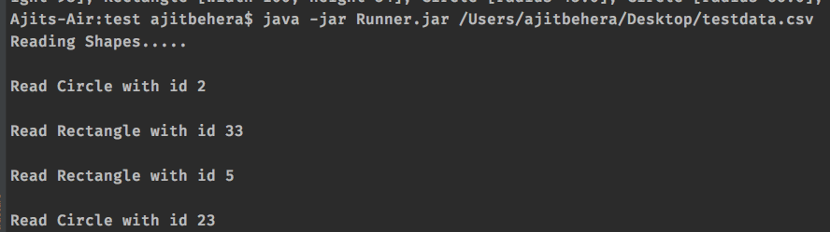

giving file which is not present it will read the file present in application

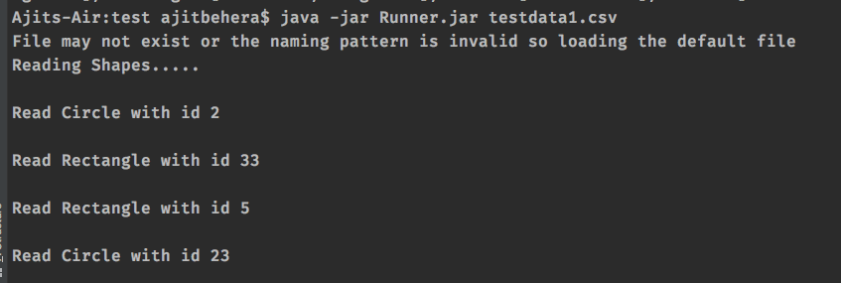

with out any argument also it will read the default file

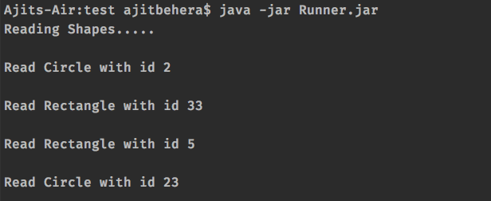

Can also check the githublink:

<https://github.com/AjitNitrkl/ShapeCalc/tree/master>