Template document status – do not change
Version | 2.0
Date | 11/2024
Status | Released
Classification | Restricted
Template document responsible | Rehulkova, Michaela/ Stefan, Livia

Important notes:
Test responsible:
In the IT Requirement (ITR) process the user acceptance test is in responsibility of the Requester/Key User. For the internal integration test as part of a bug fix (Change request) the test is in responsibility of the Application Analyst.
Test result:
The test result must be recognizable.
Screenshots:
All screenshots must have an IPE-compliant display which means that date, time and the SAP System/Client must be included in every screenshot.
Naming Convention:
Name of the test document should start with SX_ followed by the ticket number of the change document. Optionally the document type UAT (FTC) can be added, e.g. S_UAT_4100002725_testdocument. – to be revised with the completion of the SHERPA X transition
Reference ticket number:
For internal integration test please use the number of the change document (e.g. normal change) as the reference ticket. The user acceptance test should refer to the respective IT Requirement.

Test document history – please fill
Title / Filename
Date | Version | Short description |  | Created by
18.11.2024 | Version | Creator vs orderer scenario |  | Rehulkova,Michaela
DD/MM/YYYY | Version | Description |  | Name
DD/MM/YYYY | Version | Description |  | Name
DD/MM/YYYY | Version | Description |  | Name
DD/MM/YYYY | Version | Description |  | Name
DD/MM/YYYY | Version | Description |  | Name

Testing details:
Date of test | 18.11.2024
Name and department of tester
System | ☐ DEV | ☒ QA | ☐ PROD
Reference ticket number

Testcase
Describe shortly the test case and the expected results / purpose of the test
Creation of a SP for an orderer in myMall through the SAP job – ARE should be 3014, orderer should be myself GID Z0028XJ
- ARE and CC from orderer must update to 3014 instead of 539D
- System T4QCLNT100 and POrg to remain as is C501
- Testing with Kristine Kanton whether she has to select Viktor or Sven as orderer

Screenshots of test, error messages, comments, test result & output
Update Shopping profile:

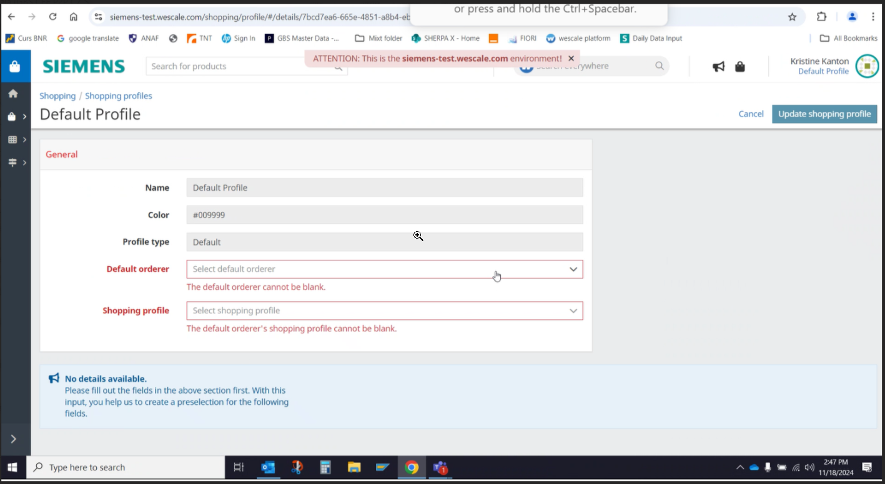

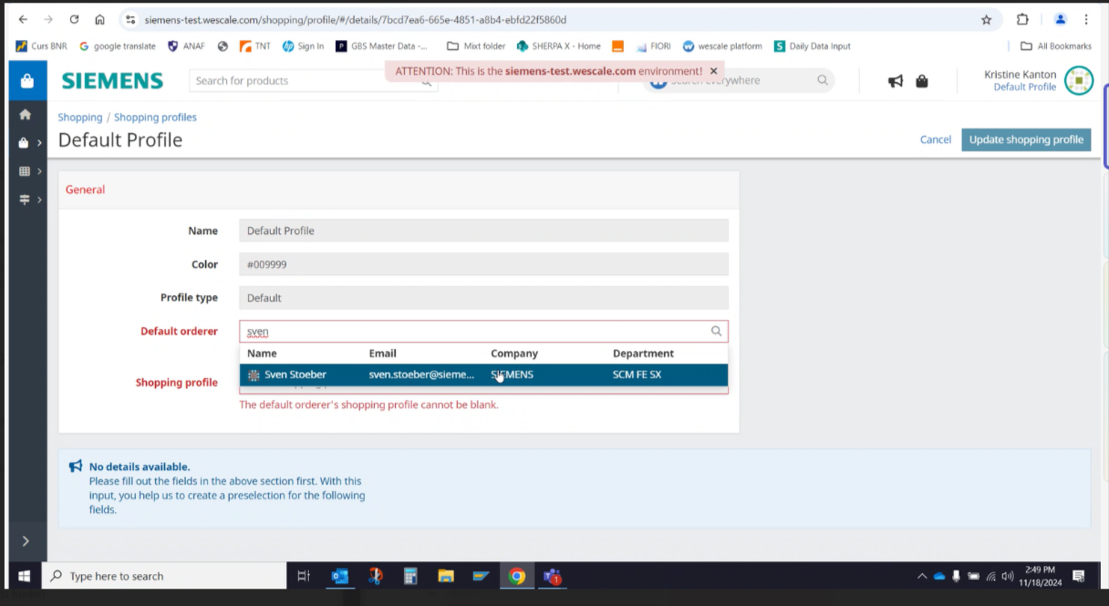

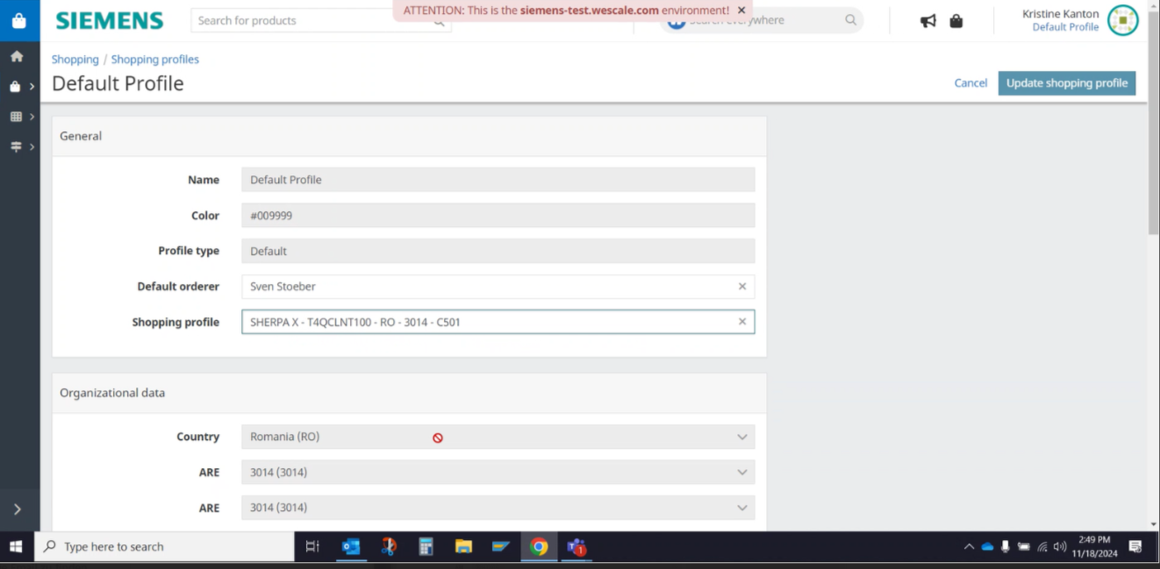

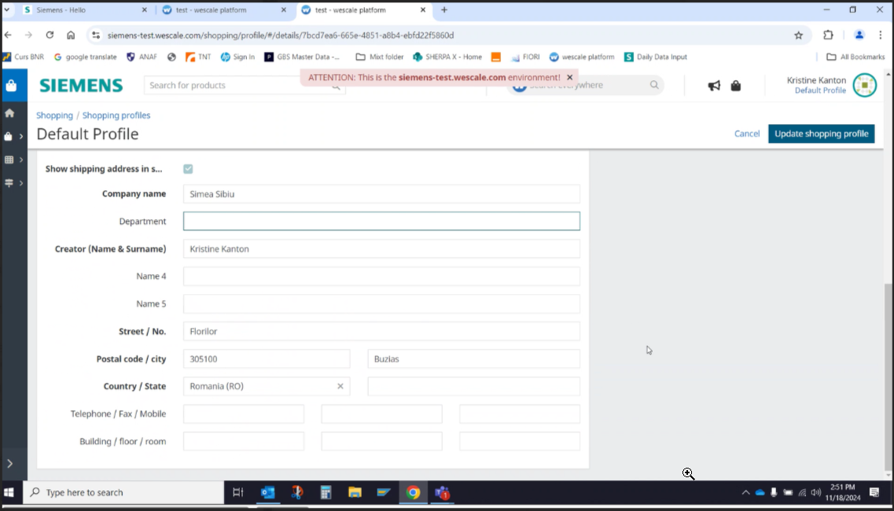

Select product:

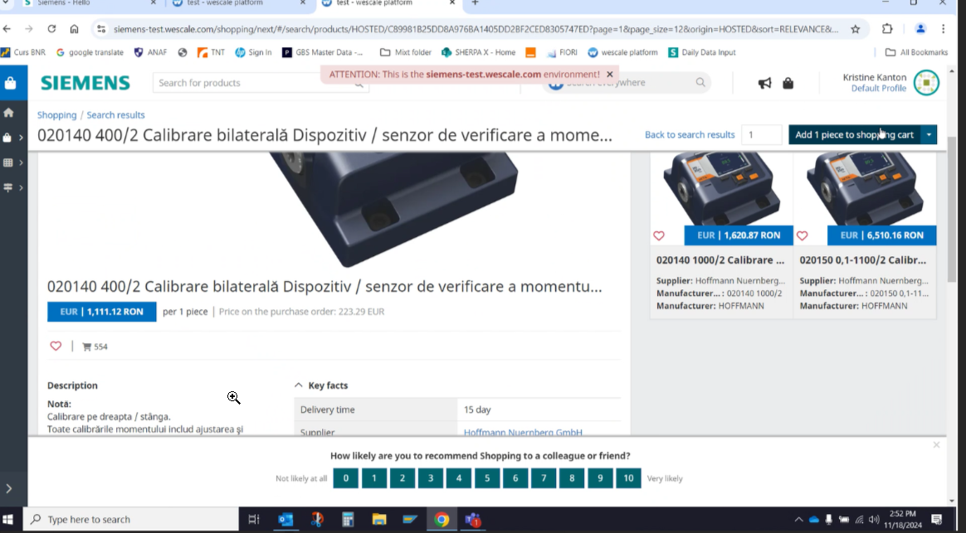

- Creator has Business Purpose automatically filled in the shopping cart with Indirect

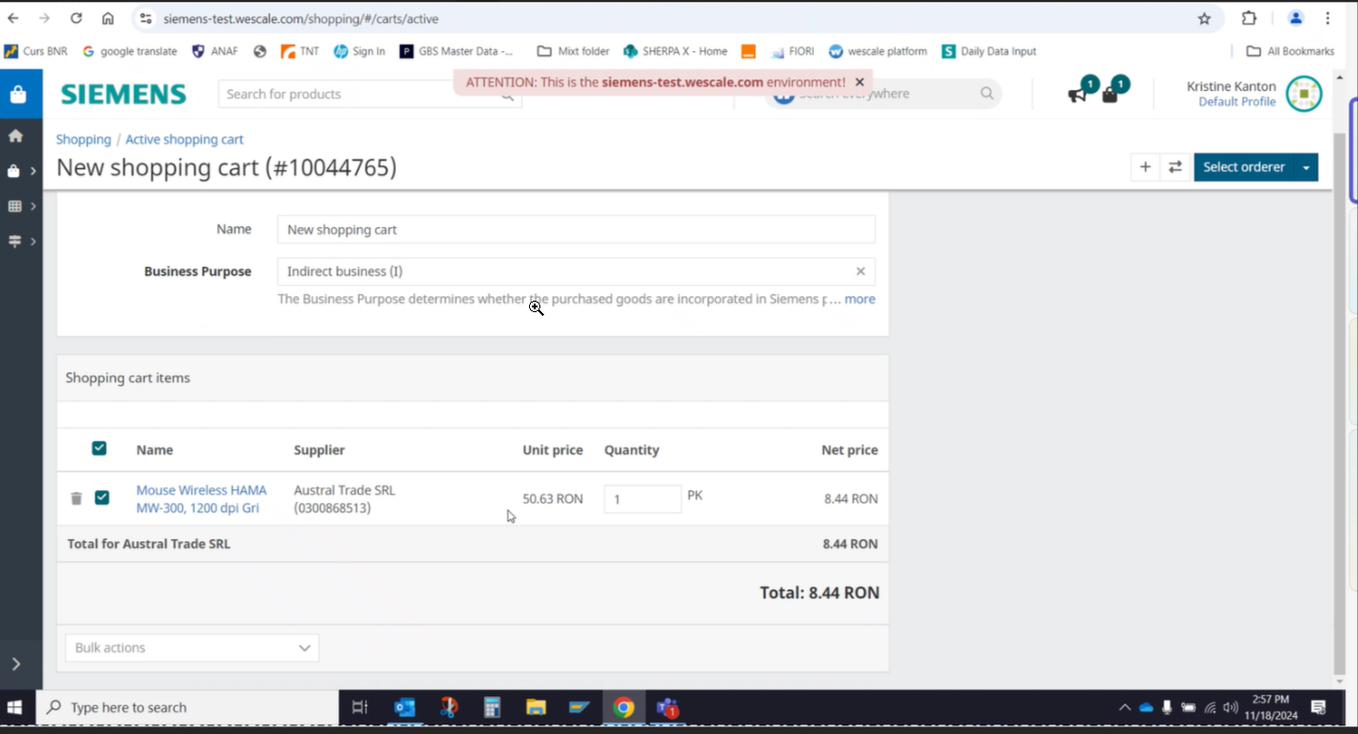

Select orderer:

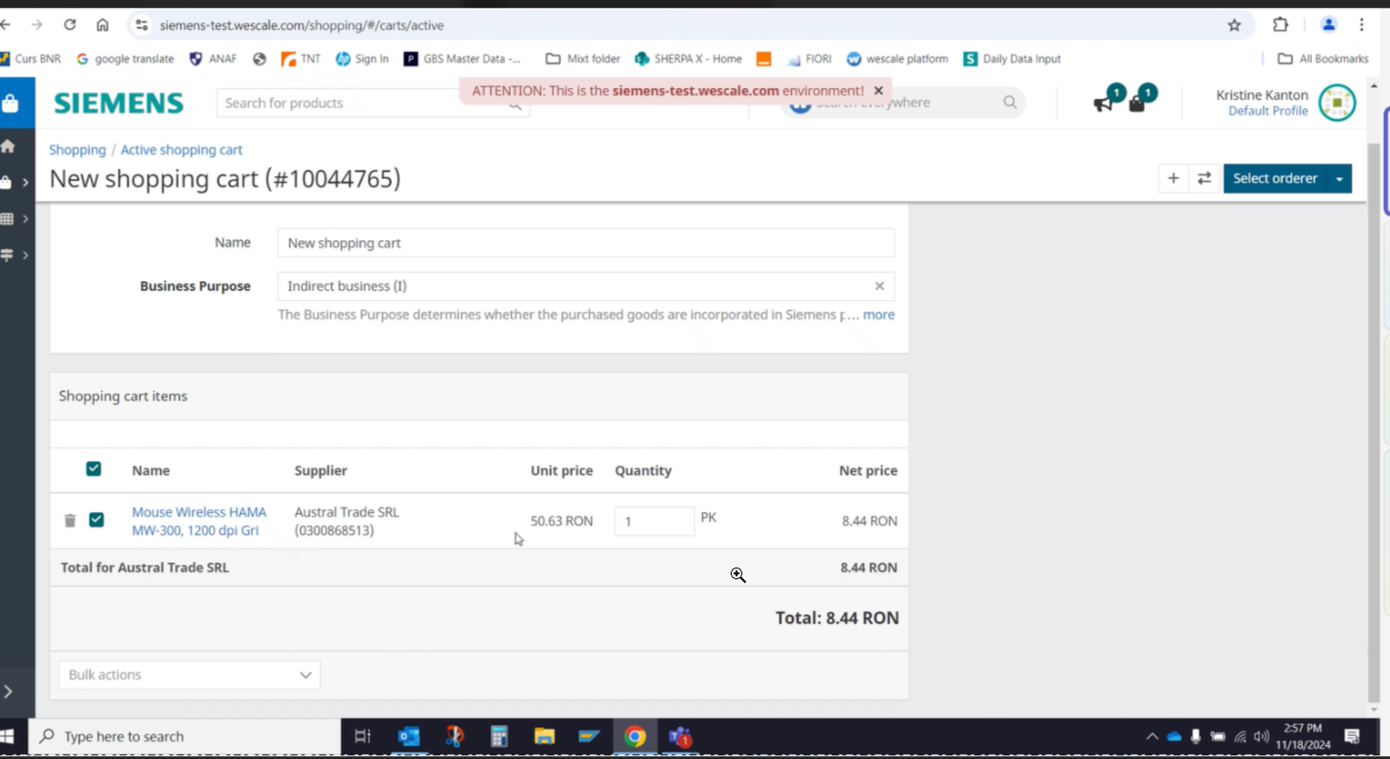

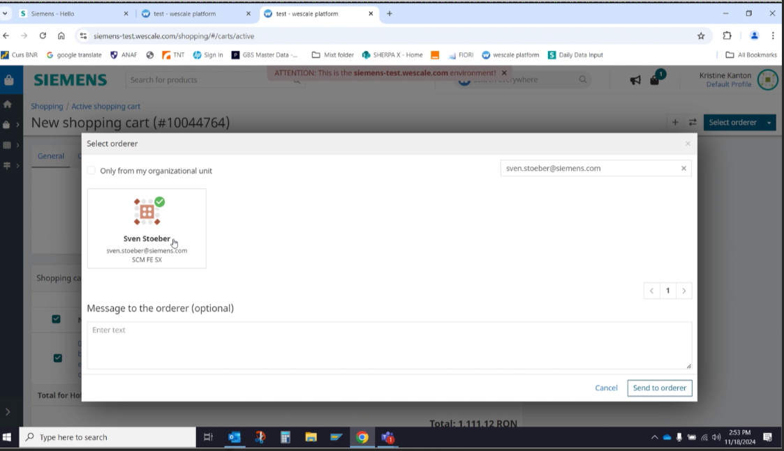

Checkout of the SC from Orderer

- Selected Business Purpose is missing

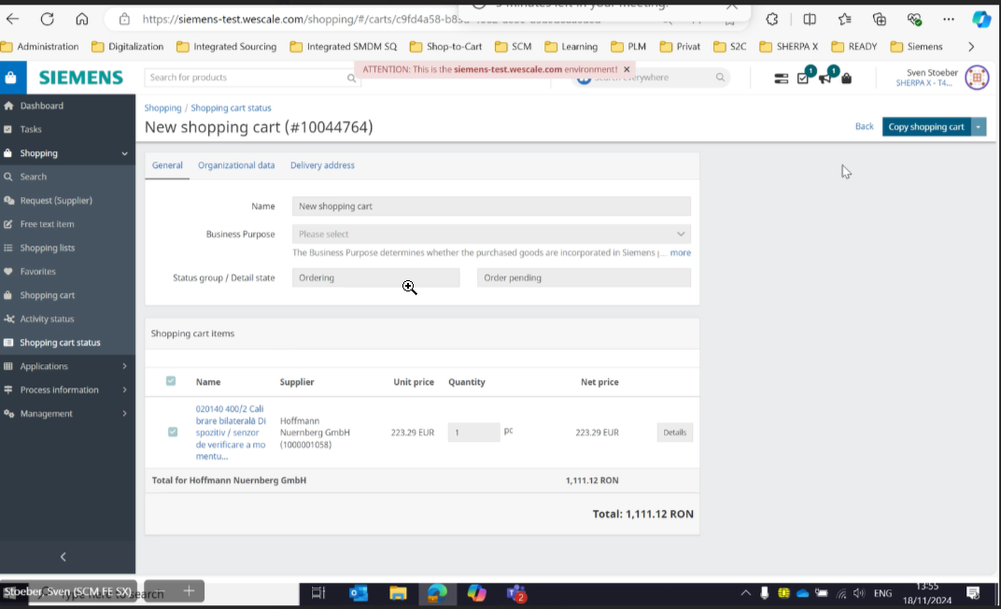

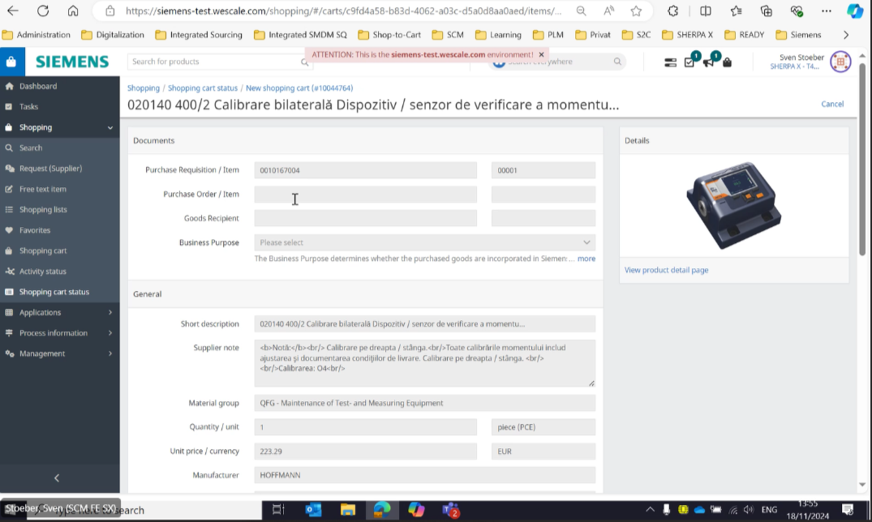

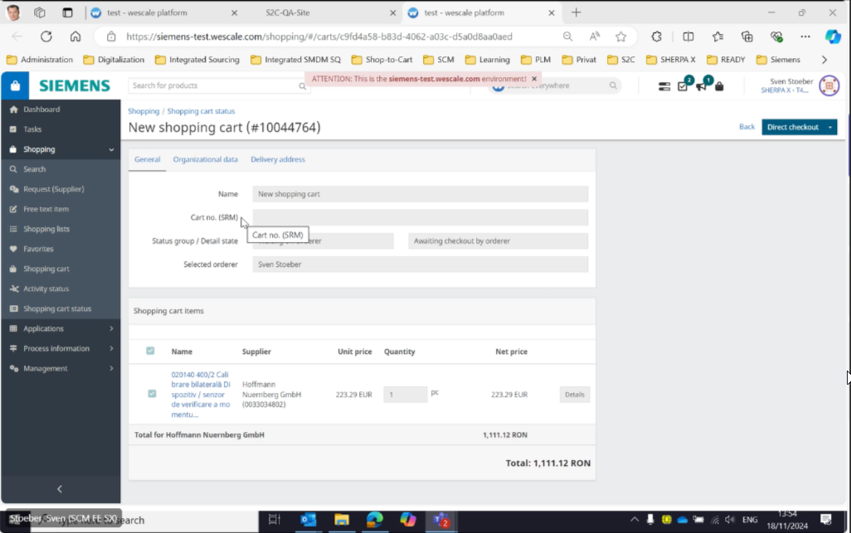

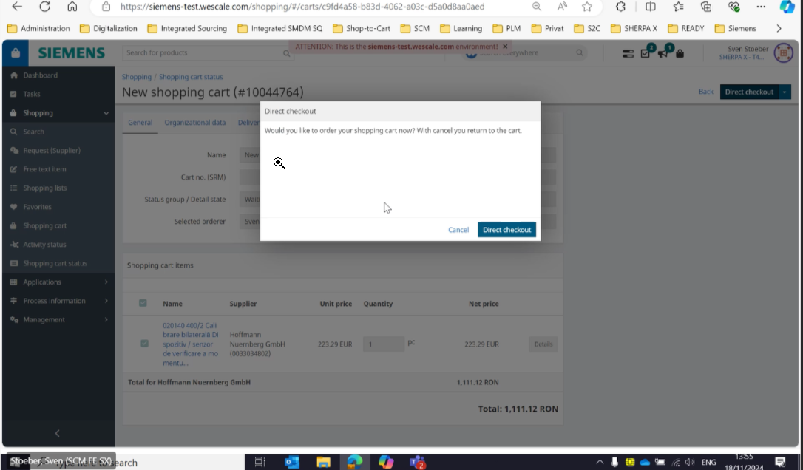

Test was successful  Please attach a screenshot of the result and of any documents output. | ☒
Test was not successful  Please attach a screenshot of the result and any error messages.  Consider a new test. Test document should be enhanced by another test case. | ☐

