BUSINESS REQUIREMENT DOCUMENT

# PROJECT GROUP : 9 (SKILLNEST)

**Prepared By**: KIRAN VIJAYAN AND AJITH REDDY TEKULA

**Date**: 19-11-2024

**PROBLEM STATEMENT 9** : The shift toward digital learning has opened up new opportunities for students but has also introduced significant challenges. Many students struggle with staying organized, motivated, and engaged in their studies when they lack the structure of a traditional classroom environment. Managing multiple assignments, keeping track of deadlines, and finding reliable study resources can be overwhelming, particularly for students who are not accustomed to self-directed learning. Additionally, the absence of in-person interactions with teachers and peers can lead to feelings of isolation, further diminishing students' motivation and performance. While learning management systems (LMS) provide a basic framework for digital education, they often lack the personalization and support needed to address these individual challenges.

## 1. PROJECT OVERVIEW

SKILLNEST is a digital learning platform designed to bridge the gap between learners and certified trainers in an online environment. It enables app-approved trainers to create courses, add modules, and assign assessments. Learners can register, explore available courses, view detailed modules, and submit assignments directly through the platform. Submitted assignments are reviewed and evaluated by the respective trainers, ensuring personalized feedback. SKILLNEST aims to tackle common digital learning challenges like lack of motivation, disorganization, and limited interaction by offering a structured, interactive, and supportive educational experience tailored to both learners and trainers.

**Key Technologies**:

* Backend: ASP.NET Core Web API
* Frontend: Angular

## 2. ABSTRACT

The rise of digital learning has transformed education by increasing accessibility and flexibility, yet it also presents challenges such as lack of motivation, poor organization, and limited interaction. To address these issues, we developed SKILLNEST, a comprehensive digital learning platform designed to enhance student engagement and streamline the learning process. SKILLNEST connects certified trainers approved by app administrators with learners in a structured, interactive environment. Trainers can create and manage courses, modules, and assignments, while learners can explore available courses, access learning materials, and submit assignments. Once submitted, assignments are evaluated directly by the respective trainer, promoting personalized feedback and accountability. By fostering trainer-learner interaction and offering an organized learning workflow, SKILLNEST aims to reduce the isolation of self-directed learning and improve overall academic performance in a digital setting.

## 3. BUSINESS OBJECTIVE

The primary business objective of SKILLNEST is to revolutionize digital education by providing a structured, interactive, and personalized learning experience that bridges the gap between trainers and learners. In an era where online learning often lacks engagement and direction, SKILLNEST offers a solution that empowers certified trainers to design comprehensive courses with modules and assignments, while allowing learners to access, complete, and submit coursework in an organized and motivating environment. By facilitating real-time assignment evaluation and feedback, the platform fosters accountability and continuous improvement. SKILLNEST aims to become a trusted hub for skill development by ensuring quality content delivery, supporting learner progress, and enhancing trainer credibility. The platform is also designed for scalability and monetization, enabling future partnerships with educational institutions, corporate training programs, and freelance educators. Ultimately, SKILLNEST strives to improve learning outcomes, promote self-discipline among learners, and create a sustainable ecosystem for digital skill enhancement.

## 4. Stakeholders

**Learners**:

Learners are the core users of the platform who enroll in courses to gain new skills and knowledge. They can browse available courses, access learning modules, complete assignments, and track their progress. The platform is designed to support their learning journey by providing structured content, timely feedback, and interactive features. Learners benefit from a personalized and supportive learning environment that helps them stay organized, motivated, and engaged.

**Trainers**:

Trainers are certified educators or domain experts approved by the platform administrators. They are responsible for creating and managing courses, adding detailed modules, and assigning coursework. Trainers review and evaluate learner submissions, provide feedback, and assign grades. They play a crucial role in maintaining content quality and ensuring learners have a meaningful, guided educational experience. Trainers also build their credibility and presence through consistent engagement and high-quality instruction.

**Administrators**:

Administrators oversee the overall operation and governance of the SKILLNEST platform. Their responsibilities include approving trainer applications, monitoring course content for quality and compliance, managing user accounts, and handling technical or user-related issues. Administrators ensure that the platform functions smoothly, securely, and fairly. They also play a strategic role in implementing platform updates, scaling the system, and exploring growth opportunities such as partnerships and monetization.

**5. Functional Requirements**

* Authentication API

◆ Purpose: The Auth API is responsible for managing user identities and securing communication between the client (Angular app) and backend APIs. It handles user registration, login, role-based authorization (learner, trainer, admin), and approval mechanisms for trainers.

◆ Primary Functions:

* + Registers a learner account
  + Registers a trainer account (requires admin approval)
  + Authenticates users and issues JWT
  + Returns the role of the authenticated user
  + Lists trainers pending approval (Admin only)
  + Admin approves a registered trainer
* Course API:

◆ Purpose: The Course API enables trainers to manage educational content and allows learners to view course material. It is the core educational resource management component.

◆ Primary Functions :

* + Create a new course (Trainer-only)
  + Retrieve all available courses (Open to all)
  + Get details of a specific course
  + Add a module to a course
  + View all modules in a course
  + List courses added by a specific trainer
* Assignment API :

◆ Purpose: The Assignment API facilitates assignment creation, submission, review, and evaluation. It supports trainer-learner interaction through practical assessments and grading.

◆ Primary Functions:

* + Trainer creates an assignment for a course
  + Learners view assignments of a course
  + Learner submits an assignment
  + Trainer views all submissions to review
  + Trainer grades a submission and adds feedback
  + Get all assignments and marks for a specific learner

## 6. System Architecture

The architecture follows a modular and scalable microservices design, integrating multiple APIs with a centralized gateway and frontend client. The Angular application serves as the user interface, where learners, trainers, and administrators interact with the system. All API requests from the client are routed through the API Gateway (port 5000), which acts as a central entry point, handling routing, load balancing, and security via JWT tokens.

The architecture is divided into three key microservices:

* .NET Identity API (Auth API, port 7266) – Handles user authentication, registration, login, and role-based access control. It generates JWTs and manages trainer approvals.
* Course API (port 5276) – Allows trainers to create and manage courses/modules and enables learners to browse them.
* Assignment API (port 5171) – Manages assignment creation by trainers, submission by learners, and evaluation by trainers.

Each API has its own dedicated database, promoting data encapsulation and service independence. The Service Bus enables asynchronous communication (e.g., sending notifications or processing background tasks) between services, enhancing scalability and decoupling. This architecture supports secure, maintainable, and extensible operations in an e-learning platform.

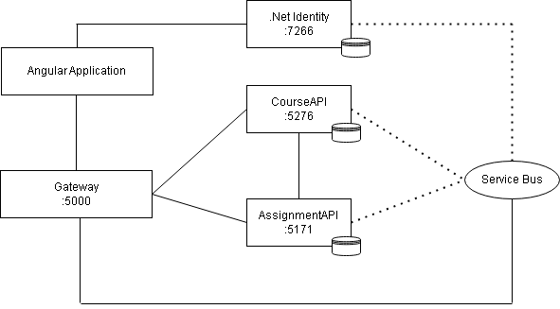

## 7. Constraints

* Trainer Certification and Verification: Only certified trainers, approved by the app administrators, can create and manage courses and assignments, which may limit the pool of available trainers.
* User Authentication: Both trainers and learners must have an active and verified account to access the platform, which can create barriers for new users without proper registration or credentials.
* Assignment Review Timeline: Trainers must manually review and evaluate assignments, which could lead to delays depending on the number of submissions, potentially affecting the timeliness of feedback.
* Internet Dependency: The platform relies on a stable internet connection for accessing courses, submitting assignments, and interacting with trainers, which may present challenges in regions with unreliable internet.
* Scalability: As the number of users grows, the app may face challenges in scaling efficiently, particularly in managing large amounts of course content and user-generated data.
* Personalization Limitations: While the platform facilitates course exploration, the level of personalized learning and support might be limited due to the absence of in-depth, adaptive learning technologies.

## 8. Class Diagram:

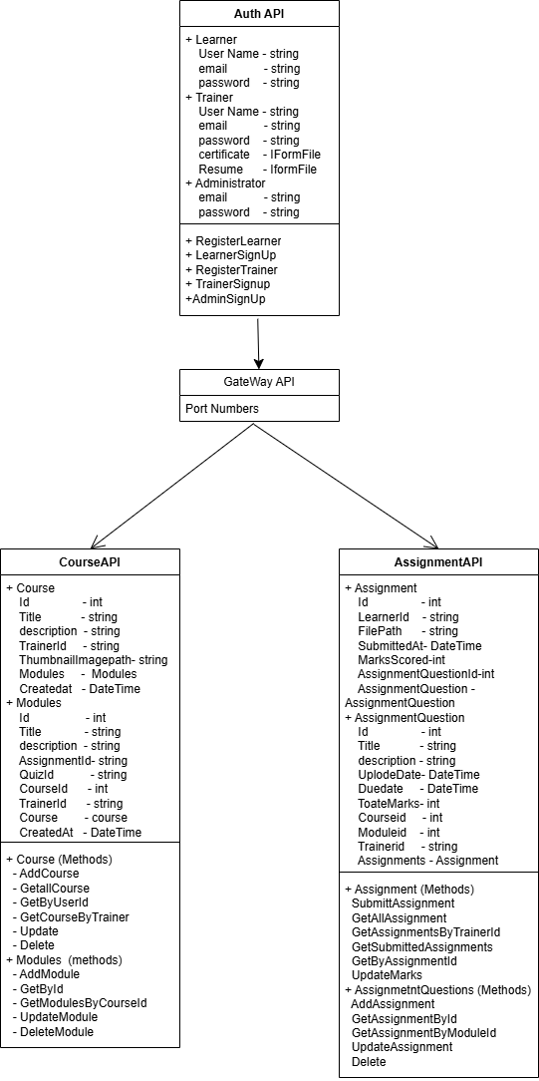

## 9. WorkFlow

The workflow of "SKILLNEST" begins with trainers being certified and approved by the app administrators. Once certified, trainers can log into the platform and create courses, add modules within each course, and set up assignments for learners to complete. Learners, after registering and logging into their accounts, can browse the available courses and view detailed course modules. Upon choosing a course, learners can access the assignments associated with that course. Once they complete the assignments, they submit them through the platform. These assignments are then automatically directed to the respective trainer who created the assignment. The trainer reviews the submitted assignments, provides evaluations, and assigns marks or feedback to the learner. Learners are notified of the assessment results. Throughout this process, both learners and trainers can interact with the platform, ensuring efficient tracking of progress and assignments. The system is designed to encourage engagement and motivation by providing clear course structures, deadlines, and a feedback loop that helps learners improve. This workflow emphasizes seamless interaction between trainers and learners while maintaining an organized, user-friendly system that fosters collaboration, learning, and growth in a digital education setting. The platform aims to provide a personalized learning experience and effective course management for both parties.